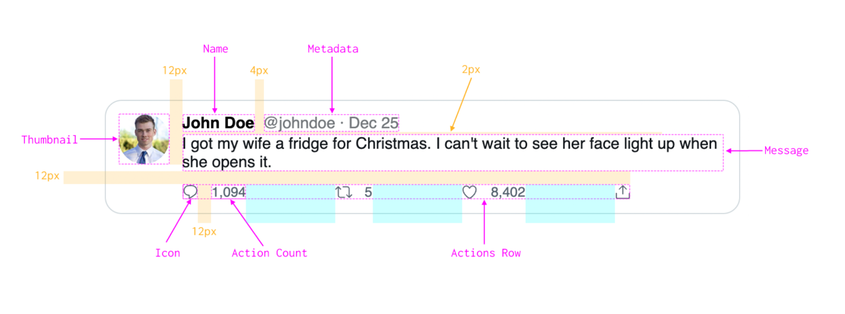

/\* Tweet

Background color: #fff

Border color: #cfd9de

Border width: 1px

Border radius: 16px

Padding: 12px

Thumbnail

Size: 48px

Fully rounded

Name

Color: #000

Font family: sans-serif

Font size: 15px

Font weight: bold

Metadata

Color: #71767b

Font family: sans-serif

Font size: 15px

Use &middot; for the dot

Message

Color: #0f1419

Font family: sans-serif

Font size: 15px

Actions Row

Max width: 425px

Equal spacing between each action

Icon

Color: #536471

Size: 16px

Vertically centered with the count

Action Count

Color: #536471

Font size: 13px \*/

<div>

<img

src="https://xsgames.co/randomusers/avatar.php?g=male"

width="48"

height="48"

/>

<svg viewBox="0 0 24 24" width="16" height="16">

<g>

<path d="M14.046 2.242l-4.148-.01h-.002c-4.374 0-7.8 3.427-7.8 7.802 0 4.098 3.186 7.206 7.465 7.37v3.828c0 .108.044.286.12.403.142.225.384.347.632.347.138 0 .277-.038.402-.118.264-.168 6.473-4.14 8.088-5.506 1.902-1.61 3.04-3.97 3.043-6.312v-.017c-.006-4.367-3.43-7.787-7.8-7.788zm3.787 12.972c-1.134.96-4.862 3.405-6.772 4.643V16.67c0-.414-.335-.75-.75-.75h-.396c-3.66 0-6.318-2.476-6.318-5.886 0-3.534 2.768-6.302 6.3-6.302l4.147.01h.002c3.532 0 6.3 2.766 6.302 6.296-.003 1.91-.942 3.844-2.514 5.176z"></path>

</g>

</svg>

<svg viewBox="0 0 24 24" width="16" height="16">

<g>

<path d="M23.77 15.67c-.292-.293-.767-.293-1.06 0l-2.22 2.22V7.65c0-2.068-1.683-3.75-3.75-3.75h-5.85c-.414 0-.75.336-.75.75s.336.75.75.75h5.85c1.24 0 2.25 1.01 2.25 2.25v10.24l-2.22-2.22c-.293-.293-.768-.293-1.06 0s-.294.768 0 1.06l3.5 3.5c.145.147.337.22.53.22s.383-.072.53-.22l3.5-3.5c.294-.292.294-.767 0-1.06zm-10.66 3.28H7.26c-1.24 0-2.25-1.01-2.25-2.25V6.46l2.22 2.22c.148.147.34.22.532.22s.384-.073.53-.22c.293-.293.293-.768 0-1.06l-3.5-3.5c-.293-.294-.768-.294-1.06 0l-3.5 3.5c-.294.292-.294.767 0 1.06s.767.293 1.06 0l2.22-2.22V16.7c0 2.068 1.683 3.75 3.75 3.75h5.85c.414 0 .75-.336.75-.75s-.337-.75-.75-.75z"></path>

</g>

</svg>

<svg viewBox="0 0 24 24" width="16" height="16">

<g>

<path d="M12 21.638h-.014C9.403 21.59 1.95 14.856 1.95 8.478c0-3.064 2.525-5.754 5.403-5.754 2.29 0 3.83 1.58 4.646 2.73.814-1.148 2.354-2.73 4.645-2.73 2.88 0 5.404 2.69 5.404 5.755 0 6.376-7.454 13.11-10.037 13.157H12zM7.354 4.225c-2.08 0-3.903 1.988-3.903 4.255 0 5.74 7.034 11.596 8.55 11.658 1.518-.062 8.55-5.917 8.55-11.658 0-2.267-1.823-4.255-3.903-4.255-2.528 0-3.94 2.936-3.952 2.965-.23.562-1.156.562-1.387 0-.014-.03-1.425-2.965-3.954-2.965z"></path>

</g>

</svg>

<svg viewBox="0 0 24 24" width="16" height="16">

<g>

<path d="M17.53 7.47l-5-5c-.293-.293-.768-.293-1.06 0l-5 5c-.294.293-.294.768 0 1.06s.767.294 1.06 0l3.72-3.72V15c0 .414.336.75.75.75s.75-.336.75-.75V4.81l3.72 3.72c.146.147.338.22.53.22s.384-.072.53-.22c.293-.293.293-.767 0-1.06z"></path>

<path d="M19.708 21.944H4.292C3.028 21.944 2 20.916 2 19.652V14c0-.414.336-.75.75-.75s.75.336.75.75v5.652c0 .437.355.792.792.792h15.416c.437 0 .792-.355.792-.792V14c0-.414.336-.75.75-.75s.75.336.75.75v5.652c0 1.264-1.028 2.292-2.292 2.292z"></path>

</g>

</svg>

</div>