This website will be a personal website that will be used to introduce myself to potential employers. The website will include some of my

* Accomplishments
* Experiences
* Projects
* Fun facts
* Other information about myself

Short bio: Hello! I am Matthew Xue and I am a fourth year student studying Business and Data Science at Northeastern University. I am excited to graduate this spring and I have a passion for analyzing data and problem solving.

CSS Screenshot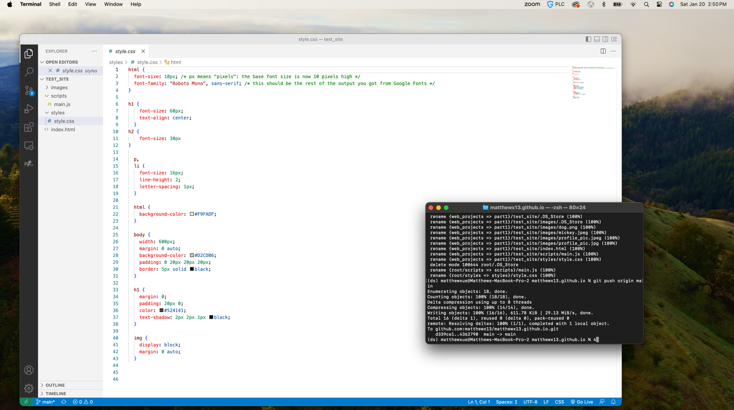

Javascript Screenshot