DGSI/IN TSD 9DL

Version number | 1.0
Status | S
Author | Fan Wei
Document name | DGSI_IN_TSD_9DLv1.0.docx
Owner | Fan Wei

DOCUMENT CONTROL
  - Summary / History of changes

Version Number | Version Date | Nature of Change (and author’s initials) | Date Approved
1.0 | 05/5/2021 | Initial version
  - Document Author / Maintainer

Responsibility | Name | Address | Issue Date
DCSI/ZAO/CHN/IN/MSI | Fan Wei | wei.fan1@michelin.com | 2021/04/30

  - Document Reviewers

Organization Represented | Name | Address | Review Date
DCAD/ACC/CHN | Xue lei | Lei.xue@michelin.com
DCAD/ACC/CHN | Niya Fu | niya.fu@michelin.com
DCSI/ZAO/CHN/IN/DAP | Matthew Liu | Matthew.liu@michelin.com
DCSI/ZAO/CHN/IN/DAP | Locke Liu | locke.liu@michelin.com
DCSI/ZAO/CHN/IN/DAP | Jing fang | jing.fang@michelin.com
DCSI/ZAO/CHN/BS | Min cheng | Min.cheng@michelin.com

  - Document Approvers

Organization Represented | Name | Address | Approval Date
DCSI/ZAO/CHN/BS | Terrence Gu | Terrence.gu@michelin.com
DCSI/ZAO/CHN/IN/DAP | Matthew Liu | Matthew.liu@michelin.com
DCAD/ACC/CHN | Edward Wang | Edward.wang@michelin.com

  - Distribution List

Organization Represented | Name | Address | Review Date
DCAD/ACC/CHN | Xue lei | Lei.xue@michelin.com
DCAD/ACC/CHN | Niya Fu | niya.fu@michelin.com
DCSI/ZAO/CHN/IN/DAP | Matthew Liu | Matthew.liu@michelin.com
DCSI/ZAO/CHN/IN/DAP | Locke Liu | locke.liu@michelin.com
DCSI/ZAO/CHN/IN/DAP | Jing fang | jing.fang@michelin.com
DCSI/ZAO/CHN/BS | Min cheng | Min.cheng@michelin.com

  - Document References

Content | Title | File
SAR | 9DL SAR

  - Acronyms

Acronym | Signification | Details
Azure | Microsoft Cloud | Microsoft public cloud platform
ADF | Azure data factory | Azure Data Factory is Azure's cloud ETL service for scale-out serverless data integration and data transformation. It offers a code-free UI for intuitive authoring and single-pane-of-glass monitoring and management. You can also lift and shift existing SSIS packages to Azure and run them with full compatibility in ADF
ADLS | Azure Data Lake Storage | Azure Data Lake Storage is a set of capabilities dedicated to big data analytics, built on Azure Blob storage.
CDP | Consumer data platform | A consumer data platform (CDP) is a collection of software which creates a persistent, unified customer database that is accessible to other systems.
DMP | data management platform | A data management platform (DMP) is a software platform used for collecting and managing data. They allow businesses to identify audience segments, which can be used to target specific users and contexts in online advertising campaigns.

Content
DOCUMENT CONTROL 2
Content 5
Figures 6
1 - Requirements 7
1.1 Project background 7
1.2 Project objective 7
1.3 Functional requirement 7
1.4 Constrains 8
1.5 Non-Functional requirement 8
1.5.1 Auditability 8
1.5.2 Availability 8
1.5.3 Confidentiality 8
1.5.4 Continuity 8
1.5.5 Integrity 9
1.5.6 Performance 9
1.5.7 Supportability 9
1.5.8 Usability requirements: 9
2 - System Context Diagram 10
3 - Infrastructure Architecture Overview 12
3.1 - Architecture Overview Diagram 12
3.1.1 - Current Architecture 12
3.1.2 - Target Architecture 12
4 - Infrastructure Logical Architecture 13
4.1 - Logical Component Model 13
4.2 - Component List 13
5 - Architecture Decisions 15
5.1 - Architecture Decisions summary 15
5.2 - Architecture Decisions - Details 15
6 - Infrastructure Physical Architecture 21
6.1 - Products for Components 21
6.2 - Physical Operational Model diagram 22
6.3 - Physical Nodes List 22
6.4 - Sizing 24
6.4.1 - Data factory 24
6.4.2 - Self-hosted integration runtime 24
6.4.3 - Databricks 25
6.4.4 - Storage account 25
6.4.5 - Key vault 25
6.4.6 - Event Hub 26
6.5 - Infrastructure Specificities 27
6.5.1 - Backup policy 27
6.5.2 - Monitoring 27
6.5.3 - Security 27
6.5.4 - CMDB 31
6.5.5 - Disaster recovery 31
6.5.6 - Network 32
6.5.7 - Resource group 32
6.5.8 - Supporting model 33
6.5.9 - Decommission 33
7 - Validation View 34
7.1 - Risks 34
7.2 - Assumptions 34
7.3 - Issues 34
7.4 - Dependencies 34
Error! Hyperlink reference not valid.
Error! Hyperlink reference not valid.
Error! Hyperlink reference not valid.
Error! Hyperlink reference not valid.
Error! Hyperlink reference not valid.
Error! Hyperlink reference not valid.
Error! Hyperlink reference not valid.
Error! Hyperlink reference not valid.
Error! Hyperlink reference not valid.
Error! Hyperlink reference not valid.
Error! Hyperlink reference not valid.
Error! Hyperlink reference not valid.
Error! Hyperlink reference not valid.
Error! Hyperlink reference not valid.
Error! Hyperlink reference not valid.
Error! Hyperlink reference not valid.
Error! Hyperlink reference not valid.
Error! Hyperlink reference not valid.
Error! Hyperlink reference not valid.
Error! Hyperlink reference not valid.
Error! Hyperlink reference not valid.
Error! Hyperlink reference not valid.
Error! Hyperlink reference not valid.
Error! Hyperlink reference not valid.
Error! Hyperlink reference not valid.
Error! Hyperlink reference not valid.
Error! Hyperlink reference not valid.
Error! Hyperlink reference not valid.
Error! Hyperlink reference not valid.
Error! Hyperlink reference not valid.
Error! Hyperlink reference not valid.
Error! Hyperlink reference not valid.
Error! Hyperlink reference not valid.
Error! Hyperlink reference not valid.
Error! Hyperlink reference not valid.
Error! Hyperlink reference not valid.
Error! Hyperlink reference not valid.
Error! Hyperlink reference not valid.
Error! Hyperlink reference not valid.
Error! Hyperlink reference not valid.
Error! Hyperlink reference not valid.
Error! Hyperlink reference not valid.
Error! Hyperlink reference not valid.
Error! Hyperlink reference not valid.
Error! Hyperlink reference not valid.
Error! Hyperlink reference not valid.
Error! Hyperlink reference not valid.
Error! Hyperlink reference not valid.
Error! Hyperlink reference not valid.
Error! Hyperlink reference not valid.
Error! Hyperlink reference not valid.
Error! Hyperlink reference not valid.
Error! Hyperlink reference not valid.

Figures
Figure 1 – Current Consumer data overview Diagram 7
Figure 2 - System Context Diagram 11
Figure 3 - Target Architecture Overview Diagram 13
Figure 4 – logical Component Model 14
Figure 5 – Physical operation model diagram 24
Figure 6 – RBAC diagram 29
Figure 7 – session scoped pattern sample diagram 30

Requirements

Project background
Michelin “B2C” business is shifting to a “Consumer Lifetime Value” model to ignite new B2C growth for the entire Group with the potential to capture the full value of each consumer over their “lifetime”.
With the Share of Mobility principle Michelin China has determined to deepen direct consumer relationship and own the consumer data. The vision of Michelin China is to be a ‘Consumer Obsession’ company, therefore Micheline China needs to define an optimal consumer engagement model which enables a premium, one-stop, data-augmented experience for all Michelin consumers in China, with the following attributes:
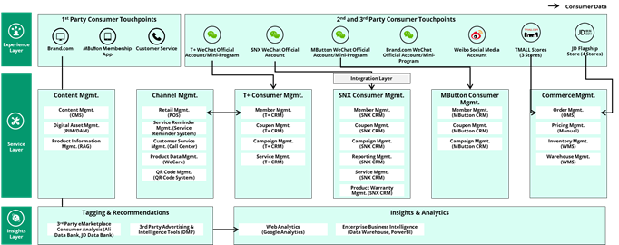
Figure 1 – Current Consumer data overview Diagram

Project objective

Project objective is to set up a consumer data lake to ingest, cleanse and provide china consumer related data for consumption by CDP or other consumer related business application. The inbound data covers all the 1st party touch points and main 2nd party and 3rd party touch points such as Alibaba Ecosystem, Tencent Eco system, Bytedance Eco system, Bilibili, communities and selected offline touch points.

Functional requirement
The basic requirements to the consumer data lake include:
- Staging for Consumer Data
Provide functionality to define the dimensions, metrics, and data maps to organize data structures based on the standards or rules by Michelin for consumption by business applications.
- Data Processing and Cleansing
Data cleansing ensures the consumer data is consistent and usable before it is compartmentalized and staged for use by business applications.
- Data Consolidation
The consumer data lake should ingest and consolidate all consumer structured and unstructured data. The consumer data is not stored in different business applications such as T+ CRM and Michelin CRM. The data ingestion is a key requirement in the project and included in the project scope.

Additional requirements of building the data lake include:

- Data Flow

  - Inbound into Data Lake:

    - All identifiers, transactions, behavioral, demographic, and tracking data (consumer data) should be batch uploaded into data lake directly.
    - If source application only supports real-time data feed, all consumer data should be streamed via API into data lake.
  - Outbound out of Data Lake:
    - All consumer data can be accessed by CDP on the lake. Data Lake should be able to support all needed computation for CDP data processing under specified performance restriction.
- Data Type and Processing
Different dimensions of consumer data must be supported in the datalake including:
  - Structured and unstructured data
  - Timely and Non-timely data
  - Behavior/engagement/event data
  - Analysis/dimension data
The requirement of data processing efficiency has been listed as following:

Data Type | Data Source | Immediacy | Requirements
Transactional | member program/app | No Immediacy | - Recorded in member center via API  - Captured and processed at T+1
 | 3rd party program/app | Immediacy | - Bypass & update in member center via API  - Captured and processed at T+1
 |  | No Immediacy | data processed at T+1
Behavior | member program/app | No Immediacy | data processed at T+1
 | 3rd party program/app | No Immediacy | data processed at T+1

Constrains
N/A

Non-Functional requirement

Auditability
# | Requirement | Details
NF01 | Archive | Data lake storage will be kept permanently (let’s assume 99 years)
NF02 | Auditability | System should provide auditability on every master data, Parameter setup change for the past 6 months
NF03 | Data Retention | Data lake storage will be kept permanently (let’s assume 99 years)

Availability

# | Requirement | Details
NF04 | Availability (expected hours of operation) | 7 days a week, (1:00-21:00 for transactional)
NF05 | Maximum tolerable duration of unavailability | Less than 4 hours of unavailability per month
NF06 | Patch capability | In terms of PaaS components, Follow Azure PaaS standard patch approach, IaaS VM such as self-hosted integration runtime. Microsoft monthly released patches need to be applied based on Michelin security requirement
NF07 | Planned outages | Monthly patch downtime for IaaS components
NF08 | Reliability | N/A
NF09 | Unplanned outages | Not more than 1 times per month

Confidentiality
# | Requirement | Details
NF10 | Authentication | RBAC model for different roles for authentication
NF11 | Authorization | System should have the function that allows system administrator to grant an authorization to different users
NF12 | Confidentiality | D2 and D3 data

Continuity

# | Requirement | Details
NF13 | Backup | Capability for data version and able to restore data in blob storage in the last 7 days
NF14 | Restore (RTO), RPO | 24 hours for RTO, and 24 hours for RPO

Integrity
# | Requirement | Details
NF15 | Integrity | 100% complete on data transfer

Performance

# | Requirement | Details
NF16 | Critical performance | To be defined
NF17 | Maximum total number of users | Year 2021 2022 2023  Users # of users 50 100 100  Year 2020 2022 2023  # of concurrent users 10 15 20
NF18 | Number of concurrent users
NF19 | Response time | tbd

Supportability

# | Requirement | Details
NF20 | Functional support | Daily from 8:00-18:00 GMT +8  To provide application functional support
NF21 | Monitoring | Daily routine monitoring on application, network, interface, batch job.  Alert report for exceptional transaction, block, … etc..  It should be included in support model for especially for role and responsibilities.
NF22 | Technical support | Daily from 8:00-18:00 GMT +8 (Depend on support study)  To provide application technical support
NF23 | Training | N/A

Usability requirements:
# | Requirement | Details
NF24 | Accessibility | Only storage account for external data upload can be access publicly from Internet. All other access including user access and application integration must access data platform through Michelin network.
NF25 | Data migration | N/A
NF26 | Data volume | It’s hard to estimate at this moment. Roughly it should be less than 100TB
NF27 | Documentation | Document available in English.
NF28 | End-user language(s) | Chinese is required.
NF29 | Ergonomic | Screen should be simple and easy enough to understand and adapted local context.
NF30 | Estimated transactional volumes | TBD
NF31 | Volumes of data integrated | TBD
NF32 | Online help/ Documentation | N/A
NF33 | Printing | N/A
NF34 | User Location | China zone

System Context Diagram
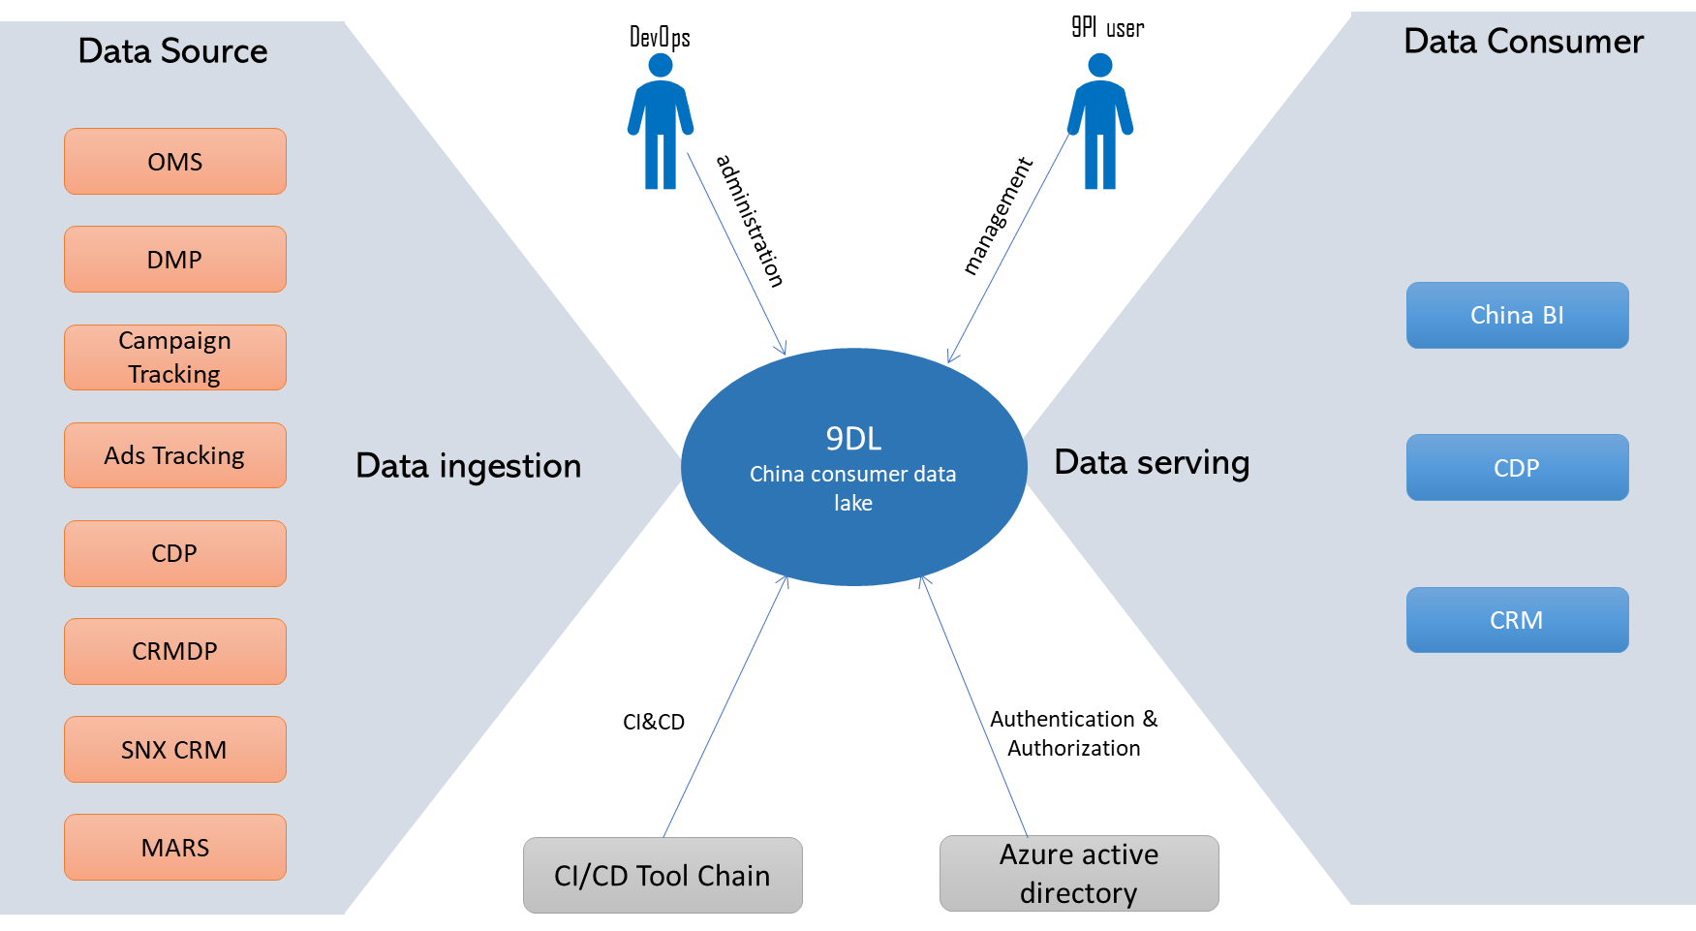

Figure 2 - System Context Diagram

Actors | Kind of user | Human / System |  | Role / name | Function | Location | Details
A_001 | Regular user | Human | 9DL user |  | Data lake user | China
A_002 | Regular user | Human | DevOps |  | Data lake application support and management | China
A_003 | Regular user | System | CI/CD tool chain |  | Michelin China CI/CD tool chain which includes Local gitlab, Jenkins, etc | China
A_004 | Regular user | System | Azure AD |  | Azure directory services for user authentication and authorization | China
A_005 | Regular user | System | OMS |  | Existing application, Part of the data source for data lake | China | Hosted in Azure east china region
A_006 | Regular user | System | DMP |  | Existing application, Part of the data source for data lake | China | Hosted in Azure east china region
A_007 | Regular user | System | Campaign tracking |  | Tracking information of campaign, Part of the data source for data lake | China | Hosted in Azure east china region
A_008 | Regular user | System | Ads tracking |  | Tracking information of advertisement, Part of the data source for data lake | China | Hosted in Azure east china region
A_009 | Regular user | System | CDP |  | The data source of data lake. It also a data consumer of data lake | China | Hosted in Azure east 2 china region
A_010 | Regular user | System | CRMDP |  | Existing application, Part of the data source for data lake | China | Hosted in Azure east china region
A_011 | Regular user | System | SNX CRM |  | Existing application, Part of the data source for data lake | China | Hosted in Azure east china region
A_012 | Regular user | System | MARS |  | Existing application, Part of the data source for data lake | China | Hosted in Azure east china region
A_013 | Regular user | System | China BI |  | BI system used to present different type of customized reports. It is the target data consumer of data lake | China
A_014 | Regular user | System | CRM |  | New CRM system to be built. it will be a data consumer of data lake in future | China

Infrastructure Architecture Overview

Architecture Overview Diagram

Current Architecture

There is no existing architecture of data lake.

Target Architecture
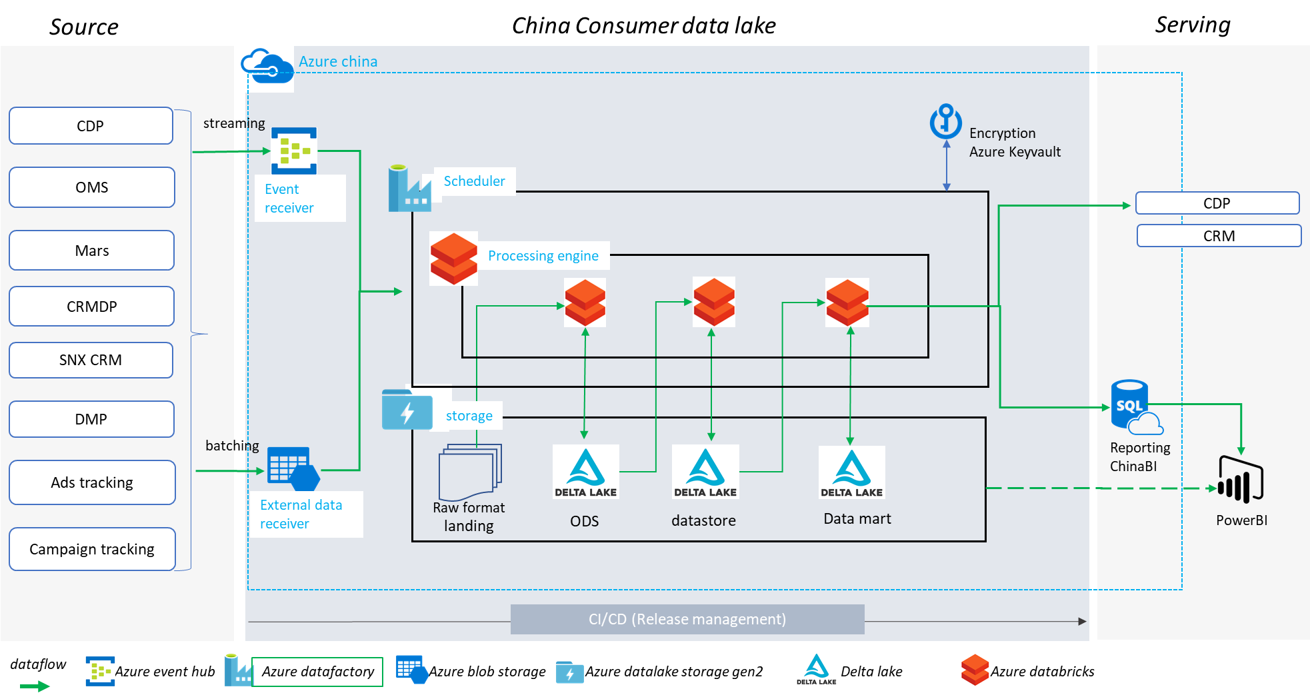

Figure 3 - Target Architecture Overview Diagram
As illustrated in above diagram, there are three elemental areas: Data source area, Data process area and Data serve area.

In the left data source area, there are different types of data generated by multiple applications such as CRMDP, OMS and MARS etc. One is batch data which normally provides to data lake in a file format like CSV. Those data will be ingested into Azure storage account by HTTP API interface and encrypted by SSL for secure transfer.
The other type of data will be streaming data. Based on the design, it will be put into the Azure event hub which is a Kafka compatible real-time data ingestion services. Event hub can be seamlessly integrating with Azure data factory, Databrick etc. for further data process and transformation.

In the middle area, it is the core of China data lake processing area. ADF aka azure data factory will manage the pipeline to copy the data from both event hub and blob storage to Azure data lake storage.

Azure databricks will manage the data transform and cleanse. Based on the design, the raw data will be converted into different types of data, such as ODS, Datastore and data mart for different data consumer.

At last, you may find the data consumer of data lake. We assume that China BI, CDP and CRM will be the 1st batch of consumer. More details could refer to the CDP design. We will more focus on data lake build within this document.

Infrastructure Logical Architecture

Logical Component Model

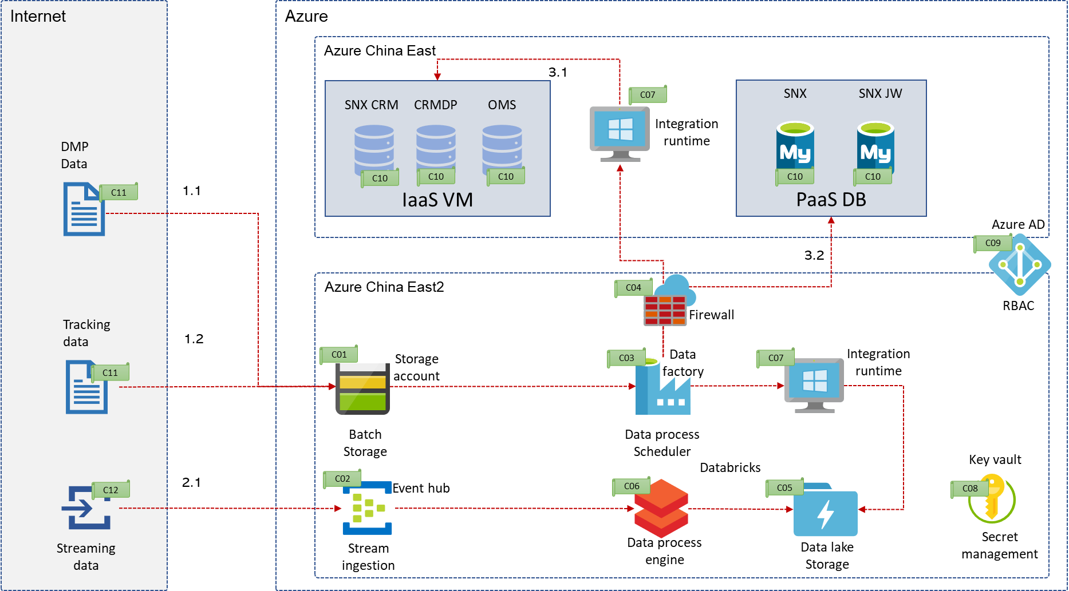
Figure 4 – logical Component Model
The main purpose of China data lake is to collect data from different sources, consolidate and process it. Finally, the processed data can be used to serve different business needs or applications such as CDP, CRM etc.
Azure Data Factory is Azure's cloud ETL service for scale-out serverless data integration and data transformation. It will be used to manage the data that are moving from different types of sources to Azure data lake storage.

After the raw data has been ingested to the data lake storage, Azure Databricks will perform additional ETL and stream processing tasks to filter, clean, transform, join, and aggregate the data into more curated Silver and Gold datasets.

Based on the analysis, our data source will include:
  - Structured and unstructured data
  - Timely and Non-timely data
  - Behavior/engagement/event data
  - Analysis/dimension data

Hence, we split those data into three major types:

- Batch data: mainly upload to azure blob storage through web API
  - DMP data
  - Consumer behavior tracking data
- Streaming data: mainly ingest the data to azure event hub
  - Streaming data to be defined, those will serve real time data ingestion
- RDBMS (Data extracted from database)
  - data from IaaS VM inside of Michelin network vdc
  - data from PaaS database such as SNX, SNX JW

To perform data integration securely in a private network environment, we will setup self-hosted azure data factory integration runtime to bridge Azure data factory and database in IaaS VM through firewall directly.

Component List

Component Code | Component | Description
C01 | Storage account | This component will use Azure storage account to store batch storage. It can be integrated with application through blob storage API. It can also be used to upload data manually through Azure storage explorer.
C02 | Event hub | Event Hubs is a fully managed and real-time data ingestion service that’s simple, trusted, and scalable. Stream millions of events per second from any source to build dynamic data pipelines and immediately respond to business challenges. It can be Integrate seamlessly with other Azure services like ADF etc.
C03 | Data factory | Azure Data Factory is Azure's cloud ETL service for scale-out serverless data integration and data transformation. It will be used to manage the data move pipeline.
C04 | firewall | In our context, we will use Azure firewall to control the network traffic.
C05 | Data lake storage | ‎Azure Data Lake Storage is a set of capabilities dedicated to big data analytics, built on Azure Blob storage. It will be used to store all data of data lake.
C06 | databricks | Azure Databricks provides the latest versions of Apache Spark and allows you to seamlessly integrate with open source libraries. Spin up clusters and build quickly in a fully managed Apache Spark environment with the global scale and availability of Azure.
C07 | Integration runtime | The Integration Runtime (IR) is the compute infrastructure used by Azure Data Factory to provide data integration capabilities across different network environments.
C08 | Key vault | Azure Key Vault is a cloud service for securely storing and accessing secrets. A secret is anything that you want to tightly control access to, such as API keys, passwords, certificates, or cryptographic keys.
C09 | Azure AD | Azure Active Directory (Azure AD) is Microsoft’s cloud-based identity and access management service, which helps your employees sign in and access resources by defined RBAC.
C10 | Data source(db) | RDBMS data sources, such as MySQL, MS SQL Server and PostgreSQL etc.
C11 | Data source (file) | File format data source Such as csv, excel etc.
C12 | Data source (real time) | Realtime message.

Architecture Decisions

Architecture Decisions summary

ARD_ID | Subject | Decision | Status | Comments
ARD_01 | Location of Data lake deployment | Alternative2 | closed
ARD_02 | Azure subscription of Data lake | Alternative2 | closed
ARD_03 | Resource group plan | Alternative2 | closed
ARD_04 | Virtual network design | Alternative1 | closed
ARD_05 | Network connectivity between CDP Vnet and China East Vnet | Alternative2 | closed
ARD_06 | Data integration between ADF and Data source in China east Vnet | Alternative1 | closed
ARD_07 | Datalake storage and Blob storage hosting plan | Alternative2 | closed
ARD_08 | logical environments of Data lake | Alternative1 | closed
ARD_09 | Physical hosting environments of Data lake | Alternative2 | closed
ARD_10 | Access control from Azure databricks to ADLS | Alternative2 | closed

Architecture Decisions - Details

Topic | Description | Comment
ID | ARD_01
Subject | Location of Data lake deployment
Status | closed
Assumption
Alternatives | - Azure Region: China East  - Azure Region: China East 2
Decision | Alternative 2
Justification | - China East is no longer considered for new application deployment  - Some key components, such as databricks is not available in China east
Implications
Related requirements
Related Architecture Decisions

Topic | Description | Comment
ID | ARD_02
Subject | Azure subscription of Data lake
Status | closed
Assumption
Alternatives | - Share subscription with other bss/digital apps  - Create one dedicate subscription for data lake and CDP
Decision | Alternative 2
Justification | - Easy to manage from cost management perspective  - Dedicated subnet is required by new data lake components. Such as databricks, ADF etc. it’s better having a dedicated VNET without touching existing shared infrastructure in BIBCNINF
Implications
Related requirements
Related Architecture Decisions

Topic | Description | Comment
ID | ARD_03
Subject | Resource group plan
Status | closed
Assumption
Alternatives | - One Resource group for each environment  - Two resource groups for each environment, one for databricks only. One for rest 9DL components, such as ADF, ADLS etc. one dedicated shared infra resource group. Totally 5 resource groups.
Decision | Alternative 2
Justification | - It will be easy to organize the application components and infra components  - RBAC defined will be easier and more precise
Implications
Related requirements
Related Architecture Decisions | ARD_10

Topic | Description | Comment
ID | ARD_04
Subject | Virtual network design
Status | closed
Assumption
Alternatives | - One Vnet for each environment  - One Vnet for all environment, split environments by subnets  - Extend existing vnet and create additional subnets for CDL and CDP
Decision | Alternative 1
Justification | - Reduce the dependency and complexity on shared network design
Implications
Related requirements
Related Architecture Decisions

Topic | Description | Comment
ID | ARD_05
Subject | Network peering between CDP Vnet and China East Vnet
Status | closed
Assumption
Alternatives | - Create a network peering between data lake VNet and data source VNet  - Use spoke hub network topology. Setup peering between Datasource vnet and China East 2 Infra VNet. Then setup peering between Azure Datalake VNet and China East2 infra VNet
Decision | Alternative 2
Justification | - Spoke-hub topology is the network connectivity standard to bridge different vnet  - All traffic cross security zone and VNet can be monitored and controlled by Azure firewall
Implications
Related requirements
Related Architecture Decisions | ARD_06

Topic | Description | Comment
ID | ARD_06
Subject | Data integration between ADF and Data source in China east Vnet
Status | closed
Assumption
Alternatives | - Setup self-hosted integration runtime to allow ADF connect to data source through firewall  - Setup direct network peering between ADF vnet and data source vnet
Decision | Alternative 1
Justification | - Spoke-hub topology is the network connectivity standard to bridge different vnet. So, configure a direct peering between data source VNet and Data lake VNet is not allowed  - There is no mandatory UDR has been implemented on all subnet in China east vnet. Without routing information, ADF can’t reach data source VM inside of China east vnet as of now. So, we have to setup an integration runtime in a specific subnet where UDR is applied | There is no way to allow network traffic between CDP VNet and China East data VNet (except infra VNet) without UDR.
Implications
Related requirements
Related Architecture Decisions

Topic | Description | Comment
ID | ARD_07
Subject | Datalake storage and Blob storage hosting plan
Status | closed
Assumption | Blob storage and Azure data lake storage all built on azure blob storage
Alternatives | - Create one storage to provide blob and Data lake storage services  - Create dedicated storage account for both blob services and data lake storage
Decision | Alternative 2
Justification | - The blob storage required by 9DL is planned for other  - There is no mandatory UDR has been implemented on all subnet in China east vnet. Without routing information, ADF can’t reach data source VM inside of China east vnet as of now. So we have to setup a integration runtime in a specific subnet where UDR is applied | There is no way to allow network traffic between CDP VNET and China East data vnet (except infra vnet) without udr.
Implications
Related requirements
Related Architecture Decisions

Topic | Description | Comment
ID | ARD_08
Subject | logical environments of Data lake
Status | closed
Assumption
Alternatives | - 3 environments, DEV,UAT,PRD  - 4 environments, DEV,QAT,UAT,PRD
Decision | Alternative 1
Justification | - Quality acceptance test is not required in this project
Implications | The test of new code might not be fully tested before move to UAT
Related requirements
Related Architecture Decisions

Topic | Description | Comment
ID | ARD_09
Subject | Physical hosting environments of Data lake
Status | closed
Assumption
Alternatives | - One physical deployment for each environment  - Consolidate DEV and UAT environment into one physical deployment. PRD into one dedicated environment
Decision | Alternative 2
Justification | - Cost effective
Implications | Data and application logics may co-exists on the same components. There is a risk that global settings adjustment may impact both environments. | Try to isolate the environment logically with different RBAC control and naming convention etc to avoid unexpected issue.
Related requirements
Related Architecture Decisions

Topic | Description | Comment
ID | ARD_10
Subject | Access control from Azure databricks to ADLS
Status | closed
Assumption
Alternatives | - Access via Service Principal  - Multiple workspaces — permission by workspace  - AAD Credential passthrough  - Cluster scoped Service principal  - Session scoped Service principal
Decision | Alternative 5
Justification | - This mechanism which ensures that each group has the appropriate level of access is through their ability to “use” a service principal which has been added to the AAD group with the desired level of access.  - The way to effectively “map” the user group’s level of access to a particular service principal is by granting the Databricks user group access to the secret scope which stores the credentials for that service principal.
Implications | The disadvantage to this approach is the proliferation of secret scopes of which there is a limit of 100 per workspace. Additionally, the premium plan is required in order to assign granular permissions to the secret scope.
Related requirements
Related Architecture Decisions

Infrastructure Physical Architecture

Products for Components

Component Code | Component | Component details | Description
C01 | Storage account | Azure storage account (StorageV2 (general purpose v2)) | This component will use Azure storage account to store batch storage. It can be integrating with application through blob storage API. It can also be used to upload data manually through Azure storage explorer.
C02 | Event hub | Azure Event hub standard | Event Hubs is a fully managed, real-time data ingestion service that’s simple, trusted, and scalable. Stream millions of events per second from any source to build dynamic data pipelines and immediately respond to business challenges. It can be Integrate seamlessly with other Azure services like ADF etc.
C03 | Data factory | Azure data factory v2 | Azure Data Factory is Azure's cloud ETL service for scale-out serverless data integration and data transformation. It will be used to manage the data move pipeline
C04 | firewall | Azure firewall (Standard) | In our context, we will use Azure firewall to control the network traffic
C05 | Data lake storage | Azure storage account (StorageV2 (data lake storage gen2)) | ‎Azure Data Lake Storage is a set of capabilities dedicated to big data analytics, built on Azure Blob storage. It will be used to store all data of data lake
C06 | databricks | Databricks premium | Azure Databricks provides the latest versions of Apache Spark and allows you to seamlessly integrate with open source libraries. Spin up clusters and build quickly in a fully managed Apache Spark environment with the global scale and availability of Azure.
C07 | Integration runtime | Self-hosted integration run time | The Integration Runtime (IR) is the compute infrastructure used by Azure Data Factory to provide data integration capabilities across different network environments
C08 | Key vault | Azure key vault standard | Azure Key Vault is a cloud service for securely storing and accessing secrets. A secret is anything that you want to tightly control access to, such as API keys, passwords, certificates, or cryptographic keys
C09 | Azure AD | Azure AD free edition | Azure Active Directory (Azure AD) is Microsoft’s cloud-based identity and access management service, which helps your employees sign in and access resources by defined RBAC
C10 | Data source(db) | database | RDBMS data sources, such as mysql, MS SQL, postgresql etc
C11 | Data source (file) | file | File format data source Such as csv, excel etc
C12 | Data source (real time) | Stream data | Realtime message

Physical Operational Model diagram
Figure 5 – Physical operation model diagram

Physical Nodes List
Physical Node Code | Components hosted | Component name | Component type | Description
PN01 | C05 | d9dlchn0dl01 | Storage account | It is a storage account general v2 with data lake storage gen2 enabled. Where we will store raw data and processed data of data lake for both DEV and UAT environment
PN02 | C05 | r9dlchn0dl01 | Storage account | It is a storage account general v2 with data lake storage gen2 enabled. Where we will store raw data and processed data of data lake for PRD environment
PN03 | C02 | d9dlchn0eh01 | Azure Event hub standard | Event hub which used to integrate real time data ingestion and Azure databricks. It will be used for both DEV/UAT environment
PN04 | C02 | r9dlchn0eh01 | Azure Event hub standard | Event hub which used to integrate real time data ingestion and Azure databricks. It will be used for both PRD environment
PN05 | C03 | d9dlchn0adf01 | Azure data factory v2 | Azure data factory which used to manage the data movement from data source and destination. It will be used for both PRD environment
PN06 | C03 | r9dlchn0adf01 | Azure data factory v2 | Azure data factory which used to manage the data movement from data source and destination. It will be used for both PRD environment
PN07 | C06 | d9dlchn0-workspace01 | Azure Databricks premium | Azure Databricks premium which used as the big data process platform to cleanse and process data for DEV/UAT environment
PN08 | C06 | r9dlchn0-workspace01 | Azure Databricks premium | Azure Databricks premium which used as the big data process platform to cleanse and process data for production environment
PN09 | C01 | d9dlchn0sa01 | Azure storage account general v2 | Azure blob storage account used for data source upload by external systems. It will be used by DEV/UAT environment
PN10 | C01 | r9dlchn0sa01 | Azure storage account general v2 | Azure blob storage account used for data source upload by external systems. It will be used by PRD environment
PN11 | C04 | AZRCNE2INFFW0001 | Azure firewall standard | Layer 4 network traffic control firewall. It is used for all internal and external traffic control.
PN12 | C07 | win000535,  win000536,  win000537,  win000538 | Azure data factory integration runtime | PRD self-hosted integration runtime for both source and destination
PN13 | C07 | win000533,  win000534 | Azure data factory integration runtime | DEV/UAT self-hosted integration runtime for both source and destination
PN14 | C10 | win000253 | Data source(database) | SNX CRM database which is the data source of Data lake. it is PRD data source
PN15 | C10 | lnx000329 | Data source(database) | CRMDP database which is the data source of Data lake. it is PRD data source
PN16 | C10 | win000376 | Data source(database) | OMS database which is the data source of Data lake. it is PRD data source
PN17 | C10 | win000254 | Data source(database) | SNX CRM database which is the data source of Data lake. it is UAT data source
PN18 | C10 | win000370 | Data source(database) | OMS database which is the data source of Data lake. it is UAT data source
PN19 | C10 | azrcnesnx  eprmys01 | Data source(database) | SNX database which is the data source of Data lake. it is PRD data source
PN20 | C10 | azrcneswp  eprmys01 | Data source(database) | SNX JW database which is the data source of Data lake. it is PRD data source
PN21 | C10 | azrcnesnx  eacmys01 | Data source(database) | SNX database which is the data source of Data lake. it is UAT data source
PN22 | C10 | azrcneswp  eacmys01 | Data source(database) | SNX JW database which is the data source of Data lake. it is UAT data source
PN23 | C11, C12 | DMP, Tracking data | File and real time streaming data | External data sources from DMP or user tracking data for both uat and prd
PN24 | C08 | Key vaults | Azure key vault | Used to store key, secrets, etc

Remarks: We have plenty of key vaults used by Databricks, etc. more details could refer to sizing section.

Sizing

Data factory
name | type | location | subscription | Resource group | Environment
d9dlchn0adf01 | Data factory (V2) | China East 2 | BIBCNCDP | d9dlchn0 | DEV/UAT
r9dlchn0adf01 | Data factory (V2) | China East 2 | BIBCNCDP | r9dlchn0 | Production

Self-hosted integration runtime
Name | Availability set | Function | Location | Size | Virtual network  /subnet | Private IP | OS | OS Disk (GB) | subscription | Resource group | Env
win000533 | N/A | Destination Self-IR | China East 2 | Standard D2s_v4 (2 vcpus, 8 GiB memory) | d9dlchn0-vnet/AZRCNE2CDPSF0001 | 10.71.255.164 | Windows (Windows Server 2016 Datacenter) | 127 | BIBCNCDP | d9dlchn0 | DEV/UAT
win000534 | N/A | Source Self-IR | China East | Standard DS3_v2 (4 vcpus, 14 GiB memory) | AZRCNEEACVN0001/AZRCNEEACSE0001 | 10.71.134.136 | Windows (Windows Server 2016 Datacenter) | 127 | BIBCNENP | i9dlchn0 | DEV/UAT
win000535 | r9dlchn0-ir-as | Destination Self-IR | China East 2 | Standard D4s_v3 (4 vcpus, 16 GiB memory) | r9dlchn0-vnet/AZRCNE2CDPSF0001 | 10.71.252.xxx | Windows (Windows Server 2016 Datacenter) | 127 | BIBCNCDP | r9dlchn0 | production
win000536 | r9dlchn0-ir-as | Destination Self-IR | China East 2 | Standard D4s_v3 (4 vcpus, 16 GiB memory) | r9dlchn0-vnet/AZRCNE2CDPSF0001 | 10.71.252.xxx | Windows (Windows Server 2016 Datacenter) | 127 | BIBCNCDP | r9dlchn0 | production
win000537 | r9dlchn0-ir-as | Source Self-IR | China East | Standard DS3_v2 (4 vcpus, 14 GiB memory) | AZRCNEEPRVN0001/AZRCNEEPRSE0001 | 10.71.130.xxx | Windows (Windows Server 2016 Datacenter) | 127 | BIBCNEPR | r9dlchn0 | production
win000538 | r9dlchn0-ir-as | Source Self-IR | China East | Standard DS3_v2 (4 vcpus, 14 GiB memory) | AZRCNEEPRVN0001/AZRCNEEPRSE0001 | 10.71.130.xxx | Windows (Windows Server 2016 Datacenter) | 127 | BIBCNEPR | r9dlchn0 | production

Databricks
Name | Type | Location | Subscription | Pricing tier | Virtual network | Private Subnet Name | Resource group | Environment
d9dlchn0-workspace01 | Azure Databricks Service | China East 2 | BIBCNCDP | premium | d9dlchn0-vnet | AZRCNE2CDPSB-PRIVATE0001 | d9dlchn1 | DEV/UAT
r9dlchn0-workspace01 | Azure Databricks Service | China East 2 | BIBCNCDP | premium | r9dlchn0-vnet | AZRCNE2CDPSB-PRIVATE0001 | r9dlchn1 | production

Storage account
Name | Type | Function | Location | Subscription | Performance  /Access tier | Replication | Private endpoint | Virtual network | Resource group | Env
d9dlchn0dl01 | StorageV2 (general purpose v2) | Data lake storage | China East 2 | BIBCNCDP | Standard/Hot | Locally-redundant storage (LRS) | d9dlchn0dl01-blob-pe;  d9dlchn0dl01-dfs-pe | d9dlchn0-vnet/AZRCNE2CDPSBPE-SHARED0001 | d9dlchn0 | DEV/UAT
r9dlchn0dl01 | StorageV2 (general purpose v2) | Data lake storage | China East 2 | BIBCNCDP | Standard/Hot | Locally-redundant storage (LRS) | r9dlchn0dl01-blob-pe;  r9dlchn0dl01-dfs-pe | r9dlchn0-vnet/AZRCNE2CDPSBPE-SHARED0001 | r9dlchn0 | production
d9dlchn0sa01 | StorageV2 (general purpose v2) | Blob storage | China East 2 | BIBCNCDP | Standard/Hot | Locally-redundant storage (LRS) | N/A | N/A | d9dlchn0 | DEV/UAT
r9dlchn0sa01 | StorageV2 (general purpose v2) | Blob storage | China East 2 | BIBCNCDP | Standard/Hot | Locally-redundant storage (LRS) | N/A | N/A | r9dlchn0 | production

Key vault
Name | type | location | subscription | Resource group | SKU | Environment | comments
d9dlchn0kv01 | Key vault | China East 2 | BIBCNCDP | AZRCNE2CDPRG0001 | Standard | DEV/UAT | Shared key vaults for dev/uat except databricks
d9dlchn0kv-dev-dbks01 | Key vault | China East 2 | BIBCNCDP | AZRCNE2CDPRG0001 | Standard | DEV/UAT | Key vault for reader service principal
d9dlchn0kv-dev-dbks02 | Key vault | China East 2 | BIBCNCDP | AZRCNE2CDPRG0001 | Standard | DEV/UAT | Key vault for writer service principal
d9dlchn0kv-dev-dbks03 | Key vault | China East 2 | BIBCNCDP | AZRCNE2CDPRG0001 | Standard | DEV/UAT | Key vault for reader service principal
d9dlchn0kv-dev-dbks04 | Key vault | China East 2 | BIBCNCDP | AZRCNE2CDPRG0001 | Standard | DEV/UAT | Key vault for writer service principal
d9dlchn0kv-dev-dbks05 | Key vault | China East 2 | BIBCNCDP | AZRCNE2CDPRG0001 | Standard | DEV/UAT | Key vault for reader service principal
d9dlchn0kv-dev-dbks06 | Key vault | China East 2 | BIBCNCDP | AZRCNE2CDPRG0001 | Standard | DEV/UAT | Key vault for writer service principal
d9dlchn0kv-dev-dbks07 | Key vault | China East 2 | BIBCNCDP | AZRCNE2CDPRG0001 | Standard | DEV/UAT | Key vault for reader service principal
d9dlchn0kv-dev-dbks08 | Key vault | China East 2 | BIBCNCDP | AZRCNE2CDPRG0001 | Standard | DEV/UAT | Key vault for writer service principal
d9dlchn0kv-dev-dbks09 | Key vault | China East 2 | BIBCNCDP | AZRCNE2CDPRG0001 | Standard | DEV/UAT | Key vault for reader service principal
d9dlchn0kv-dev-dbks10 | Key vault | China East 2 | BIBCNCDP | AZRCNE2CDPRG0001 | Standard | DEV/UAT | Key vault for writer service principal
r9dlchn0kv01 | Key vault | China East 2 | BIBCNCDP | AZRCNE2CDPRG0001 | Standard | production | Shared key vaults for production except databricks
r9dlchn0kv-prd-dbks01 | Key vault | China East 2 | BIBCNCDP | AZRCNE2CDPRG0001 | Standard | production | Key vault for reader service principal
r9dlchn0kv-prd-dbks02 | Key vault | China East 2 | BIBCNCDP | AZRCNE2CDPRG0001 | Standard | production | Key vault for writer service principal
r9dlchn0kv-prd-dbks03 | Key vault | China East 2 | BIBCNCDP | AZRCNE2CDPRG0001 | Standard | production | Key vault for reader service principal
r9dlchn0kv-prd-dbks04 | Key vault | China East 2 | BIBCNCDP | AZRCNE2CDPRG0001 | Standard | production | Key vault for writer service principal
r9dlchn0kv-prd-dbks05 | Key vault | China East 2 | BIBCNCDP | AZRCNE2CDPRG0001 | Standard | production | Key vault for reader service principal
r9dlchn0kv-prd-dbks06 | Key vault | China East 2 | BIBCNCDP | AZRCNE2CDPRG0001 | Standard | production | Key vault for writer service principal
r9dlchn0kv-prd-dbks07 | Key vault | China East 2 | BIBCNCDP | AZRCNE2CDPRG0001 | Standard | production | Key vault for reader service principal
r9dlchn0kv-prd-dbks08 | Key vault | China East 2 | BIBCNCDP | AZRCNE2CDPRG0001 | Standard | production | Key vault for writer service principal
r9dlchn0kv-prd-dbks09 | Key vault | China East 2 | BIBCNCDP | AZRCNE2CDPRG0001 | Standard | production | Key vault for reader service principal
r9dlchn0kv-prd-dbks10 | Key vault | China East 2 | BIBCNCDP | AZRCNE2CDPRG0001 | Standard | production | Key vault for writer service principal

There will be multiple key vaults to be created for different type of application folder and activities based on the access control design of databricks.

Event Hub
name | type | location | subscription | Pricing tier | Throughput Units | Resource group | Environment
d9dlchn0eh01 | Azure Event Hub | China East 2 | BIBCNCDP | Standard | 1 | d9dlchn0 | DEV/UAT
r9dlchn0eh01 | Azure Event Hub | China East 2 | BIBCNCDP | Standard | 2 | r9dlchn0 | production

the above sizing for event hub is a estimation only as of now. We will consider adjusting it based on the volume of real time message

Infrastructure Specificities

Backup policy
For Integration runtime VM:
- backup policy for production environments: 15 days retention, 15 versions;
- for non-production environments: 7 days retention, 7 versions.
All VMs will be backup by Azure recovery service vault.
For Apps configuration and code:
- No backup is required (to be managed by devops team)
Storage account:
- Soft delete needs to be turned on to protect data for PRD: 15 days retention, 15 versions;
- for non-production environments: 7 days retention, 7 versions.
Key vault:
Need to enable soft-delete and purge protection to allow data recovery in retention period. Recommend to keep the retention period as below
- Soft delete needs to be turned on to protect data for PRD: 15 days retention, 15 versions;
- for non-production environments: 7 days retention, 7 versions.

Monitoring
Most components in this solution use PaaS services in Azure. There is no CMS covered for PaaS. Hence all monitoring will need to manage by Michelin. The monitoring will be configured and setup by CCC team through standard tools. More details will be covered in self-service technical design document.

Security

IAM
Normally, Azure active directory will be leveraged to control the access and authorization. As of now, we will consider it from component and application level.
as below diagram illustrated, Databricks, Azure data factory etc will have dedicated resource group to define dedicated user groups to authorized and control the access. At this moment, detailed role and group hasn’t been finalized yet.
Figure 6 – RBAC diagram

In terms of the access control within databricks. We will implement the security control based on Session scoped Service principal.

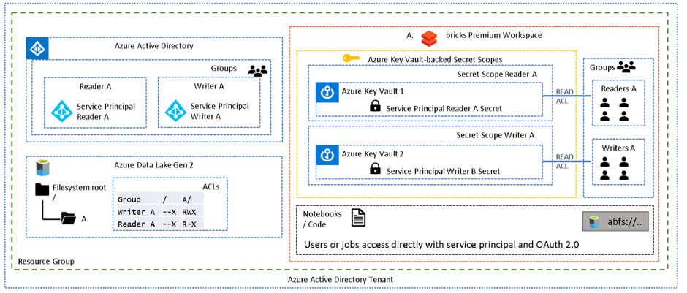
Figure 7 – session scoped pattern sample diagram

The above diagram depicts a single folder (A) with two sets of permissions, readers and writers. AAD groups reflect these roles and have been assigned appropriate folder ACLs. Each AAD group contains a service principal and the credentials for each service principal have been stored in a unique secret scope. Each group in the Databricks workspace contains the appropriate users, and the group has been assigned READ ACLs on the associated secret scope, which allows a group of users to “use” the service principal mapped to their level of permission.

Data security
Based on the evaluation, Both D2 and D3 data will be hosted on Azure. Most of them are in blob storage and data lake storage. We need to encrypt those data to assure our data is secure.
Thanks to the encryption feature within storage account. Storage service encryption protects your data at rest. Azure Storage encrypts your data as it's written in our datacenters, and automatically decrypts it for you as you access it.

Network security
Solving for data exfiltration can become an unmanageable problem if the PaaS service requires you to store your data with them or it processes the data in the service provider’s network. But with Azure Databricks, we can keep all data in our Azure subscription and process it in our own managed private virtual network(s).
Meanwhile, Azure data factory is also used in our solution to integrate the data source and data lake storage. With Data Factory, we will create data-driven workflows to orchestrate movement of data between supported data stores, and processing of data by using compute services in both China east and China east 2 regions.

We have different data source VMs in different virtual networks. Mostly in China east region which doesn’t have a direct peering connection with CDP virtual network. Based on the cloud security requirements. All cross-zone traffics need go through firewall.

Hence In our context, our data source and destination are separated in different virtual networks by azure firewall.

A self-hosted integration runtime can run copy activities between a cloud data store and a data store in a private network. It also can dispatch transform activities against compute resources in an on-premises network or an Azure virtual network.

In below diagram, you may find the high-level network traffic flows in different zones.

Figure 8 – Network flow diagram

Based on the different components, we summarized the transition protocol and ports as below. Those need to be allowed on relevant security components, such as NSG and Firewall etc.

Source name | Source IP | Destination name | Destination ip | protocol | ports | comments
Self-host integration runtime | win000533,  win000534,  win000535,  win000536  win000537,  win000538 | Internet | * | TCP | 443 | - Required by the self-hosted integration runtime for interactive authoring.  - Required by the self-hosted integration runtime to connect to the Data Factory service.  - Used by the self-hosted integration runtime to connect to the Azure storage account when you use the staged copy feature.
Self-host integration runtime | win000533,  win000534,  win000535,  win000536  win000537,  win000538 | Internet | * | TCP | 1443 | Required only when you copy from or to Azure SQL Database
Self-host integration runtime | win000533,  win000534,  win000535,  win000536  win000537,  win000538 | Internet | * | TCP | 3306 | Required only when you copy from or to Azure Mysql Database
Dest SHIR - PRD | win000535 | Dest SHIR - PRD | win000536 | TCP | 8060 | Required by self-host integration node communication between different nodes in the same pool
Dest SHIR - PRD | win000536 | Dest SHIR - PRD | win000535 | TCP | 8060 | Required by self-host integration node communication between different nodes in the same pool
Source SHIR - PRD | win000537 | Source SHIR - PRD | win000538 | TCP | 8060 | Required by self-host integration node communication between different nodes in the same pool
Source SHIR - PRD | win000538 | Source SHIR - PRD | win000537 | TCP | 8060 | Required by self-host integration node communication between different nodes in the same pool
Source SHIR - PRD | win000537, win000538 | SNX CRM DB - PRD | win000253 | TCP | 1433 | Required only when you copy from or to MS SQL server
Source SHIR - Dev | win000533 | SNX CRM DB - UAT | win000254 | TCP | 1433 | Required only when you copy from or to MS SQL server
Source SHIR - PRD | win000537, win000538 | CRMDP DB - PRD | lnx000329 | TCP | 3306 | Required only when you copy from or to Mysql Database
Source SHIR - PRD | win000537, win000538 | OMS DB - PRD | win000376 | TCP | 1433 | Required only when you copy from or to MS SQL server
Dev Azure Databricks workspace subnets | 10.71.255.0/26;  10.71.255.64/26 | Internet | * | TCP | 443;  9093;  3306 | - Access to databricks-webapp  - Access to databricks-observability-eventhub  - Access tp databricks-sql-metastore
PRD Azure Databricks workspace subnets | 10.71.252.0/26;  10.71.252.64/26 | Internet | * | TCP | 443;  9093;  3306 | - Access to databricks-webapp  - Access to databricks-observability-eventhub  - Access tp databricks-sql-metastore
Dev Azure Databricks workspace subnets | 10.71.255.0/26;  10.71.255.64/26 | AZRCNE2CDPSBPE-SHARED0001 | 10.71.255.128/27 | TCP | 443 | Access to datalake storage
PRD Azure Databricks workspace subnets | 10.71.252.0/26;  10.71.252.64/26 | AZRCNE2CDPSBPE-SHARED0001 | 10.71.253.0/26 | TCP | 443 | Access to datalake storage

Databricks got self-built default NSG has been built. we will not force databricks go through firewall before it reaches azure databricks management plane. But for any internal traffic, it needs go through firewall.

Security patch
All PaaS components will be managed by Azure. The IaaS VM will be managed by CMS vendor. Patches will be deployed monthly.

Compliance

Data protection
Protecting PII (personally identifiable information) is very important as the number of data breaches and records with sensitive information in consumer datalake. we need to incorporate multiple layers of data and information security. To make sure it’s only allowed the right people access to sensitive information, using a combination of Fernet encryption libraries, user-defined functions (UDFs), and Databricks secrets to restricts a normal user with file or table access from retrieving sensitive information from azure databricks. We will build process to enforce column-level encryption. We’ll create a configurable table listing the entities and their attributes which we want to be masked with appropriate masking rules based on the attribute types. Passing the the source plain text data along with the masking rules into the utility method. Based on relevant masking rules, the masking utility method will produce a DataFrame after masking the sensitive attributes only.

The below diagram provides a high-level overview of components that are required for this process.
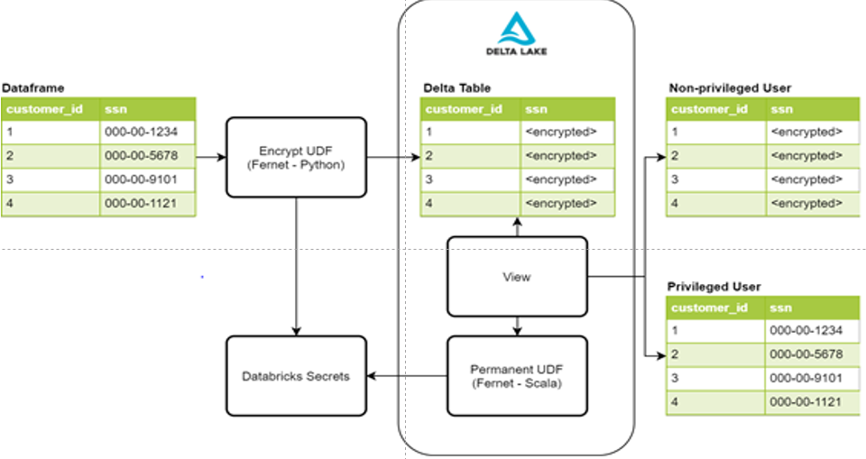
Figure 9 – database table design
To encrypt PII data, use Fernet Python library is one of option. Fernet uses symmetric encryption, which is built with several standard cryptographic primitives. This library is used within an encryption UDF that will enable us to encrypt any given column in a dataframe. To store the encryption key, we use Databricks Secrets with access controls in place to only allow our data ingestion process to access it. Once the data is written to our Delta Lake tables, PII columns holding values such as social security number, phone number, credit card number, and other identifiers will be impossible for an unauthorized user to read.
To read sensitive data, we will create a permanent UDF for decryption and use it within our view definitions for privileged users to see the decrypted data.
We may have two view objects for a single dataset. one each for privileged and non-privileged users. The view for non-privileged users does not have the UDF, so they will see PII values as encrypted values. The other view for privileged users does have the UDF, so they can see the decrypted values in plain text for their business needs. Access to these views is also controlled by the table access controls provided by Databricks.

Data movement in Azure datafactory

In a Data Factory solution, you create one or more data pipelines. A pipeline is a logical grouping of activities that together perform a task. These pipelines reside in the region where the data factory was created.

Even though Azure Data Factory is only available in few regions, the data movement service is available globally to ensure data compliance, efficiency, and reduced network egress costs.

Azure Data Factory including Azure Integration Runtime and Self-hosted Integration Runtime does not store any temporary data, cache data or logs except for linked service credentials for cloud data stores, which are encrypted by using certificates. With Data Factory, you create data-driven workflows to orchestrate movement of data between supported data stores, and processing of data by using compute services in other regions or in an on-premises environment. You can also monitor and manage workflows by using SDKs and Azure Monitor.
Data Factory has been certified for:

CSA STAR Certification
ISO 20000-1:2011
ISO 22301:2012
ISO 27001:2013
ISO 27017:2015
ISO 27018:2014
ISO 9001:2015
SOC 1, 2, 3
HIPAA BAA
HITRUST

CMDB
All resources will be deployed in the new resource group for both UAT and production environments. The application mega code: 9DL will be populated to the relevant resource groups.

Disaster recovery
There is no disaster recovery requirement for 9DL.

Network

Virtual network
name | type | location | subscription | Resource group | Address space | DNS servers | Environment
d9dlchn0-vnet | Virtual network | China East 2 | BIBCNCDP | AZRCNE2CDPRG0001 | 10.71.255.0/24 | 10.71.128.69, 10.71.128.70 | DEV/UAT
r9dlchn0-vnet | Virtual network | China East 2 | BIBCNCDP | AZRCNE2CDPRG0001 | 10.71.252.0/23 | 10.71.128.69, 10.71.128.70 | production

Subnet
Subnet name | Address space | Vnet name | location | subscription | Resource group | NSG | Route table | Environment
AZRCNE2CDPSBPE-SHARED0001 | 10.71.255.128/27 | d9dlchn0-vnet | China East 2 | BIBCNCDP | AZRCNE2CDPRG0001 | TBD | AZRCNE2CDPSBPE-SHAREDUDR0001 | DEV/UAT
AZRCNE2CDPSB0001 | 10.71.255.192/27 | d9dlchn0-vnet | China East 2 | BIBCNCDP | AZRCNE2CDPRG0001 | TBD | AZRCNE2CDPSBUDR0001 | DEV/UAT
AZRCNE2CDPSF0001 | 10.71.255.160/27 | d9dlchn0-vnet | China East 2 | BIBCNCDP | AZRCNE2CDPRG0001 | TBD | AZRCNE2CDPSFUDR0001 | DEV/UAT
AZRCNE2CDPSB-PRIVATE0001 | 10.71.255.0/26 | d9dlchn0-vnet | China East 2 | BIBCNCDP | AZRCNE2CDPRG0001 | databricksnsg654eqnn3yzk52 | AZRCNE2CDPSB-PRIVATEUDR0001 | DEV/UAT
AZRCNE2CDPSB-PUBLIC0001 | 10.71.255.64/26 | d9dlchn0-vnet | China East 2 | BIBCNCDP | AZRCNE2CDPRG0001 | databricksnsg654eqnn3yzk52 | AZRCNE2CDPSB-PUBLICUDR0001 | DEV/UAT
AZRCNE2CDPSBPE-SHARED0001 | 10.71.253.0/26 | r9dlchn0-vnet | China East 2 | BIBCNCDP | AZRCNE2CDPRG0001 | TBD | AZRCNE2EPRCDPSBPE-SHAREDUDR0001 | production
AZRCNE2CDPSB0001 | 10.71.252.192/26 | r9dlchn0-vnet | China East 2 | BIBCNCDP | AZRCNE2CDPRG0001 | TBD | AZRCNE2EPRCDPSBUDR0001 | production
AZRCNE2CDPSF0001 | 10.71.252.128/26 | r9dlchn0-vnet | China East 2 | BIBCNCDP | AZRCNE2CDPRG0001 | TBD | AZRCNE2EPRCDPSFUDR0001 | production
AZRCNE2CDPSB-PRIVATE0001 | 10.71.252.0/26 | r9dlchn0-vnet | China East 2 | BIBCNCDP | AZRCNE2CDPRG0001 | databricksnsg654eqnn3yzk52 | AZRCNE2EPRCDPSB-PRIVATEUDR0001 | production
AZRCNE2CDPSB-PUBLIC0001 | 10.71.252.64/26 | r9dlchn0-vnet | China East 2 | BIBCNCDP | AZRCNE2CDPRG0001 | databricksnsg654eqnn3yzk52 | AZRCNE2EPRCDPSB-PUBLICUDR0001 | production
AZRCNE2CDPMGT0001 | 10.71.253.64/27 | r9dlchn0-vnet | China East 2 | BIBCNCDP | AZRCNE2CDPRG0001 | TBD | AZRCNE2CDPMGT UDR0001 | production

Route table
Azure automatically creates system routes and assigns the routes to each subnet in a virtual network. You can't create system routes, nor can you remove system routes.
To make sure that all cross-security zone traffic and internet traffic will be control and monitored by Azure firewall, we must create custom, or user-defined(static), routes in Azure to override Azure's default system routes, or to add additional routes to a subnet's route table.

Resource group
The resources will be placed into one group in each subscription as is:
Resource group | subscription | location | Environment | comments
AZRCNE2CDPRG0001 | BIBCNCDP | China East 2 | DEV/UAT/PRD | Shared components, such as virtual network, route table, nsg etc
d9dlchn0 | BIBCNCDP | China East 2 | DEV/UAT | Datalake components except databricks and infra shared components of dev and uat environment
d9dlchn1 | BIBCNCDP | China East 2 | DEV/UAT | Databricks components of dev and uat environment only
r9dlchn0 | BIBCNCDP | China East 2 | Production | Datalake components except databricks and infra shared components of production environment
r9dlchn1 | BIBCNCDP | China East 2 | Production | Databricks components of production environment only

Supporting model
Except a few self-hosted integration runtime VM. The solution itself is a pure PaaS solution. Based on the agreement, 9DL is considered as a self-service model, the 9DL support team need to handle the L1 support. CCC team will implement relevant policy, security settings as per below attachment.

Decommission
It is a new deployment. There is nothing to decommission.

Validation View

Risks

Topic | Description | Comment
RISK ID
Date Added
Risk Description
Risk Occurence
Risk impact
Mitigation Plans
Status

Assumptions

Topic | Description | Comment
ASSUMPTION ID
Date Added
Assumption Description
Assumption Confidence
Assumption impact
Status

Issues

Topic | Description | Comment
ISSUE ID
Date Added
Issue Description
Solution
Alternative
Status

Dependencies

Topic | Description | Comment
DEPENDENCY ID
Date Added
Dependency Description
Dependency impact
Associated Risk ID
Status

END OF THE DOCUMENT

