Exercise 1

Name: BOCK Matthias
Student ID: 1337023

Lab questions:

Question 1:

Code
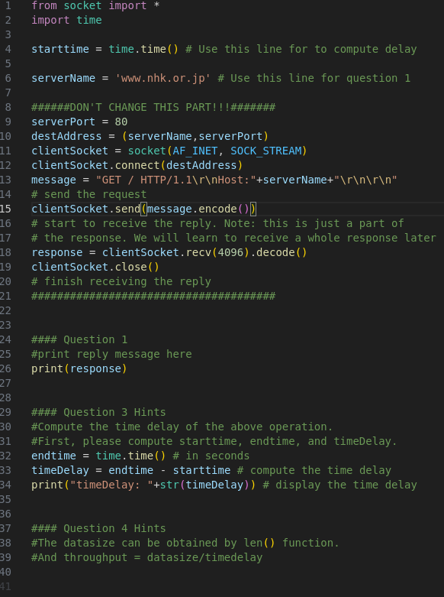

Response

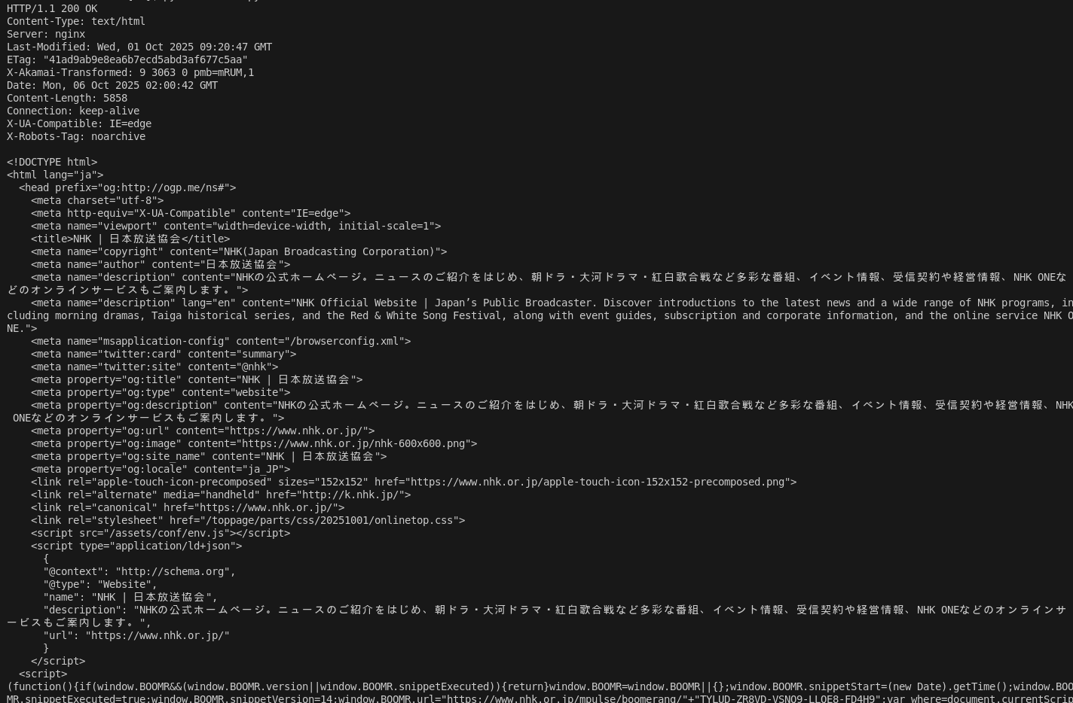
Question 2:
Protocol: HTTP/1.1
Date: Mon, 06 Oct 2025
Time: 02:00:42 GMT
Content type: text/html
Document: type:html

Question 3:

Code

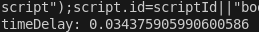
Output:

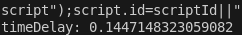
Explanation:
The total delay is made up of 4 types of delay. Each of these delays contribute to the randomness of the total delay.
1. Nodal processing: Each node (router etc.) on the route of the packet has to process parts of it. It needs to check for bit errors and routers have to determine the output link to send the packet to the right destination. The time each node takes for these tasks is not fixed and can vary between packets.
2. Queuing delay: If a router is very busy, packets will be queued before being processed. The number of packets in the queue varies for each request. Therefore, the queue delay is different for each process.
3. Transmission delay: The packet gets transmitted between many different nodes. Since the bandwidth of the connections these nodes share is different for each pair of nodes, the transmission delay is also impacted. Every time a request is sent to the server, the packets get routed in a different way, which causes the transmission delay to be random.
4. Propagation delay: While the propagation time in one media (Copper, Optic fiber, …) is usually very consistent, the type of connection used between nodes may vary. Similarly to the transmission delay, different nodes are connected using different types of media. Since the packet can be routed in many different ways, this also contributes to the randomness.

Question 4:

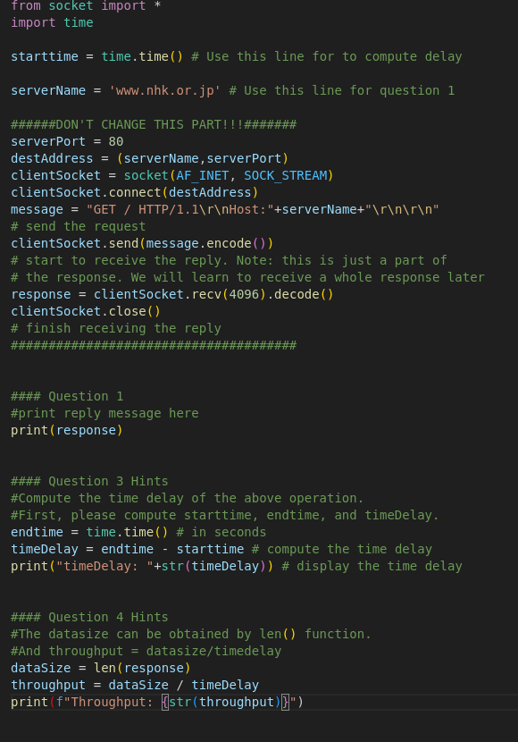
Code

Output

Question 5:

Question 6:
Changed target address to: www.u-aizu.ac.jp

Redo question 2
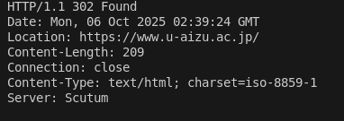
Protocol: HTTP/1.1
Date: Mon, 06 Oct 2025
Time: 02:39:24 GMT
Content type: text/html
Document: empty (The response was a redirect to https and did not contain a document)

Redo question 3
The request to the web server is not guaranteed to be routed the same way every time the request is made. This means that the request might be routed in a different way, resulting in a fluctuating time delay.

Redo question 4
The code modifications are the same as before.

Question 6
When comparing the requests to the two different web servers, the time delay did not vary significantly, but connecting to the universities web server was slightly faster. That is probably because both servers are located in Japan, so the overall difference in delay was not big. Since the university web server is closer to the computer used for this exercise (lab PC), the delay was overall shorter.
If the second web server where located outside of Japan, the delay differences would be more significant, since the signal has to travel a much longer distance.
The throughput did vary between the two connections. The connection to NHK had a higher throughput than the connection to the university server. This might be because the NHK web server as a faster internet connection than the university web server.

Homework questions

Question 1
Application layer: DNS, SMTP, HTTP
Transport layer: TCP, UDP
Network layer: IP, routing protocols
Link layer: Ethernet, 802.111, PPP
Physical layer: Ethernet, WiFi

Question 2
Hosts: Hosts are the end system of the network. They run network apps and send and receive data.
Communication links: They connect different parts of the network with each other. Communication links can use different transmission media like copper, fiber or radio. They transmit data with a transmission rate also called bandwidth.
Packet switches: Packet switches forward chunks of data called packets. They are responsible for making sure the packets arrive at the correct destination.

Question 3
Routing determines the source-destination route taken by packets. It determines which path the package should take through the network. This route is determined using routing algorithms.
Forwarding moves a package from a routers input port to the appropriate output port. The correct output port is determined by the routing of the package.

Question 4
Packet loss: The queues of routers preceding links have a finite capacity. Packages arriving at a full queue are dropped (lost).

Question 5
A process is program running at the application layer on a host. In order to communicate with another host, the program uses a transport service API. This Transport API is called “socket”. The process sends and receives messages from its socket. In order to receive data, the process must have an identifier. The identifier of the host is the IP address, but since there can be multiple processes running on the same host, the process gets its own identifier called a port number. The IP address combined with the port number allows a process to send data to another process on a different host.

Question 6
The address of a host is the IP address.
The address of a process on that host is its port number.

Question 7
On the same operating system, processes can use inter-process communication (IPC) to talk to each other. This is defined by the operating system.
Processes on different hosts can use the transport layer to exchange messages with each other.

Question 8
The network layer is responsible for the logical communication between two hosts. Similar to the postal service, it makes sure that data packets arrive at the right host.
The transport layer is responsible for process to process communication. Once a packet arrives at a host, it makes sure that the packet is delivered to the correct process. The transport layer relies on the network layer to deliver the packets to the correct host and enhances its capabilities with its own protocols.

Question 9
TCP provides several services to the user. It offers reliable transport, flow control to not overwhelm receivers, congestion control to throttle the sender if the network is overloaded and is connection oriented.
UPD does not offer any of these services. It is a simple extension of the “best effort” IP protocol. UDP is used because the missing connection establishment and its simplicity allow it to send data with reduced delay.

Question 10
Both the IPv4 and IPv6 header share a source and destination address, although they differ in length according to the protocol used. Both also declare the IP protocol version used at the start of the header. They also share a field for the length of the payload transmitted.

