Flora2 Outdoor – Verkabelung
V0.1 10.03.2021
Einbaustecker/  -buchsen | Pin | Signal | Leitung extern | Leitung  intern
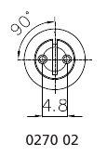  Lumberg Quicklock 12 | 1 | GND |  | sw
 | 2 | power |  | rt
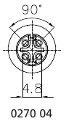  Lumberg Quicklock 12 | 1 | GND | bl | sw
 | 2 | power | br | rt
 | 3 | output | ge | gn
 | 4 | mode | sw | -
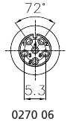  Lumberg Quicklock 12 | 1 | GND |  | sw
 | 2 | 3V3 |  | rt
 | 3 | SCL |  | ge
 | 4 | SDA |  | gn
 | 5 | n.c. | - | -
 | 6 | n.c. | - | -

