TTN Node – Wiring
19.05.2022
Sockets  (Lumberg Quicklock 12) | Pin | Signal | Wire external | Wire internal
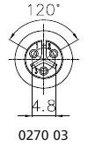 | 1 | GND | br (sw)
 | 2 | VDD | ws (rt)
 | 3 | DQ | ge (ge)
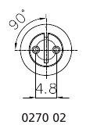 | 1 | GND | sw | sw
 | 2 | Power | rt | rt

