DIY QuantiFluorONE dsDNA Fluorometer
  - Assembly and Operating Manual
Dipl.-Ing. Matthias Birkicht
Centre for Tropical Marine Research
24 October 2026

About this manual
Project repository — hardware files, firmware, calibration tools and supporting records.
This manual covers construction, software installation, calibration, routine dsDNA analysis, quality control and maintenance of the DIY QuantiFluorONE instrument. Chapters 1–12 describe the established ONE configuration and its supporting evidence. Chapter 13 describes the literature-based SYBR Safe transfer procedure and the verification required before its use. Chapter 14 consolidates references and design sources.
The routine ONE assay uses 1 µL sample plus 200 µL ready-to-use reagent with an on-device two-point calibration. Initial characterization with the Calibration Suite is performed for each new instrument or configuration; a provisional calibration is not required for routine sample batches.
The manual is issued for author review on 24 October 2026. The fastener schedule, cable connection details and physical installation checks remain subject to the recorded build review. Read those qualifications before reproducing the instrument. The SYBR Safe transfer has not yet been verified on this device.
Contents
1 Instrument Overview and Intended Use 3
2 Safety and Laboratory Requirements 5
3 Measurement Principles 7
4 Components Tools and Reproduction Files 9
5 Instrument Assembly 12
6 Software Installation and Updates 16
7 First Startup and Instrument Operation 20
8 Calibration and Calibration Management 24
9 Routine dsDNA Analysis with QuantiFluor ONE 29
10 Results Quality Control and Data Management 32
11 Analytical Performance and Limitations 35
12 Maintenance and Troubleshooting 38
13 Alternative Assay with SYBR Safe 41
14 References Design Sources and Acknowledgements 44

1 Instrument Overview and Intended Use
The DIY QuantiFluorONE dsDNA Fluorometer measures the mass concentration of double-stranded DNA using the Promega QuantiFluor ONE dsDNA assay. This manual explains how to reproduce the documented instrument, install its software, establish its performance, calibrate it and measure samples. It is intended for laboratory users who can handle DNA samples and small-volume pipetting, and for builders familiar with basic electronics and mechanical assembly.
The routine assay uses 1 µL of DNA-containing sample plus 200 µL of ready-to-use QuantiFluor ONE reagent. Samples are measured against an on-device two-point calibration. The principal result is the DNA concentration of the sample solution before reagent addition, expressed in ng/µL.

1.1 The documented instrument
An Adafruit PyBadge controls one TSL2591 detector through a PCA9546 I2C multiplexer. A nominal 485 nm LED illuminates the assay tube through an Ex470BP-40 excitation filter. Fluorescence reaches the detector through an Em532BP-40 emission filter on an axis at 90° to the excitation beam. Printed parts locate the tube, filters and electronics, and exclude ambient light.
The installed LED driver is the ioRodeo fixed-current radial 16 mA board, revision ver_0p1_rev_3. The documented mechanical configuration uses the combined E LED Board + Vial Halter. Chapter 4 identifies the components and links to their CAD, printing and PCB files; Chapter 5 explains assembly. The documented software is the QuantiFluorONE v1.0.0 RC2 release on CircuitPython 9.1.1.
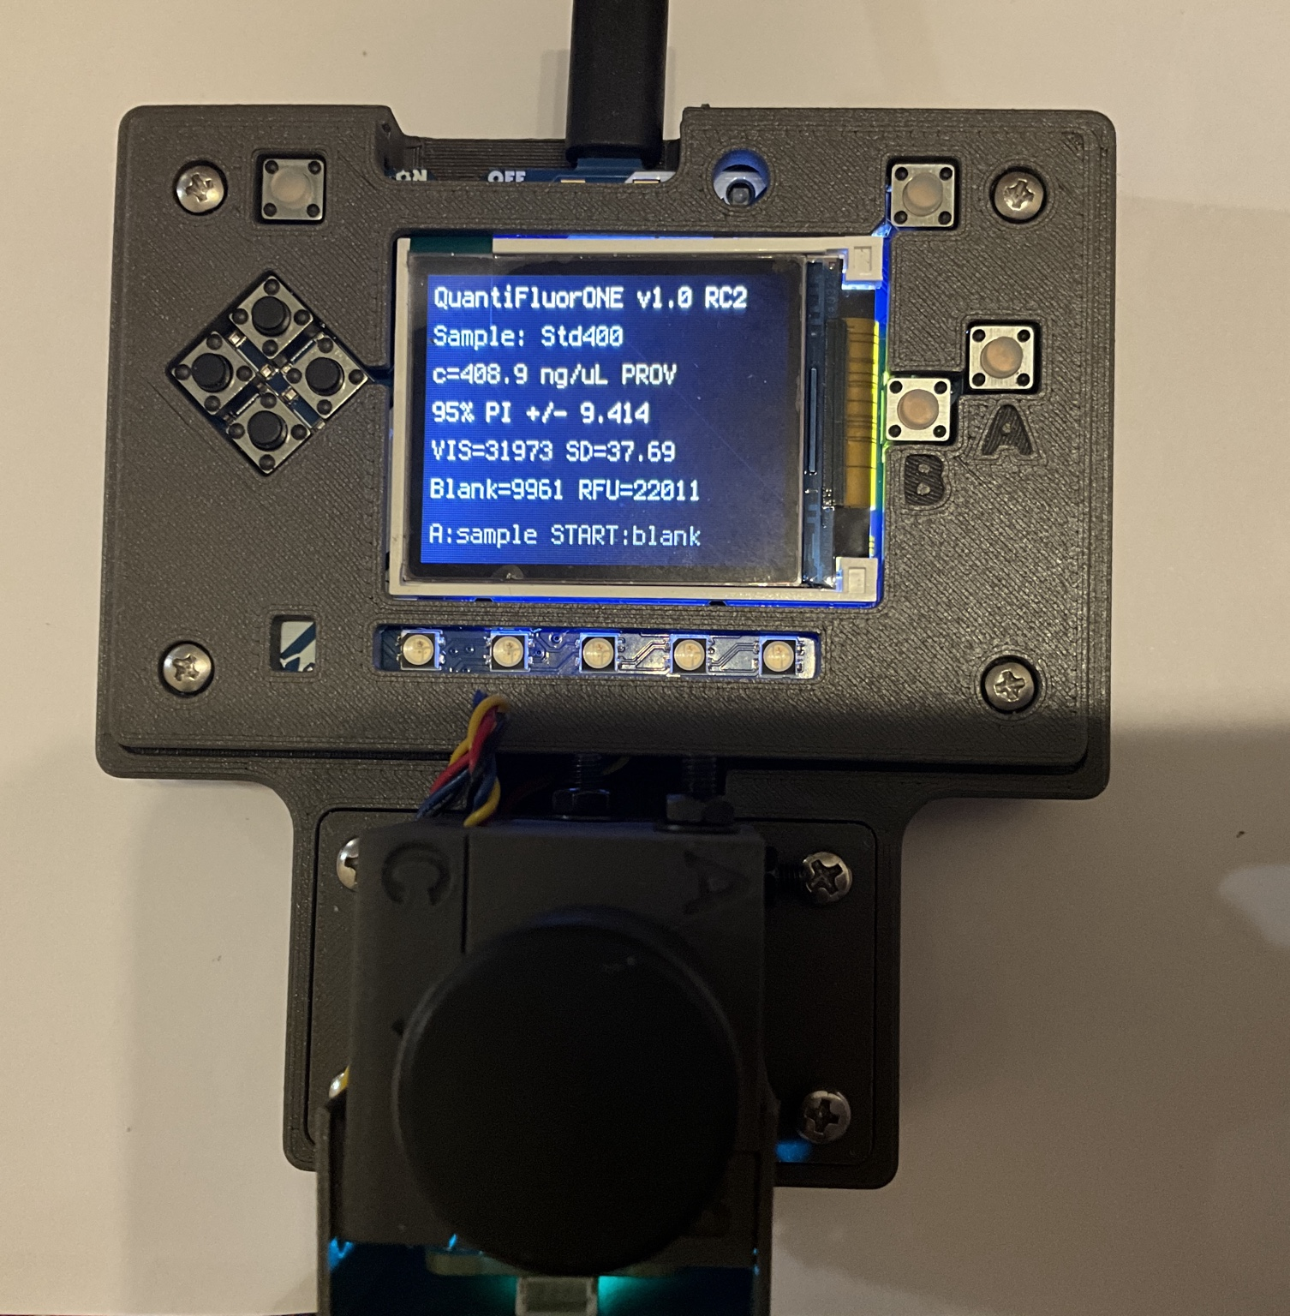
Completed instrument with controller, display, controls and covered optical module. The display shows a historical provisional measurement; its PROV label and prediction interval are not the required state for routine two-point operation.

1.2 From construction to routine analysis
Three stages establish readiness. First, assemble the instrument and verify electrical connections, optical alignment, light exclusion, software operation and data saving. Second, characterize each new instrument or changed configuration with a concentration series evaluated in the Calibration Suite. Retain the regression diagnostics and performance evidence used to define the working range. Third, perform the on-device two-point calibration and verify an independently prepared control before accepting routine samples.
The characterization series is performed initially for each new instrument or configuration. It is not repeated for every sample batch. Routine measurements do not require loading a provisional calibration or importing a multipoint model. Later changes or unresolved quality-control findings may require relevant characterization to be repeated.
A stored two-point calibration can be reused when its configuration, corresponding blank and control checks remain suitable. The ordinary START action replaces the blank and invalidates an active two-point calibration in RC2. Chapter 8 explains how to retain a calibration, check a blank without replacing it, or perform a complete new calibration.

1.3 How to use this manual
Task | Chapters
Understand the instrument and its measurement | 1–3
Select parts and assemble the instrument | 4–5
Install software and check startup | 6–7
Calibrate and measure DNA samples | 8–9
Evaluate results and retain data | 10–11
Maintain the instrument and resolve faults | 12
Assess the alternative SYBR Safe assay | 13
Find references and design provenance | 14 and source registers

The project repository contains the design sources, firmware, supporting software, photographs and analytical records. Links in this manual identify the files relevant to each task. Preserve the release archive and record the repository revision used for a build; files on the main branch may change as the design develops.

1.4 Intended use and limits
The instrument is intended for research, teaching and development. It is not a medical or clinical diagnostic device. A fluorescence result estimates dsDNA mass concentration under the established assay conditions. It does not identify a species, establish DNA integrity or fragment length, prove sample purity, or demonstrate suitability for a particular downstream reaction.
Reported performance applies to the tested instrument configuration and procedure. The reagent manufacturer's nominal assay range is not automatically the quantitative range of every reproduced device. Chapter 11 describes the existing evidence, including the Quantus comparison and blank-based limits. Use an accepted range and controls established for the actual instrument.
SYBR Safe is a separate assay option. It requires its own preparation procedure, optical assessment, characterization and calibration. A different LED or filter may be needed. Do not transfer QuantiFluor ONE calibration coefficients or performance limits to that assay.

2 Safety and Laboratory Requirements
Prepare a clean, dry work area before assembly or measurement. Read the instructions and applicable safety data sheets for the actual reagents, samples, cleaning products and optional battery. The laboratory is responsible for assessing its materials and procedures, providing suitable protective equipment, identifying emergency arrangements and assigning waste streams.

2.1 Separate construction from sample handling
Carry out printing, drilling, trimming and soldering away from the clean assay area. Remove print debris and metal fragments before installing electronics or optical parts. Secure workpieces, use eye protection when cutting or drilling, and provide suitable extraction when soldering. Let the soldering iron and freshly soldered parts cool before handling them.
Inspect printed parts for sharp edges, cracks and poor fit. Do not force a tube, filter or circuit board into position. Handle glass filters by their edges and avoid bending or scratching them. Keep screws and loose components away from the electronics during assembly.

2.2 Electrical power and batteries
Switch the instrument off and disconnect USB power and the optional battery before opening the enclosure, changing wiring or moving boards. The switch alone is not a substitute for disconnecting power during internal work. Never hot-plug internal connectors.
Check connector orientation, supply polarity and pin correspondence against the documented hardware before applying power. Do not infer pin assignments from wire colour alone. Use intact cables and the documented USB supply arrangement. Keep conductive tools away from powered boards and provide strain relief so cable movement cannot pull on connectors.
If using a LiPo battery, use a compatible battery and connector and follow the battery and controller manufacturers' charging instructions. Do not puncture, crush, short-circuit or use a swollen, damaged or unusually hot battery. Stop using the instrument if wiring, the enclosure or a power source becomes abnormally hot or shows damage.

2.3 Optical exposure
The documented excitation source is a visible blue LED. Avoid looking directly into the powered LED or viewing it through magnifying optics. Keep the optical module closed during normal measurements. Disconnect power before aligning or replacing the LED or filters, and use indirect observation for any necessary functional check.
The filter set separates excitation from fluorescence; it does not establish an eye-safety classification for an exposed assembly. A change of LED, drive current or optics requires a fresh assessment. The separate SYBR Safe chapter must be followed when considering optical substitutions.

2.4 Reagents and biological samples
Wear suitable laboratory clothing, gloves and eye protection when preparing assays. Avoid skin and eye contact with reagents, do not mouth-pipette, and keep reagent containers closed when not in use. Do not assume that a DNA-binding dye is harmless because it is used in small amounts. Promega TM405 instructs users to treat the ONE dye as a potential mutagen because it binds nucleic acids and notes that it contains an irritant that facilitates entry of organic compounds into tissues. Consult the safety data sheet for the exact product and formulation.
Treat the sample's biological and chemical hazards separately from those of the dye. Environmental extracts and purified DNA preparations may contain extraction chemicals or other contaminants. Use the containment and waste route required for the actual material. This manual does not establish that a sample has been rendered biologically inactive.
Keep liquids away from the PyBadge, USB connection, battery and internal boards. Close tubes before insertion and inspect their exterior for droplets. If liquid enters the enclosure, stop work, disconnect power if it is safe to do so and follow the laboratory's spill procedure. Inspect and dry the affected assembly before returning it to service; verify its function and calibration as appropriate.

2.5 Clean handling and reliable pipetting
Use a clean assay area, DNA-free tubes and tips, and pipettes suitable for 1 µL and 200 µL transfers. Change tips between samples and standards, and replace contaminated gloves. Keep stocks separate from sample preparation where practical. Avoid carrying high-concentration DNA into the reagent blank or reagent stock.
Bring assay components to room temperature before preparation. Mix DNA solutions and prepared assays consistently, avoid bubbles and protect dye-containing tubes from light. The QuantiFluor ONE procedure uses a five-minute incubation at room temperature in the dark. Chapter 9 gives the complete preparation and measurement sequence.

2.6 Storage and disposal
Follow the product label and manufacturer instructions for reagent and standard storage. Keep containers labelled with product identity and relevant lot and preparation information. Protect the dye from light and do not confuse the ready-to-use ONE reagent with a concentrated dye from another kit.
Collect used assays, tips and tubes in the laboratory's designated waste streams for their combined chemical and biological contents. Do not assume that drain disposal is permitted. Dispose of batteries and electronic components through their appropriate collection routes.

2.7 Before work begins
☐ Work area is clean and dry, and construction tools are separated from assay preparation.
☐ Reagent and sample hazards, protective equipment, spill response and waste routes are defined.
☐ Power sources, cables, enclosure and any battery are intact.
☐ Optical shielding is installed and internal connectors are secure.
☐ Suitable pipettes, clean consumables and traceable sample labels are available.
The assay handling instructions are based on Promega's QuantiFluor ONE dsDNA System Technical Manual TM405, including its Handling and Disposal section. The applicable safety data sheets and local assessment remain the sources for product-specific hazard classification and emergency measures.

3 Measurement Principles
The fluorometer converts the fluorescence of a dye–DNA assay into a dsDNA mass concentration. The complete measurement depends on the reagent, sample tube, optical arrangement, sensor settings, blank and calibration. Understanding these relationships helps distinguish a valid concentration result from a display value affected by preparation or instrument conditions.

3.1 Fluorescence and selective DNA detection
A fluorophore absorbs excitation light and emits some of that energy as light at longer wavelengths. The separation between excitation and emission maxima is called the Stokes shift. Promega specifies excitation and emission maxima of approximately 504 nm and 531 nm for the QuantiFluor ONE dsDNA system. Its DNA-binding dye responds preferentially to dsDNA; the assay is designed to quantify dsDNA in purified samples.
Within a suitable working range, fluorescence increases with DNA input. The relationship also depends on dye binding, sample composition, temperature, illumination and geometry. Absorbing or fluorescent contaminants, quenching, inadequate mixing and detector saturation can alter the response. Selectivity for dsDNA does not remove the need to assess the sample matrix.

3.2 Excitation and detection paths
The installed nominal 485 nm LED provides blue excitation through the Ex470BP-40 filter. Fluorescence from the tube passes through the Em532BP-40 filter to the TSL2591. The detector axis is at 90° to the excitation axis, reducing direct illumination by the excitation beam. Scattered excitation and ambient light can still reach the sensor, which is why both filters and the light shield are necessary.
The LED wavelength need not equal the dye's excitation maximum to generate a signal. Useful excitation depends on the overlap of the LED spectrum, excitation-filter transmission and dye absorption. Detection depends on the overlap of dye emission, emission-filter transmission and sensor response. Nominal component labels alone do not establish the complete optical response.
The tube holder fixes insertion depth and optical position. Use the same tube type and reproducible seating for blank, standard, control and sample. Changes to the LED, filters, detector, holder or sensor settings can change the calibration slope or background.

3.3 From sensor readings to relative fluorescence
The TSL2591 reports FULL and IR channels. For each sensor reading, RC2 calculates a project-defined visible signal:
VIS = max(FULL − IR, 0)
This is a derived instrument signal, not an independently resolved emission spectrum. One measurement cycle contains three sensor readings from the same tube. The firmware calculates their mean and standard deviation. These describe short-term sensor repeatability; they are not three independent assay preparations.
The blank-corrected response is:
RFU = mean VIS of sample − mean VIS of the active reagent blank
RFU denotes relative fluorescence units. It is instrument-dependent and is not an SI unit or an absolute optical power. The reagent blank includes the reagent, tube and instrument background under the chosen conditions. For the documented ONE protocol it contains 200 µL reagent without an added DNA aliquot.
A negative blank-corrected response means that the sample's signal was below the retained blank signal. It does not mean that a negative physical amount of DNA is present. Preserve the raw value and apply the reporting rules in Chapter 10.

3.4 Two-point calibration for routine analysis
The reagent blank defines the zero-DNA endpoint and a known high standard defines the response scale. With blank-corrected RFU, the routine two-point model has a zero working intercept:
Slope = RFU of standard / concentration of standard
Sample concentration = RFU of sample / slope
The confirmed ONE Lambda DNA stock is 400 µg/mL = 400 ng/µL. Adding 1 µL of this stock to 200 µL reagent introduces 400 ng DNA into a nominal total volume of 201 µL. The calibration entry of 400 ng/µL refers to the stock solution before reagent addition.
Two-point calibration establishes the current response scale but does not independently test linearity between its endpoints. A separate concentration series, evaluated in the Calibration Suite, establishes regression diagnostics and relevant performance measures for each new instrument or configuration. For a general linear characterization model, response = intercept + slope × concentration. Routine operation continues to use the on-device two-point calibration.
The active blank belongs to the calibration. In RC2, pressing ordinary START to replace that blank invalidates a two-point model. A check blank measured as a sample with A can assess the retained baseline without replacing it. Chapter 8 provides the operational steps.

3.5 DNA mass and concentration basis
DNA mass equals concentration multiplied by the volume of DNA solution added. With a 1 µL aliquot, numerical values of original-solution concentration in ng/µL and DNA input in ng are equal, although they describe different quantities.
Quantity for the high standard | Value
Stock DNA concentration | 400 ng/µL
Stock aliquot | 1 µL
DNA mass added | 400 ng
Reagent volume | 200 µL
Nominal total assay volume | 201 µL
DNA concentration in the prepared assay | Approximately 1.99 ng/µL

Unknowns use the same 1 µL sample plus 200 µL reagent procedure. The principal firmware concentration is on the original-solution basis. Do not multiply that result by 201. The firmware's separate in-assay field describes concentration in the prepared tube. If the original sample was deliberately prediluted before the 1 µL aliquot was taken, multiply the principal result only by that recorded predilution factor.
A concentration in ng/µL describes DNA mass per volume. Conversion to numbers of molecules or fmol additionally requires an appropriate fragment length and molecular-mass assumption. Fluorometry alone does not determine those quantities, and this manual sets no universal DNA-input requirement for downstream PCR or sequencing.

3.6 Controls and analytical limits
An independently prepared control tests whether a known solution is recovered within predefined limits. The high calibration standard alone cannot provide an independent test of the calibration it defines. Blank checks assess background; controls assess the combined response of preparation, reagent and instrument. Retain both with the batch record.
LOD and LOQ describe detection and quantification limits for a stated method and dataset. They are not fixed properties of the sensor or dye. In the documented RC2 ten-blank routine, ten independently prepared reagent-blank tubes provide a standard deviation of cycle means. With the supplied factors:
LOD estimate = 3.3 × blank standard deviation / slope
LOQ estimate = 10 × blank standard deviation / slope
These are blank-based screening estimates, not a complete calibration-curve assessment under DIN 32645. The limit units follow the calibration slope. Repeated readings of one tube do not replace independently prepared blanks. Chapter 11 reports the evaluated instrument's limits and their concentration basis.
A high regression R² describes the fitted relationship but does not establish correct sample preparation, absence of bias or suitability at low concentrations. Assess residuals, recovery, independent preparation variability, blank behaviour and the intended matrix. Agreement with a Quantus provides comparison evidence; it does not make that instrument an error-free definition of the true concentration.

3.7 Sources and practical continuation
Assay properties and preparation follow Promega TM405 (R1). The RC2 firmware archive defines the signal calculation and calibration behaviour. Chapter 14 consolidates sources; Chapters 6–11 provide operation and analytical evidence.

4 Components Tools and Reproduction Files
This chapter identifies the components and files used to build the QuantiFluor ONE configuration. The instrument contains one TSL2591 detector, a 485 nm excitation LED and separate excitation and emission filters. Keep this configuration unchanged when using calibration and performance information established for it.
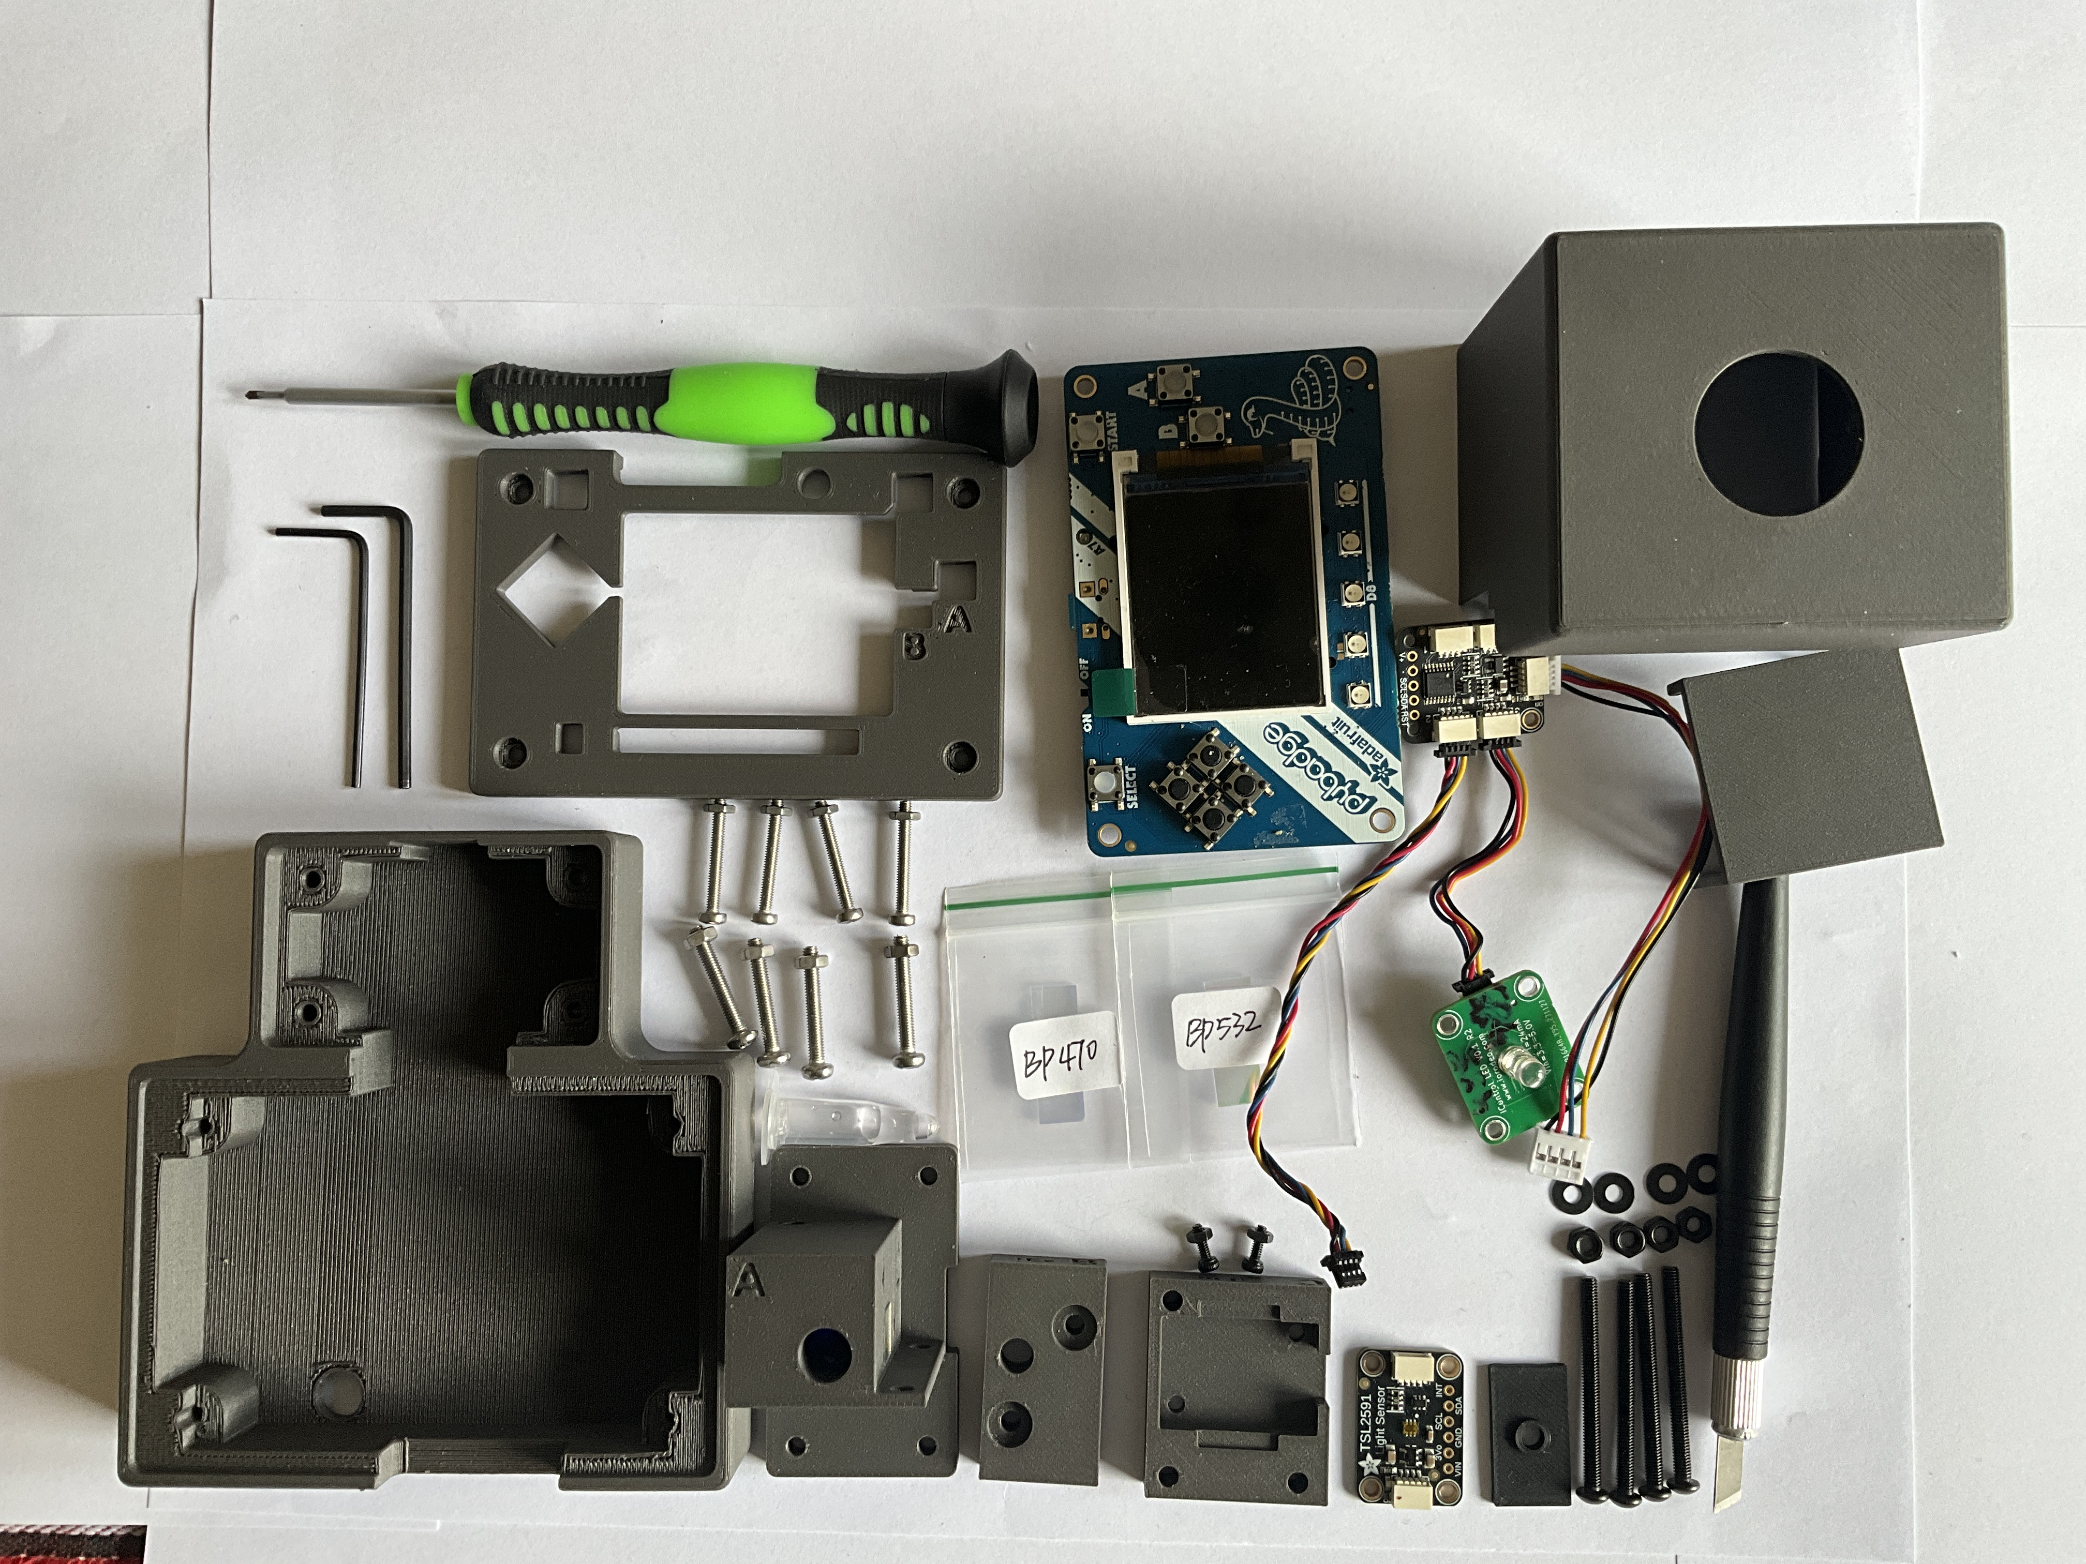
Electronic, optical and mechanical components of the instrument. Use the tables below to identify parts before assembly.

4.1 Electronics and optics
Quantity | Component | Identification and function
1 | Adafruit PyBadge | Product 4200; controller, display and buttons; documented runtime CircuitPython 9.1.1
1 | Adafruit PCA9546 | Product 5664; four-channel I2C multiplexer; upstream address 0x70
1 | Adafruit TSL2591 STEMMA QT | Product 1980; fluorescence detector; address 0x29 on the selected downstream channel
1 | ioRodeo fixed-current radial LED board | radial_16mA, revision ver_0p1_rev_3; nominal LED current 16 mA
1 | Radial excitation LED | 5 mm; 485 nm; article 1030055 in the project BOM
1 | Excitation filter | Neemoo Ex470BP-40; 8 x 8 x 1 mm; between LED and tube
1 | Emission filter | Neemoo Em532BP-40; 8 x 8 x 1 mm; between tube and detector
As required | Sample tubes | Promega E4941 thin-walled 0.5 mL PCR tubes
1 | Upstream adapter | SparkFun PRT-15109 Qwiic-to-Grove adapter
As required by routing | Internal cables | Four-conductor JST-SH STEMMA QT / Qwiic cables
1 | USB data cable | USB Micro connection to the PyBadge
Optional | Portable power | Suitable USB powerbank or compatible 3.7 V LiPo battery

The LED board has no I2C address. Its SDA and SCL connections pass the bus through; firmware does not select an LED address. The multiplexer selects the sensor bus branch.
Use the master BOM for the recorded procurement list. Its costs are historical entries rather than current quotations. Cable quantities, fasteners and optional battery capacity must be reconciled with the final build before ordering a complete kit; the review register records the remaining discrepancies.

4.2 Optional preassembled LED board
To avoid soldering during instrument assembly, the LED driver board may be ordered fully assembled, including the specified excitation LED, through a PCB assembly service such as PCBWay or JLCPCB, provided that the required components and assembly options are available. Before ordering, verify the board revision, LED wavelength, drive current, polarity and mechanical fit with the documented optical module. Assembly of the excitation LED must be explicitly included in the order, with its required rear-side mounting position and alignment. The supplied SMD assembly files alone do not establish that the radial LED is included.

4.3 Mechanical parts and files
STEP files are editable CAD exchange files. STL files are meshes for slicing and printing. The following links identify the actual repository files; a filename alone does not establish that two revisions have identical geometry.
Part | STEP design | STL for printing | Selection note
A Main body and tube holder | A v13 | A mesh | Tube insertion and optical alignment
B Excitation housing | B design | B mesh | LED-side filter housing
C Emission housing | C v3 | C mesh | Detector-side housing
D Emission baffle | D design | D mesh | Detector aperture and light exclusion
E Combined LED board and vial holder | Installed E design | Export from STEP | Confirmed by the author as the holder used in the documented build
E Thin holder alternative | Thin version | Thin mesh | Retained alternative; not the holder used in the documented build
E Alternative holder | Alternative design | Alternative mesh | Retained alternative; not an additional required part
F Optical cover | F design | F mesh | Light shielding
Controller enclosure | Enclosure v1r4 | Export from STEP | No corresponding enclosure STL is included in the inspected directory
Controller cover | Cover v1r4 | Export from STEP | No corresponding controller-cover STL is included in the inspected directory

The combined LED-board and vial-holder model is the standard E part, confirmed by the author on 23 October 2026. No matching STL for this combined model is present in the inspected directory. The thin and alternative E meshes belong to different models and must not be substituted as its printing files. All variants remain listed in the file index.
The seven optical STEP/STL pairs can be opened or parsed and have matching overall dimensions within 0.01 mm after accounting for axis order. This is a file consistency check; it does not establish identical surfaces, printability or fit with the physical instrument.
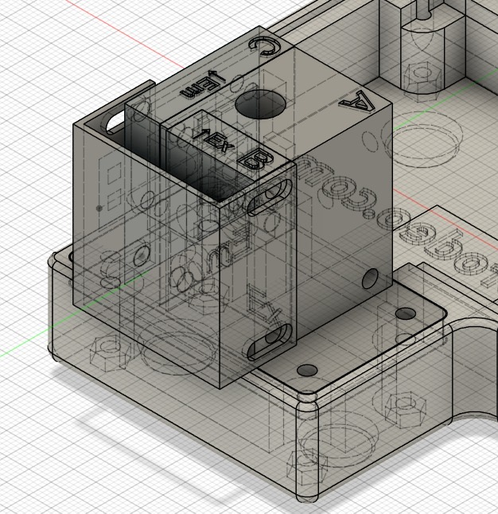
CAD overview of the optical module on the enclosure. The assembly shows the relative locations of the tube holder and optical housings.

4.4 PCB and fabrication files
For the installed ioRodeo radial board, the repository supplies the KiCad schematic, KiCad PCB, fabrication ZIP, assembly BOM and component placement file. The ZIP contains Gerber layers and plated and non-plated drill files. The wavelength-specific radial LED is fitted separately.
The PyBadge is used as an assembled commercial controller. Its Eagle schematic and PCB source document the controller design; reproducing that PCB is not a required assembly step.
Keep the LED-board source and licence notes, PyBadge source notes and third-party notices with redistributed design files. Source presence does not replace a fabrication or electrical design review.

4.5 Fasteners and tools
The current master BOM lists four M2.5 x 20 screws with matching nuts for the controller cover and four M3 x 20 screws with matching nuts for mounting the optical holder to the enclosure. The older assembly text additionally lists two M2 x 6, two M3 x 35 and two M3 x 40 screws with their associated nuts; it assigns M3 x 40 screws twice during the excitation assembly. The exact joints and quantities require confirmation. Do not use screw length to force mismatched printed parts together.
Prepare suitable screwdrivers, small pliers, flush cutters, a soldering iron and solder for the radial LED, a multimeter, a magnifier, clean tweezers for filter edges and nonabrasive optical cleaning materials. A computer and a known-good USB data cable are required for software installation. Access to a slicer and 3D printer is needed when making the mechanical parts locally.
Check printed parts with an empty E4941 tube and, where available, an 8 x 8 x 1 mm non-optical test piece. Confirm filter-pocket dimensions before inserting the actual filters. Printing material, layer height, orientation, infill and supports must be documented for the accepted build; these settings are not yet specified by the existing source files.

4.6 Configuration changes and SYBR Safe
Record the LED, LED board revision, filters, tube type, detector and printed-part versions used in each instrument. The existing QuantiFluor ONE configuration uses a 485 nm LED with Ex470BP-40 and Em532BP-40 filters. Chapter 13 assesses this combination as a starting point for SYBR Safe and explains when another LED or filter set may be needed. Optical changes require a separate calibration and assessment of blank, range and analytical performance.

5 Instrument Assembly
Assemble the mechanical and optical parts with USB and battery disconnected. Use the component and file tables in the preceding chapter to identify each part. Keep the filters in their protective packaging until the printed parts have been cleaned and checked.

5.1 Assembly sequence
Stage | Work | Check before proceeding
1 | Inspect printed parts | No debris; tube and filter test pieces fit
2 | Fit the main body to the enclosure | Mounting holes align without distorting either part
3 | Assemble excitation housing and LED holder | LED, excitation aperture and tube position align
4 | Fit emission filter, baffle and detector | Active detector area faces the emission aperture
5 | Mount controller and multiplexer | Boards supported; controls and connectors accessible
6 | Connect and route cables | Supply and signal connections checked; no cable strain
7 | Fit optical cover | Tube accessible; optical path protected from room light
8 | Complete pre-power inspection | All checklist items pass
9 | Install software and perform first power-up | Instrument starts and the detector is found

Use the combined E LED-board and vial holder confirmed for the documented build. The fastener schedule remains subject to the build review. Use a confirmed matching assembly for those joints before tightening hardware or committing to a full print set.

5.2 Stage 1 Inspect the printed parts
1. Identify A, B, C, D, the combined E holder, F and the controller enclosure and cover using their file names and locating features.
2. Remove support material and loose print debris from the tube bore, filter pockets, screw holes and cable openings.
3. Insert an empty E4941 tube gently. It must reach the mechanical stop and remain upright without excessive force.
4. Check each filter pocket with a clean 8 x 8 x 1 mm test piece where available. Do not grind or drill a pocket with an optical filter installed.
5. Test the board seats without power. The TSL2591 and LED PCB must fit without bending.
6. Inspect the empty optical housing against a lamp for gaps and thin regions that admit light. Remove all debris before fitting filters.
Check: The tube is removable without pulling the holder or wiring. All locating faces seat without forcing them.

5.3 Stage 2 Mount the main body
1. Place main body A on the enclosure mounting surface.
2. Align its mounting holes and check clearance for the tube and both optical sides.
3. Use the matching mounting hardware without allowing screw ends to contact electronics.
4. Tighten gradually and check that the tube remains vertical and reaches its stop.
Check: The holder does not rock or shift during tube insertion and removal. Verify screw length against the actual joint before tightening.

5.4 Stage 3 Assemble the excitation side
If a compatible board with the specified excitation LED already fitted is used, omit the soldering action in step 3. Check LED polarity, mounting position and alignment before installing the board. Chapter 4 describes this procurement option.
1. Identify the anode and cathode of the 485 nm radial LED from the component information and PCB markings.
2. Dry-fit the LED and selected E holder with excitation housing B. Align the LED with the excitation opening and tube position before soldering.
3. Solder the LED into the radial LED-board position with the correct polarity. Limit heating and trim leads so they cannot touch another conductor or mounting hardware.
4. Handle Ex470BP-40 by its edges. Insert it into the excitation-side pocket without twisting or loading the coated optical surface.
5. Refit B and the E holder. Retain the board and filter with the intended locating features; do not use the filter as a structural spacer.
6. Confirm that no lead, screw or printed edge blocks the aperture.
Check: The optical sequence is LED → Ex470BP-40 → sample tube. The LED points toward the tube centre. Use the combined E holder; the excitation-side screw schedule still needs confirmation.
The available disassembled photographs show the loose LED board and the emission-filter region. They do not show every excitation-filter seating step. A dedicated close-up is still needed for an unambiguous photographic record of this stage.

5.5 Stage 4 Assemble the detection side
1. Identify emission housing C and baffle D by function and file name. Check the aperture and detector locating faces before installing the filter.
2. Handle Em532BP-40 by its edges and seat it in the detector-side filter pocket.
3. Check that the filter covers the complete optical aperture and is retained without pressure on its clear surface.
4. Position the single TSL2591 so its active optical area faces the emission filter. Mount the board flat without bowing it.
5. Fit the baffle using the locating features of the matching parts. The central opening must remain aligned with the active detector area.
6. Leave room to connect the sensor cable without moving the detector.
Check: The optical sequence is sample tube → Em532BP-40 → TSL2591. The detection axis is at 90 degrees to the excitation axis. Both axes interrogate the same tube region.
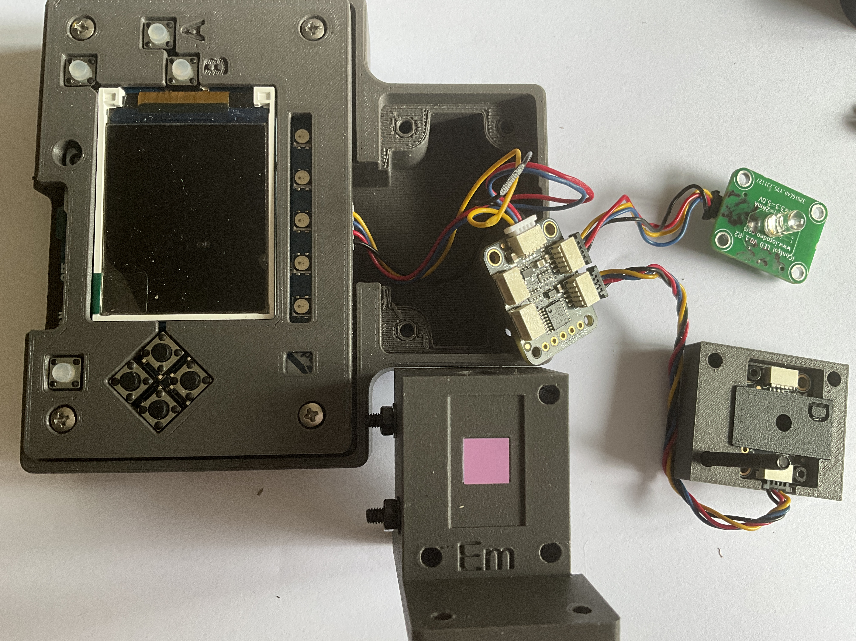
Disassembled instrument with the emission-filter region exposed and the detector assembly placed alongside it. The photograph provides orientation; the filter identity must be checked from its packaging or documented installation.
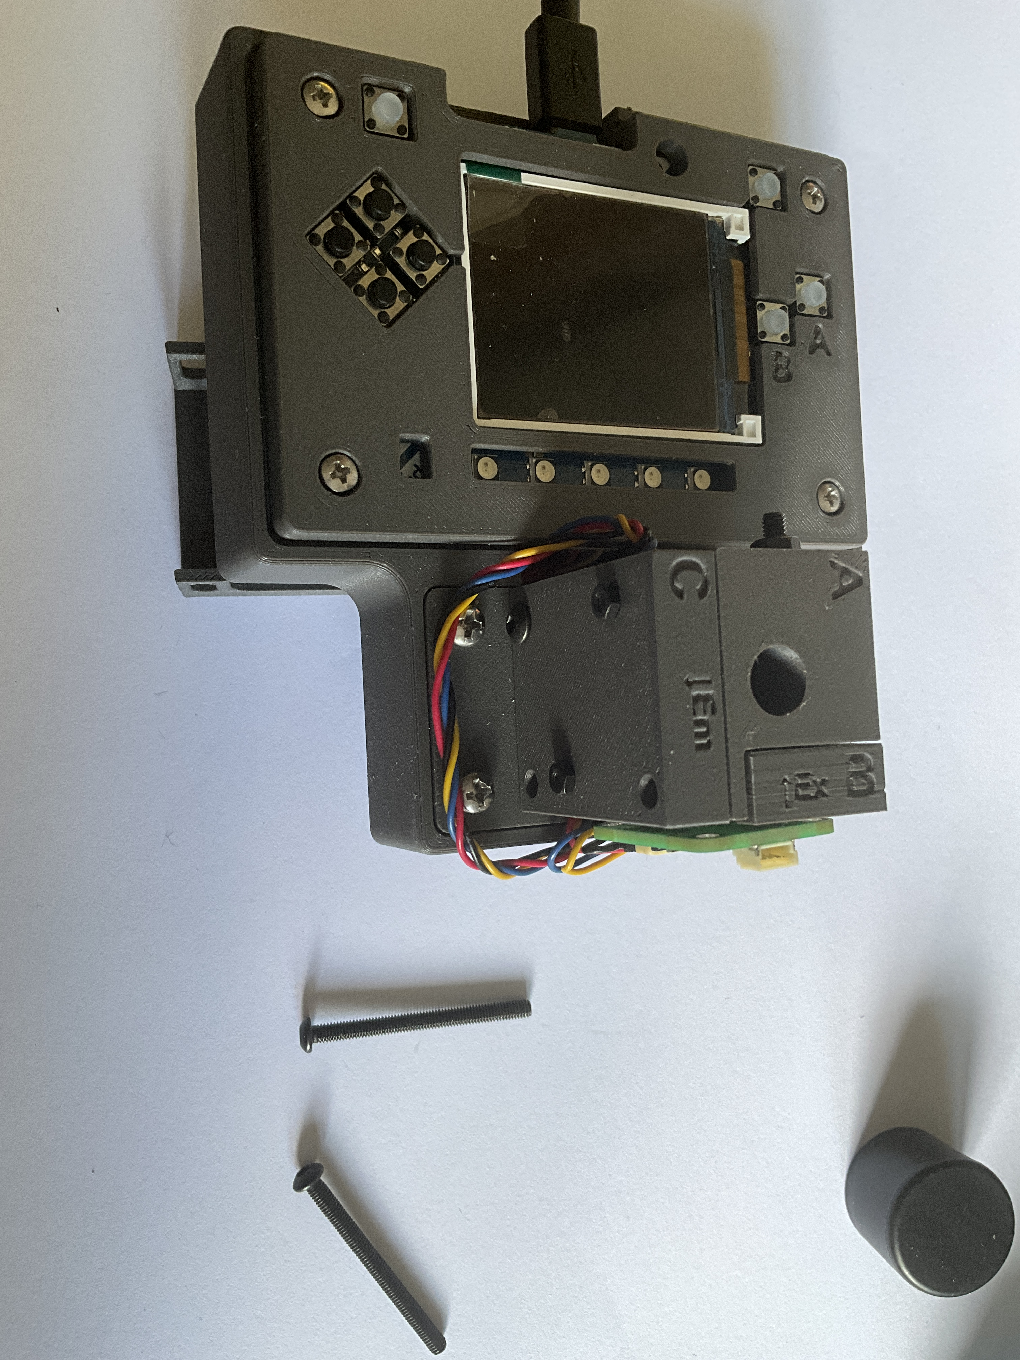
Detector-side assembly fitted to the main body. The photograph shows the Em marking and the retained detector assembly; do not infer screw lengths from the image.

5.6 Stage 5 Install the controller and multiplexer
1. Place the PyBadge in its enclosure with the battery disconnected.
2. Check that no printed edge holds down a button or presses on the display.
3. Confirm access to the USB Micro port, reset control, power switch and battery connector.
4. Mount the PCA9546 where its upstream and downstream ports remain accessible.
5. Support the radial LED board and sensor mechanically. Cables must not hold boards in position.
6. Check that solder joints and screw ends cannot contact adjacent boards.
Check: Controls move freely, boards remain supported and connectors can be reached without pulling the wires.

5.7 Stage 6 Connect and route the cables
With power disconnected, connect the intended upstream chain PyBadge → PRT-15109 adapter → PCA9546 upstream port. Connect the TSL2591 to a downstream multiplexer port. The existing firmware description states that it scans downstream channels for the sensor. Record the actual chosen port so the physical build remains reproducible.
The LED board requires the documented power connection and has no I2C address. Its connection point and the adapter pin mapping must be confirmed against the physical build and schematic before first power-up. The current cable map still marks these details as unconfirmed; it is not a complete wiring instruction.
Device | Address | Expected detection
PCA9546 | 0x70 | Upstream I2C bus
TSL2591 | 0x29 | Selected downstream bus
Fixed-current LED board | None | No addressed I2C response

1. Verify connector identity, supply polarity and signal correspondence before inserting plugs. Wire colours alone do not establish pin identity.
2. Hold each connector body, align it and insert without levering the socket.
3. Route cables along enclosure walls, leaving service loops near detachable modules.
4. Keep cables clear of the tube opening, filter apertures, buttons and enclosure screw joints.
5. Add strain relief without pulling on JST-SH sockets.
6. Record port assignments, cable lengths and the LED-board supply connection in the cable map.
Check: No cable is stretched or trapped when the cover closes. Do not power an assembly with an unresolved supply or adapter connection.

5.8 Stage 7 Fit the optical cover
Fit cover F and the intended light-excluding parts. Check the tube opening, filter pockets, enclosure seams and cable exits for light paths. The tube must still reach its stop and be removable without disturbing the optics.
Check: All optical parts remain seated when the shield is fitted. The shield must be in its measurement position during blank, calibration and sample measurements.

5.9 Stage 8 Complete the pre-power inspection
☐ USB and LiPo are disconnected during inspection.
☐ LED polarity and the radial-board revision have been checked.
☐ Supply and adapter pin assignments have been verified.
☐ No exposed lead, solder joint or screw end can short another conductor.
☐ Ex470BP-40 is on the excitation side and Em532BP-40 is on the detector side.
☐ The single TSL2591 faces the emission aperture.
☐ Boards and filters are retained without distortion.
☐ Tube insertion and removal do not move the optical assembly.
☐ All plugs are seated and cables remain clear of optical openings.
☐ Display, buttons, reset and USB port are accessible.
☐ The enclosure closes without pinching cables.
☐ No loose screw, wire clipping or print debris remains inside.

5.10 Stage 9 Perform the first power-up
Install the documented software release using the software-installation chapter. For the initial hardware check, use a known-good USB data cable and leave the optional LiPo disconnected.
1. Switch on and confirm that the display starts.
2. Check detection of the PCA9546 at 0x70 and the TSL2591 at 0x29 on a downstream channel using the supported software or diagnostic procedure.
3. Confirm LED operation without looking directly into the LED or excitation aperture. Do not expect the LED board to appear as an I2C device.
4. Fit an empty tube and the light shield. Observe the effect of changing room illumination while keeping the shield closed. A substantial response requires investigation of light leakage before calibration.
5. Measure the intended reagent blank repeatedly with the shield closed. Investigate instability, saturation or mechanical sensitivity before proceeding to calibration.
6. Record the completed configuration, wiring and any departures from the supplied build.
An empty-tube check tests hardware and shielding. Use the specified reagent blank for analytical calibration. Hardware startup alone does not establish readiness to report dsDNA concentrations; calibration and independent quality-control checks follow in the operating chapters.
After replacing the LED, either filter, the detector or the sample holder, repeat the relevant hardware checks and establish a suitable calibration before reporting new sample results.

6 Software Installation and Updates
Install the documented software set as a complete release, back up the device before replacing files, and establish an instrument-specific calibration after installation. The preserved firmware archive includes demonstration calibration and saved state files. Their presence does not qualify a newly assembled instrument for sample analysis.

6.1 Supported software files
Component | Repository file | Use
PyBadge bootloader 3.15.0 | UF2 updater | Update only when required
CircuitPython 9.1.1 | PyBadge runtime UF2 | Runtime for this documented firmware
QuantiFluorONE RC2 | Complete stable RC2 ZIP | Device application, libraries and support files
Checksums | Software SHA256 list | Identify the supplied installation files

The preserved ZIP is named QuantiFluorONE_Firmware_1.0.0-rc2-stable.zip. Its SHA256 digest is 48cc941c12578308e4cb6ec68f8119962941370f60ce40eff16f0564134e97d1. Keep this archive unchanged. The application declares QF1-1.0.0-rc2 and displays v1.0 RC2; the bundled configuration and saved calibration retain some earlier RC1 metadata. The configuration version string alone therefore does not identify the running application.
Use a computer, a USB Micro data cable and a plain-text editor. A charge-only cable cannot provide file access. The raw bootloader BIN file is an archive/recovery image and is not the file to drag onto the UF2 drive.

6.2 Back up the existing instrument
1. Connect the powered PyBadge to the computer with the USB data cable.
2. Stop the application using CircuitPython safe mode as described below.
3. Copy the complete contents of CIRCUITPY into a dated computer folder identified by instrument and firmware version.
4. Confirm that required CSV logs, configuration, saved calibration, multipoint source JSON and state files are present in the backup.
5. Safely eject the drive before resetting or disconnecting the device.
A clean installation removes the previous device state. Keep the backup until the new installation has been checked and required data have been archived. Do not automatically restore old libraries or calibration files over the new installation.

6.3 Reset and drive modes
The reset switch is reached through the opening on the underside of the enclosure. Use a short nonconductive tool without forcing it into the electronics.
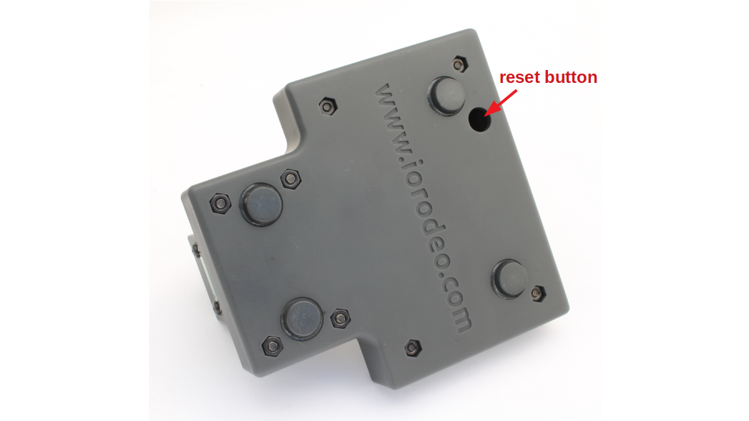
Reset access through the underside of the enclosure. The photograph identifies the opening rather than an exposed electrical contact.
Action | Mode and computer drive | Purpose
One reset press | Normal application startup; CIRCUITPY when connected to a data host | Start or restart the application
Slow second press during startup | CircuitPython safe mode; CIRCUITPY | Maintain files with the application stopped
Two quick reset presses | UF2 bootloader; PYBADGEBOOT or BADGEBOOT | Install a UF2 updater or runtime

For safe mode, press Reset once, allow startup to begin, then press it again during the approximately one-second safe-mode window. Check that the application remains stopped. A fast double-click enters the UF2 bootloader instead. If the boot drive appears unexpectedly, reset once and repeat with slower timing.
The existing image named circuitpython_safe_mode_screen.jpeg shows automatic reload and soft-reboot messages. It is not proof of safe-mode entry and is not used here as a safe-mode reference.

6.4 Check the bootloader and install the runtime
1. Enter UF2 bootloader mode with a fast double-click.
2. Open INFO_UF2.TXT on the boot drive and record the installed version.
3. If an update to the documented 3.15.0 is needed, copy the supplied UF2 updater to that drive and wait for it to finish. Re-enter the bootloader and verify the version in INFO_UF2.TXT.
4. To install CircuitPython 9.1.1, copy the supplied PyBadge runtime UF2 to the boot drive.
5. Wait for the board to restart. Confirm that CIRCUITPY appears.
6. Inspect the device-generated boot_out.txt for CircuitPython 9.1.1 and board ID pybadge after runtime installation.
Do not downgrade a different bootloader merely because it has another version number. A working installation does not need a bootloader update for every application reinstall. The repository also contains an archived boot_out.txt; do not mistake a copied historical file for proof of the runtime currently executing.
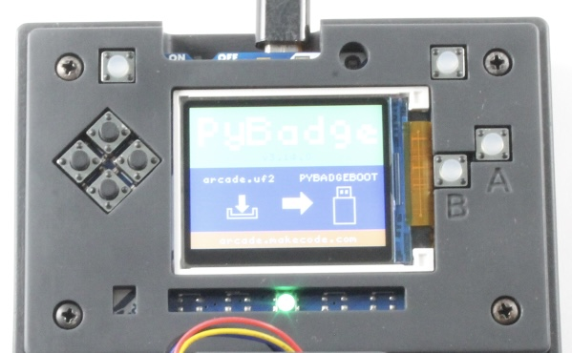
PyBadge UF2 bootloader screen. Use the mounted boot drive for the supplied UF2 files.

6.5 Install the complete application
1. Extract the unchanged RC2 ZIP on the computer.
2. Open the outer folder QuantiFluorONE_Firmware_1.0.0-rc2-stable.
3. Confirm that the complete old CIRCUITPY drive has been backed up.
4. Enter safe mode and delete the existing contents of CIRCUITPY.
5. Copy all files and folders inside the extracted release folder into the root of CIRCUITPY. Do not copy the enclosing release folder itself.
6. Confirm that boot.py, code.py, quantifluorone_app.py, quantifluorone_config.json, lib and src are directly in the drive root.
7. Complete the initial-state cleanup below before the first analytical use.
The ZIP remains the preserved release. The initial-state cleanup removes historical instrument data from the installed device without changing the application source or creating another firmware variant.

6.6 Remove the bundled demonstration state
The supplied quantifluorone_calibration.json is enabled and identifies the provisional model QF1-PROVISIONAL-20260731. The companion multipoint JSON states dataset_purpose: software_verification and calibration_status: PROVISIONAL. The saved state also contains a historical blank. The application can load these files and calculate concentrations; it does not reject the calibration solely because its status is provisional.
For a new or cleanly reinstalled instrument, while still in safe mode:
1. Preserve the extracted release on the computer as the source record.
2. Remove quantifluorone_calibration.json and quantifluorone_state.json from the installed CIRCUITPY root so an old calibration and blank cannot become the starting state.
3. Remove the bundled quantifluorone_multipoint.json from the device root. Retain it on the computer as an example, clearly separated from approved calibration files.
4. Archive and remove any historical measurement CSV copied with the release. Start a new log for the new installation.
5. Keep the configuration, application, libraries and other support files. Do not delete all JSON files indiscriminately.
6. Safely eject the drive, disconnect the USB data host and restart on a suitable standalone supply.
7. Confirm the RC2 banner and use CAL STATUS to check that no active calibration remains. If a model is still active, stop and inspect the installed files before accepting results.
A device-specific calibration restored after a reinstall needs documented compatibility with the instrument, assay and software. Restore its matching blank state only as a deliberate decision and check an independent control before reporting samples.

6.7 Select the correct power mode
The supplied boot.py checks for a USB data host at startup. With a data host connected, the computer owns write access and the firmware cannot reliably save measurement and calibration files. With a charger, powerbank or suitable LiPo and no data host, the firmware requests write access.
Task | Required operating arrangement
Copy firmware or edit JSON | USB data host; application stopped in safe mode
Save a calibration or log measurements | Standalone supply; normal restart after disconnecting the data host
Download the resulting CSV | Stop acquisition, connect the data host, enter safe mode and copy files

Safely ejecting a drive while leaving the USB data connection present does not change the startup decision. Disconnect the data host and restart normally for firmware-side writes. A concentration shown on the display does not prove that a CSV row was saved.

6.8 Verify the installation and persistence
1. Start on standalone power and confirm QuantiFluorONE v1.0 RC2.
2. Confirm that no fatal-error screen appears.
3. Perform the startup checks in the following chapter. Record any test measurements as installation checks.
4. After creating the intended calibration, restart and verify that it is retained.
5. Stop acquisition, connect to the computer in safe mode and inspect the new CSV and saved JSON files. Confirm that the expected rows and calibration values are present.
6. Archive this installation check before beginning a reportable sample batch.
This procedure verifies files and persistence on the actual instrument. The source-code review alone cannot verify USB enumeration, reset timing, sensor operation or write access on a particular computer.

6.9 Installation problems
Observation | Action
No drive appears | Check switch position, USB port and data-capable cable
Boot drive appears instead of CIRCUITPY | Reset once; use slower timing for safe mode
Files trigger repeated reloads during copying | Stop the application in safe mode
Missing module or missing configuration | Compare the complete installed release with the extracted folder; check that it is not nested
RC2 banner but PROV results | Remove or replace the historical provisional calibration through the documented workflow
Values display but new CSV rows are absent | Check logging configuration, standalone startup and device write access
Failure persists after reinstall | Record the error type, stage and serial traceback; retain the backup and failed installation record

7 First Startup and Instrument Operation
Use this chapter to verify that the assembled instrument starts, detects its sensor and records measurements with the intended calibration. Hardware checks and a successful software startup precede analytical qualification; samples are reportable only after the calibration and quality-control requirements have been met.

7.1 First startup
1. Complete the assembly inspection, including verified supply and adapter connections. The deferred fastener review remains recorded in the project to-do list.
2. Start on standalone power after disconnecting the USB data host.
3. Confirm the display banner QuantiFluorONE v1.0 RC2.
4. Open the menu and inspect CAL STATUS. After a clean installation with historical state removed, it should report no active calibration.
5. For a new instrument, measure a test blank and use Details to record the sensor channel, gain and integration time. This is an installation check rather than a calibration.
6. Check shielding and repeated blank response before performing the calibration described in the operating protocol.
The default configuration uses gain max, 600 ms integration and three consecutive sensor readings per measurement cycle. The code searches all four PCA9546 branches unless a channel is specified and requires exactly one matching sensor. A configurable direct-sensor fallback also exists; it is not the documented multiplexer build. Investigate a reported channel of -1 before treating that instrument as the standard configuration.
The earlier operating procedure specifies a 20-minute instrument warm-up. Retain this as the project operating condition and record it. Its sufficiency must be assessed through blank and control stability; the application does not enforce or count down this interval.

7.2 Controls
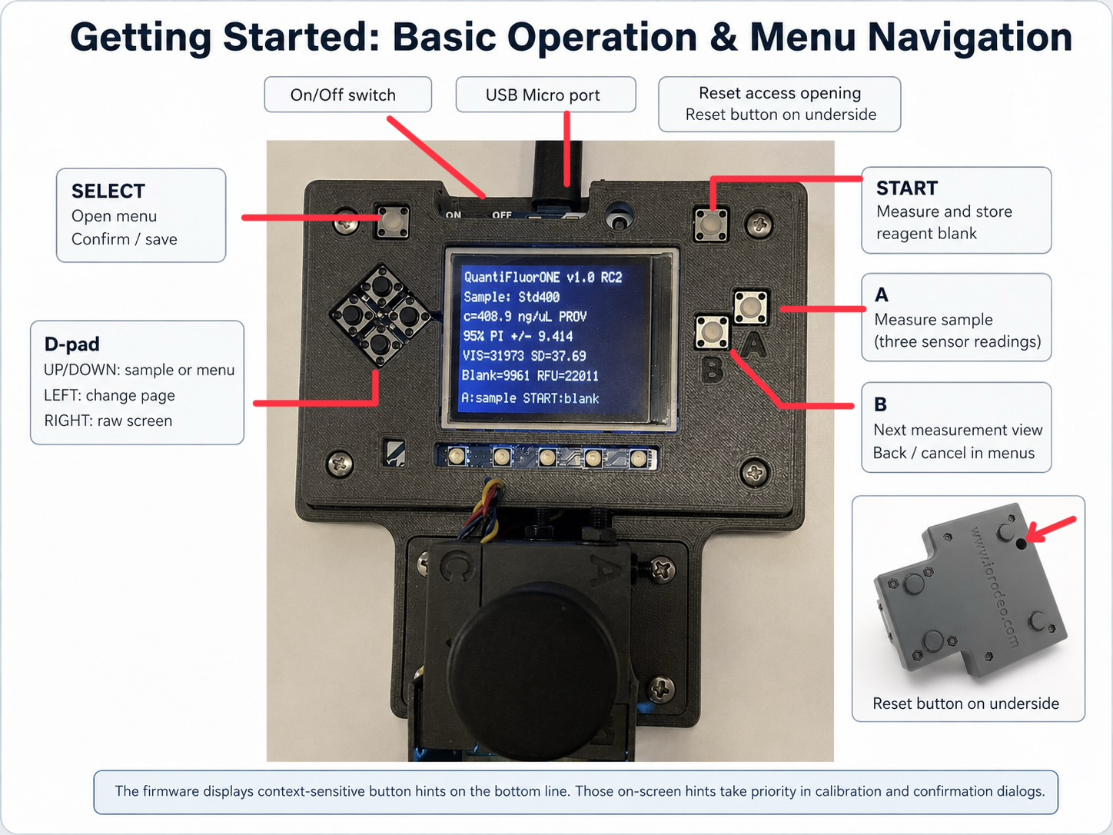
Front-panel controls for RC2. The example screen shows a provisional calibration and is an illustration of the interface, not an accepted analytical result.
Control | Measurement screen | Menu or calibration screen
SELECT | Open the menu from Live | Open or confirm the selected action
START | Acquire a new reagent blank | Measure the blank requested by the two-point or ten-blank routine
A | Measure the selected sample | Measure the high standard when requested
B | Cycle Live, Details and RAW | Back or cancel
UP or DOWN | Select sample ID in Live | Select menu entry or high-standard concentration
RIGHT | Enter RAW from Live or Details; return to Live from RAW | No general menu action
LEFT | Change RAW page | Change calibration-result or calibration-status page

Use the hints on the current screen. UP/DOWN changes the sample ID only in Live. SELECT opens the menu from Live; return to Live first if viewing Details or RAW. The internal button names gain and itime are historical names: B and A do not change detector gain or integration time in this application.

7.3 Menu functions
Entry | Purpose | Consequence
2-PT CAL | Acquire blank and one high standard | Saving replaces the active calibration
10-BLANK L/Q | Evaluate independently prepared blanks | Requires an active two-point calibration; saved estimates belong to that calibration
LOAD MP CAL | Import compatible OLS calibration JSON | Replaces the active calibration and attaches the current sensor settings
CAL STATUS | Inspect calibration parameters | LEFT changes between two pages
CLEAR CAL | Remove the active model after confirmation | Concentrations are no longer available until calibration is established

Successful import confirms that the required mathematical fields can be read. It does not verify assay identity, independent reference values or analytical approval. RC2 accepts provisional multipoint data; the operator must establish that the model is appropriate before use.

7.4 Handle blank measurements according to calibration type
In RC2, START on the measurement screen invalidates an active two-point calibration. The application acquires a fresh blank, disables that model and attempts to delete the saved calibration file. It does not simply substitute a new blank while retaining the two-point slope.
Intended task | Procedure
Create a new two-point calibration | Enter 2-PT CAL; acquire its requested blank with START, select 400 ng/µL, measure the high standard with A, review and save with SELECT
Continue with a stored two-point calibration and its stored blank | Review calibration and unchanged conditions, then measure an independent control with A. Do not press START as a routine preliminary step
Check a new blank without replacing the stored two-point blank | Give the tube a traceable sample identifier and measure it with A. Evaluate that check in the QC workflow
Deliberately replace the two-point blank | Use a complete new two-point calibration, including the high standard
Use an approved multipoint model | Confirm the model and measurement context, acquire the required fresh blank with START and verify an independent control

Measuring a new blank under a multipoint model retains the imported model. It changes the signal baseline and still requires a control check. The stored model must have been prepared for the same signal definition and assay conditions.

7.5 Follow the two-point dialog
1. Press SELECT from Live, select 2-PT CAL and open it.
2. Insert the reagent blank, close the shield and press START.
3. On HIGH STANDARD, select 400 ng/uL with UP/DOWN and press SELECT.
4. Insert the incubated high-standard tube and press A. For the confirmed ONE standard, the tube contains 1 µL of 400 ng/µL stock plus 200 µL reagent, corresponding to 400 ng DNA in 201 µL.
5. Review both result pages using LEFT. Check the standard concentration, blank, standard signal, slope and QC indications.
6. Save with SELECT only when the result is acceptable; use B to cancel otherwise.
7. Verify a separately prepared control before unknown samples are accepted.
The code reports CV, SNR and SAT warnings during review but can still save a calibration containing those warnings. Treat warnings as conditions to investigate, not as an automatic acceptance decision. A saved ACTIVE status does not replace independent quality control.

7.6 Prepare sample identifiers
In safe mode, edit the samples.list array in quantifluorone_config.json with a plain-text editor. For example, use the array ["BlankCheck", "QC1", "Sample01", "Sample02"]. Preserve valid JSON syntax and the remaining configuration.
The selected sample index is stored in quantifluorone_state.json, not in a samples.selected_index configuration field. After editing the list, restart and explicitly select the correct ID in Live before each measurement. Keep identifiers unique and avoid commas, quotation marks and line breaks: the RC2 CSV writer does not escape those characters.
If the list is unchanged, record the physical samples and their exact measurement order separately. The application records the selected identifier; it cannot determine which tube was inserted.

7.7 Read the measurement views
Each sample cycle collects three consecutive FULL and IR readings and calculates VIS as FULL minus IR, clipped at zero for each reading. The displayed mean and standard deviation describe repeated sensor readings of the same tube, not three independently prepared assays.
View | Information
Live | Sample ID, concentration/status, prediction interval or limits, VIS mean and SD, blank and RFU
Details | FULL, IR and VIS statistics, RFU, concentration, sensor channel, gain and integration time
RAW | Individual readings over two pages, VIS statistics and peak-related indication
Calibration status | Two-point standard, RFU, slope and QC, or multipoint model, coefficients, range, limits and statistical parameters

The calibration ID is stored in JSON but is not shown on the RC2 calibration-status pages. Identify it from the archived calibration file and batch record. The interface truncates text to fit the screen, so full identifiers and metadata must be checked in the files where necessary.
An out-of-range or provisional result may still have a numerical concentration. Review its status and applicable range before reporting it. A numerical display is not an analytical acceptance flag.

7.8 Record and verify data
File on CIRCUITPY | Role
quantifluorone_config.json | Hardware, measurement, sample-list and assay configuration
quantifluorone_state.json | Saved blank and interface selections
quantifluorone_calibration.json | Active saved calibration
quantifluorone_multipoint.json | Source JSON for deliberate multipoint import
quantifluorone_log_v100rc2.csv | Appended measurement records

The CSV field t_s is the monotonic runtime clock in seconds, not UTC or a calendar timestamp. Record the batch date, instrument identity and restart boundaries separately. Time values restart when the device restarts, and rows from several sessions can be appended to one file.
The Live screen does not consistently expose CSV write failures. Verify logging during installation by retrieving the file and checking the expected new rows. Retain that verification when computer access is unavailable during the actual measurement batch.
1. Complete acquisition and stop taking measurements.
2. Connect to the computer and enter safe mode.
3. Copy the CSV, current calibration JSON, configuration and relevant source calibration into the dated batch folder.
4. Confirm sample IDs, row count, firmware, sensor settings, calibration status, result flags and units.
5. Safely eject before disconnecting. Return to standalone power and restart if further measurements are needed.

7.9 Ready for analytical work
Proceed to sample analysis when the instrument starts without error, the expected sensor settings are documented, shielding and blank stability pass, logging has been verified, and a suitable calibration has passed an independent control check. Preserve the calibration and batch record together. The detailed calibration, assay preparation and acceptance criteria follow in the operating chapters.

8 Calibration and Calibration Management
Calibrate the completed instrument using the same assay, tube type, optical configuration and sensor settings that will be used for samples. Routine sample analysis uses the on-device two-point calibration. A separate multipoint concentration series evaluated in the Calibration Suite characterizes a newly built instrument or a changed configuration. The preserved provisional dataset is a development/characterization record, not a required operational calibration for routine samples.

8.1 Choose the calibration route
Route | Requirements | Operational decision
New two-point calibration | Reagent blank and confirmed 400 ng/µL ONE stock standard | Use the on-device procedure below; verify an independent control
Stored two-point calibration | Unchanged conditions, retained matching blank and passing independent control | Reuse deliberately; START on the measurement screen invalidates this model
Multipoint series for instrument characterization | Independently assigned concentrations spanning the intended range | Evaluate regression and analytical performance in the Calibration Suite for each new instrument or changed configuration; routine samples still use two-point calibration
No suitable calibration | Hardware inspection only | Record signals, but do not report sample concentrations

The routine workflow does not require importing a multipoint or provisional calibration. Characterization is performed initially for each new instrument or changed configuration; it need not be repeated for every sample batch. Retain its data and conclusions as the basis for the working range and performance claims. Repeat relevant characterization if configuration changes or QC findings undermine that basis.

8.2 Prepare the calibration tubes
Use Promega QuantiFluor ONE Lambda DNA stock at 400 µg/mL = 400 ng/µL, confirmed for this instrument's procedure. QuantiFluor ONE reagent is ready to use. The separate QuantiFluor dsDNA kit has different reagent preparation and stock-standard instructions and is not a substitute protocol.
Tube | Reagent | DNA addition | DNA mass and concentration basis
Reagent blank | 200 µL ONE reagent | None | No intentionally added dsDNA; 200 µL total
High standard | 200 µL ONE reagent | 1 µL ONE stock at 400 ng/µL | 400 ng DNA; 201 µL total; approximately 1.99 ng/µL in assay
Independent control | 200 µL ONE reagent | 1 µL of a separately prepared control | Target expressed as concentration of the control solution before reagent addition

The blank follows the manufacturer's single-tube TM405 procedure. Adding 1 µL of DNA-free buffer is a different blank preparation. If a matched-buffer blank is introduced, document and evaluate that choice; do not silently alternate between blank preparations.
Allow components to reach room temperature. Mix each DNA-containing tube thoroughly, avoiding bubbles, and incubate for 5 minutes at room temperature protected from light. Use the same preparation and timing conditions for calibration, controls and samples.
The calibration setting 400 ng/µL represents the concentration of the 1 µL stock aliquot. It does not mean that the finished assay tube contains 400 ng/µL. The corresponding sample output is expressed on the same original-solution basis.

8.3 Perform the on-device two-point calibration
1. Start on standalone power after the documented warm-up and mechanical checks. A USB data host prevents the intended firmware-side saving workflow.
2. From Live, press SELECT, choose 2-PT CAL and open it.
3. Insert the reagent blank fully, close the light shield and press START when the calibration dialog requests it.
4. On HIGH STANDARD, select 400 ng/uL with UP/DOWN. Press SELECT to continue.
5. Replace the blank with the incubated high-standard tube, close the shield and press A.
6. Review both result pages using LEFT. Confirm the concentration setting, signals, slope and QC indications.
7. If preparation, signal or QC is unacceptable, cancel with B and investigate before repeating the calibration.
8. Save an acceptable calibration with SELECT.
9. Open CAL STATUS, record the two-point parameters and measure an independently prepared control with A.
10. Verify persistence after a restart and archive the saved calibration and matching state files with the batch record.
One calibration measurement consists of three sensor readings of the same tube. The slope is the blank-corrected standard signal divided by 400 ng/µL. This two-point procedure does not independently test linearity between its endpoints.
The firmware displays CV, SNR or SAT warnings but does not prevent every warned result from being saved. Investigate warnings and confirm a control. Avoid imposing old example RFU or slope values as universal acceptance limits; those depend on the actual optical configuration and blank.

8.4 Reuse or replace a stored calibration
Before reuse, compare the archived calibration with the instrument, LED/filter set, sensor channel, gain, integration time, assay volumes, reagent condition and temperature history. Measure a fresh blank-check tube with A under a traceable ID and check an independent control using the retained calibration. The laboratory must define acceptance intervals before the batch.
Do not press START on the measurement screen merely as a preliminary step when retaining a two-point calibration. START replaces blank state and invalidates that model. If a new calibration blank is required, repeat the complete two-point procedure with the high standard.
Replacing optics, the tube holder or detector, changing sensor settings or assay volumes, or observing unresolved blank/QC drift requires renewed assessment and calibration. The firmware checks some stored sensor settings; it cannot detect reagent changes, optical replacement, contamination or temperature equivalence.

8.5 Estimate blank-based limits on the device
The 10-BLANK L/Q routine requires an active two-point calibration. Prepare ten independent reagent-blank tubes using the same blank preparation. Ten cycles on one tube measure a different component of variation and must not be described as ten independent blanks.
1. Select 10-BLANK L/Q from the menu.
2. Insert a fresh blank for each requested position, close the shield and press START inside this routine.
3. Complete all ten tubes, then review the results.
4. Save with SELECT if the study is acceptable and archive its CSV rows and updated calibration JSON.
This menu routine does not call the ordinary blank-replacement action. The routine retains the two-point calibration while estimating limits from the standard deviation of the ten cycle means.
With the shipped configuration, the calculations are LOD = 3.3 × blank SD / slope and LOQ = 10 × blank SD / slope. The slope uses original-solution concentration units, so the resulting limits have that basis too. Record the actual factors, blank count, preparation and settings.
These are blank-based screening estimates, not a complete DIN 32645 calibration-curve assessment. A fresh two-point calibration clears the earlier saved limits; do not assume that the new model has inherited them. Do not infer limits from a single tube's three-reading SD.

8.6 Characterize a new instrument or configuration
Use independently assigned standard concentrations across the intended working range, with independently prepared assay replicates where practical. Record assigned concentrations, blank preparation, signal definition, tube identities, reagent information and sensor settings.
Use original-solution concentration in ng/µL for the 1 µL sample aliquot and blank-corrected RFU as the response when creating a model for RC2. Do not regress measured RFU against concentrations calculated from that same RFU and then claim independent linearity. Do not import a model fitted to uncorrected VIS as if it were an RFU model: RC2 subtracts its active blank before applying the slope and intercept.
Open the Calibration Suite v7.3 in the browser for model diagnostics, retaining its complete report. The HTML source and offline copy and v7.3 Standards Audit Notes remain in the repository. The web link launches the application; the source link opens GitHub's file view. To work offline, download the actual HTML file and open the saved file in a browser.
With the standard 1 µL aliquot, verify that the suite reference values remain numerically the intended original concentrations. The supplied suite parser multiplies concentration by sample volume when its concentration basis is selected; using another volume changes the numerical scale. Changing an axis label does not change this calculation.
Inspect residuals, replicate spread, recovery and the linear-versus-quadratic diagnostic alongside the calibration plot. A high R² alone is insufficient. Retain suspected outliers and investigate technical causes rather than deleting them to improve the fit. The suite also offers weighted fits, but RC2 imports only an OLS model.

8.7 Use the Calibration Suite v7.3
Use this workflow when characterizing a new instrument, assay or optical configuration. It is not an additional step before every routine sample. The instructions below refer to the supplied v7.3 application and its Standards Audit Notes; the controls are named as they appear on screen.

Start and check the application
The suite opens with an embedded example already calculated. These are demonstration data, not measurements from the instrument being characterized. Confirm the version badge reads v7.3 Standards-Audit. The built-in openDIN self-test runs at startup; use Run openDIN standards self-test to repeat it and inspect the eight checks in section 13. They cover slope, intercept, R², residual SD, Qx, NWG, EG and BG. The self-test uses its own fixed reference dataset and settings, independently of the selected sample dataset.
A PASS checks the implemented reference calculation against the embedded expected values. It does not qualify the instrument, establish a working range or certify conformity with a standard. If the test fails or a compatibility error appears, retain the message and resolve the software problem before relying on the results.

Prepare the calibration CSV
Use a header row and one row per measured assay replicate. Retain independently assigned reference concentrations and the corresponding blank-corrected RFU cycle means. The firmware's three sensor readings within one cycle do not represent three independently prepared assays. Its routine concentration log must be supplemented with independently assigned references before it becomes calibration input; do not use the instrument's calculated concentrations as the reference values.
The following column layout is suitable for the standard ONE procedure. Semicolon-separated columns and decimal points avoid ambiguity. These two rows illustrate the format only; prepare a complete series spanning the selected range, with blanks and replicates as designed.
level_id | replicate | reference_ng_uL | sample_volume_uL | RFU
Blank | 1 | 0 | 1 | 2
Std45 | 1 | 45 | 1 | 563

Use the exact headers shown, including RFU; do not rename them to descriptive phrases. The application reads a supplied signal column directly. Optional VIS and blank_VIS columns do not cause it to calculate RFU by subtraction. Calculate and verify RFU beforehand if it is not already available. Keep the blank preparation and signal definition consistent throughout the series. A measured blank-corrected blank can fluctuate around zero; retain its recorded value.
The parser accepts semicolons, commas or tabs and requires a header and at least three usable numeric rows. That parser minimum is not an adequate characterization design by itself. Avoid quoted fields containing delimiters because this simple parser splits fields at the delimiter. Check the imported row count: unusable numeric rows can be omitted. Store the raw measurements separately from the prepared import file.

Import data and set the analysis
1. In section 1, Import and settings, choose the prepared file using Calibration CSV. Alternatively replace all demonstration text in section 3, Imported calibration data, with the complete CSV text. File import calculates immediately; after pasting, press Calculate selected model.
2. For the ONE method set Sample volume [µL] to 1, Reference values represent to Original sample concentration, x-axis unit to ng/µL and y-axis unit to RFU. A sample_volume_uL column overrides the global sample-volume value for each row; verify that every value is 1. The reference concentration times 1 µL is numerically equal to DNA mass in ng. This numerical equivalence is specific to this aliquot; see Chapter 13 before adapting another volume.
3. Select OLS linear for the documented characterization baseline. Enter a meaningful Calibration ID and actual Calibration date; replace the prefilled example values.
4. Select and record Significance level α, Determination-limit factor k and Future replicate determinations m. The startup defaults are α = 0.05, k = 3 and m = 1. Set m to the number of independent determinations represented by a future reported mean; it is not automatically 3 because the firmware averages three sensor readings. Record the intended repeatability design.
5. Press Calculate selected model after completing all settings, including ID and date, so the scientific JSON and report reflect them. Confirm the imported row count, number of levels, signal scale and reference range before interpreting any statistics.
Selecting Amount in assay tube uses reference numbers directly, without multiplying them by sample volume. It does not convert a mass result to original-sample concentration. Choose units and interpretation explicitly; for the standard 1 µL ONE workflow use the settings above. Resolve a different concentration or mass basis before comparing slopes, limits or exporting coefficients.

Review the results and limits
Read section 4 for the equation, slope, intercept, residual SD and limits. Review the calibration curve in section 7 and residuals in section 8 for curvature, changing spread and isolated deviations. Sections 9 and 10 show level repeatability, back-calculated concentrations and individual residuals. Recovery calculated from the fitted standards describes the fit; it does not replace separately prepared control samples.
Section 11 provides Grubbs screening, an approximate residual-normality diagnostic, the Mandel linear-versus-quadratic test and adjacent-level slope comparisons. A significant Mandel result indicates evidence for curvature within that dataset; a non-significant result alone does not prove linearity. Investigate flags using preparation records and repeat measurements where justified. The default 10% deviation threshold for local slopes is user-defined, not a formal DIN acceptance threshold. Suspected outliers are not removed automatically.
Compare all models populates the comparison in section 6; choose a model in the selector to inspect its outputs. Weighted models 1/c, 1/c² and 1/s² are exploratory alternatives. Do not select a model solely for its R². v7.3 suppresses OLS-style confidence/prediction bands and DIN-labelled limits for weighted fits. Document why any weighting is appropriate; the RC2 multipoint importer accepts only OLS.
Section 12 separates NWG (decision limit), EG (detection limit) and BG (determination limit) for the implemented OLS calibration-curve calculation. EG uses the assumption α = β; BG also depends on k and m. Retain the displayed method, settings, reference basis and units with the results. Limits estimated from a wide-range calibration require particular care near zero; assess independent low-level samples and blanks before adopting a reporting threshold. An implementation self-test does not establish that the calibration design satisfies all requirements of a standard.
Section 14 is a separate two-point and blank-sigma calculator. It uses repeated blank and standard signals and shows 3σ, 6σ and 10σ divided by slope. These estimates differ from the instrument's documented 3.3σ and 10σ screening factors and from the calibration-curve calculation. The sample signal for that calculator must have the same signal basis as its blank and standard inputs. This section does not replace the on-device routine two-point calibration, and its JSON is not an approved RC2 calibration file.

Save the characterization record
Use Save scientific JSON or Save JSON to download the selected model's scientific record. Use Print / save report as PDF and save the browser's print output. On iPad, the print preview can be opened or shared to Files as a PDF; the exact controls depend on the browser. Recalculate after final edits and confirm the intended model, ID, date, units and audit status appear in the saved output.
Archive raw measurements, the prepared CSV, settings, scientific JSON, PDF report, HTML release and acceptance decision together. The scientific JSON is an analysis record, not a directly compatible RC2 import; see the next section before any firmware transfer.

8.8 Optional multipoint import for development
Multipoint import is an optional development capability, not part of routine sample analysis or a prerequisite for evaluating a concentration series in the Calibration Suite. The supplied importer expects the following mathematical fields. Their presence is necessary but does not establish analytical suitability.
Location | Required field names
Top level | calibration_mode equal to multipoint; calibration_model equal to OLS; residual_sd_signal
multipoint object | intercept_signal, slope_signal_per_x, n_replicates, mean_concentration, sxx_concentration2, t_factor_two_sided

Document calibration ID, accepted range, status, alpha, concentration basis, units and limit method as well. For the standard original-solution basis, the relevant dilution_factor is 201. The importer defaults a missing dilution factor to 1, which can make the secondary in-assay outputs incorrect even when the principal concentration is correct.
The v7.3 export uses OLS linear, mean_reference and sxx_reference2, and places its t factor in another object. It is not a file that can simply be renamed and loaded. The older v7.2 scientific JSON is closer to the mathematical contract but omits dilution/range/status metadata needed for the documented workflow. Its separate DIYNAFLUOR configuration export targets another application and must not replace QuantiFluorONE configuration.
A verified exporter or conversion workflow is recorded as an optional development follow-up. Its absence does not prevent instrument characterization in the Calibration Suite or routine analysis with the on-device two-point calibration. Do not repair the workflow by casually editing coefficients or relabelling the provisional example as approved.
For a verified compatible model, transfer its JSON in safe mode, disconnect the data host, restart on standalone power, use LOAD MP CAL and confirm. Review parameters in CAL STATUS; verify ID and units from JSON because the RC2 status pages do not display every metadata field. Acquire the intended blank with START for this multipoint workflow and verify an independent control before accepting samples.

8.9 Calibration record
Keep raw calibration data, assigned values and preparation records, model/report version, acceptance decision, exported operational JSON, matching state, sensor settings, blank-study data and independent control results together. Mark example and superseded files clearly so they cannot be mistaken for the current operational calibration.

9 Routine dsDNA Analysis with QuantiFluor ONE
This protocol uses 1 µL of sample plus 200 µL of ready-to-use QuantiFluor ONE reagent in a Promega E4941 thin-walled 0.5 mL PCR tube. Measure these prepared samples against the on-device two-point calibration after the instrument has been characterized and a quality-control plan established. No provisional or imported multipoint calibration is required for this routine procedure. The instrument reports concentration of the DNA solution before reagent addition.

9.1 Prepare the batch
Use clean DNA-free tubes and tips, fresh gloves, a P2 or P10 pipette suitable for 1 µL transfers, a 200 µL pipette, a tube rack and a timer. Prepare sufficient reagent, the confirmed ONE stock standard when recalibration is required, an independent control solution and any required sample dilutions.
Record the batch date, operator, instrument, firmware, reagent and standard identity, calibration ID, working range, applicable LOD/LOQ and the pre-established blank/QC acceptance intervals. Record actual clock times separately; the device CSV contains runtime seconds rather than UTC.
1. Start the instrument on standalone power and allow the documented 20-minute warm-up.
2. Confirm mechanical integrity, light shielding, sensor settings and available power.
3. Check the intended two-point calibration. Keep its stored blank or perform a complete two-point recalibration; do not replace that blank with START and then proceed as if its model were still active.
4. Prepare traceable IDs for blanks, controls, each sample and each independently prepared replicate.
5. Arrange tubes in measurement order and keep the laboratory record aligned with the selected instrument IDs.

9.2 Prepare and incubate the tubes
Tube | Preparation | Purpose
Reagent blank or blank check | 200 µL ONE reagent; no DNA addition | Calibration blank, independent blank study or batch blank check, according to the chosen action
High standard when required | 200 µL reagent + 1 µL confirmed 400 ng/µL stock | 400 ng two-point calibration anchor
Control | 200 µL reagent + 1 µL control solution | Independent check against a known target
Unknown | 200 µL reagent + 1 µL sample solution | Standard sample assay
Diluted unknown | 200 µL reagent + 1 µL deliberately prediluted sample | Assay within the established range; record the predilution factor

1. Bring assay components to room temperature and mix DNA solutions before pipetting.
2. Label tubes and dispense 200 µL reagent into each.
3. Add 1 µL standard, control or sample to the appropriate tubes, changing tips for every transfer. Add no DNA solution to the reagent blank.
4. Close and mix thoroughly by vortexing or the manufacturer's pipette-mixing approach. Avoid introducing bubbles.
5. Incubate for 5 minutes at room temperature protected from light. Use timed groups for a large batch so incubation is consistent.
6. Inspect tubes for bubbles, external droplets and fingerprints. Clean the exterior or prepare a replacement tube if necessary.
Promega permits other sample volumes on the Quantus, where the entered volume is used for calculation. This DIY procedure fixes the sample aliquot at 1 µL. Do not increase it to 2 or 20 µL while retaining the same calibration and simply expect the displayed concentration to remain correct. A changed volume needs a documented compatible calibration and evaluation of assay geometry and response.

9.3 Establish the batch baseline and verify a control
Active route | Blank action | Next action
New two-point calibration | Measure its blank inside 2-PT CAL | Complete the high-standard measurement, review and save
Retained two-point calibration | Measure a fresh blank-check tube with A under its own ID | Evaluate the check using the retained blank and model

Measure the independent control with A. Evaluate its recovery and any blank deviation against the limits established before the batch. Do not accept unknowns while these checks fail. If a retained two-point calibration needs a replacement blank, repeat the complete two-point calibration and control.

9.4 Measure the unknown samples
1. Return to Live and choose the correct sample ID with UP/DOWN.
2. Insert the incubated tube to its reproducible stop and close the light shield.
3. Press A and leave the instrument and tube undisturbed during all three readings.
4. Read the concentration, result status and signal statistics. Use Details and RAW when investigating unusual readings.
5. Record any repetition, independent replicate or sample predilution. Do not substitute a new tube under an unrelated ID.
6. Repeat the control after a long interruption, suspected drift or other event defined in the laboratory plan. Include an end-of-batch control where required.
7. Keep affected results on hold if QC no longer passes.
The high calibration standard cannot also serve as the sole independent control proving that calibration correct. Use a separate preparation at a different concentration; an independently assigned material is preferable when available.

9.5 Repeat or dilute when necessary
For an isolated unstable reading, inspect bubbles, mixing, tube seating, external contamination and light exclusion. Correct an identified cause and repeat the measurement without deleting its original record. If separately prepared assay tubes disagree, investigate preparation and make fresh replicates when needed.
For above-range or saturated results, dilute the original sample with a suitable DNA-free diluent, record the preparation volumes and repeat the entire 1 µL assay. Do not dilute an already prepared dye-containing assay and apply the ordinary calibration without evaluating that altered procedure.
The firmware can treat saturation as a fatal acquisition error. Record the error and restart after correcting the cause; do not assume the previous display is a valid new result.

9.6 Calculate and release the result
For an undiluted original sample, the displayed original-solution concentration is already the reportable concentration if calibration, range and QC requirements pass. Do not multiply it by 201. That factor describes dilution within the standard assay and is already implicit in the concentration calibration.
For a deliberately prediluted sample, multiply the displayed concentration by the predilution factor. For example, a 1:10 predilution measured as 30 ng/µL corresponds to 300 ng/µL in the original sample. Record the factor as total diluted volume divided by sample volume; avoid ambiguous dilution notation.
The corresponding CSV field concentration_in_assay_ng_uL describes the prepared assay and is not interchangeable with the original-sample result. Interpret LOD/LOQ and any interval on the same concentration basis. For prediluted samples, the effective original-sample limits also increase by the predilution factor.

9.7 Complete and archive the batch
1. Review blanks, controls, sample IDs, repeats, range flags, limits and dilution calculations.
2. Hold or reject results that do not meet the pre-established conditions.
3. Retrieve CSV and calibration/configuration/state files using safe mode and the backup procedure.
4. Confirm that the expected measurements were actually written and archive them with the laboratory record.
5. Remove used tubes, clean the instrument exterior without introducing liquid and dispose of consumables under laboratory rules.
6. Store reagent and standard according to the ONE kit instructions.
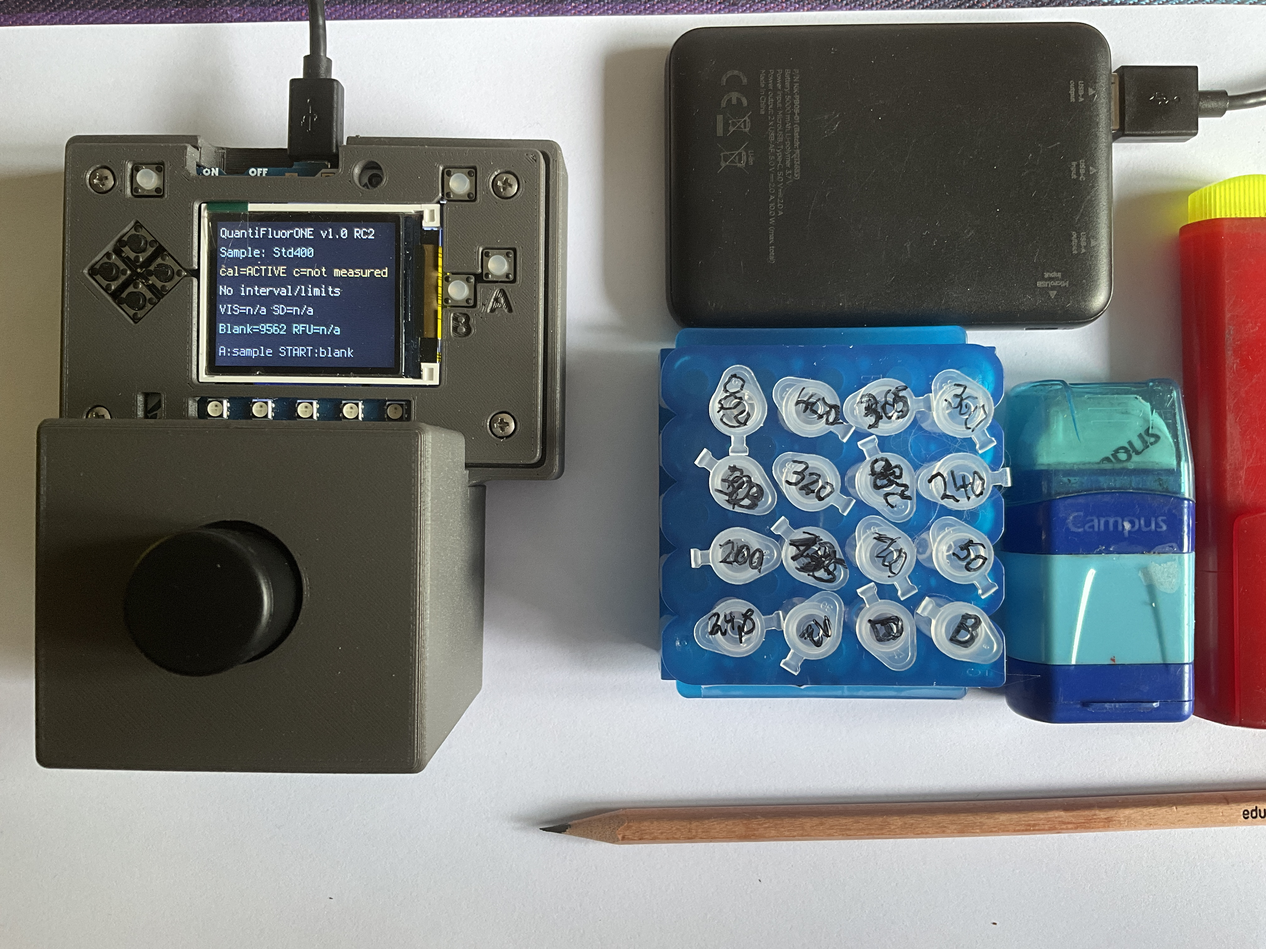
Instrument on standalone power alongside prepared sample tubes. The photograph illustrates the measurement arrangement.

9.8 Bench checklist
☐ Instrument warmed up, closed and operating from a supply that permits logging.
☐ Correct calibration and corresponding blank procedure selected.
☐ Reagent blank/check and independent control accepted.
☐ Tubes labelled, mixed and incubated for 5 minutes in the dark at room temperature.
☐ Exactly 1 µL sample added to 200 µL reagent for this procedure.
☐ Correct sample ID selected before each A measurement.
☐ Range, limits, replicate behavior and result flags reviewed.
☐ Only deliberate sample predilution applied to the reported concentration.
☐ Expected CSV rows and calibration record archived.

9.9 Protocol source
Promega Corporation, QuantiFluor ONE dsDNA System, TM405, revised October 2022, Section 3, printed page 4. The supplied PDF has this procedure on PDF page 5. The blank, 400 ng standard, mixing and five-minute incubation are drawn from that procedure. The fixed 1 µL sample aliquot and RC2 controls are the project-specific implementation.

10 Results Quality Control and Data Management
Accept a quantitative dsDNA result only when its calibration is suitable, batch blank and independent control pass, the signal is valid and the result lies within the established quantitative range. A numerical display or an ACTIVE calibration label alone is insufficient.

10.1 Establish acceptance criteria before the batch
Define the intended concentration range, blank acceptance interval, QC target and allowed deviation, replicate expectations and circumstances requiring recalibration. Use method performance, independent targets and historical control data to justify these criteria. Do not create limits after inspecting the current results.
For control solutions, calculate recovery as 100 × measured concentration / assigned concentration, using the same concentration basis and applying any recorded predilution appropriately. A control prepared independently from the same stock tests preparation and instrument behavior but does not independently confirm the stock's assigned concentration.
A passing mid-range control is a useful routine check; add low and high controls when the application requires them. Control placement and frequency belong to the laboratory plan. Record the interval since the last passing QC when deciding which results are affected by a later failure.

10.2 Distinguish the repeat measurements
Measurement design | What its spread describes | Interpretation
Three sensor readings in one cycle | Short-term measurement repeatability for one tube | The displayed VIS SD is in signal counts, not concentration units
Repeated cycles on one tube | Repeatability including handling and time effects | Does not include independently repeated pipetting
Independently prepared assay tubes | Combined preparation and measurement variation | Record each concentration; calculate mean and SD when appropriate
Independent samples or extractions | Sampling/extraction plus later analytical variation | Keep distinct from instrumental precision

Do not count three technical sensor readings as three independent calibration or sample preparations. Near zero, relative spread can become misleading; evaluate absolute differences together with blank behavior and applicable limits. Investigate systematic trends as well as isolated deviations.

10.3 Apply limits on the correct basis
The documented original-sample calibration interval is 0–400 ng/µL. The blank is an endpoint of calibration, not an assertion that every concentration above zero is quantitatively reportable.
The existing primary blank-study summary reports approximately 8 ng/µL LOD and 24 ng/µL LOQ on the original-sample basis, equivalent to about 0.04 and 0.12 ng/µL in the assay for the 201-fold assay dilution. These describe the evaluated configuration and blank-based calculation. They are not guaranteed limits for every new device or a newly saved calibration.
Use limits that have been established for the actual configuration and recorded with their method, blank design and calculation basis. The blank-performance summary distinguishes ten independent blank tubes from repeated cycles on two tubes.
Result category | Reporting action
Below the applicable LOD | Report below the detection estimate using the stated method and limit; do not report zero DNA as an established fact
At or above LOD but below LOQ | Report detected but not quantified, or below LOQ according to the laboratory convention
At or above LOQ and inside the accepted working range | Report quantitatively if all other checks pass
Above range or saturated | Predilute the original sample and repeat the complete assay
Invalid or incompatible calibration, failed blank/QC, or unresolved acquisition error | Hold or reject the result and document the reason

If limits are unavailable, do not infer them from the presence of a slope or R². Establish suitable limits and an accepted lower reporting boundary before claiming low-level quantitative results. RC2 may display negative blank-corrected concentrations; retain these raw results in the record and apply the reporting convention rather than describing them as physically negative DNA.

10.4 Distinguish characterization statistics from routine results
Routine analysis uses the two-point calibration and does not require a provisional calibration or a displayed multipoint prediction interval. Regression statistics from the separate characterization series document instrument performance; they do not require that model to replace the routine two-point calibration.
For the optional development use of a compatible imported multipoint model, RC2 calculates an approximate inverse OLS prediction interval using the imported residual SD, slope, number of calibration observations, mean concentration, sum of squares and t factor. Its variance includes one future determination. It is not a complete measurement-uncertainty budget and does not automatically account for standard uncertainty, sample matrix, extraction, manual predilution or independently prepared sample replicates.
The on-device three-reading SD and the model prediction interval are different quantities. Do not present a VIS SD as a concentration uncertainty. If the reported result and interval are multiplied by a sample predilution factor, note that this scaling alone does not include uncertainty in that dilution.
The menu blank-study factors 3.3 and 10 also differ from the Suite v7.3 blank-screening factors and its separate DIN-labelled calibration-curve limits. Record the calculation actually used. NWG, EG and BG in the suite must not be silently mapped to firmware LOD/LOQ labels without documenting the intended definition.

10.5 Accept repeat dilute or reject
Observation | Decision | Required action
Suitable calibration, passing blank/QC, consistent results, within quantitative range | Accept | Record result, basis, applicable limits and predilution
Bubbles, poor seating or another identified tube problem | Repeat measurement | Correct the cause; retain the earlier record
Independent preparation replicates remain inconsistent | Repeat preparation | Investigate pipetting, mixing, timing and sample homogeneity
Above-range concentration or saturation | Dilute and repeat | Predilute original sample and prepare a new assay
Elevated or unstable blank check | Hold batch | Check contamination, reagent, temperature, optical shielding and calibration
Independent control fails | Hold affected results | Correct the cause; repeat control and affected unknowns as needed
Wrong sample identity, unit, volume, model or concentration basis | Reject | Repeat the applicable preparation and calibration steps correctly
Below applicable LOQ | Qualify result | Use the stated detection/quantification category

When a retained two-point blank check fails, investigate before changing state. Replacing that blank requires a complete new two-point calibration; do not press START and continue measuring unknowns under the assumption that the former model remains active.

10.6 Read the CSV with its limitations
The RC2 example measurement log contains historical and provisional measurements as well as later work. A row's existence in the repository does not make it an accepted result.
Field group | Meaning
t_s, firmware_version, row_type, sample_id | Runtime seconds, software identity, event type and selected sample label
sensor_channel, gain, integration_time_ms | Measurement configuration
full_1 through vis_3, means and SDs | Raw and derived signal readings and within-cycle statistics
blank_mean, blank_sd, rfu | Active or event-related blank information and corrected signal
Calibration fields, range, slope and intercept | Model metadata present in that row
concentration_ng_uL | Principal concentration on the calibration's original-solution basis
concentration_in_assay_ng_uL | Principal result divided by the stored assay dilution factor
pi_low_ng_uL, pi_high_ng_uL | Model interval endpoints where available
Limit fields, result_flag, qc | Stored limits and selected range/calibration indications

Calibration acquisition and blank-study events are not ordinary unknown-sample rows. During calibration acquisition, some active-model fields may still describe the previous model. Distinguish event rows by row_type and retain the final saved calibration JSON as the record of the accepted new model.
The qc field can contain the saved calibration warning or IMPORTED status. It is not the pass/fail assessment of every independent QC tube. Record actual QC targets, recovery and acceptance separately. result_flag primarily describes the configured range; it does not automatically classify every result below LOD or LOQ.
The log does not provide a UTC timestamp, unique instrument identity, reagent lot, deliberate predilution factor or complete operator decisions. Retain these in the batch record. Do not assume that every metadata item checked by the operator is recorded automatically by RC2.

10.7 Minimum batch record
- Batch date, start time, operator and instrument identity.
- Firmware and suite versions; relevant configuration and sensor settings.
- Calibration ID, preparation date, range, model, limits and calculation method.
- Reagent/standard identification, assay volumes, blank preparation and incubation conditions.
- Blank-check and independent control IDs, targets, acceptance intervals and results.
- Original sample identity, assay replicate identity and measurement order.
- Predilution preparation, factor and final concentration calculation.
- Raw log and matching calibration/configuration/state files.
- Accepted, qualified or rejected result and reason for repeats or exclusions.

10.8 Archive without overwriting evidence
Stop acquisition, enter safe mode with the data host connected and copy the files to a dated instrument/batch folder. Verify row counts and expected sample IDs. Preserve the original log rather than editing it to hide failed or repeated measurements; keep calculations and accepted results in a separate analysis record.
Archive model source data and the report alongside the operational JSON. A two-point ID such as QF1-2PT is reused by the firmware and is not a unique batch identifier; use the dated archive and preparation record to distinguish successive calibrations. Link every final result to the specific calibration and blank state that applied when it was measured.

11 Analytical Performance and Limitations
The reported performance describes the evaluated QuantiFluor ONE instrument configuration using 1 µL DNA solution plus 200 µL reagent and routine two-point calibration. The evidence consists of a Quantus comparison, independent reagent-blank preparations and technical sensor repeats. It does not establish identical performance for every reproduced device, another dye or changed optics.

11.1 Initial characterization and routine use
Characterize each new device or changed configuration using an assigned concentration series and the Calibration Suite to document regression and relevant performance measures. Retain the resulting data and conclusions as the basis for the accepted working range. This is separate from routine sample analysis, which uses the two-point calibration.
The provisional development dataset is not a calibration that must be loaded for each sample batch. Routine controls check continued suitability of the established method. Repeat relevant characterization when configuration changes or unresolved QC findings call that suitability into question.

11.2 Comparison design
The study used separately prepared nominal 400 ng/µL lambda-DNA calibration standards for the DIY instrument and Quantus. The DIY standard measured 395 ng/µL on the Quantus. Its assigned value was retained at 400 ng/µL for the DIY two-point calibration.
Fifteen paired values were recorded. The upper DIY two-point anchor was shown in the comparison but excluded from the independent regression, leaving 14 paired results. Here, independent means independent of that fitted anchor; it does not mean that every result represents a separately extracted sample or an independently prepared assay replicate.
The Quantus provides an external comparison scale. It is not treated as a traceable reference method or as an error-free definition of the true concentration. Agreement assesses comparability under the tested conditions; it does not alone establish analytical trueness.

11.3 Response across the tested range
The stored comparison analysis gives a slope of approximately 1.003, an intercept of approximately −1.64 ng/µL and R² = 0.999387 for DIY concentration against Quantus concentration, excluding the upper anchor. These values support an approximately linear relationship over the tested interval.
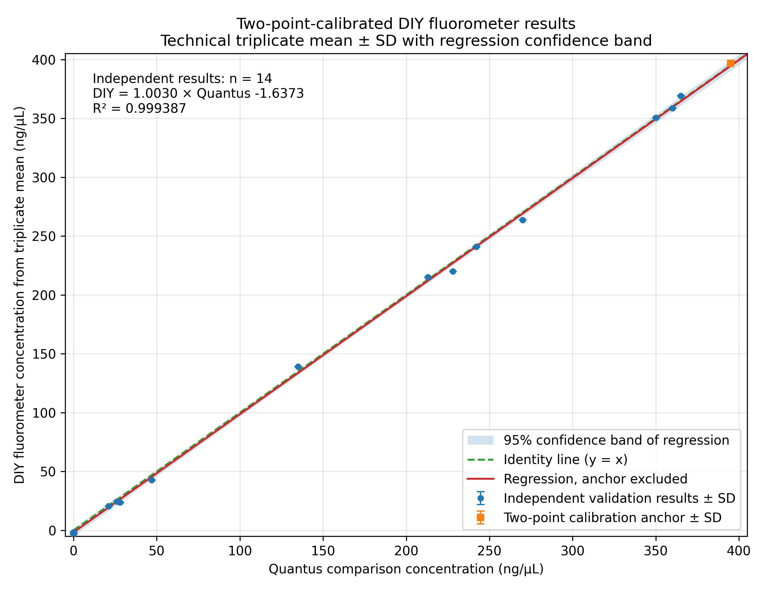
Two-point-calibrated DIY results compared with Quantus results. The square marks the upper calibration anchor excluded from the regression. Error bars describe the three technical sensor readings; the shaded band describes uncertainty of the fitted mean relationship.
High R² is not sufficient proof that a method is linear under all conditions. Inspect residuals and independently assigned concentrations during characterization. Technical repeats on one tube cannot substitute for independent assay preparations when evaluating preparation variability or lack of fit.
A plot of RFU against concentrations calculated from that same RFU and the same calibration equation is an arithmetic-consistency check. Its near-perfect fit is expected mathematically and is not independent evidence of analytical linearity.

11.4 Agreement with the comparison instrument
Measure | Rounded result and scope
Paired results excluding the upper calibration anchor | 14
Mean difference, DIY minus Quantus | Approximately −1.2 ng/µL
Mean absolute difference | 2.71 ng/µL
Root mean squared difference | 3.62 ng/µL
Mean absolute relative difference | 3.79%, for the subset with Quantus concentration at or above the primary LOQ
Approximate 95% limits of agreement | −8.14 to +5.83 ng/µL

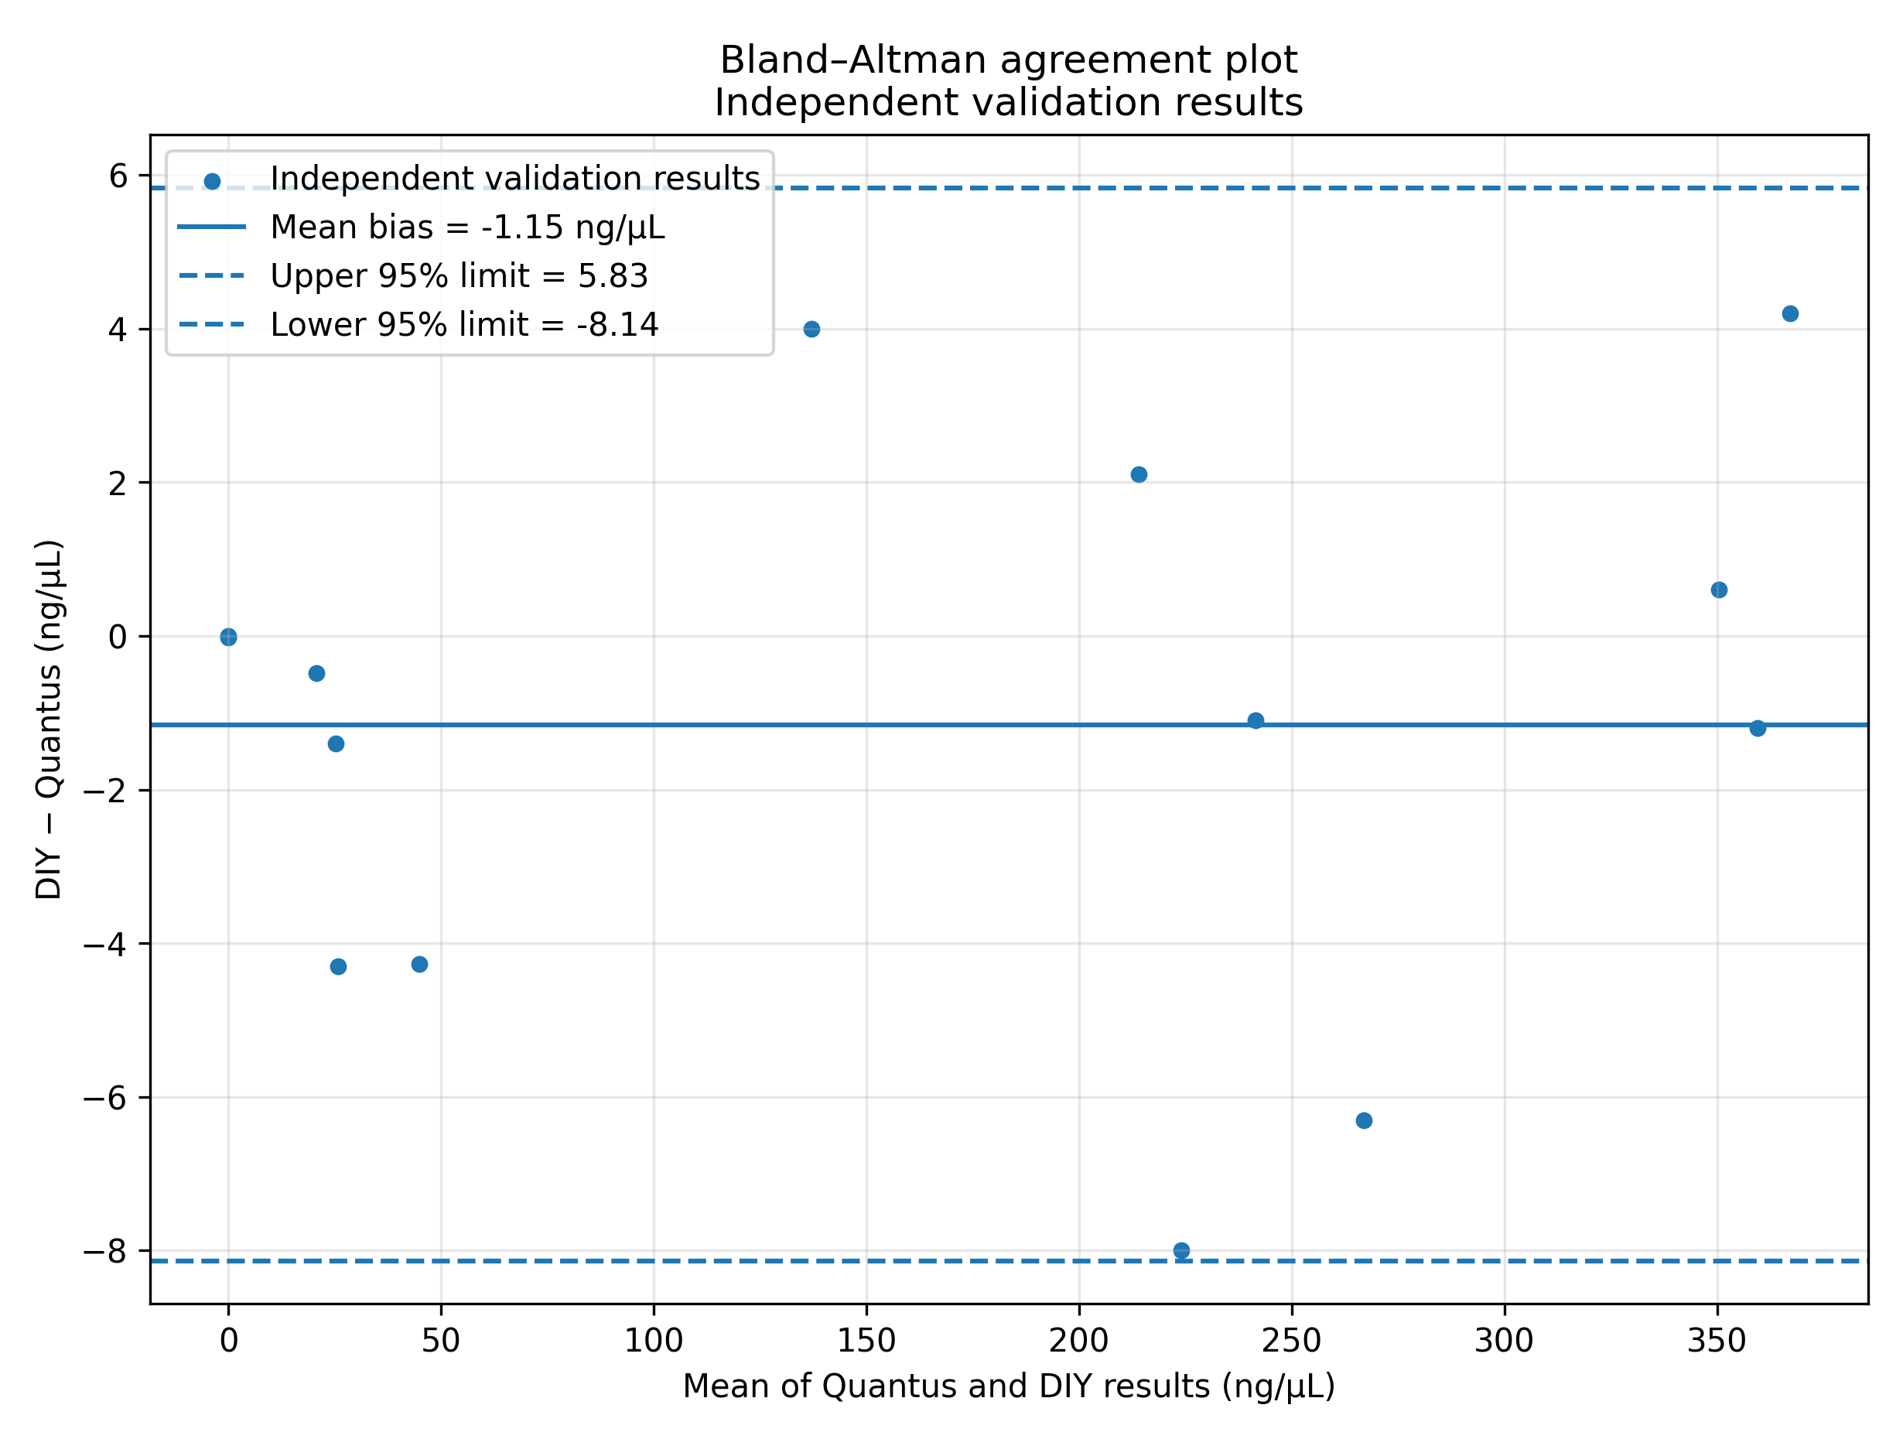
Bland–Altman comparison for the 14 paired results excluding the calibration anchor. Differences are plotted against the mean of the two instrument results. The dashed lines are approximate limits of agreement, not individual sample acceptance limits.
The 3.79% value is a mean absolute relative difference for the specified subset. It is not a universal maximum error, a confidence interval or a guaranteed accuracy specification for another instrument. The limits of agreement describe this dataset and should not be adopted automatically as QC limits.

11.5 Blank performance and low-level reporting
Ten independently prepared reagent blanks were each measured in one cycle of three sensor readings. The primary study reports a mean VIS signal of 9,557.563 counts and an SD of cycle means of 126.514 counts. The corresponding blank-based limits are:
Concentration basis | LOD estimate | LOQ estimate
Original DNA solution | 7.902 ng/µL | 23.946 ng/µL
Prepared assay using a 201-fold dilution | 0.03931 ng/µL | 0.11913 ng/µL

The concise operational values are approximately 8 ng/µL LOD and 24 ng/µL LOQ on the original-sample basis. They derive from the documented blank-based calculation and the evaluated calibration slope. They must not be transferred uncritically to another device or configuration.
Two further independent blank preparations were measured in eleven cycles each. Their confirmatory estimates were 7.027 and 21.294 ng/µL. These are 22 cycles on two preparations, not 22 independent blank preparations.
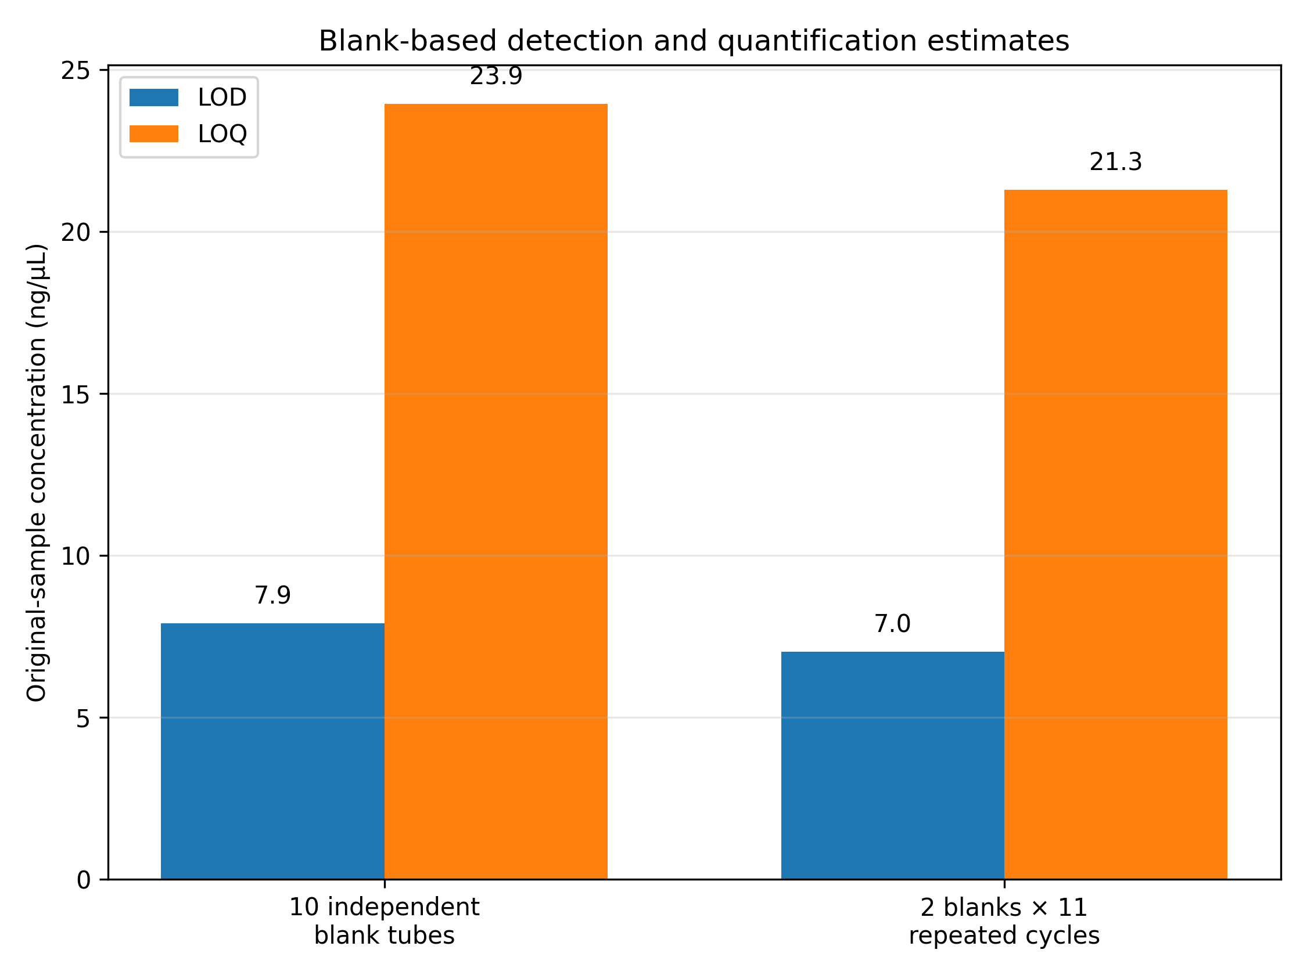
Existing primary and confirmatory blank-limit summaries. The different numbers of independent preparations are stated explicitly. These bars display precomputed estimates rather than a new recalculation from the raw blanks.
The blank-sigma estimates are distinct from a full calibration-curve limit calculation under DIN 32645. Identify the calculation method whenever reporting LOD or LOQ. A displayed limit is not evidence of preparation precision or acceptable recovery at that level.

11.6 Repeatability and practical range
Three consecutive readings within one cycle characterize short-term sensor repeatability. They do not include separate pipetting, extraction or sample variability. Use independently prepared tubes to assess assay precision.
The documented calibration interval is 0–400 ng/µL on the original-sample basis. Approximately 24–400 ng/µL is the quantitative reporting interval suggested by the primary LOQ, subject to blank, QC and other acceptance conditions. The blank endpoint remains part of calibration even though it is not a quantitative sample result.
Above-range or saturated samples need predilution and a new assay. Below-LOQ results need the stated qualified reporting category. Matrix effects, DNA fragment size, reagent condition, temperature, tube seating and optical changes may affect the response and require assessment for the intended application.

11.7 Evidence and reproduction files
Retain the paired comparison data, stored statistics, blank summary, technical-repeat summary and original measurement log.
The analysis script reproduces core comparison statistics and basic figures using the supplied requirements. It does not recalculate the blank limits from the original blanks or fully regenerate every annotated technical-repeat figure in this chapter. Preserve those additional preparation and figure-generation records when extending the characterization.

12 Maintenance and Troubleshooting
Start fault finding with sample identity, preparation, power, calibration state and mechanical fit. Preserve the original data and settings before changing hardware or reinstalling software. A correction that changes optics, assay conditions or blank state must be followed by the appropriate calibration and control checks.

12.1 Routine care
Remove the sample tube after use. Keep the optical compartment dry and free of dust, and inspect tube seating, filter retention, cables and the light shield before a batch. Wipe the exterior without allowing liquid into electronics or filter pockets.
Disconnect USB and the optional battery before opening the enclosure or moving boards. Handle filters by their edges and use suitable optical tissue or a clean optical blower. Do not scrape detector surfaces or use abrasive material on filter coatings. Check material and coating compatibility before using a cleaning solvent.
Keep boards supported and strain-relieve cables so connectors are not carrying mechanical loads. If a battery is swollen, damaged or unusually hot, take it out of service. Record maintenance that might change the measurement response.

12.2 Startup and connections
Observation | Checks | Action
Dark display or no startup | Power switch, USB supply, cable and optional battery | Test with a known-good USB data cable; inspect for a short with power disconnected before reinstalling software
No computer drive | Data-capable cable, USB port and reset mode | Confirm whether CIRCUITPY or the UF2 boot drive is intended
Boot drive appears during file maintenance | Reset double-click was too fast | Reset once and use the slower safe-mode sequence
Missing configuration or module | Root-directory layout and complete release contents | Back up the drive; repeat the documented clean installation if files are incomplete
TSL2591 not found | Upstream adapter, mux supply, downstream cable and detector connection | Inspect connections without power; restart after correction
Need exactly one TSL2591 | Number of matching sensors on scanned branches and configured channel | Restore the documented single-detector setup or correct the configured channel
LED board absent from I2C scan | Board is a fixed-current driver without an I2C address | This absence is expected; check supply and LED polarity if it remains dark
Fatal application error | Error type, stage and serial traceback | Record the error before resetting; correct the underlying cause

Do not hot-plug internal connectors. Confirm pin identity and supply polarity from the actual assembly and design records rather than wire colour alone. The unresolved cable/connector details in the build review require physical confirmation.

12.3 Signals and sample handling
Observation | Possible cause | Action
Blank changes with room light | Gap at tube opening, filter pocket, seam or cable exit | Check the closed optical path and refit the shield; recheck before calibration
Persistently saturated signal | Missing/displaced emission filter, light leak or excessive sample fluorescence | Inspect the optics; predilute the original sample when its concentration is above range
Low response from a known standard | LED polarity/supply, alignment, filter identity, detector position or reagent/preparation error | Verify the optical sequence, preparation and reference tube before changing gain
High within-cycle spread or drift | Bubbles, incomplete mixing, movement, changing temperature or unstable tube seating | Correct an identified cause and repeat; retain the earlier result
Tube sticks or shifts the module | Print debris, poor fit or damaged tube | Remove the obstruction or replace the part; do not force the tube
Unexpectedly high sample result | Identity error, contamination, wrong volume or incompatible calibration | Check records and make a fresh independently prepared assay
Negative blank-corrected estimate | Sample signal below the retained blank or baseline mismatch | Inspect the blank check and controls; retain the raw estimate and apply the reporting convention

The detector's FULL and IR channels contribute to the calculated VIS signal. Inspect all three when diagnosing unusual behavior. A small technical SD does not rule out wrong concentration, contamination or a preparation error.

12.4 Calibration and controls
Observation | Meaning or check | Action
Calibration disappears after START | Ordinary blank replacement invalidates the two-point model in RC2 | Repeat the complete two-point calibration if replacing the blank was intended
Stored two-point calibration should be retained | A fresh blank check is needed without replacing state | Measure the blank-check tube with A under a traceable ID and evaluate it with QC
PROV displayed | Historical/provisional multipoint state is active | Return to the intended routine two-point workflow; do not accept provisional model output as routine calibration
Standard signal invalid | Nonpositive or insufficient blank-corrected signal | Check standard identity, pipetting, reagent and optics; prepare and calibrate again
CV, SNR or SAT in calibration review | Firmware warning, even if saving is possible | Investigate and obtain an acceptable calibration/control before sample analysis
Independent control fails | Calibration, blank or assay conditions may be unsuitable | Hold affected results; investigate and repeat QC and the necessary calibration/assays
Limits unavailable after recalibration | New two-point calibration resets the saved blank-limit estimates | Establish suitable limits for that calibration or apply a documented accepted method boundary

Do not use the historical example slope or blank counts as universal pass/fail thresholds. Maintain control targets and acceptance intervals for the actual instrument and assay. A failed control is a reason to investigate, not a reason to widen its acceptance interval after measurement.

12.5 Files and data recovery
Observation | Check | Action
Concentrations display but CSV is unchanged | USB data-host connection at startup and logging setting | Restart on standalone power and verify newly saved test rows
Calibration save fails | Device write access and available storage | Back up data, restore the documented write arrangement and repeat calibration/save
Wrong sample names | Live-screen selection, configuration list and saved index | Select the correct ID before A; document any already mislabelled rows without overwriting evidence
CSV rows split into extra columns | Commas or line breaks in sample IDs | Use simple IDs without CSV separator/quote characters; preserve and document the damaged source file
Apparent time jumps | Runtime clock restarts or several sessions appended | Reconstruct sessions from batch notes; t_s is not UTC
Multipoint JSON rejected during development | Model label, field names and schema mismatch | Check the documented RC2 contract; v7.3 export is not directly compatible

Multipoint import is an optional development capability. It is not required to characterize a series in the Calibration Suite or to analyze routine samples with two-point calibration. Avoid changing unrelated configuration files to repair an import problem.

12.6 Return the instrument to service
1. Record the fault, affected batch interval, corrective work and any replaced part.
2. Recheck mechanical fit, optical shielding and the intended sensor settings.
3. Verify blank behavior and use the correct blank action for the calibration route.
4. Recalibrate after a change that invalidates the active calibration, and repeat relevant characterization for a new configuration.
5. Measure an independently prepared control and verify logging.
6. Resume reportable samples only when the applicable checks pass; repeat affected samples where required.
The screw schedule remains a deferred build task until the instrument can be inspected. Do not turn a provisional screw entry into a confirmed maintenance instruction without that check.

13 Alternative Assay with SYBR Safe
SYBR Safe provides a literature-based alternative to the QuantiFluor ONE assay. Anderson and colleagues describe its use for DNA quantification on DIYNAFLUOR in the supplied December 2024 preprint [R3]. This chapter gives that preparation method and the changes needed to evaluate it on the DIY QuantiFluorONE instrument. SYBR Safe has not yet been analytically verified on this instrument. Establish its working range, controls and limits before reporting routine concentrations.
Sample availability determines the aliquot. The 10 µL volume below belongs to the published DIYNAFLUOR reference procedure; it is not a minimum sample-volume requirement of this instrument. A smaller aliquot may be developed when sample is scarce. Its reagent preparation, calibration basis and reporting limits must be established for that volume. Do not increase sample consumption solely to reproduce the publication.
The manufacturer supplies SYBR Safe primarily as a gel stain [R4]. Its solution-based use here follows the DIYNAFLUOR research procedure. It is not an interchangeable replacement for ready-to-use ONE reagent, and the 1 µL plus 200 µL ONE protocol does not apply.

13.1 Why the existing optics suit SYBR Safe
The installed 485 nm LED, Ex470BP-40 excitation filter and Em532BP-40 emission filter are spectrally well matched to SYBR Safe. Retain this hardware for the first characterization series. An LED or filter replacement is an optimization option if measurements identify a problem, rather than a prerequisite for changing the assay.
DNA-bound SYBR Safe has excitation maxima near 280 nm and 502 nm and an emission maximum near 530 nm [R4]. The visible excitation band is broad enough for blue excitation: Thermo Fisher identifies 470 nm LEDs and 488 nm excitation as usable for visualization [R5]. The installed 485 nm LED therefore provides a suitable excitation wavelength in principle. The overlap of its actual spectrum with the excitation filter and dye absorption determines the useful excitation intensity; proximity to the absorption maximum alone does not quantify efficiency.
Ex470BP-40 has a nominal centre of 470 nm and a nominal 40 nm bandwidth, commonly expressed as approximately 450–490 nm. It transmits the blue excitation band while reducing longer-wavelength LED output. Those limits describe a passband, not a guarantee of zero transmission above 490 nm. Filter edges are gradual; transmission at 485 nm and blocking in the fluorescence band matter for actual performance.
Em532BP-40 has a nominal centre of 532 nm and a 40 nm bandwidth, giving nominal half-maximum edges near 512 and 552 nm. The 530 nm emission maximum lies close to its centre, only 2 nm away. This is a strong spectral reason to retain the installed emission filter. The project's normalized measurements report approximate half-maximum intervals of 450–490 nm for the excitation specimen and 518–555 nm for the emission specimen. These measurements check band position and shape, rather than absolute transmission or out-of-band blocking. See the excitation-filter record and emission-filter record.
The nominal separation between 490 nm and 512 nm is 22 nm. This separation supports rejection of excitation light, together with the 90° geometry and light shield. It does not ensure that no scattered LED light reaches the detector. Residual background depends on filter blocking, spectral tails, reflections and light leaks and must be checked with the matched assay blank.
Component | Reason to retain it | Change only if measurements indicate a need
485 nm radial LED | Lies within the usable blue excitation region | Check preparation, alignment and output before trying another blue LED
Ex470BP-40 | Passes blue excitation and reduces longer-wavelength LED output | Assess useful throughput and residual excitation leakage
Em532BP-40 | Detection band includes the 530 nm fluorescence maximum near its centre | Assess blocking and blank-corrected response before changing the band
LED board and holder | Preserve the documented current and optical geometry | A substitute must match current, polarity, LED position and mechanical fit

The published DIYNAFLUOR uses a 470 nm LED with 470 ± 15 nm excitation and 525 ± 15 nm emission filters [R3]. Both instruments use nominal 90° fluorescence detection, but their holders, optical distances and illumination and collection arrangements differ. The source, filter bands and geometry together determine background and response. This provides a comparison configuration, not evidence that its components improve this instrument or that its sensitivity transfers unchanged. Do not choose a 502 nm LED merely to match the absorption maximum: the existing excitation filter can attenuate it and excitation rejection becomes more demanding. A preassembled LED board remains an option under the compatibility checks in Chapter 4. Optical changes require renewed characterization and calibration.

13.2 Materials and published dye preparation
Use the 10,000X SYBR Safe concentrate, such as the DMSO concentrate described in the manufacturer's guide, rather than a ready-to-use gel-staining solution [R4]. Use LTE buffer with 10 mM Tris and 0.1 mM EDTA at pH 8.0, and suitable thin-walled 0.5 mL PCR tubes. The publication used Axygen tubes; adopting the documented E4941 tube on this instrument is a transfer choice that requires checking.
The published preparation [R3] has two dilution stages:
1. Dilute the 10,000X concentrate 1:50 in LTE to obtain a 200X dye stock. For example, combine 2 µL concentrate with 98 µL LTE; mix thoroughly.
2. For the master mix, combine 1 µL of the 200X stock with 199 µL LTE per nominal preparation unit. Scale volumes together for the complete batch and allow for pipetting losses.
3. Dispense 190 µL master mix per assay tube, then add 10 µL DNA solution or blank buffer.
The stated dilution sequence gives 1X dye in the master mix and approximately 0.95X after the 190 µL portion receives 10 µL DNA solution. These factors are calculated from the published volumes; do not silently replace the sequence with a different dye concentration.
Prepare dye stocks and master mix with traceable labels and protection from light. Follow the manufacturer's instructions for the purchased concentrate and establish any holding time for diluted solutions before using stored mixtures. Apply Chapter 2 to reagent handling, sample hazards and disposal; the product name does not remove the need for appropriate precautions.
A 10 ng/µL high-standard solution can be prepared from the confirmed 400 ng/µL ONE lambda DNA stock by mixing 5 µL stock with 195 µL LTE, giving 200 µL total. This substitutes the stock source used in the publication; record that choice and verify the transferred assay. Prepare controls separately.

13.3 Published tube preparation and measurement timing
Tube | Master mix | Added solution | Purpose
Calibration blank | 190 µL | 10 µL LTE | Zero-DNA endpoint with matched final volume
High standard | 190 µL | 10 µL lambda DNA at 10 ng/µL in LTE | 100 ng DNA in 200 µL; 0.5 ng/µL in assay
Independent control | 190 µL | 10 µL independently prepared control in the selected range | Check recovery without using the calibration anchor alone
Unknown | 190 µL | 10 µL sample or recorded predilution | Determine concentration after method verification

Mix by vortexing, briefly centrifuge to collect liquid and remove bubbles, and incubate for 1 minute at room temperature before measuring, following the publication [R3]. Keep timing, tube seating and light protection consistent. This differs from the five-minute ONE procedure. A fresh SYBR Safe blank contains both dye master mix and 10 µL LTE; do not use the ONE blank preparation for this assay.

13.4 Configuration for the published reference procedure
The published 10 µL aliquot gives a total-volume-to-sample-volume factor of 20, compared with 201 for the ONE method. The high-standard setting is 10 ng/µL on the original-solution basis, corresponding to 100 ng DNA and 0.5 ng/µL in the assay. Do not choose 400 ng/µL or reuse the ONE slope.
RC2 reads assay metadata from quantifluorone_config.json. Source inspection identifies the following settings for a transfer trial. They are a configuration specification, not an already qualified SYBR Safe software release.
Setting in the assay object | Value for this preparation
name | SYBR Safe DNA assay
sample_volume_uL | 10.0
reagent_volume_uL | 190.0
total_volume_uL | 200.0
dilution_factor | 20.0
reported_concentration_basis | original_sample

Back up the entire ONE configuration, calibration, state and log before a transfer trial. Use the file-maintenance procedure in Chapter 6, identify the SYBR Safe installation clearly, and remove the old operational calibration and blank state before establishing the new assay. Configuration edits do not convert a saved ONE calibration. Restart so the application reads the intended settings; confirm the actual installed files and archived record.
The supplied standard selection list includes 10 ng/µL. After characterizing the new assay, use the on-device two-point dialog with the matched SYBR Safe blank and the 10 ng/µL high-standard solution. Check the saved calibration's standard concentration, slope, range and dilution factor of 20, then verify a separately prepared control and file persistence. RC2 reuses the identifier QF1-2PT and retains ONE branding; neither uniquely identifies this dye. Keep separate dated assay archives and do not rely on the screen banner to distinguish configurations.
Under this calibration, the principal concentration is the DNA solution concentration before assay addition. The in-assay value is that result divided by 20. For example, 4 ng/µL original solution corresponds to 0.2 ng/µL in the assay. Apply an additional factor only for a deliberate sample predilution. When returning to ONE, restore its matching configuration and establish or verify its matching calibration and blank; do not mix assay records.

13.5 Adaptation when sample volume is limited
The published 10 µL procedure is a reproducible reference, not the only possible assay design. A smaller aliquot, for example 1 µL if it can be pipetted reliably, can be investigated while retaining a liquid volume compatible with the optical holder. This is an adaptation to develop and characterize, not an already verified low-volume protocol.
Choose the sample and master-mix volumes explicitly and control the final dye concentration, buffer composition, mixing and incubation. Merely changing 10 µL to 1 µL changes DNA mass input and can also change assay chemistry. Prepare blanks, standards, controls and unknowns with the chosen matching volumes. Perform initial characterization and establish a fresh two-point calibration for that procedure.
Calculate the assay dilution factor as total assay volume divided by sample volume and enter the actual values in the configuration. The factor 20 and the settings table above apply only to the published 10 µL in 200 µL preparation. Do not reuse those settings for a smaller aliquot. Report original-sample and in-assay limits separately. Where the sample is sufficient, larger aliquots can be evaluated as an option; they are not assumed for routine use.

13.6 Verification before routine use
Evaluate a concentration series on the actual optical configuration, including independently prepared low-level samples and controls. Assess blank variation, recovery, residuals, response stability, saturation and sample-matrix effects. Keep gain, integration time, tube type and assay volumes fixed. If the Calibration Suite is used for characterization, verify its reference-value basis explicitly: its concentration parser multiplies concentration by the entered sample volume. With a 10 µL aliquot, mass and concentration are no longer numerically equal as they are in the 1 µL ONE procedure.
For the literature's 20-fold assay dilution, 0.5 ng/µL in-assay corresponds to 10 ng/µL in the original solution. The preprint reports in-assay LOD and LOQ estimates of 0.014 and 0.048 ng/µL, respectively [R3]. These are DIYNAFLUOR results, not limits established for this device. Do not adopt them as reporting thresholds here.
Sensitivity and application scope must be measured on this instrument. The ONE configuration has a 0–400 ng/µL calibration interval and a blank-based LOD near 8 ng/µL on the original-solution basis, equivalent to about 0.04 ng/µL in the assay. A higher SYBR Safe LOD cannot be inferred from the dye name or from DIYNAFLUOR results obtained with different optics and geometry. Compare limits on the same concentration basis and at the actual sample volume. Suitability for laboratory or eDNA samples depends on concentration, matrix and the required quantification limit; calibration alone does not establish sufficient sensitivity.
SYBR Safe can also respond to RNA [R4]. The RNA-spiking result in the preprint does not establish universal selectivity in arbitrary extracts. Where RNA or extraction reagents may contribute, assess their effect and any sample treatment separately. Once the procedure is accepted, use its own two-point calibration, controls and limits in the routine workflow. Retain raw signals and preparation records so a change of dye remains traceable.

14 References Design Sources and Acknowledgements
This chapter identifies the assay instructions, scientific literature, design sources and project records supporting the manual. References R1–R5 distinguish the established ONE procedure from the literature-based SYBR Safe transfer. Hardware and software source links identify upstream projects; the adjacent repository records preserve the versions and licences supplied with this build.

14.1 Assays and scientific literature
R1. Promega Corporation. QuantiFluor ONE dsDNA System Technical Manual, TM405, revised October 2022. Sections 1–3 cover assay properties, the 400 µg/mL lambda DNA standard and single-tube preparation; Section 7 covers handling and disposal. This is the supplied ONE protocol used in Chapters 2, 3, 8 and 9. Manufacturer protocol.
R2. Promega Corporation. Quantus Fluorometer Operating Manual, TM396, revised November 2024. Describes the commercial comparison instrument and its manufacturer-defined operation. Its instructions do not replace the DIY firmware controls. Manufacturer manual.
R3. Anderson W, Antaw F, Kenny S, Rupani H, Khamis R, Constantin N, Kumar V, Gemmell A, Bell C, Trau M and Korbie D. DIYNAFLUOR: An Affordable DIY Plug-and-Play Nucleic Acid Fluorometer for eDNA Quantification in Resource Limited Settings. bioRxiv preprint, version posted 16 December 2024. DOI 10.1101/2024.12.16.626200. The supplied version was not certified by peer review. Its Low Cost SYBR Safe Assays methods section supplies the preparation in Chapter 13; its results describe DIYNAFLUOR performance. This manual summarizes the method and does not reproduce or adapt the preprint's figures.
R4. Thermo Fisher Scientific. SYBR Safe DNA Gel Stain User Guide, MAN0002338, MP33100, revision A.0. Documents product formulations, DNA-bound excitation and emission, handling and gel-staining applications. It does not establish performance of the solution assay on this device. Manufacturer guide. Accessed 23 October 2026.
R5. Thermo Fisher Scientific. SYBR Safe DNA Gel Stain Frequently Asked Questions. Identifies usable blue excitation wavelengths and discusses optical filters for visualization. These are spectral design inputs, not a quantitative instrument qualification. Manufacturer FAQs. Accessed 23 October 2026.
R6. Lakowicz JR. Principles of Fluorescence Spectroscopy, third edition. Springer, 2006. DOI 10.1007/978-0-387-46312-4. General fluorescence theory and instrumental effects.
R7. Valeur B and Berberan-Santos MN. Molecular Fluorescence: Principles and Applications, second edition. Wiley-VCH, 2012. DOI 10.1002/9783527650002. General fluorescence mechanisms and measurement principles.
R8. Singer VL, Jones LJ, Yue ST and Haugland RP. Characterization of PicoGreen Reagent and Development of a Fluorescence-Based Solution Assay for Double-Stranded DNA Quantitation. Analytical Biochemistry 249, 228–238, 1997. DOI 10.1006/abio.1997.2177. Background on dye-based dsDNA quantification; this is not the ONE or SYBR Safe operating protocol.

14.2 Calibration and limit references
R9. DIN 38402-51:2017-05. German standard methods for the examination of water, waste water and sludge — General information — Part 51: Calibration of analytical methods — Linear calibration A 51. DOI 10.31030/2657448.
R10. DIN 32645:2008-11. Chemical analysis — Decision limit, detection limit and determination limit under repeatability conditions — Terms, methods, evaluation. DOI 10.31030/1465413.
These editions are methodological references used in the project. A statement of conformity requires assessment against the applicable licensed normative text. The RC2 ten-blank screening estimates and the Calibration Suite's separate calibration-curve calculations must be identified by their actual methods, as explained in Chapters 8–11.

14.3 Open hardware and software
R11. ioRodeo. Open Colorimeter Plus firmware. Technical basis for the controller software architecture and open optical-instrument approach.
R12. ioRodeo. Fixed-current radial 16 mA LED board revision ver_0p1_rev_3. The installed revision, with the wavelength-specific radial LED mounted on the rear side for integration. Local design and assembly records include KiCad, Gerber, drill, BOM and placement files, and the supplied CC BY 4.0 licence. An addressable I2C LED-driver variant is not the installed board.
R13. ioRodeo. Fluorometer tube holder. Mechanical design reference contributing to the holder development.
R14. Trau Lab. DIYNAFLUOR repository. Code, mechanical files, bill of materials and build instructions accompanying the fluorometer concept described in R3. The present design adapts the optical concept for the installed board, filters, tube and PyBadge enclosure.
R15. Adafruit Industries. PyBadge product 4200, TSL2591 product 1980 and PCA9546 product 5664. Controller, detector and bus multiplexer. PyBadge design records identify supplied controller files and upstream provenance.
R16. Adafruit Industries and CircuitPython contributors. CircuitPython for PyBadge. The documented project runtime is 9.1.1. Use the archived installation files and checksums in Chapter 6 rather than assuming a newer runtime is interchangeable.
R17. SparkFun Electronics. Qwiic to Grove adapter PRT-15109. Adapter identification. Verify actual pin correspondence as required by the cable-map review.
R18. Wright L. PySpectrometer2. Basis of the project spectrometer used to check filter passband positions. The project's normalized curves are not absolute transmittance calibrations.
R19. Neemoo. Ex470BP-40 and Em532BP-40 band-pass filters. Recorded supplier listing. Supplier pages can change; retain the purchased filter identity and project measurement records. Procurement identification is not an independent optical certification.

14.4 Project software and analytical records
R20. Birkicht M. DIY QuantiFluorONE dsDNA Fluorometer repository. Hardware integration, modified mechanical designs, firmware, calibration tools, documentation and measurement records. The source inspection for this manual began at commit e9de6b394860beec91f53efd38cc55459f0cb216; this manual incorporates the subsequent editorial corrections described in the project review registers.
R21. ZoidTechnology. Torch-Bearer-Tools. GPL-3.0 tools: Flameeye Android patcher and Python serial interface. This licence does not establish redistribution rights for the separate manufacturer application.
R22. Birkicht M. Modified Torch-Bearer-Tools repository. Fork with Y2 Android corrections and Windows acquisition and spectral export. The author reports successful LED measurements with this software route.
The RC2 release archive, software checksums and Calibration Suite notes define the documented software context. The release archive is preserved unchanged. Multipoint JSON compatibility limitations do not prevent routine two-point analysis or off-device characterization.
Chapter 11 links the paired Quantus comparison data, stored statistics, blank summaries and original logs. Preserve these records together with their preparation and calibration context. Published figures are summaries of the tested configuration and do not replace raw data or establish equivalent performance for another device.
The hardware file index maps CAD and PCB files to their repository paths. The bibliography, hardware sources, source register and standards register provide machine-readable or supporting provenance.

14.5 Additional option for LED spectra
Alongside PySpectrometer2 [R18], the Torch Bearer Y2 spectrometer can measure excitation LED spectra using the ZoidTechnology tools [R21] and Matthias Birkicht’s modified fork [R22]. Follow the respective Android-patcher or Python/Windows instructions in those repositories. Record LED identity, drive current, optical arrangement, exposure, software version and applied calibration; avoid saturation and retain the spectral export.
The original Android application can be obtained from the archived manufacturer download dated 3 April 2025. Check that the downloaded APK is the Flameeye version 1.6.4 required by the upstream patcher before patching. This is a download reference, not permission to redistribute the manufacturer application.
This option supports checking the LED peak and filter overlap. It is based on the author’s practical experience; it does not replace the existing filter records or establish absolute transmission, blocking or fluorometer sensitivity.

14.6 Engineering contributions and acknowledgements
Dipl.-Ing. Matthias Birkicht, Centre for Tropical Marine Research, developed the project integration and documentation. The modified printed parts and their mechanical integration were developed collaboratively with Florian Bock, 3D-Haven, Bremerhaven, Germany. Adaptations accommodate the installed filters, detector, rear-mounted LED board and PyBadge enclosure.
The project acknowledges the developers and contributors of ioRodeo, DIYNAFLUOR, Adafruit, CircuitPython, PySpectrometer2 and ZoidTechnology. Joanne Long of ioRodeo donated a fluorometric holder for 0.2 mL tubes for comparative investigations of the Open Colorimeter Plus. That donated holder is distinct from the E4941 holder used in the documented configuration. Thanks are also due to Florian Bock for the collaborative mechanical development.

14.7 Licences and redistribution
The repository's MIT licence accompanies the project's software and associated documentation. Keep the third-party notices, upstream licence files, source records and binary checksums with redistributed material. Imported hardware designs and other third-party content retain their own supplied terms; the repository-level licence does not replace those notices. Product names identify the components used and do not imply manufacturer endorsement.

