**TAD**

**TOC**

Contents

**TAD** 1

**TOC** 1

**About** 1

**Metrics** 1

**Demo setup** 2

**The results** 4

**General feedback** 4

**IS1** 4

**IS2** 5

**IS3** 6

**An external example** 7

**Conclusion** 8

**More information** 8

**About**

The Transformation Advisor tool (TA for short) is a program that comes with the ACE v11 and v12 installation.

It takes your old (v10) sources, launches a standalone container, deploys the sources and matches the result against a set of rules, to determine if any actions need to be taken before migrating to ACE.

At the end of the report, you *should* also get a rough estimate on how long it should take you to mitigate complex issues (however, this estimate did not show up in my demo but that might be because I did not have any red severities)

Remember that TA will compare your setup to a container setup. If you plan on running node-managed, a lot of the suggestions don't apply but they are interesting should you consider using the containers/cloud setup.

Since the TA needs to start from your v10 sources, you have 2 options

* Backup the existing v10 node and supply the backup file
* Create a bar file with flows/applications you want to check

The most useful scenario would be to start from a backup of the current running system, and that is what I did in the demo.

**Metrics**

The TA tool collects and assesses the supplied data and pours the result into an html report.

TA uses 2 metrics to weigh any issues it finds: Complexity and Severity Classification.

|  |  |
| --- | --- |
| **Complexity** | **Action** |
| Simple | Admin change is required. |
| Moderate | Development change is required. |
| Complex | Difficult development task or an alternative strategy is required. |

|  |  |
| --- | --- |
| **Severity Classification** | **Action** |
| GREEN (INFO) | No immediate action is required, but you might want to be aware. |
| YELLOW (WARNING) | Immediate action is probably required or advised before you proceed. |
| RED (ERROR) | You cannot proceed without taking remedial action. |

These two combined determine the overall complexity and actions you need to take.

**Demo setup**

I've created a demo setup with some nodes and configurations that requires some attention when moving to ACE.

The demo consists of 3 Integration Servers with a mix of:

* MQ publication node
* MQ bindings connections
* Local FileInput
* Standalone resources
* Non-dynamic policies
* MRM
* Timeout node
* Java compute with user defined configurable server

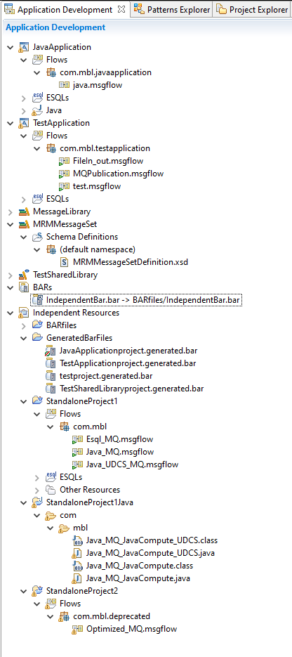

**The results**

As expected, I got feedback from the TAD that some changes were advised before moving to ACE.

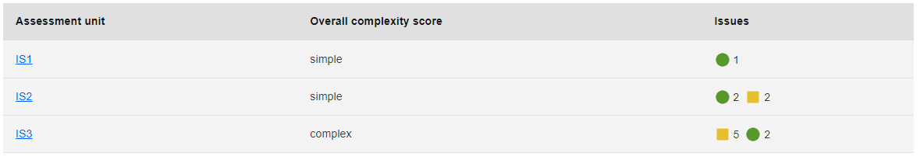

**General feedback**

TA gives you the target it checked against (this is always the same)

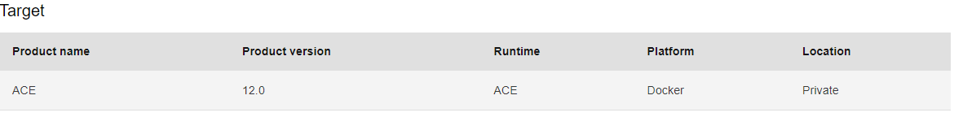

**IS1**

For IS1, no actions were required however I got a suggestion



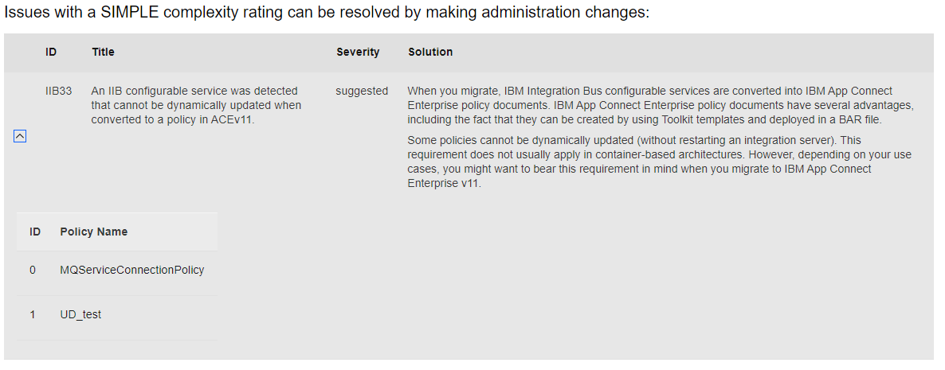

This states the obvious limitations that have to do with non-dynamic policies. Do keep in mind that configurable services are defined node in IIB v10, so you will get this suggestion for all integration servers if one or more non-dynamic policies are present.

Since ACE v12.0.3.0, you can deploy non-dynamic policies whilst triggering an application restart directly from the deploy command. In ACE v11 you can just overwrite the policies directly on disk and restart the IS to circumvent the deployment issue.

No real actions are needed here.

**IS2**

For IS2, there are some potential issues and some suggestions:



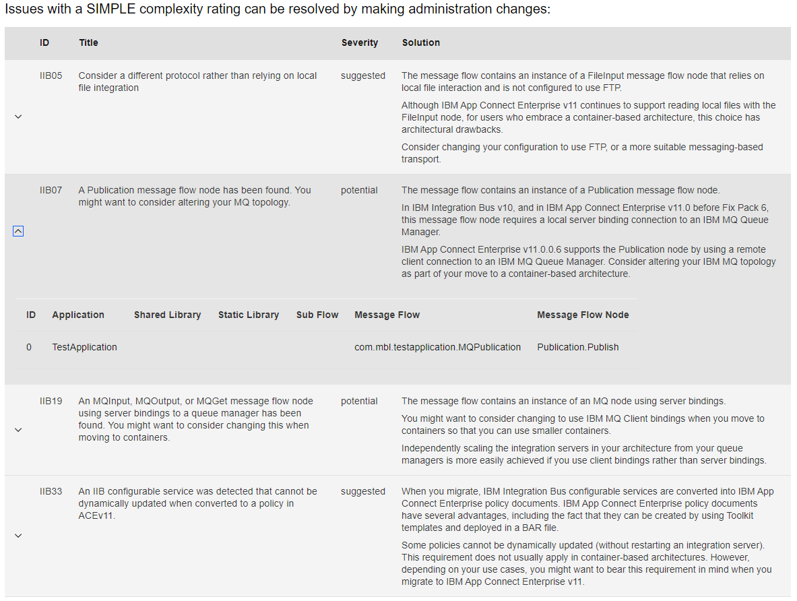

Again, no real issues here, the potential issues have to do with the QMGR in binding mode.

The suggestions handle with a local file read and with the non-dynamic policy.

If you migrate this setup to a node managed integration server with a local QMGR, no actions are required.

**IS3**

IS3 is the more complex one, it is here that I dumped the standalone message flows and the MRM message set.

You have your standard simple issues/suggestions

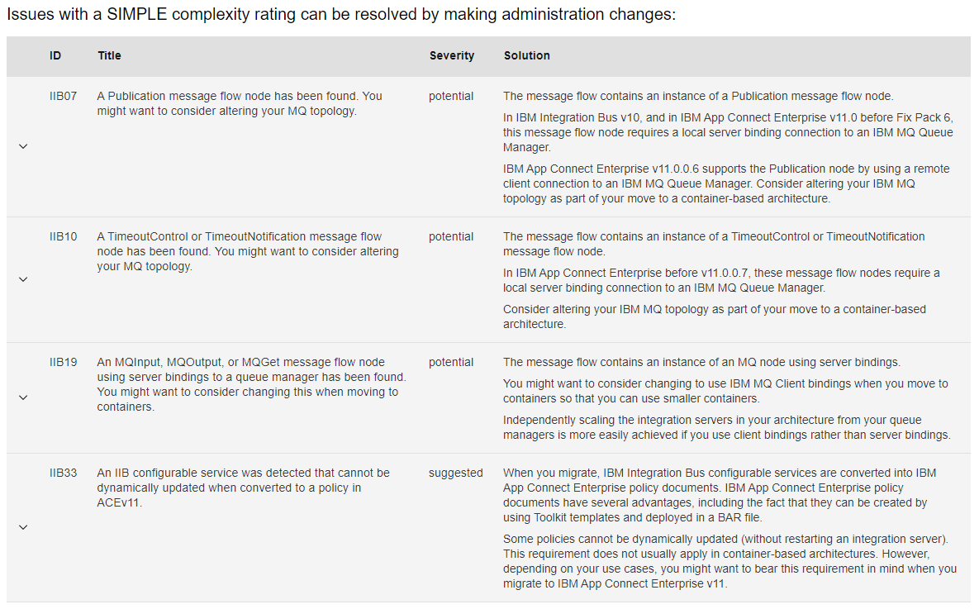

But here we also have a moderate and complex topics

The moderate topics handle the standalone message flows and the need to put them inside an application (or the default application)

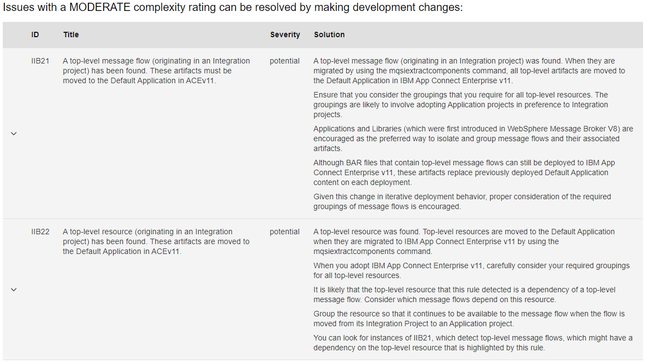

The complex topic handles the MRM, stating that DFDL is the future. MRM is still supported in ACE but not in shared libraries anymore.

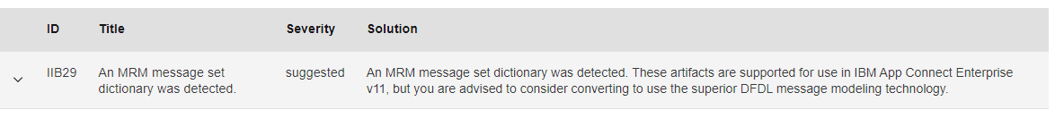

One thing I am missing here is my java compute node that calls a user defined configurable service. In ACE the code to call a UDP has changed, so it is a shame that part is not showing here.

**An external example**

Just to show you what a RED severity looks like, on the IBM documentation page there is the output for a .Net node, stating that this is not supported in containers.

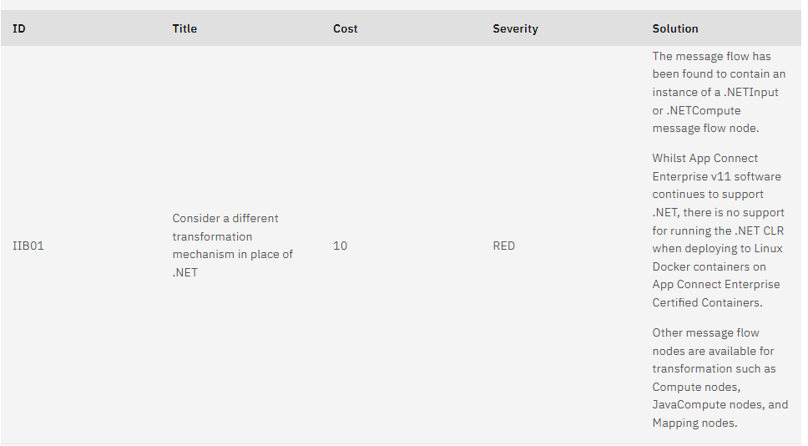

**Conclusion**

Is the output from the Transformation advisor to be considered as your go-to oracle? No.

However, let me refine and explain that "No".

Depending on how you plan on using your ACE installation, some of these issues are important. For containers or cloud a lot of these do make sense and need to be handles. If you keep running node-managed, most of the issues can be ignored and can be considered as warnings or good-to-know.

If you run an extract migration, you can also get the RED and COMPLEX issues from the log and output files, but they won't be as nicely formatted.

In my opinion this still is a nice tool for a quick environment analysis.

And it pretty prints and organizes the issues for less tech savvy people.

**More information**

Running the Transformation Advisor tool: <https://www.ibm.com/docs/en/app-connect/11.0.0?topic=tasks-running-transformation-advisor-tool>

Rules for the Transformation Advisor tool: <https://www.ibm.com/docs/en/app-connect/11.0.0?topic=tasks-rules-transformation-advisor-tool>

The demo and output used and generated above :

<<TADOutput.7z>>

<<Demo.zip>>