Crisp POS — Application Documentation
Comprehensive guide to the Crisp POS system
Generated: Wednesday 13 May 2026

1. Application Overview
Crisp POS is an Electron-based point-of-sale system designed for retail shops. It runs as a desktop application on Windows, with a local SQLite database, optional cloud sync via Supabase, and LAN multi-register support.

Key Features:
- Full POS register with barcode scanning, weighted products, and multi-payment support
- Admin panel with 8+ management tabs
- Offline-first architecture — works without internet
- LAN sync for multi-register deployments (server/client model)
- Cloud sync via Supabase for backup and remote management
- ESC/POS receipt printing and cash drawer control
- Price tag / label designer and printer
- Linkly EFTPOS terminal integration

Tech Stack:
- Electron v33.2.0 (Chromium + Node.js desktop app)
- sql.js v1.11+ (SQLite via WebAssembly)
- Vanilla JS + HTML — no build step, no framework
- IPC bridge via contextBridge/ipcRenderer

2. POS Register Screen
The main register screen (pos/index.html) is the cashier-facing interface used during daily operations. It occupies the full screen in kiosk mode.

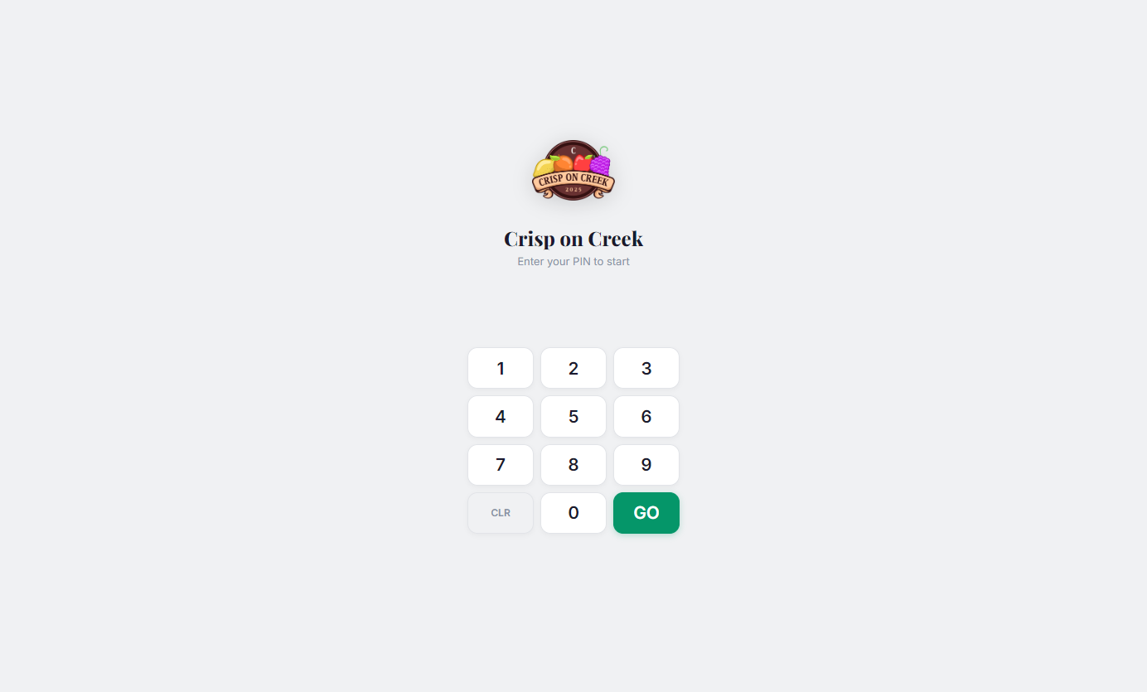
Figure 1: POS Register — Login screen with PIN pad

2.1 Layout
- Login Overlay — Full-screen PIN login (visible until staff authenticates)
- Status Bar — Store name, barcode input field, staff badge, sync indicator, health dots
- Cart Panel (300px sidebar) — Current sale items, totals, Pay Cash / Card / Park buttons
- Keyboard Panel — Register function buttons, department buttons, numpad with LED display
- Bottom Bar — Navigation buttons loaded from database
- Footer — Lane ID and clerk name

2.2 Transaction Flow
- 1. Staff logs in via PIN pad
- 2. Items added via barcode scan, PLU code, or keyboard buttons
- 3. Weighted products (kg/100g) trigger a weight entry modal
- 4. Quantity multiplier via numpad: type number, press QTY X
- 5. Open-price items: cashier enters price in cents
- 6. Subtotal → Cash modal with quick-tender buttons ($5/$10/$20/$50/$100)
- 7. Payment confirmed → receipt prints, drawer opens, sale completes

2.3 Register Functions
Button | Function
VOID / ERROR CORRECT | Remove last item from cart
HOLD SALE | Park current cart (retrieve later with RECALL)
NO SALE / MOVE DRAWER | Open cash drawer without a sale
PRICE CHECK | View/change price of last item
RECALL SALE | Restore a previously parked transaction
LOCK | Lock register, show PIN login overlay
SUPERVISOR | Prompt for manager PIN, enables elevated access for 60s
REPRINT | Reprint last completed receipt
RETURN | Toggle return mode (items scan as negative)
% DISCOUNT | Percentage off whole sale
% ONE ITEM | Percentage off last item only
UBER EATS ADJ | Add 30% markup to current sale

2.4 Keyboard Shortcuts
- F1 — Focus barcode input
- F2 — Open cash payment modal
- F3 — Card/EFTPOS payment
- F4 — Clear cart
- F11 — Toggle fullscreen/kiosk mode
- Escape — Close modals or pop section

3. Admin Panel
The admin panel (pos/admin.html) provides management tools organized into a sidebar-navigated interface with a dark theme. It includes Dashboard, Products, Deals, Price Tags, Transactions, Cash & Close, Staff, Keyboard, and Settings tabs.

3.1 Dashboard
Displays daily sales summary with date navigation including prev/next/today buttons, date picker, and quick presets (Yesterday, This Week).
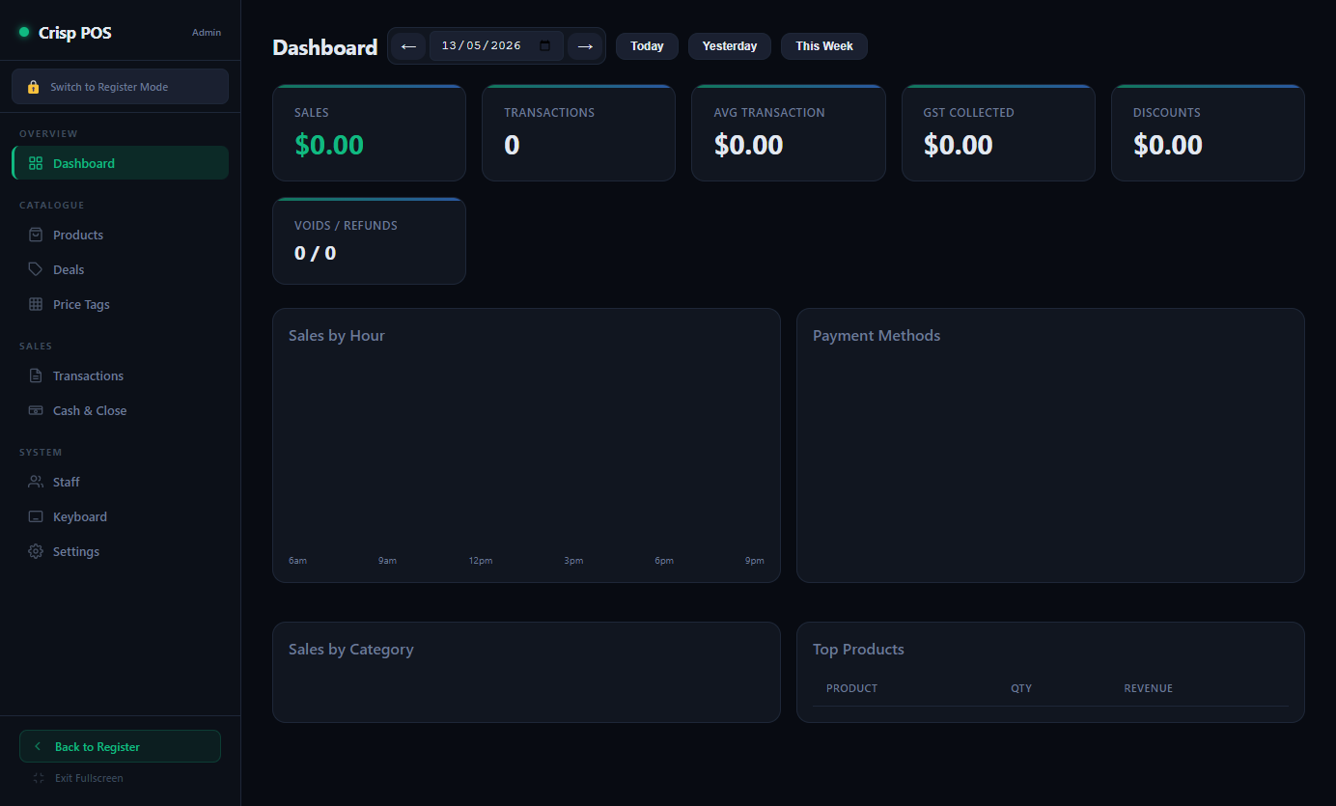
Figure 2: Admin Dashboard — Daily sales summary with charts

- 6 stat cards: Sales, Transactions, Avg Transaction, GST Collected, Discounts, Voids/Refunds
- Sales by Hour — bar chart showing hourly transaction volume
- Payment Methods — breakdown with percentage bars (cash, card, eftpos, account)
- Sales by Category — top 10 categories by revenue
- Top Products — table of top 20 products by quantity sold

3.2 Products
Three sub-tabs: Categories, All Products, and Stock.
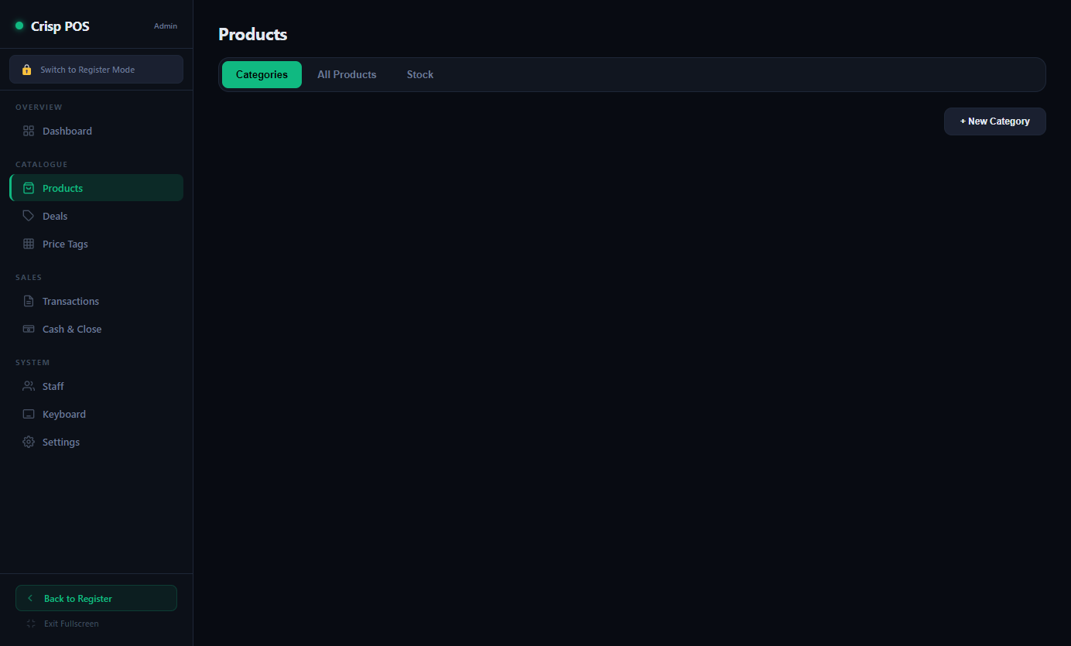
Figure 3: Admin Products — Category management view

Categories Sub-tab:
- Card-based grid view showing all categories with product counts
- Click a category to drill into its products
- Inline category editor for name, colour, and sort order

All Products Sub-tab:
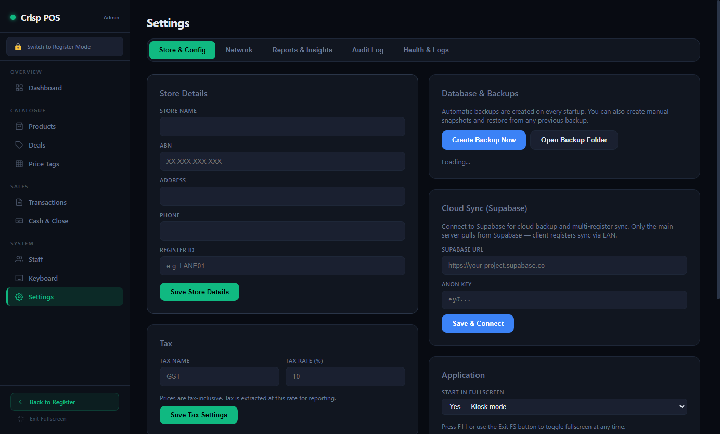
Figure 4: Admin Products — All Products list with search and filters

- Searchable table with filters: category, unit type, sort order
- Columns: Name, Barcode, Category, Price, Unit, Stock
- Click to edit — modal with all product fields including margin calculator
- Duplicate button to clone products
- Soft-delete (sets active=0)

Stock Sub-tab:
- Low stock alerts for products with stock tracking enabled
- Quick adjust buttons: +10, +25, +50

3.3 Deals
Multi-buy pricing management (e.g., "2 for $4", "3 for $10") with status filtering and quick toggle.
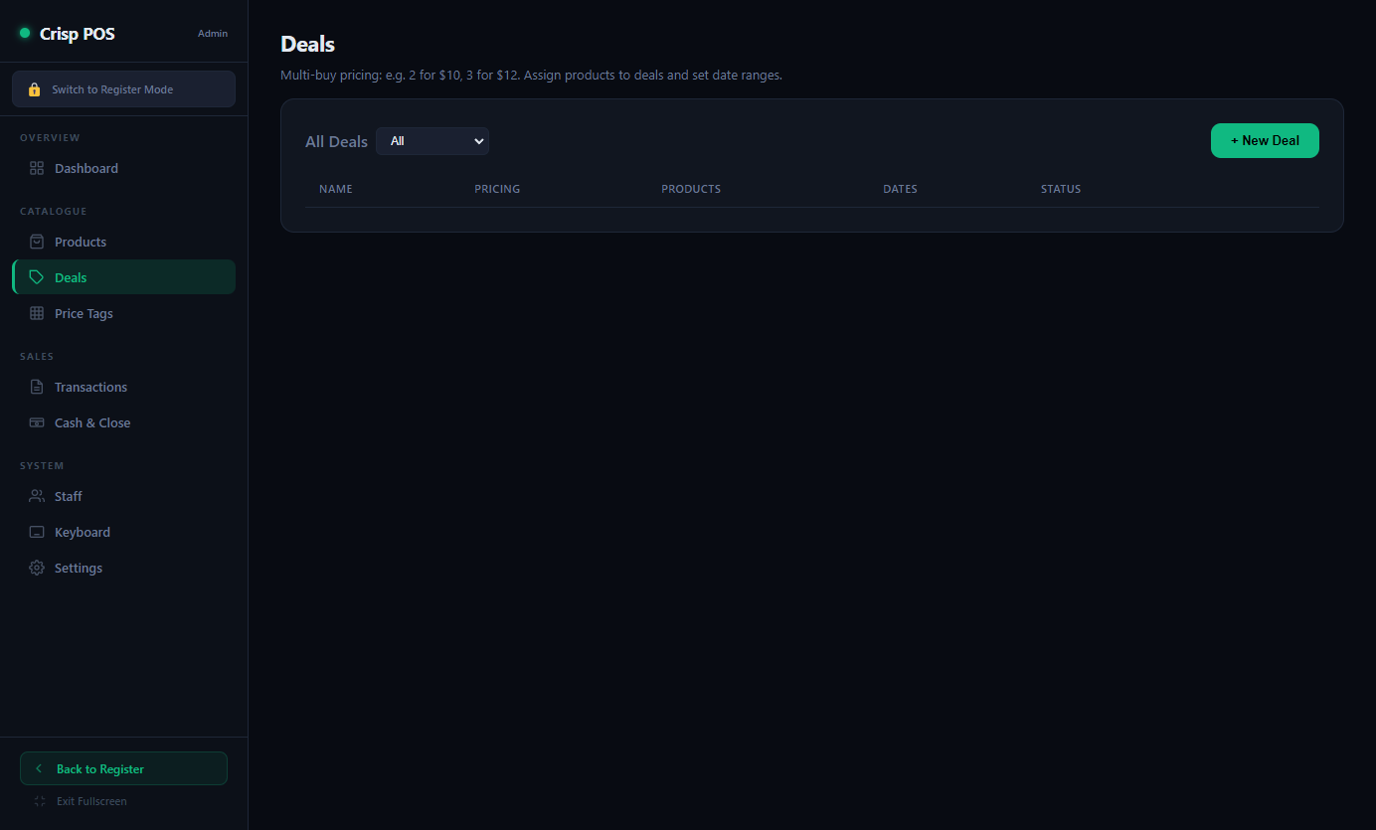
Figure 5: Admin Deals — Promotion management

- Table listing all deals with name, pricing tiers, products, dates, status
- Status filter: All, Active Only, Inactive Only, Expired
- Quick toggle button to activate/deactivate deals inline
- Modal editor with: deal name, price tiers, date range, product picker
- Product picker: search and add products as badge chips

3.4 Price Tags
WYSIWYG label designer for printing price tags on label sheets.
- Tag Designer — drag elements (name, price, barcode, unit, category) on a scaled canvas
- Sheet Preview — see how labels will print on a sheet (configurable cols x rows)
- Print Queue — add products with quantities, then print a full sheet
- Product Search — find and add products to the print queue

3.5 Transactions
Transaction history browser with search, export, and quick date range presets.
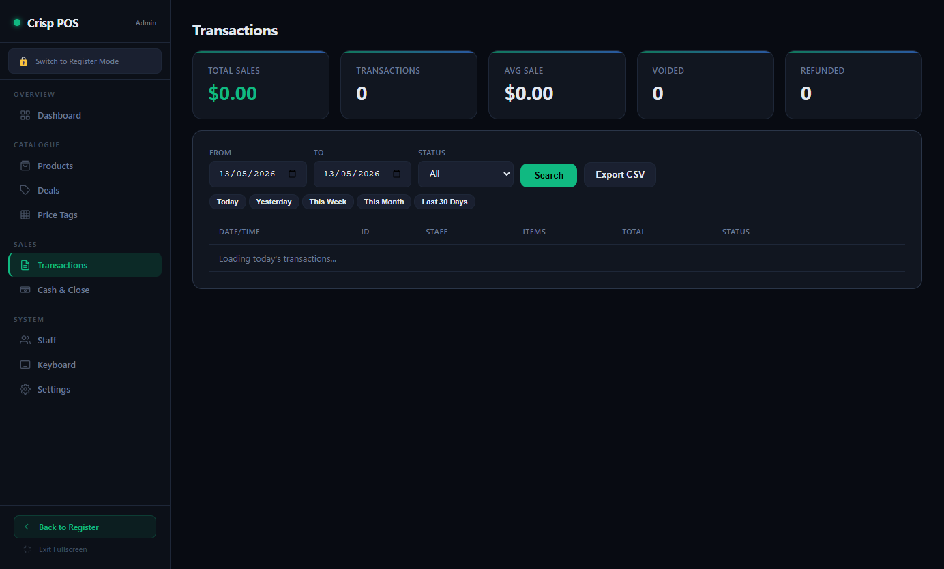
Figure 6: Admin Transactions — History browser with filters

- Summary stats: Total Sales, Transactions, Avg Sale, Voided, Refunded
- Quick date presets: Today, Yesterday, This Week, This Month, Last 30 Days
- Filters: date range, status (completed/voided/refunded/parked)
- View detail: item breakdown with quantities, prices, discounts, payments
- Actions: Void or Refund completed transactions
- CSV Export for the filtered date range

3.6 Cash & Close
Two sub-tabs: Cash Drawer and End-of-Day Report (Z Report).
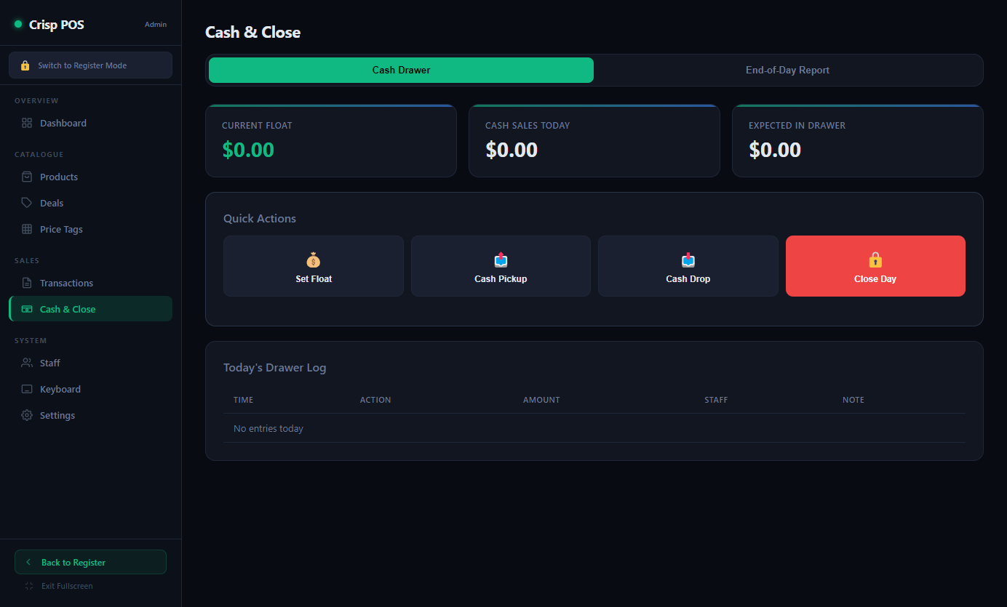
Figure 7: Admin Cash & Close — Drawer management and Z Report

Cash Drawer:
- Stats: Current Float, Cash Sales Today, Expected in Drawer
- Quick Actions: Set Float, Cash Pickup, Cash Drop, Close Day
- Enhanced Close Day with counted cash entry and variance calculation
- Drawer log table showing all actions with timestamps

End-of-Day Report (Z Report):
- Generates comprehensive end-of-day summary for any date
- Stats: Net Sales, Transactions, Average, GST, Discounts, Voids, Refunds
- Payment Methods breakdown with totals
- Cash Drawer reconciliation (float, sales, drops, pickups, expected)
- Sales by Category and Sales by Hour
- Print button opens printable version in new window

3.7 Staff
Staff management with PIN-based access control, role descriptions, and staff count display.
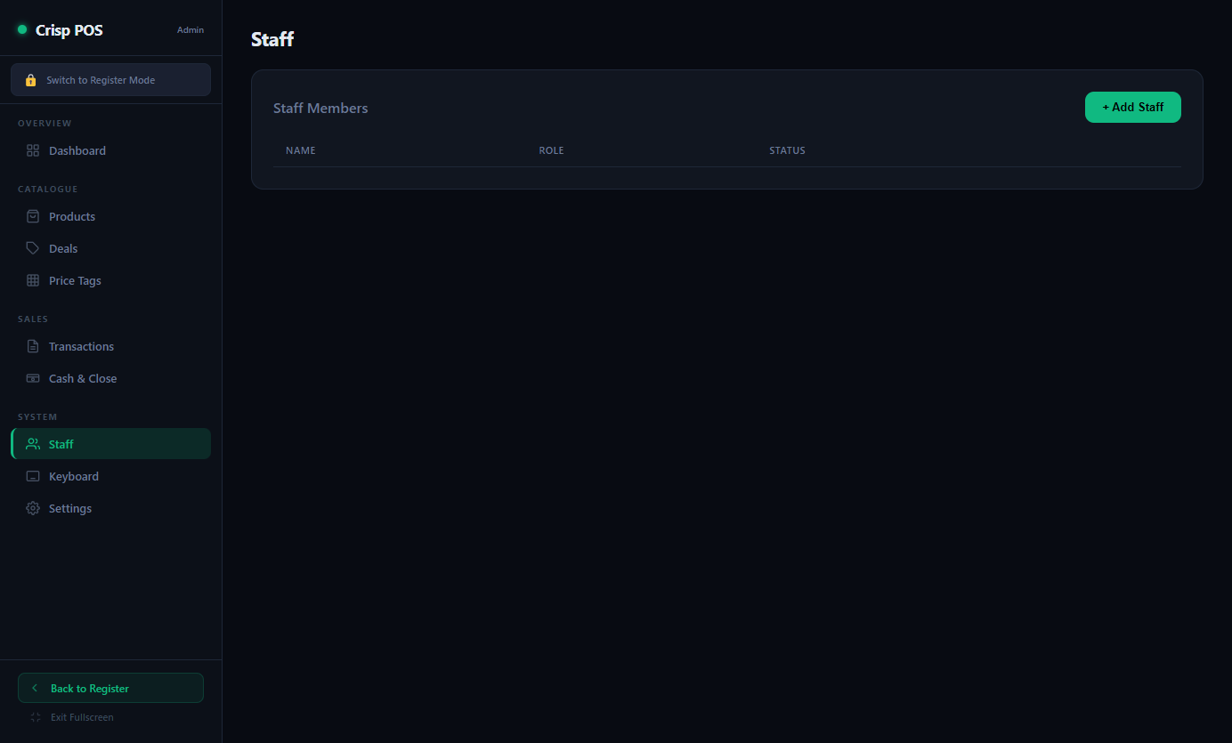
Figure 8: Admin Staff — Staff management with role-based access

- Table: Name, Role (with icon), Active/Inactive status
- Roles: Cashier, Manager, Admin — each with description tooltip
- Modal editor: Name, PIN (masked with toggle visibility), Role
- Activate/Deactivate toggle for soft disabling staff

3.8 Keyboard Layout Editor
Visual grid editor for the POS register keyboard. Supports multiple pages with a tree-based page navigator.
- Page tree with sub-pages, drag-to-reorder, rename, duplicate, delete
- Grid with configurable columns x rows per page
- Click empty cells to add buttons, drag across cells for multi-span
- Drag-and-drop to move buttons between cells
- Product sidebar: search products, click to select, then click empty cell to place
- Auto-fill: Reflow buttons to uniform size (1x1, 2x2, 3x3)
- Alphabetical sort, select all, bulk color/move/delete
- Undo (Ctrl+Z) with 30-level undo stack
- Export/Import as JSON, Reset to factory default

3.9 Settings
Five sub-tabs under Settings with enhanced save feedback:

Figure 9: Admin Settings — Store configuration

Store & Config:
- Store Details: Name, ABN, Address, Phone, Register ID
- Tax: Tax Name (GST) and Rate (inclusive pricing)
- Receipt: Header and Footer text
- Database & Backups: Create manual backups, restore from previous, relative timestamps
- Cloud Sync (Supabase): URL + Anon Key, pull/push
- Application: Fullscreen/kiosk mode toggle
- Software Update: Pull latest from GitHub with one click

Network (LAN Multi-Register):
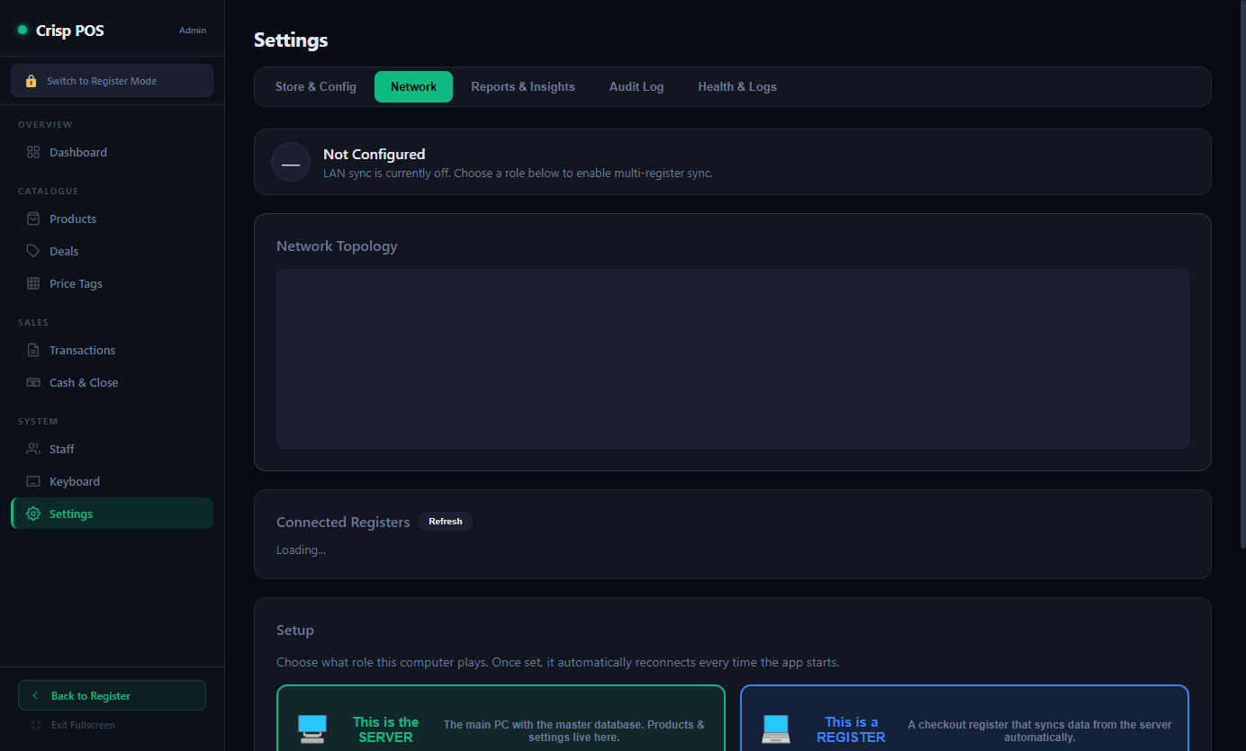
Figure 10: Admin Settings — Network / LAN Multi-Register

- Server/Client role selection
- Network topology diagram with animated data flow
- Connected registers list with status
- Auto-discovery for client registers
- Network diagnostic tool (subnet scan, firewall check, UDP test)

Reports & Insights:
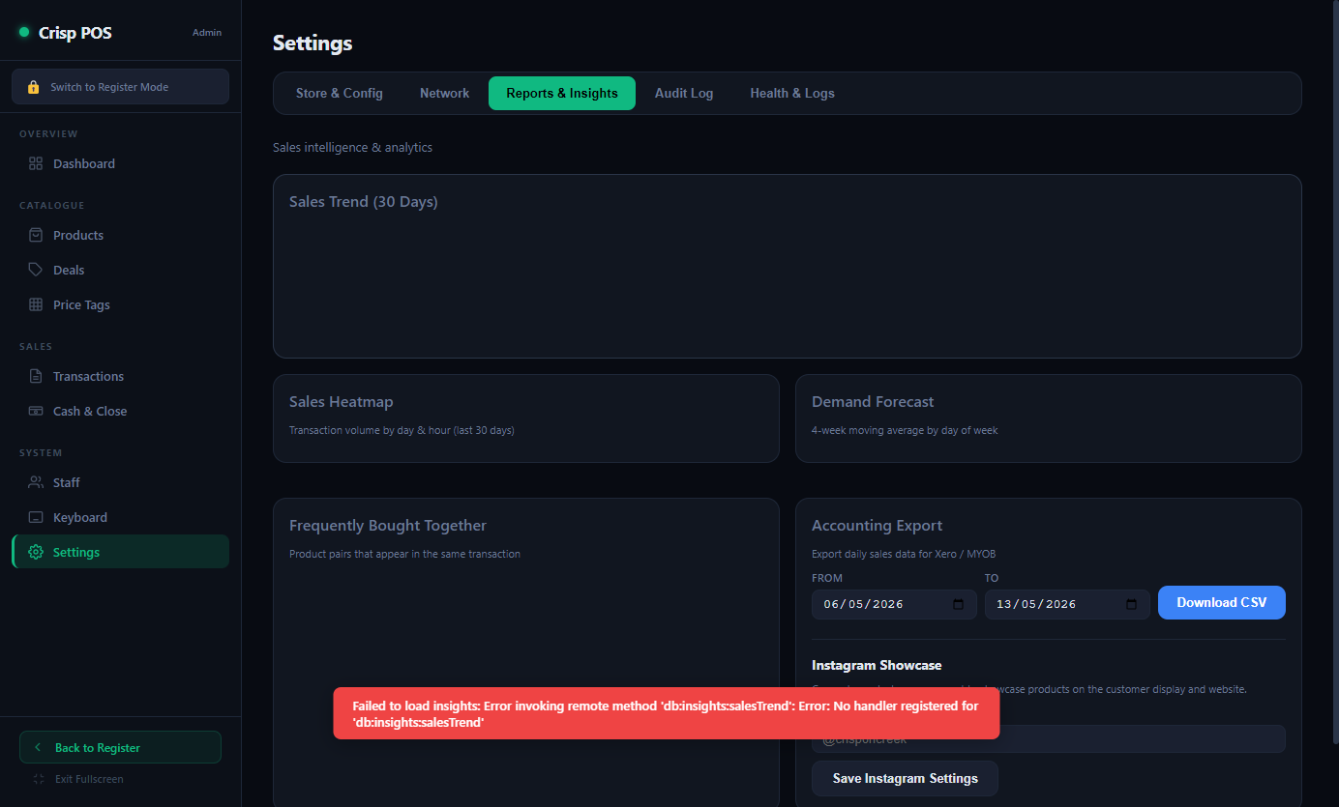
Figure 11: Admin Settings — Reports & Insights

- 30-day sales trend chart
- Sales heatmap (day x hour)
- Demand forecast (4-week moving average by day of week)
- Frequently Bought Together product pairs
- Accounting Export (CSV for Xero/MYOB)
- Instagram Showcase settings

Audit Log:
- Searchable audit trail: voids, no-sales, discounts, price changes, refunds
- Filter by date and action type

Health & Logs:
- System health: Last DB Save, Last Backup, Last Error, Uptime
- Application logs viewer with severity filter and text search
- Export, Copy, Clear log actions

4. Database Schema
SQLite database stored at ~/AppData/Roaming/crisp-pos/crisp-pos.sqlite. Schema defined in db/schema.sql.

4.1 Core Tables
Table | Purpose | Key Fields
categories | Product categories | id, name, colour, sort_order, active
products | All products | id, barcode, plu, name, category_id, price, unit, tax_rate, stock_qty
specials | Price overrides (date-ranged) | id, product_id, special_price, start_date, end_date
deals | Multi-buy promotions | id, name, type, config (JSON), start_date, end_date
deal_products | Deal-Product linking | deal_id, product_id, role
staff | Staff members | id, name, pin, role, active
transactions | Sale records | id, register_id, staff_id, total, status, created_at
transaction_items | Line items per transaction | id, transaction_id, product_id, qty, unit_price, line_total
payments | Payment records | id, transaction_id, method, amount, reference
cash_drawer | Drawer actions log | id, register_id, staff_id, action, amount, note
settings | Key-value store | key, value
keyboard_buttons | POS grid layout | id, label, type, price, page, grid_row, grid_col, col_span, row_span
sync_queue | Offline sync queue | id, table_name, record_id, action, payload, synced

4.2 Write Path
- 1. Renderer calls window.pos.someMethod(args) via preload bridge
- 2. Main process IPC handler executes SQL via sql.js
- 3. scheduleSave() — 1-second debounced write to disk
- 4. queueSync() — appends to sync_queue for cloud push

5. Hardware Integration
Device | Protocol | Status
Receipt Printer | ESC/POS via USB, Windows print queue, or Network (TCP) | Auto-detected
Cash Drawer | ESC/POS pulse via printer DK port | Auto-detected via printer
Barcode Scanner | HID keyboard mode (USB) | Auto-detected
Scale | RS-232 serial (Mettler Toledo Ariva-S) | COM port auto-scan
EFTPOS Terminal | Linkly Cloud API | Configured in Settings

6. Sync Architecture
Three layers of data synchronization:
- 1. Local SQLite — all reads/writes go here first (offline-first)
- 2. LAN Sync — server broadcasts to client registers over TCP/UDP on port 5555
- 3. Cloud Sync — Supabase push/pull with 30-second auto-sync interval

LAN sync uses a server/client model. The server holds the master database. Clients auto-discover via UDP broadcast and pull products, categories, deals, and keyboard layout from the server.

7. Running the Application
Commands:
- npm start — Production mode (fullscreen/kiosk)
- npm run dev — Dev mode (windowed + DevTools)
- npm run build — Build Windows portable executable

Keyboard Shortcuts (Global):
- F11 — Toggle fullscreen/kiosk
- Escape — Exit kiosk mode

