**Voorstel 1**

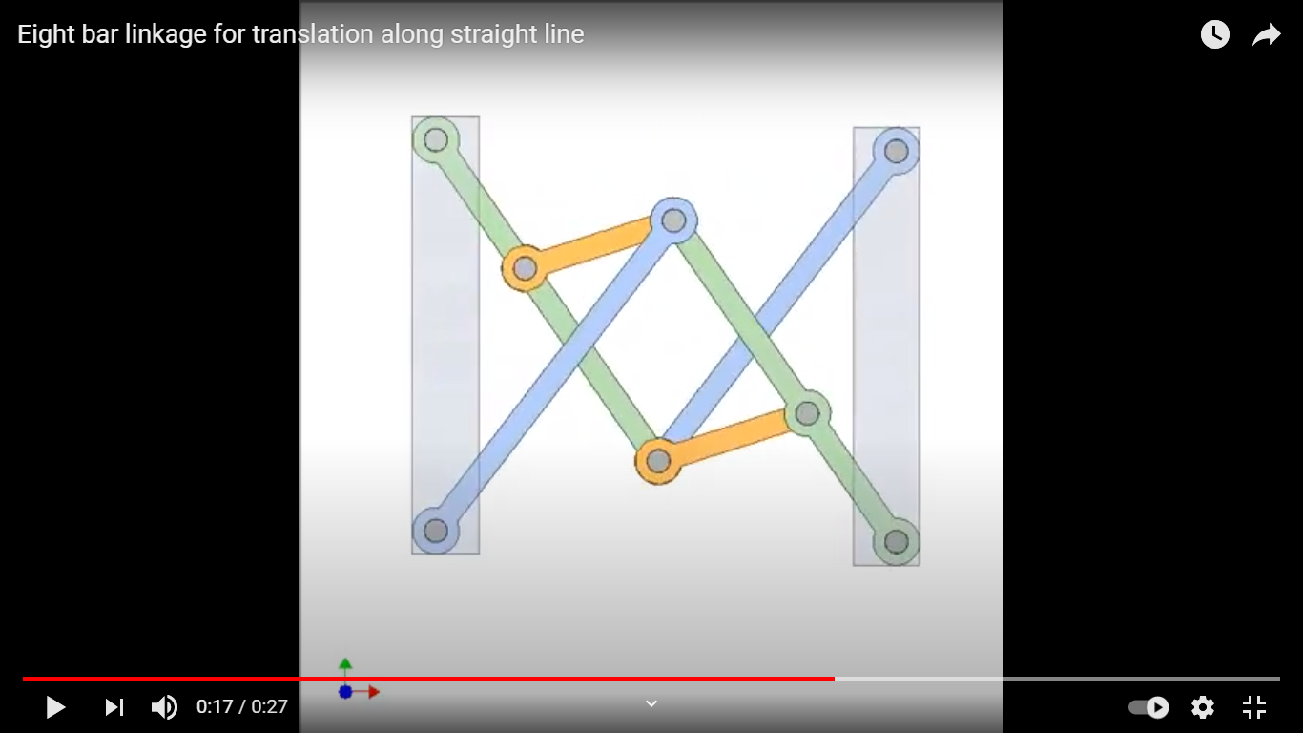

y

x

1

2

4

3

6

5

7

8

C

A

B

E

F

D

G

H

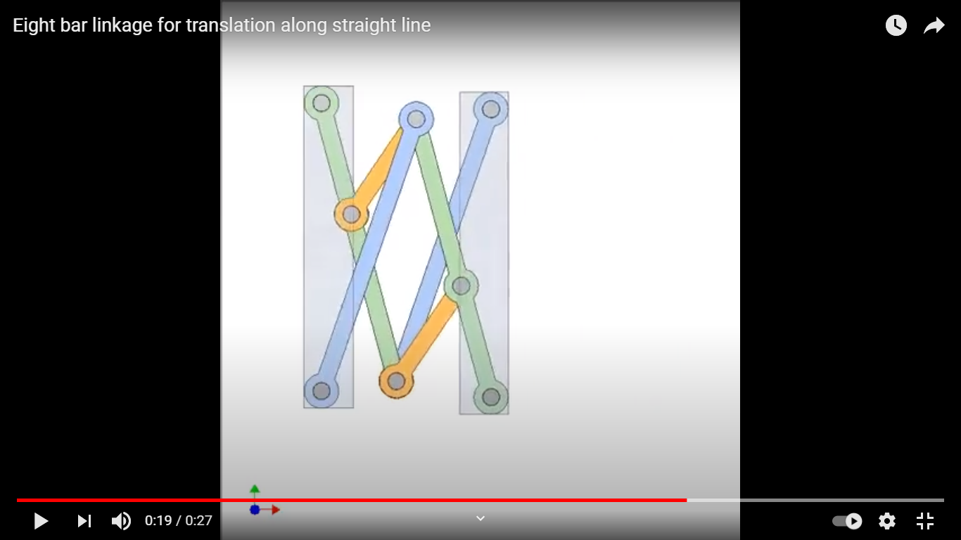

f1=10 want je moet er 2 dubbel tellen

<https://www.youtube.com/watch?v=Xw1oPM2gNac>

**Voorstel 2**

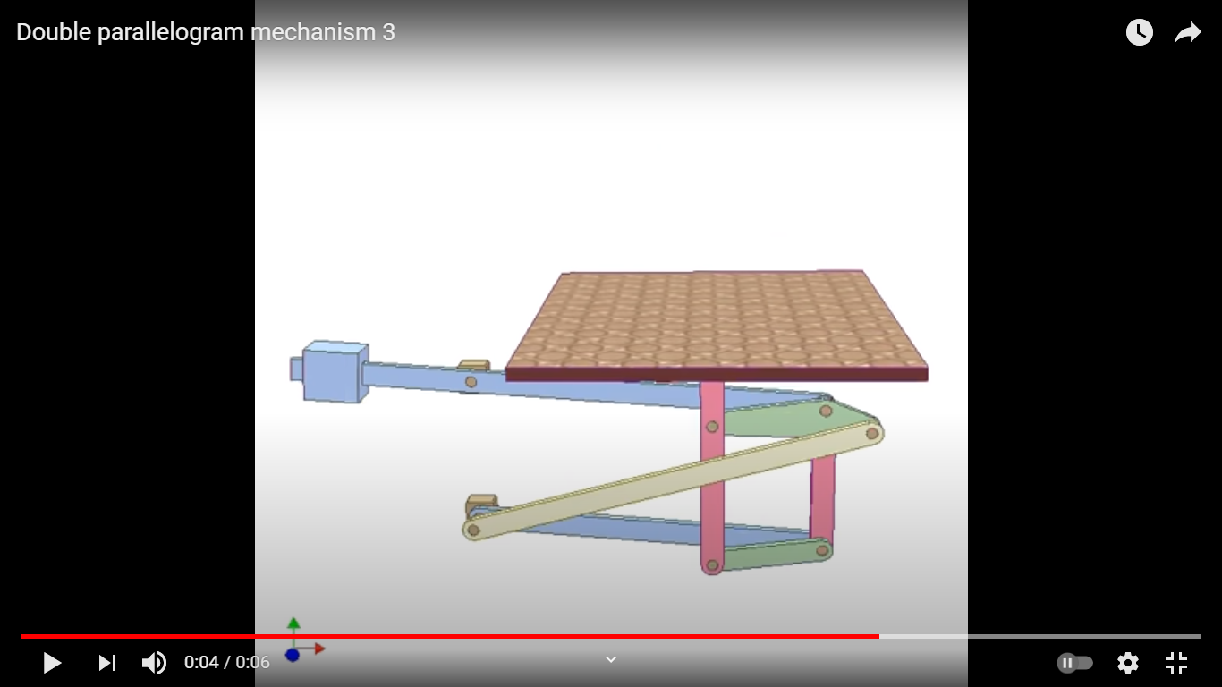

8

7

6

5

3

4

2

1

1

<https://www.youtube.com/watch?v=RJBoh5k4KDs>

**Voorstel 3**

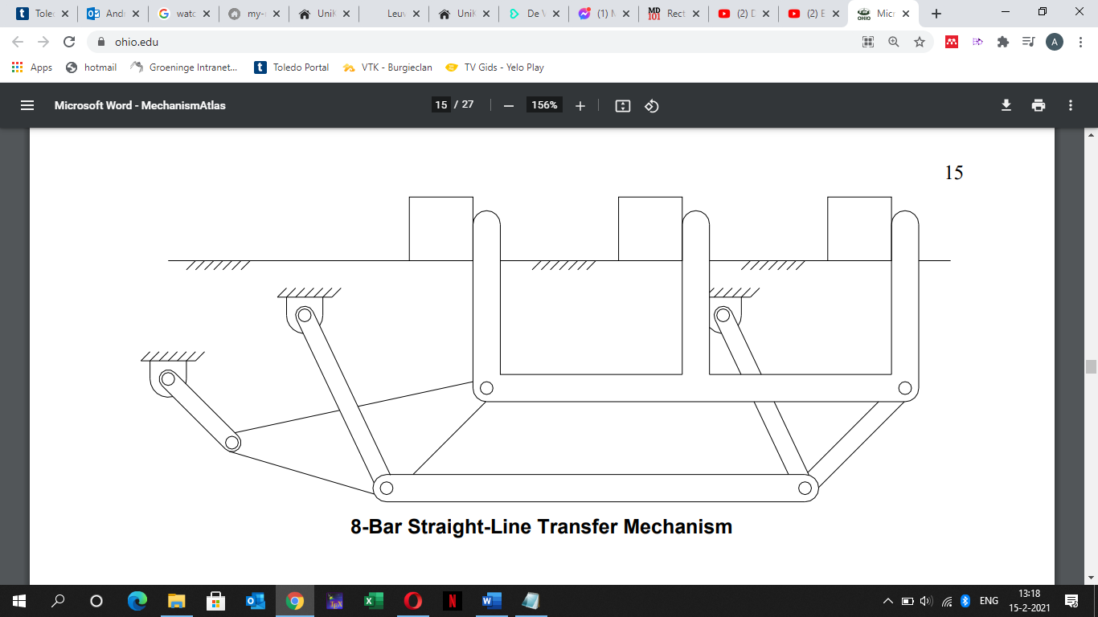

8

7

5

6

3

4

2

1

Scharnier bij 3 4 6 dubbel tellen, 6 7 8 ook

[https://www.ohio.edu/mechanical-faculty/williams/html/PDF/MechanismAtlas.pdf p15](https://www.ohio.edu/mechanical-faculty/williams/html/PDF/MechanismAtlas.pdf%20p15)

<https://www.youtube.com/watch?v=hPsEyN0Y8rM>

<https://www.youtube.com/watch?v=s2Z2TVbs8Og>

