# Cholestasis and bile duct ligation (BDL)

## Introduction

Cholestatic liver disease consists of a variety of disorders. The causes of cholestasis can be either a functional defect in bile formation at the level of hepatocytes (hepatocellular cholestasis) or from impaired bile secretion and flow at the level of bile ductulus or ducts (ductular/ductal cholestasis) {Trauner, Molecular Pathogenesis of Cholestasis}. Among the most common causes of cholestatic liver disease in the adult population are primary biliary cirrhosis (PBC) and primary sclerosing cholangitis (PSC), while biliary atresia and Alagille syndrome are commonly found in the pediatric population {Wang2013, Nguyen2014}. Cholestasis is present in multiple pathologies including gall stone obstruction of the bile duct, local tumor impingement and drug toxicity {Woolbright2013}. Chronic cholestatic liver disease with massive fibrosis is one of the most common occurrences after liver transplantation {Shen2015}.

The hallmark of cholestasis is an impairment of hepatic bile flow and secretion due to biliary tract obstruction or impairment of bile acid uptake, conjugation, or excretion followed by a lack of bile in the intestine and accumulation of potentially toxic cholephiles/biliary constituents in the liver and systemic circulation {Wagner2008, Trautner1998, Wang2013}.

“As this disease progresses, hepatic inflammation and hepatocyte injury ultimately develop [5]. If cholestasis is not corrected and hepatocyte injury persists, portal myofibroblasts and hepatic stellate cells are stimulated to proliferate and produce extracellular matrix, a process that ultimately results in the development of biliary fibrosis and eventually cirrhosis [6]. A major consequence of acute cholestasis, especially obstructive cholestasis, is the development of severe liver injury [7].” {Allen2011}

“Extrahepatic cholestasis leads to complex injury and repair processes that result in bile infarct formation, neutrophil infiltration, cholangiocyte and hepatocyte proliferation, extracellular matrix remodeling, and fibrosis.” {Wang2005}

*BDL experimental model*

Understanding the disease progression of the liver following cholestatic injury is an important first step toward the development of new therapeutic interventions. Biliary tract obstruction is a common mechanism of hepatic injury in a variety of clinical settings, including obstructing neoplasms, post-operative bile duct injury, biliary atresia, sclerosing cholangitis, and primary biliary cirrhosis. Surgical bile duct ligation (BDL) is a widespread experimental model to induce obstructive cholestatic injury in mice and rats {Tag2015 -> [4,23,24], Georgiev2008 -> [2-7]}. “This method reliably induces stereotypical histopathological changes, including hepatocellular necrosis, neutrophil infiltration, cholangiocyte and hepatocyte proliferation, stellate cell activation, and progressive fibrosis. BDL also causes early mortality in mice and mimics human cholestatic liver disease.” {Wang2005}

The BDL experimental model has been well described and evaluated in rats and mice {Huss2010 -> [9,10]} and has been widely used to study cholestatic liver injury {Huss2019 -> [11,12]} and fibrogenesis {Huss2010 -> [9,13,14]}

## Cholestasis

“Cholestatic liver disease consists of a variety of disorders. Primary sclerosing cholangitis and primary biliary cirrhosis are the most commonly recognized cholestatic liver disease in the adult population, while biliary atresia and Alagille syndrome are commonly recognized in the pediatric population.” {Nguyen2014} “Cholestasis is present in multiple pathologies including gall stone obstruction of the bile duct, biliary atresia, local tumor impingement and drug toxicity (Kim et al., 2000; Poupon et al., 2000; Yang et al.,2013a).

“Cholestasis is the impairment of bile flow due to biliary tract obstruction or impairment of bile acid uptake, conjugation, or excretion[1]. It is classified as intrahepatic or extrahepatic. Intrahepatic cholestasis primarily involves the bile canaliculi and the intrahepatic bile ducts. Extrahepatic cholestasis involves the extrahepatic ducts, the common hepatic duct or the common bile duct. The diagnosis of intrahepatic cholestasis is made once extrahepatic biliary obstruction is ruled out by various imaging modalities, and depending on the clinical situation, may be confirmed by liver biopsy. Among the most common causes of cholestatic liver disease are primary biliary cirrhosis (PBC) and primary sclerosing cholangitis (PSC).” {Wang2013}

“The hallmark of cholestasis is an impairment of bile secretion and flow followed by a lack of bile in the intestine and accumulation of potentially toxic cholephiles in the liver and the systematic circulation.” {Wagner2009, Trautner1998}.

“Cholestatic liver disease develops when bile flow from the liver is interrupted [1,2]. This can occur during autoimmune reactions, congenital disorders, pregnancy, drug hepatotoxicities, and other forms of liver disease [1]. Cholestasis causes concentrations of bile acids to rapidly increase in liver and plasma [3,4]. As this disease progresses, hepatic inflammation and hepatocyte injury ultimately develop [5]. If cholestasis is not corrected and hepatocyte injury persists, portal myofibroblasts and hepatic stellate cells are stimulated to proliferate and produce extracellular matrix, a process that ultimately results in the development of biliary

fibrosis and eventually cirrhosis [6].

A major consequence of acute cholestasis, especially obstructive cholestasis, is the development of severe liver injury [7]. It is generally assumed that exposure of hepatocytes to high concentrations of potentially toxic bile acids is mainly responsible for cholestatic liver injury [8]. In support of this concept, several studies have demonstrated that high concentrations of certain bile acids produce hepatocyte cell death in vitro through activation of proapoptotic pathways [9–11]” {Allen2011}

“Extrahepatic cholestasis leads to complex injury and repair processes that result in bile infarct formation, neutrophil infiltration, cholangiocyte and hepatocyte proliferation, extracellular matrix remodeling, and fibrosis.” {Wang2005}

“Cholestasis is present in multiple pathologies including gall stone obstruction of the bile duct, biliary atresia, local tumor impingement and drug toxicity (Kim et al., 2000; Poupon et al., 2000; Yang et al.,2013a). Persistent cholestasis leads to injury of hepatocytes and

bile duct epithelial cells, inflammation, and progression to fibrosis, cirrhosis and death.” {Woolbright2013}

“Chronic cholestatic liver disease with massive fibrosis is one of the most common occurences after liver transplantation {Shen2015 -> [2]}.

“Liver fibrosis is manifested by significant deposition of extracellular matrix and stellate cells

play a major role in the process [16]. Fibroblasts derive from hepatocytes also contribute to fibrosis [17].The specific role of myofibroblast and endothelial cells in developing liver fibrosis

has also been reported [18, 19]. Thus, liver fibrosis is a complex process involving different cell types with specific role. The most important trigger for fibrosis is chronic inflammation and inflammatory cells plays a an orchestrated network with liver cell types to develop conducive environment for fibrosis [20].” {Shen2015}

The differentially expressed factors reported here constitute a resource of candidate genes for roles in cholestatic disease.**BDL experimental model**

“Biliary tract obstruction is a common mechanism of hepatic injury in a variety of clinical settings, including obstructing neoplasms, post-operative bile duct injury, biliary atresia, sclerosing cholangitis, and primary biliary cirrhosis. For this reason, understanding

mechanisms that control the liver’s response to cholestatic injury and determine the extent and rate of repair is a necessary first step toward the development of new therapeutic

interventions.” {Wang2005}

“Extrahepatic cholestasis can be modeled by surgical bile duct ligation (BDL) in rodents. This method reliably induces stereotypical histopathological changes, including hepatocellular necrosis, neutrophil infiltration, cholangiocyte and hepatocyte proliferation, stellate cell activation, and progressive fibrosis. BDL also causes early mortality in mice and mimics human cholestatic liver disease.” {Wang2005}

Cholestatic liver injury is one of the major causative factors for the development of liver fibrosis and cirrhosis in patients with chronic liver disease. Therefore, experimental models have been generated that mimic various aspects of the complex mechanisms that lead to hepatic inflammation, fibrosis and cirrhosis {Tag2015, [1]}.

“The common bile duct ligation (BDL) model has been used widely to study cholestatic liver injury [2–7], fibrogenesis [2,3,6,8–10], and the impact of obstructive jaundice on a second hit such as infection [11,12] or hepatic ischaemia [12].” {Georgiev2008}.

“Surgical BDL is one of the most widespread experimental models that is used to induce obstructive cholestatic injury in mice and rats{Tag2015 -> [4,23,24]}. As a consequence, the mice and rats that received this surgery develop a strong fibrotic reaction that at first originate from the periportal fields.” {Tag2015 ->[25]}.

<http://www.jove.com/video/52438/bile-duct-ligation-mice-induction-inflammatory-liver-injury-fibrosis>

The BDL experimental model has been well described and evaluated in rats and mice {Huss2010 -> [9,10]} and has been widely used to study cholestatic liver injury {Huss2019 -> [11,12]} and fibrogenesis {Huss2010 -> [9,13,14]}

“The experimental BDL model is well accepted and used worldwide in hundreds of laboratories to induce liver cholestasis and fibrosis. It induces intrahepatic biliary epithelial cell proliferation, myofibroblastic differentiation of portal fibroblasts around proliferating biliary epithelial cells, resulting in a highly reproducible, massive expression and deposition of ECM [10,11].” {Tag2015}

## BDL phenotype progression

## 

Typical changes observed after BDL {Tag2015, Georgiev2008}

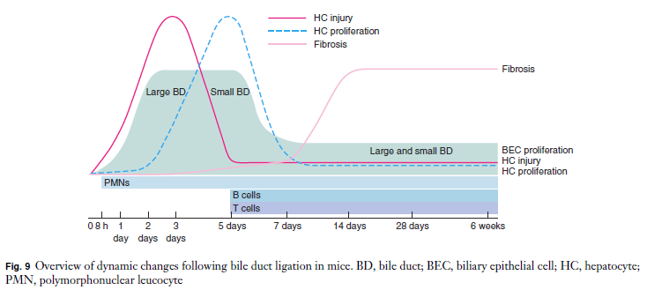{Georgiev2008, BDL in C57BL/6}

“The first week after BDL reflects the acute cholestatic injury with consequent reparative reactions, followed by a phase of chronic injury resulting in liver fibrosis.” {Georgiev2008}

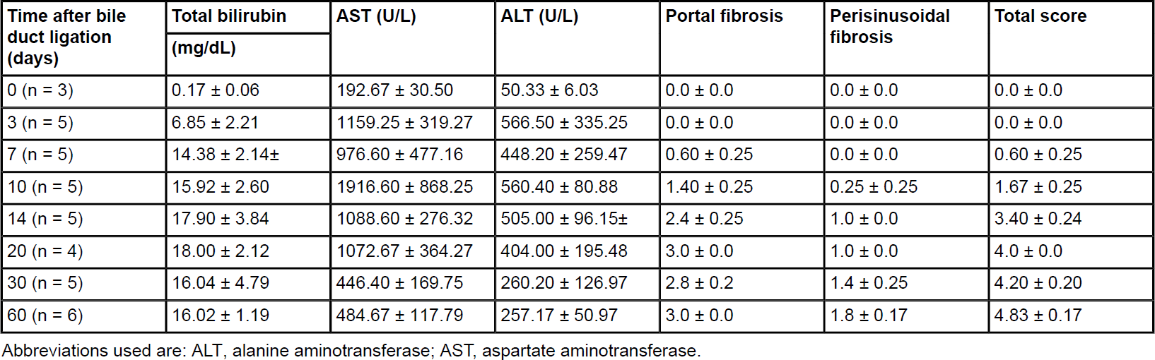{Tag2015, BDL in C57BL/6}

“In a typical experimentation BDL was performed in 40 male C57BL/6 wild-type mice weighting about 18-20 gram. This experiment was done to investigate hepatic fibrogenesis in the initiation phase (3 and 7 days), during progression (10, 14, and 20 days), and during longterm (30 and 60 days) [16]. In this model, persinusoidal fibrosis has already developed on day 10 after the surgery, while periportal fibrosis that permanently increased up to the end of the experiment was fully developed after 20 days.” {Huss2010}

“The biochemical markers ALT and bilirubin reproduce time course results in recent BDL and sham operated wild type C57BL/6 mice which served as a model of time-dependent induction of liver fibrosis.Quantitative accumulation of collagen fibres was observed from day 3 to day 14. During ongoing fibrogenesis there was a significant elevation of ALT and bilirubin.” {Huss2010}.

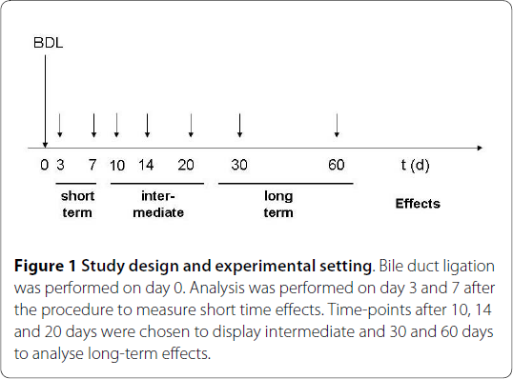 {Huss2010}

“Alanine aminotransferase (ALT) and aspartate transaminase (AST) increased rapidly after BDL, peaking at 7 respectively twenty days after the surgery. After the peaking, ALT and AST decreased steadily until day 30; serum levels remained almost unchanged after 60 days. Bilirubin levels steadily elevated and reached a plateau after 7 days. {Huss2010}

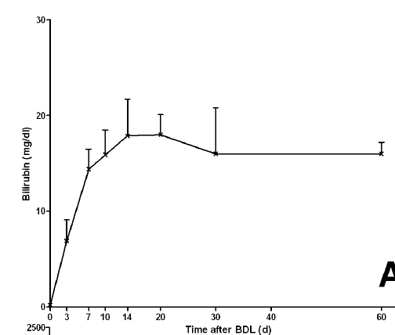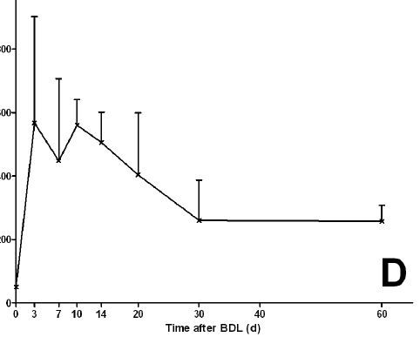bilirubin & ALT {Huss2010, BDL C57BL/6}

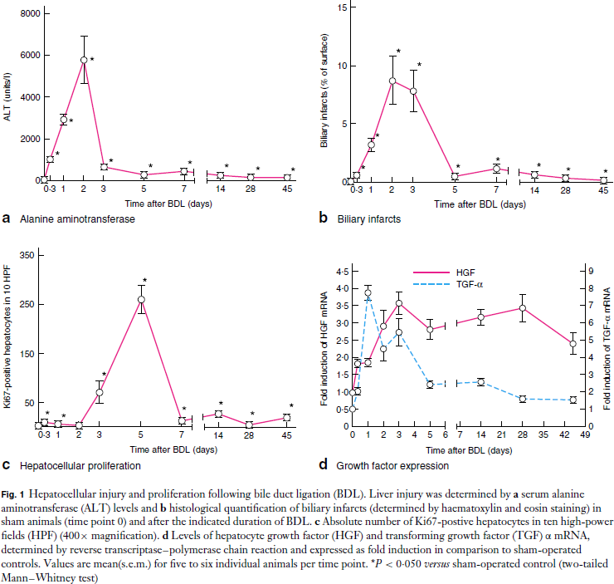{Georgiev2008} BDL C57BL/6 mice

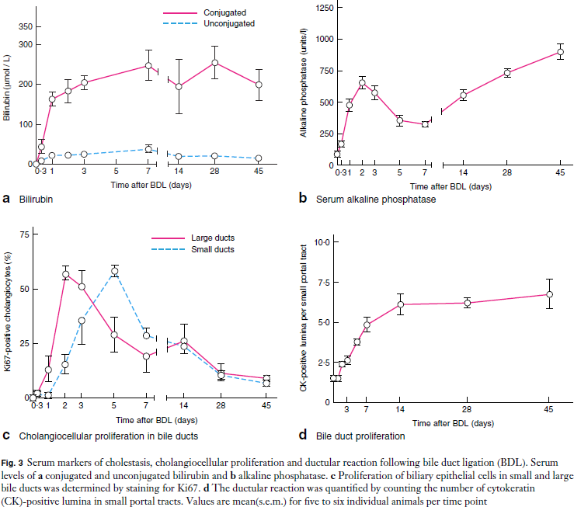 {Georgiev2008} BDL C57BL/6 mice

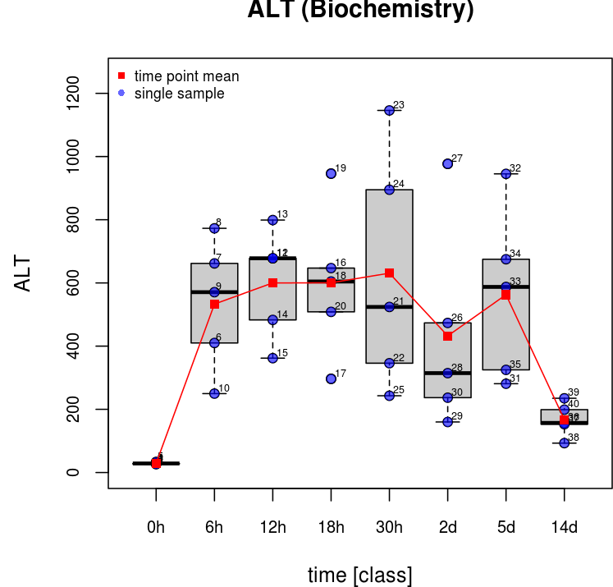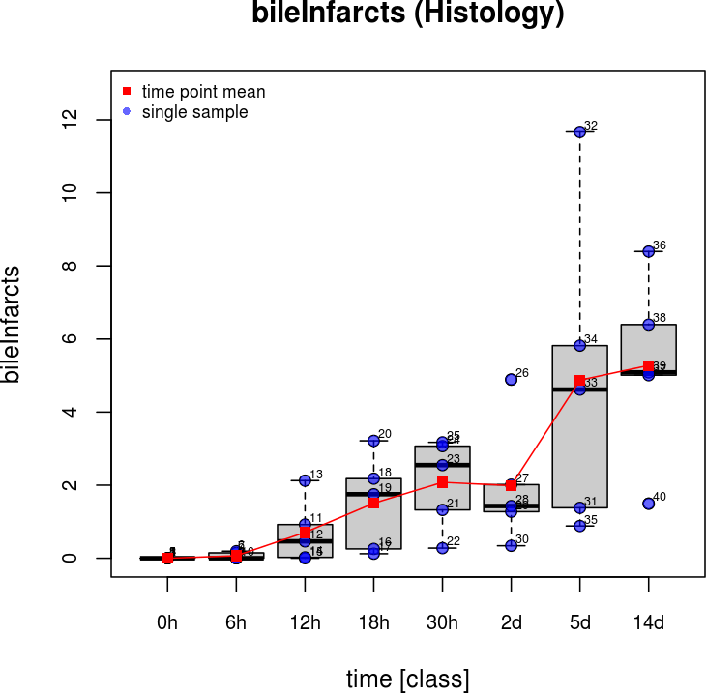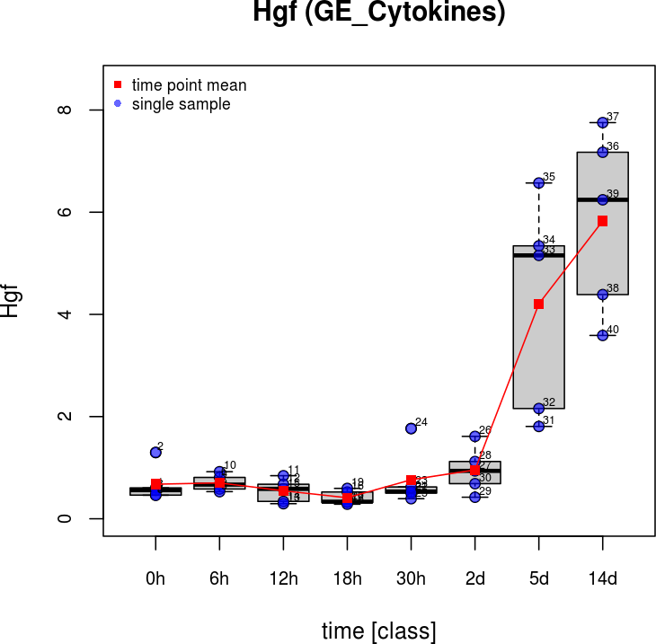

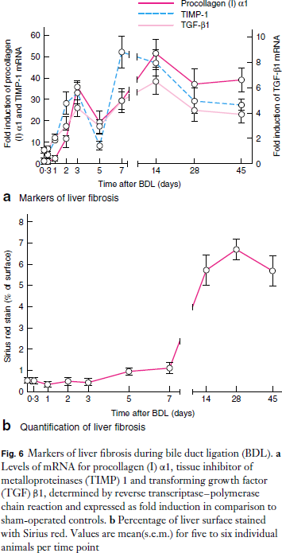{Georgiev2008} **Timp1, Tgfb1, Col1a1, Sirius Red**

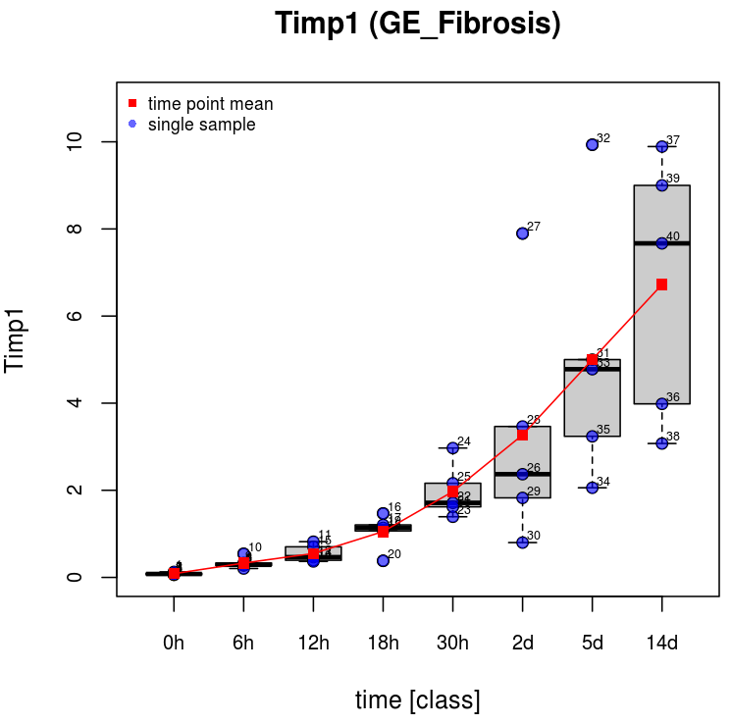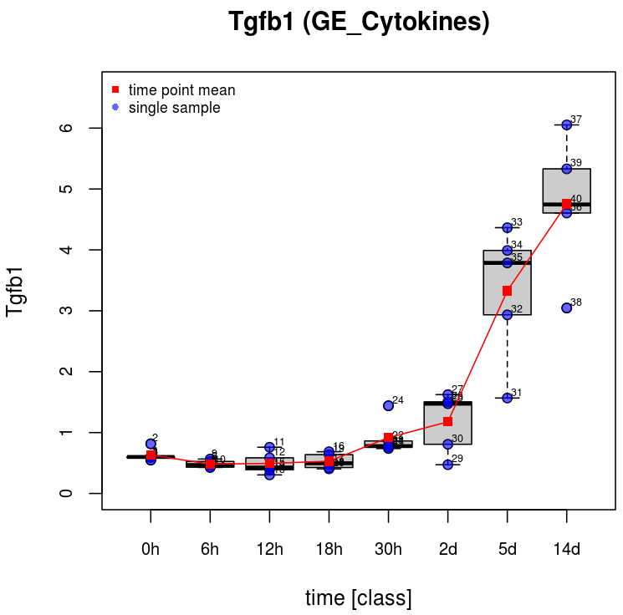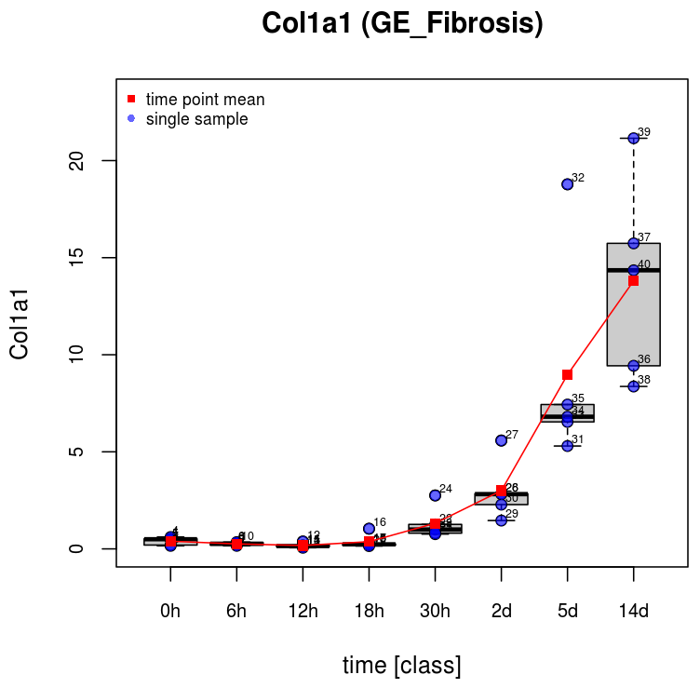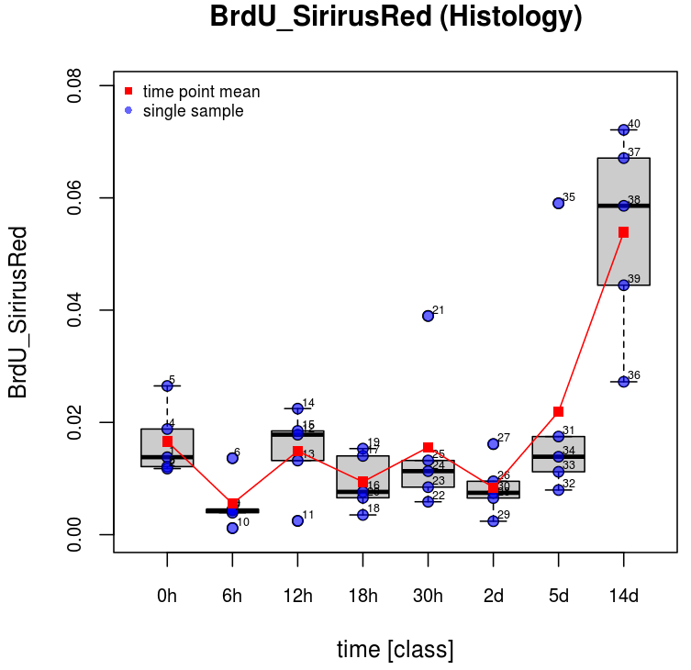

{Georgiev2008}

## 

## Proliferation

“To determine whether BDL induces the expression

of proliferative mediators, gene expression levels of

two key mediators of hepatocellular regeneration, HGF

and TGF-α, were measured by quantitative RT–PCR.

Transcript levels of both **HGF and TGF-α** increased

rapidly after BDL with initial peaks 1 day (TGF-α) or

3 days (HGF) after BDL (Fig. 1d). Together, these data

indicate that BDL rapidly led to hepatocellular injury and

gene activation, initiating a regenerative response which

culminated in a distinct peak of hepatocellular proliferation

at day 5.” {Georgiev2008}

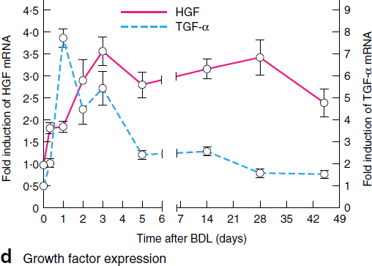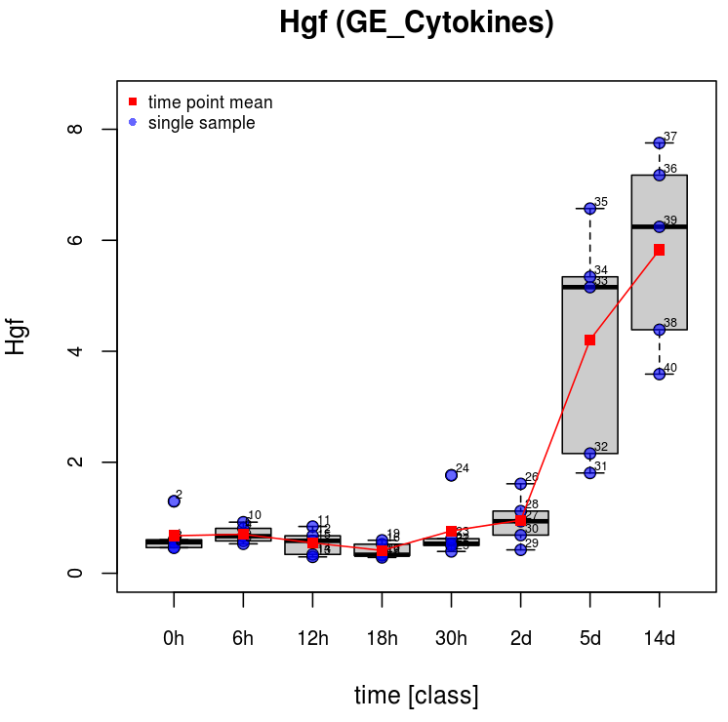

## 

## Fibrosis

BDL resulted in liver fibrosis as assessed by increased α-smooth muscle actin (α-SMA) and collagen I production/deposition in the liver.

“Liver fibrosis is a major parameter guiding the diagnosis and prognosis of chronic liver diseases and liver biopsy and its histological evaluation remains the gold standard for diagnosis and prognosis. Therefore, accurate qualitative and quantitative assessment of fibrosis is essential. Many scoring systems were designed to classify and stage different chronic liver diseases {Huss2010} [1,2,15]. One major flaw of these scoring systems is that they are dependent on the visual interpretation of the observer and require experienced pathologist.” {Huss2010}.

# 

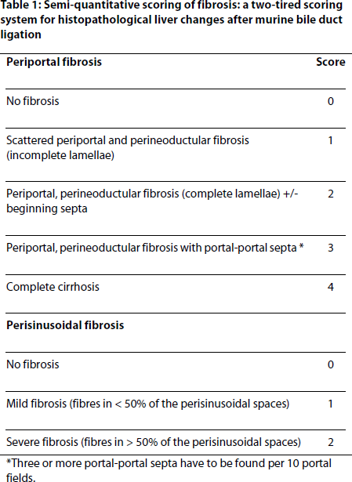

“In their model, periportal fibrosis was fully developed after 20 days; persinusoidal fibrosis become evident at day 10 and increased until the end of the experiment (day 60) {Huss2010}.

“A strong accumulation of collagen fibres was observed between day 3 (0.10 ± 0.03%) and 14 (4.75 ±0.35%), with a slight further increase thereafter (Table 2, Figure 3). The mean fibrosis score in sham operated animals was 0.00 ± 0. It increased steadily until day 60 to 4.83 ± 0.17. The maximum of periportal fibrosis (stage 3; complete lamellae) was reached at day 20 (3.0 ± 0.0).” {Huss2010}

Peripsinusoidal fibrosis was absent during the first 10 days and was established after 14 days (1.0 ± 0.0) {Huss2010}. In our model, periportal fibrosis was fully developed after 20 days; persinusoidal fibrosis become evident at day 10 and increased until the end of the experiment (day 60) {Huss2010}. However, stage 4 fully developed cirrhosis was not observed in their experimental setting. This finding is different to description of the rat model. Here fibrosis is progressive and cirrhosis can develop within 15 days after BDL {Huss2010 -> 25]}.

### Collagen deposition & Sirius Red staining

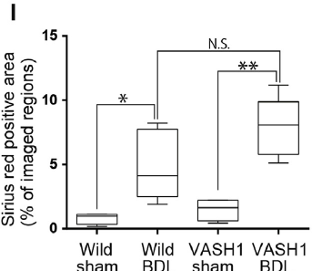{Furutani2015, Sirius Red Staining after 14d BDL}

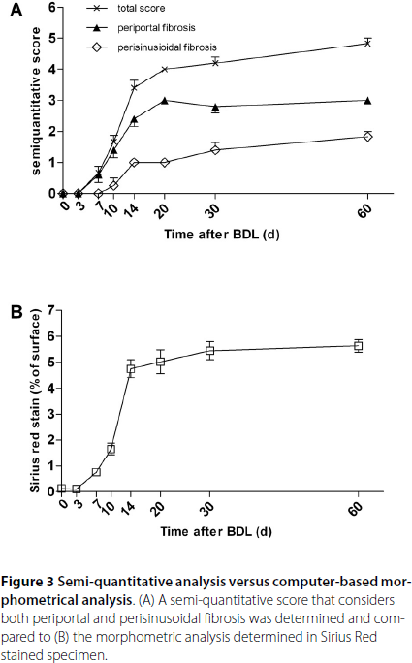{Huss2010}

“In liver fibrosis, damaged hepatocytes induce trigger signal by releasing cytokines which promote macrophage kupffer cells and lymphocyte recruitment {Shen2015 -> [21]}.”{Shen2015}

“Hepatocytes also release paracrine molecules (such as fibroblast growth factor) which lead to stellate cell activation. Activated stellate cells with altered morphology secrete pro-inflammatory cytokines, induce adhesion molecules and generate extracellular matrix [22]. Activated HSC also converted to myofibroblastic phenotype which have contractile capability and differentiate into collagen producing cells and expressing myogenic and fibrotic markers such as **smooth muscle actin**, **TGF-beta**, … {Shen2015}.

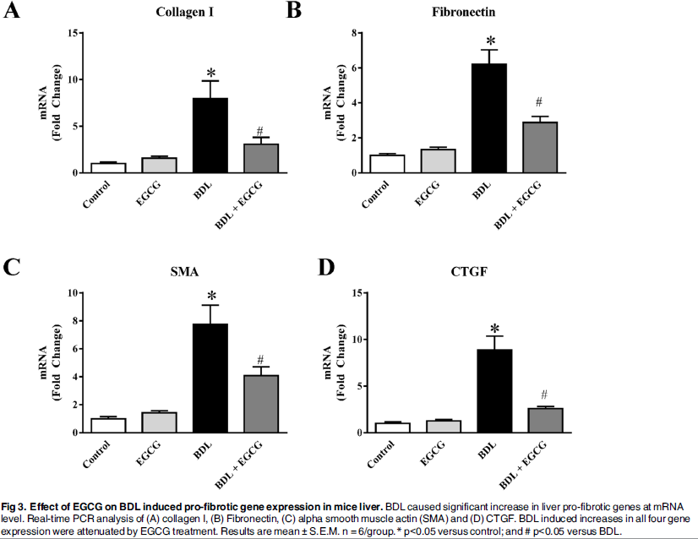{Shen2015} BDL 15d, C57BL/6 mice

“We also examined expression of four key genes associated with fibrosis by real-time PCR All four genes namely **collagen I, Fibronectin (FN1), SMA and CTGF** were induced at mRNA level to 7.9 fold, 6.2 fold,7.7 fold and 8.8 fold respectively in BDL model as expected.”

**Development of liver fibrosis**

“Quantitative RT–PCR was used to determine the time

course of three markers of liver fibrosis, TIMP-1, TGF-β1

and type I collagen. An initial peak at day 3 after BDL was

followed by lower transcript levels at day 5 and a second

peak at day 7 (TIMP-1) or day 14 (TGF-β1 and type I

collagen) (Fig. 6a).

To analyse activated hepatic stellate cells, an immunohistochemical

analysis for α-SMA was performed. α-SMApositive

cells were first detectable around biliary infarcts at day 3.” {Georgiev2008}

“In accordance

with these findings, accumulation of collagen was observed

until day 14, with no further increase thereafter as determined

by quantification of the Sirius red-positive liver

surface (Figs 6b and 8).” {Georgiev2008}

“It is well established that BDL induces fibrogenesis in

the liver. Transcript levels for type I collagen, TIMP-1,

and TGF-β1 increased rapidly after BDL, and α-SMApositive

cells appeared at day 3. Collagen deposition was

visible at the end of the first week. Activation of the

fibrogenetic process during the first week presumably

resulted in further collagen deposition by α-SMA-positive

cells during the second week.” {Georgiev2008}

## Transcriptional profiling

{Wang2005}

BDL mice 24h

http://www.ncbi.nlm.nih.gov/geo/query/acc.cgi?acc=GSE29776

### Signalling

“Cholestasis is associated with complex transcriptional and post-transcriptional alterations of hepatobiliary transporters and enzymes participating in bile formation.” {Wagner2009}.

“Ligand-activated nuclear receptors for bile acids and other biliary compounds play a key role in the regulation of genes required for bile formation.” {Wagner2009}.

“A striking finding from this body of work is that many of the transcription

factors regulating the expression of the cholesterol 7-hydroxylase and sterol

12-hydroxylase genes are nuclear receptors (Figure 5). Suppression is triggered

by the binding of bile acids (when in excess) to the farnesoid X receptor (FXR,

NR1H4), which then activates transcription of the short heterodimeric partner

(SHP, NR0B2) gene, a second nuclear receptor {Goodwin2000, Lu2000 (105, 106)}. SHP binds to and inhibits a third receptor, the liver receptor homologue-1 (LRH-1, NR5A2), which

normally activates the genes encoding cholesterol 7-hydroxylase and sterol 12-hydroxylase (47, 107, 108).” {Russel2003}

“Suppression of bile acid synthesis is mediated by FXR, which binds bile acids

and activates the transcription of genes involved in bile acid and lipid metabolism

(112–114). Target genes include those encoding the ileal bile acid binding

protein (112), SHP (105, 106), the phospholipid transfer protein (115), several

ABC transporters (116, 117), the organic anion transporting polypeptide 8 (118),

and apolipoprotein C-II (58).”{Russel2003}

“SHP also inhibits the activity of several other nuclear receptors in transfected

cells via direct protein-protein interactions (124). One of these nuclear receptor

targets may be hepatic nuclear factor-4 (HNF-4, NR2A1).”{Russel2003}

### Differences mouse - human

“It should be emphasized that the bile acid pool in mice

consists **mostly of hydrophilic bile acids**, muricholic acids,

and cholic acid and is very different from the hydrophobic

bile acid pool consisting predominantly chenodeoxycholic

acid (CDCA), cholic acid (CA), and deoxycholic acid (DCA) in humans. Hydrophobic, but not hydrophilic, bile

acids are effi cacious endogenous ligands of the nuclear

receptors FXR (NR1H4), pregnane X receptor (PXR;

NR1I2), and vitamin D receptor (VDR; NR1I1) that play

critical roles in the regulation of bile acid synthesis and

metabolism. Therefore, results from studying bile acid synthesis

in the mouse models may not be extrapolated to

humans without verification in suitable human models.{Chiang2009}”

“The structures of primary bile acids vary widely between different vertebrate species. For example, in humans and rats, cholic acid and chenodeoxycholic acid are the primary bile acids, whereas in mice cholic acid and –muricholic acid predominate. {Russel2003}”

“One caveat of these studies, however, is that plasma and liver concentrations of secondary bile acids (eg, lithocholic acid and DCA) do not dramatically increase in humans with cholestasis or in animal models of cholestasis,14–16” {Allen2011}

## Bile acids

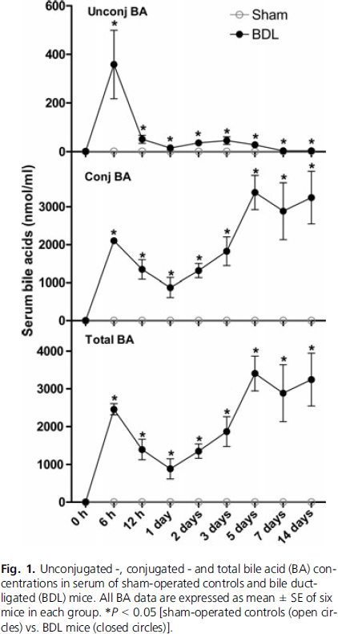{Zhang2011, C57BL/6, BDL time course}

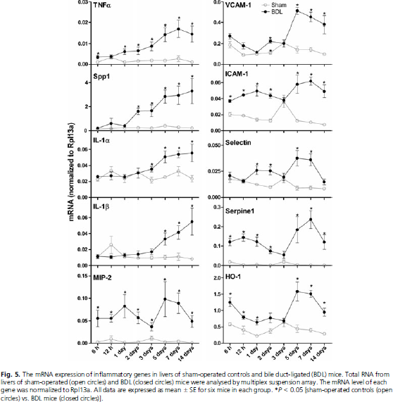{Zhang2011, C57BL/6, BDL time course}

### Bile acid synthesis

“About 95% of bile acids are recovered in the gut during each cycle of the enterohepatic circulation, and the 5% that are lost are replaced by new synthesis in the liver. This production (500 mg/day in humans) accounts for about 90% of the cholesterol that is actively metabolized in the body, and steroid hormone biosynthesis accounts for the remainder.” {Russel2003}

“The steps leading to synthesis of a primary bile acid include: (a) the initiation of synthesis by 7-hydroxylation of sterol precursors, (b) further modifications to the ring structures, (c) oxidation and shortening of the side chain (Figure 3), and (d) conjugation of the bile acid with an amino acid.” {Russel2003}

**CTGF**

CTGF is associated with [wound healing](https://en.wikipedia.org/wiki/Wound_healing) and virtually all [fibrotic](https://en.wikipedia.org/wiki/Fibrotic) pathology.

# Top ANOVA

|  |  |  |  |  |
| --- | --- | --- | --- | --- |
| p.value | sig | p.holm | sig.holm |  |
| Cyp1a2 | 1.91342264023676E-016 | *** | 2.94667086596461E-014 | *** |
| **bilirubin** | 3.27395955367953E-014 | *** | 5.00915811712969E-012 | *** |
| Il10rb | 7.63982399859513E-014 | *** | 1.16125324778646E-011 | *** |
| Tgfb1 | 2.19724754091711E-013 | *** | 3.31784378678484E-011 | *** |
| Ccl2 | 2.32001535448977E-013 | *** | 3.48002303173466E-011 | *** |
| Cd86 | 4.43398094033834E-013 | *** | 6.60663160110413E-011 | *** |
| Ccr2 | 4.7207988695294E-013 | *** | 6.98678232690351E-011 | *** |
| Mrc1 | 4.76201704229549E-013 | *** | 7.00016505217438E-011 | *** |
| Tnfrsf1b | 5.44303026552875E-013 | *** | 7.94682418767197E-011 | *** |
| Cxcl5 | 4.34564483500159E-012 | *** | 6.3011850107523E-010 | *** |
| CTGF | 5.46635298072514E-012 | *** | 7.8715482922442E-010 | *** |
| Il10ra | 1.15477077793218E-011 | *** | 1.65132221244301E-009 | *** |
| Gstm1 | 6.51380591994191E-011 | *** | 9.24960440631751E-009 | *** |
| Ccl7 | 2.43088335234461E-010 | *** | 3.4275455268059E-008 | *** |
| Ccr5 | 3.13926202190641E-010 | *** | 4.39496683066897E-008 | *** |
| Hgf | 4.20334360409302E-010 | *** | 5.8426476096893E-008 | *** |
| Osmr | 7.38949941761375E-010 | *** | 0.000000102 | *** |
| Ccl4 | 7.67090680670405E-010 | *** | 1.05091423251846E-007 | *** |
| Nr0b2 | 0.000000001 | *** | 1.30672786047445E-007 | *** |
| Tgfbr2 | 1.27699003792023E-009 | *** | 1.72393655119231E-007 | *** |
| BrdU_HSC | 1.56963992826678E-009 | *** | 2.10331750387749E-007 | *** |
| Ccl5 | 2.10407584924822E-009 | *** | 2.79842087950013E-007 | *** |
| **Col1a1** | 3.35663234495581E-009 | *** | 4.43075469534167E-007 | *** |
| Ifnar1 | 5.93309462206502E-009 | *** | 7.77235395490518E-007 | *** |
| S100A4 | 7.12298809471991E-009 | *** | 0.000000926 | *** |
| Sparc | 8.38363234548618E-009 | *** | 1.08148857256772E-006 | *** |
| Cyp2e1 | 1.18106363259919E-008 | *** | 1.51176144972696E-006 | *** |
| Cxcr2 | 1.39031297789528E-008 | *** | 1.76569748192701E-006 | *** |
| Ccr3 | 1.52418929058291E-008 | *** | 1.92047850613446E-006 | *** |
| Cd69 | 0.000000022 | *** | 2.75034504981931E-006 | *** |
| Cyp2c29 | 2.38412801732629E-008 | *** | 2.9563187414846E-006 | *** |
| Gsta2 | 3.18037362655874E-008 | *** | 3.91185956066725E-006 | *** |
| Tnf | 0.000000036 | *** | 0.000004395 | *** |
| Gdf2 | 4.95804294192854E-008 | *** | 5.99923195973354E-006 | *** |
| **Il1b** | 6.12872857427699E-008 | *** | 7.35447428913239E-006 | *** |
| Ifng | 6.36729003696979E-008 | *** | 0.000007576 | *** |
| Osm | 6.36637501453233E-008 | *** | 0.000007576 | *** |
| Ccl3 | 7.3549197590383E-008 | *** | 8.60525611807481E-006 | *** |
| Il13 | 8.08157001605371E-008 | *** | 9.37462121862231E-006 | *** |
| Cxcr1 | 9.41283110829526E-008 | *** | 1.08247557745396E-005 | *** |
| Cyp2c37 | 9.65026773866885E-008 | *** | 1.10013052220825E-005 | *** |
| Cd14 | 1.0281684108002E-007 | *** | 1.16183030420422E-005 | *** |
| **Col3a1** | 1.8165609631441E-007 | *** | 2.03454827872139E-005 | *** |
| Tnfrsf1a | 3.02825864088077E-007 | *** | 3.36136709137765E-005 | *** |
| Il2 | 4.43711365153111E-007 | *** | 4.88082501668422E-005 | *** |
| Ifnb1 | 4.50419343820152E-007 | *** | 4.90957084763966E-005 | *** |
| Egf | 4.55680005521404E-007 | *** | 4.92134405963116E-005 | *** |
| Il4 | 4.60199593762361E-007 | *** | 4.92413565325726E-005 | *** |
| Il28b | 4.64575161516398E-007 | *** | 0.000049245 | *** |
| Il10 | 4.6663710756229E-007 | *** | 0.000049245 | *** |
| Slc10a1 | 5.10222512673073E-007 | *** | 5.30631413179996E-005 | *** |
| Timp2 | 6.11614358775742E-007 | *** | 6.29962789539014E-005 | *** |
| Cxcl3 | 0.000000675 | *** | 6.88516389428801E-005 | *** |
| Ccl8 | 1.23279663549998E-006 | *** | 0.0001245125 | *** |
| Ctgf | 1.33622451654719E-006 | *** | 0.0001336225 | *** |
| Gstp1 | 1.40917342020316E-006 | *** | 0.0001395082 | *** |
| Ppara | 1.68310618760453E-006 | *** | 0.0001649444 | *** |
| Ifnar2 | 1.89821207406025E-006 | *** | 0.0001841266 | *** |
| Il6 | 2.35209617540156E-006 | *** | 0.0002258012 | *** |
| Il17a | 2.58037790633237E-006 | *** | 0.0002451359 | *** |
| Bad | 4.12522559223528E-006 | *** | 0.0003877712 | *** |
| Timp1 | 4.67845283519821E-006 | *** | 0.0004350961 | *** |
| Cdh1 | 0.00000492 | *** | 0.0004526391 | *** |
| Cebpa | 5.47343865919207E-006 | *** | 0.0004980829 | *** |
| alpha.SMA | 0.000005638 | *** | 0.0005074204 | *** |
| BrdU_NHC | 0.000006005 | *** | 0.0005344464 | *** |
| Cdh2 | 6.17914742457919E-006 | *** | 0.000543765 | *** |
| **BrdU_SirirusRed** | 8.81983941044958E-006 | *** | 0.000767326 | *** |
| Pdgfb | 9.03245409952277E-006 | *** | 0.0007767911 | *** |
| Il6st | 1.03707632879727E-005 | *** | 0.0008815149 | *** |
| **Fn1** | 1.45776163221202E-005 | *** | 0.0012245198 | ** |
| Mki67 | 1.77462324214441E-005 | *** | 0.0014729373 | ** |
| Ifna1 | 1.80502947443697E-005 | *** | 0.0014801242 | ** |
| Egfr | 1.98831180442088E-005 | *** | 0.0016105326 | ** |
| BrdU_Kupffer | 2.47061167978283E-005 | *** | 0.0019764893 | ** |
| Tnc | 2.61121496644436E-005 | *** | 0.0020628598 | ** |
| Ugt1a1 | 3.57068529161741E-005 | *** | 0.0027851345 | ** |
| Sult1a1 | 3.92227409891161E-005 | *** | 0.0030201511 | ** |
| GLDH | 5.71185646136636E-005 | *** | 0.0043410109 | ** |
| Notch1 | 0.000060164 | *** | 0.0045123018 | ** |
| Met | 6.80346774563997E-005 | *** | 0.0050345661 | ** |
| **Cyp7a1** | 0.00013651 | *** | 0.0099652314 | ** |
| Cyp24a1 | 0.0001391831 | *** | 0.0100211829 | * |
| Tgfb2 | 0.0001542364 | *** | 0.010950784 | * |
| Birc5 | 0.0002454637 | *** | 0.0171824558 | * |
| Actb.y | 0.000280664 | *** | 0.019365815 | * |
| Bak1 | 0.0004077548 | *** | 0.0277273274 | * |
| Bax | 0.0004371327 | *** | 0.0292878876 | * |
| Rarres1 | 0.0005491381 | *** | 0.0362431116 | * |
| bileInfarcts | 0.0005904178 | *** | 0.0383771539 | * |

**Cyp7a1**

Hepatocellular bile acids are either derived from cholesterol by *de novo* synthesis via the key enzyme **Cyp7a1** or via hepatocellular uptake from from the sinusoidal blood {Wagner2009}.

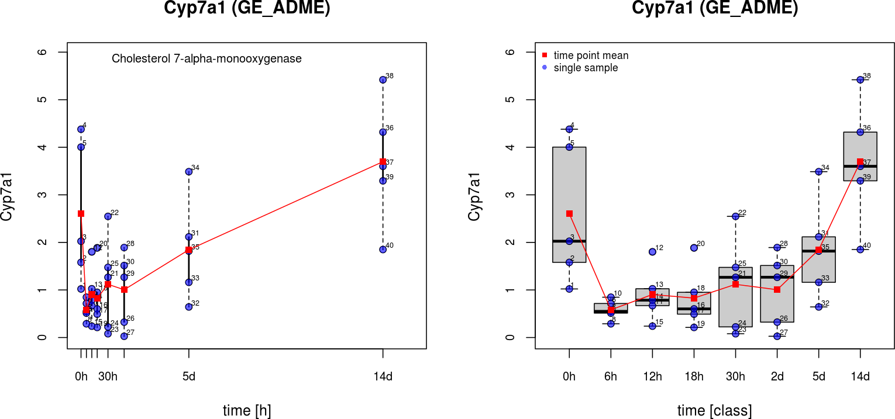

“In the liver, bile acids activate a nuclear receptor, farnesoid

X receptor (FXR), that induces an atypical nuclear

receptor small heterodimer partner, which subsequently inhibits nuclear receptors, liver-related homolog-1, and hepatocyte nuclear factor 4 and results in inhibiting transcription of the critical regulatory gene in bile acid synthesis, cholesterol 7-hydroxylase (CYP7A1). {Chiang2009}”

“In the classic bile acid synthesis pathway, cholesterol is converted into 7-hydroxycholesterol by cholesterol 7-hydroxylase, a microsomal cytochrome P450 enzyme

(CYP7A1) expressed only in the liver.” {Russel2003}

“It has been known since the late 1960s that the amount of bile acid synthesized

by the liver is regulated precisely (103, 104). When bile acids accumulate,

synthesis is reduced by a negative feedback mechanism that decreases the

expression of two enzymes in the biosynthetic pathway, cholesterol 7-hydroxylase

(Figure 1, reaction 1) and sterol 12-hydroxylase (Figure 2, reaction 8).

Conversely, cholesterol accumulation induces bile acid synthesis by activating

cholesterol 7-hydroxylase in some but not all species. The regulatory responses

of cholesterol 7-hydroxylase were shown to be mediated at the transcriptional

level in the late 1980s (2).” {Russel2003}

**Bilirubin**

Comparabal to {Huss2010}, Increase and than.

**TNF-alpha**

“Bile acids stimulate

secretion of pro-infl ammatory cytokines, tumor necrosis

factor (TNF ), and interleuken-1 (IL-1 ) from Kupffer

cells (resident macrophages in hepatocytes) that activate

TNF receptor signaling and the mitogen-activated protein

kinase (MAPK)/JNK pathway ( 25, 26 ).” {Chiang2009}

**Sirius Red, Colagen**

Highly significant changes in **Col3a1** and **Col1a1** (liver fibrotic marker).

TODO: Test selected differences between 0 and 14d

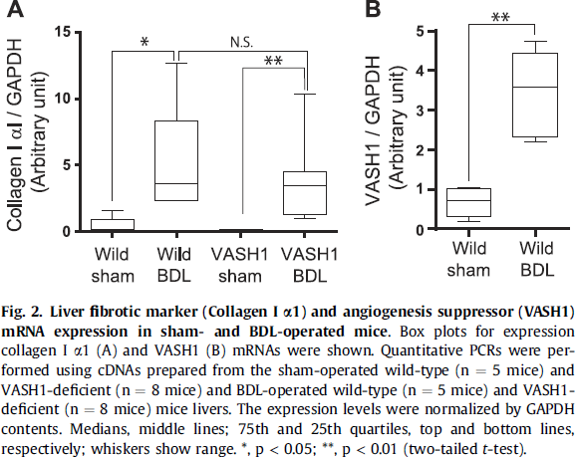{Futurani2015}

**ALT**

{Huss2010}

TODO: top pairwise changes between

0 - 6h

0 - 14d (alternative Collagens)

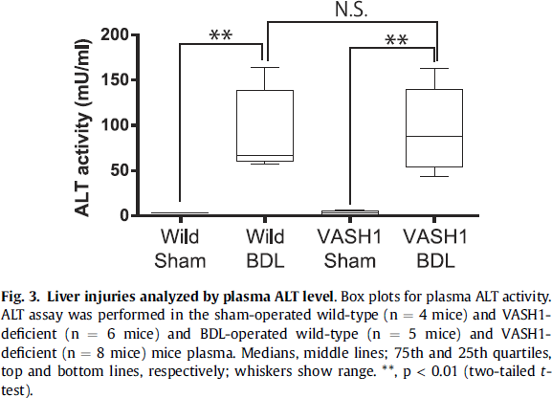{Futurani2015}

**Ugt1a1**

**Sul1a1**

**Fn1, fibronectin**

{Shen2015} 6.2 fold increase in 15d BDL, with much higher fibrosis (>15% of total field area)

Compared increase and decrease in data.

**SHP** **(Nr0b2)**

|  |  |  |  |  |
| --- | --- | --- | --- | --- |
| **Nr0b2** | [Q62227](http://www.uniprot.org/uniprot/Q62227) | NR0B2_MOUSE | **Nuclear receptor subfamily 0 group ...** | **Nr0b2, Shp** |

“Because of its toxicity in excess amounts, BA synthesis is tightly controlled by a negative feedback mechanism. BAs bind farnesoid X receptor (FXR) in hepatocytes (Makishima et al.,

1999; Parks et al., 1999) and transactivate small heterodimer partner (SHP) to repress the expression of Cyp7a1 that encodes cholesterol 7a-hydroxylase, the rate-limiting enzyme for BA synthesis (Lu et al., 2000). FXR knockout (KO) mice displayed

increased BA levels, higher plasma cholesterol, phospholipids,

and triglycerides and were more susceptible to cholesterolinduced

hepatic steatosis (Anakk et al., 2011; Sinal et al.,

2000). However, SHP deletion rendered only a mild increase of

the BA pool size in mice (Kerr et al., 2002), and SHP KO mice

were protected from liver damage induced by cholesterol and

BA diet (Wang et al., 2003). These observations suggest SHP independent

pathways in the control of Cyp7a1 expression.

Consistently, FXR and SHP double-knockout (DKO) mice displayed

early-onset cholestasis, more severe liver damage, and

higher BA synthesis than mice with loss of either gene alone

(Anakk et al., 2011). {Li2014}”

**Cyp24a1**

|  |  |  |  |
| --- | --- | --- | --- |
| **Cyp24a1** | [**Q64441**](http://www.uniprot.org/uniprot/Q64441) | **CP24A_MOUSE** | **1,25-dihydroxyvitamin D(3) 24-hydro...** |

**VDR Vitamin D3**

“Cyp24a1 Has a role in maintaining **calcium homeostasis**. Catalyzes the NADPH-dependent 24-hydroxylation of calcidiol (25-hydroxyvitamin D3) and calcitriol (1-alpha,25-dihydroxyvitamin D3). The enzyme can perform up to 6 rounds of hydroxylation of calcitriol leading to calcitroic acid. {Uniprot}”

|  |  |  |  |
| --- | --- | --- | --- |
| **Abcb1a** | [P21447](http://www.uniprot.org/uniprot/P21447) | MDR1A_MOUSE | **Multidrug resistance protein 1A** |

|  |  |  |  |  |
| --- | --- | --- | --- | --- |
| **Abcg2** | [**Q7TMS5**](http://www.uniprot.org/uniprot/Q7TMS5) | **ABCG2_MOUSE** | **ATP-binding cassette sub-family G m...** | **Abcg2, Abcp, Bcrp1** |
| **Abcc2** | [**Q8VI47**](http://www.uniprot.org/uniprot/Q8VI47) | **MRP2_MOUSE** | **Canalicular multispecific organic a...** | **Abcc2** |

**MDR1A, MRP2**

**LXRA (Nr1h3) Liver X Receptor alpha)**

“That cholesterol could induce the expression of cholesterol 7-hydroxylase and

hence bile acid synthesis was initially controversial; however, the isolation of

cDNAs encoding this enzyme allowed an unambiguous demonstration that this is

the case in rats (7) and mice (137). Substrate mediated induction occurs via

LXR, which binds oxysterol ligands and induces transcription of the cholesterol

7-hydroxylase gene (109–111).” {Russel2003}

“Mice deficient in LXR appear phenotypically normal until challenged with

diets high in cholesterol, which cause dramatic accumulation of the sterol in the

liver and eventually death (139). The mutant mice fail to induce cholesterol

7-hydroxylase and thus are unable to convert excess cholesterol into bile acids.” {Russel2003}

**PXR**

|  |  |  |  |  |
| --- | --- | --- | --- | --- |
| **Nr1i2** | [**O54915**](http://www.uniprot.org/uniprot/O54915) | **NR1I2_MOUSE** | **Nuclear receptor subfamily 1 group ...** | **Nr1i2, Pxr** |

“Bile acids also bind and activate **PXR [20]** and VDR [21]. These two receptors play important

roles in detoxification of bile acids, drugs, and xenobiotics [20, 22, 23].” {Chiang2009}

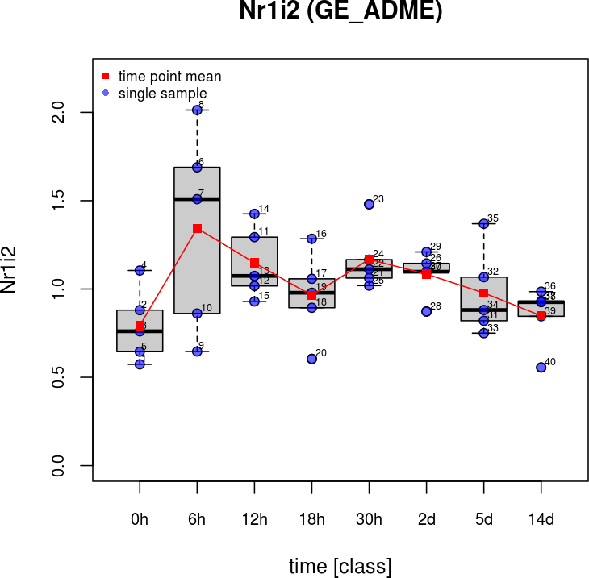

|  |  |  |  |
| --- | --- | --- | --- |
| **Vdr** | [**P48281**](http://www.uniprot.org/uniprot/P48281) | **VDR_MOUSE** | **Vitamin D3 receptor** |

“Bile acids also bind and activate PXR [20] and **VDR [21]**. These two receptors play important

roles in detoxification of bile acids, drugs, and xenobiotics [20, 22, 23]. {Chiang2009}”

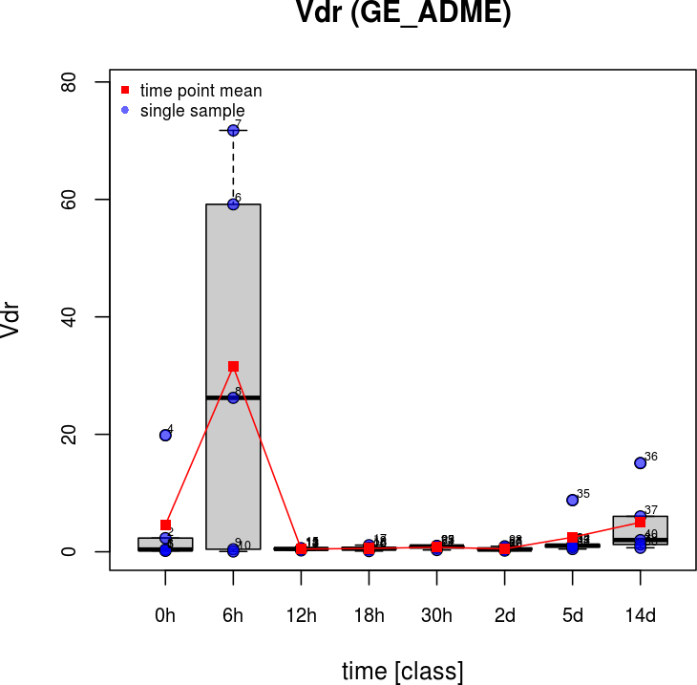

**Cholesterol genes**

**Ch25h (Cholesterol 25-hydroxylase)**

# Top pairwise