Software Tool Article

cy3sabiork: A Cytoscape app for visualizing kinetic records from SABIO-RK

*Matthias König¹\**

1Humboldt-University Berlin, Institute for Theoretical Biology, Invalidenstraße 43, 10115 Berlin, Germany

*Corresponding author: konigmatt@googlemail.com

# Abstract

Cy3sabiork is a Cytoscape 3 app for the visualization of kinetic records from SABIO-RK. This visualization method allows for easy comparison of kinetic data, visual inspection of the elements involved in the kinetic record and simple access to the annotation information of the kinetic record. Cy3sabiork uses the SBML exchange format building on cy3sbml functionality. A seamless integration with the SABIO-RK webservice is provided which allows direct queries from within Cytoscape. Alternatively advanced queries can be performed on the SABIO-RK web page and the results be exported as SBML which then is imported using cy3sabiork. The results can be exported as a high quality vector image.

# Keywords

Data display, Graphical user interfaces, Web service, SABIO-RK, kinetic parameters.

# Introduction

*Importance of kinetic information for computational modelling.*

One of the main challenges in kinetic modeling of biochemical systems is the availability of reliable parameters from the literature.

Importance of clear definition of experimental conditions, sources of the kinetic parameter, … []

*SABIO-RK*

* Sources: BRENDA [REF], literature, SABIO-RK ) {Wittig2012}
* With the 10 year anniversary of SABIO-RK it is an established resource in the kinetic modelling community.

*SBML*

The Systems Biology Markup Language (SBML) is a free and open interchange format for computer models of biological processes {Hucka2003}. SABIO-RK provides access to the kinetic information in SBML format either (I) by export of SBML from the SABIO-RK webpage (<http://sabiork.h-its.org/>) after searching and selecting kinetic records, or (II) by SBML return of kinetic records via web service queries (<http://sabiork.h-its.org/layouts/content/webservices.gsp>).

*Semantic annotations & Knowledge Integration*

The annotation information and semantic layer accessible to the user and linking these data to additional web resources. SBML can be annotated based on Minimum Information Required for the Annotation of Models (MIRIAM; {Laibe2007}), a set of controlled vocabularies in systems biology.

The annotation information in form of RDF-based MIRIAM annotations and XML based SABIO-RK annotations of the kinetic records are made accessible. Hyperlinks to the annotated online resources are provided, like for instance to CHeBI, UniProt, Pubmed, SABIO-RK, or KEGG. In this way, information from a wide range of resources and databases is integrated with the graph visualization of the kinetic records. This allows for instance direct access to the publication from which the kinetic information was retrieved or the Protein for which the kinetic information was measured.

*What is problem and what is solution!*

Despite the importance of kinetic information for modelling there is no easy way to visualize the kinetic information from kinetic records in SABIO-RK. There is currently no visualization tool enabling the visualization of kinetic records from SABIO-RK. Therefore, we developed the Cytoscape app cy3sabiork, that takes advantage of the web service and SBML export from SABIO-RK for importing and displaying graphs of the kinetic records in Cytoscape. We applied cy3sabiork for the search of kinetic parameters for the galactose metabolism in Human liver.

# **Methods and implementation**

# **Implementation**

Cy3sabiork was written in Java as an OSGi bundle. It adds a “cy3sabiork” tab with specific functionality to the Cytoscape “Results Panel”. Kinetic records are retrieved in SBML format either via the SABIO-RK web page export or the cy3sabiork web service queries. The data import functionality is implemented as a Cytoscape Task using the registered cy3sbml {Koenig2012} SBMLReaderTask via the Cytoscape LoadNetworkFileTaskFactory. The cy3sbml SBML reader was extended to support the SABIO-RK specific SBML annotations.

# **Operation**

Visualizing kinetic records data with cy3sabiork consists of four main steps:

(I) …

(II) ..

(III) …

(IV) ...

# **Use case**

We used cy3sabiork for the model building of galactose metabolism of the human liver. Example queries and results are shown in Figure 1. Via the SABIO-RK curation service the kinetic parameters used in the model could be integrated in the database and are now easily accessible via the web service.

TODO: discuss galactose metabolism, provide draft SBML with kinetic record annotations.

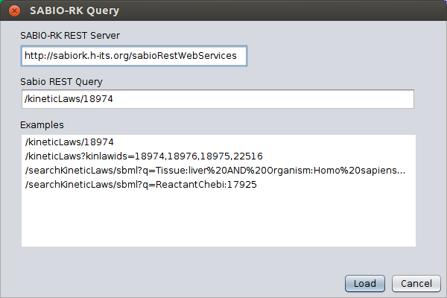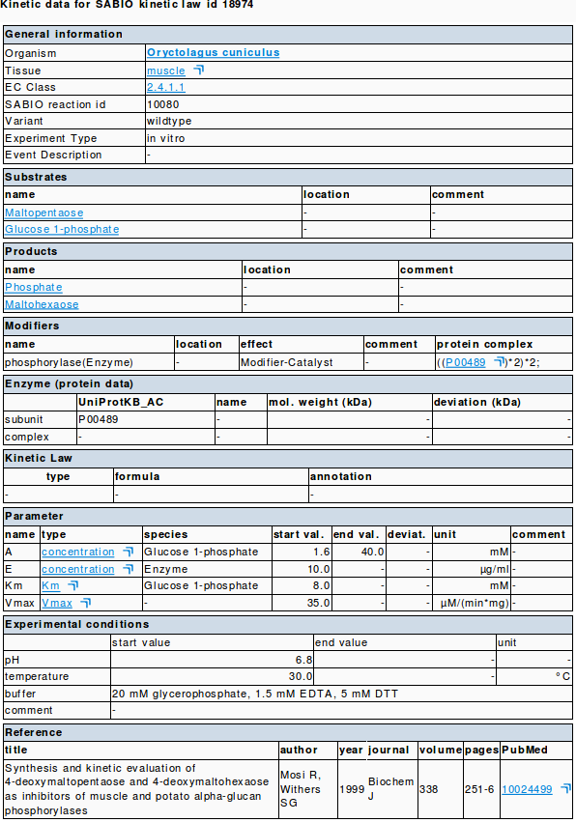

Figure 1. cy3sabiork GUI for webservice queries. TODO: update GUI & integrate with app

<http://sabiork.h-its.org/kineticLawEntry.jsp?viewData=true&kinlawid=18974>

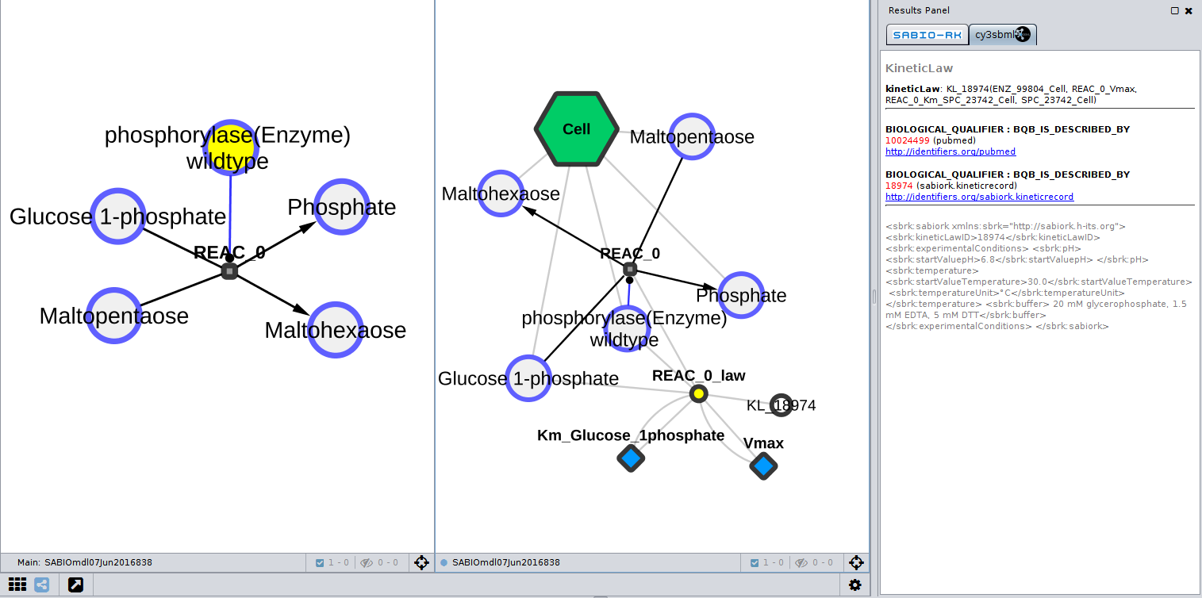

Figure 2. Resulting SBML species-reaction graph (left) and kinetic graph (right) for query /kineticLaws/18974.A single kinetic record is retrieved via the web services and imported using cy3sbml.

# Conclusion

cy3sabiork allows easy visual analysis of kinetic records from SABIO-RK kinetic records. Especially the availability of direct links to the SABIO-RK database and ontology annotations of the kinetic records provide additional knowledge integration.

# Data and software availability

cy3sabiork is freely available from the Cytoscape app store <http://apps.cytoscape.org/apps/cy3sabiork>. The code is open source under GNU General Public License, version 3 (GPL-3.0) license available at <https://github.com/matthiaskoenig/cy3sabiork>.

# Author contributions

MK developed the app and wrote the manuscript.

# Competing interests

No competing interests.

# **Grant information**

This work was supported by the Federal Ministry of Education and Research (BMBF, Germany) within the research network Systems Medicine of the Liver (LiSyM) [grant number 031L0054] and the Virtual Liver Network VLN [grant number 0315741].

# Acknowledgements

We thank the SABIO-RK team, the SBML community, and Cytoscape community for their support and help.

# **Supplementary material**

Supplementary File S1: SBML file for use case examples web service query: TODO

# **References**

Hucka, M., Finney, A., Sauro, H. M., Bolouri, H., Doyle, J. C., Kitano, H., et al. (2003). The systems biology markup language (SBML): a medium for representation and exchange of biochemical network models. *Bioinformatics*, *19*(4), 524-531.

Laibe, C., & Le Novère, N. (2007). MIRIAM Resources: tools to generate and resolve robust cross-references in Systems Biology. *BMC Systems Biology*, *1*(1), 58.

König, M., Dräger, A., & Holzhütter, H. (2012). CySBML: a Cytoscape plugin for SBML. *Bioinformatics*, *28*(18), 2402-2403.

Wittig, U., Kania, R., Golebiewski, M., Rey, M., Shi, L., Jong, L., et al. (2012). SABIO-RK—database for biochemical reaction kinetics. *Nucleic acids research*, *40*(D1), D790-D796.