Systems biology
cy3sbml: a Cytoscape app for SBML
Matthias König^{1,*}, Nicolas Rodriguez2 and Andreas Dräger²
¹Institute of Biochemistry, University Medicine Charité Berlin, Berlin, Germany
²Center for Bioinformatics Tuebingen (ZBIT), University of Tuebingen, Tübingen, Germany
Received on XXXXX; revised on XXXXX; accepted on XXXXX

Associate Editor: XXXXXXX

abstract
Summary: CySBML is a plugin for the work with SBML in Cytoscape having the following features: SBML import, support of the SBML Layout and Qualitative Model packages, navigation in network layouts based on SBML structure, access to MIRIAM and SBO-based annotations, and SBML validation. CySBML includes an importer for BioModels to load SBML from standard repositories.
Availability and implementation: Freely available for non-commercial purposes via the Cytoscape plugin manager or for download at http://sourceforge.net/projects/cysbml/.
Contact: matthias.koenig@charite.de
Supplementary information: Tutorial, usage guide, installation instructions and additional figures are available at http://www.charite.de/sysbio/people/koenig/software/cysbml/.

introduction
The SBML (Systems Biology Markup Language) is a free and open interchange format for computer models of biological processes (Hucka, et al., 2003) currently supported by over 230 software tools [March 2012]. SBML is used to represent models for a wide range of cell biology, including cell signaling, metabolism and gene regulation. SBML provides a common standard of interoperability and exchange allowing several researchers to work with diverse tools on building, curation, annotation, simulation, analysis, and visualization of the same model. Standard repositories of SBML models such as BioModels (Li, et al., 2010) have been established, providing annotated models on a molecular level for a wide range of biological questions with access to their resources via web services (Li, et al., 2010). However, preserving models without the semantic layer of information needed for an unambiguous identification and interpretation of model components is meaningless (Courtot, et al., 2011). To this end, SBML can be annotated based on MIRIAM (Minimum Information Required for the Annotation of Models) (Laibe and Novère, 2007) and SBO (Systems Biology Ontology) (Novère, 2006; Novère, 2006), a set of controlled vocabularies in systems biology.
Cytoscape (Shannon, et al., 2003), a widely used open-source platform for complex network analysis and visualization, currently only provides rudimentary SBML capabilities: Its application to SBML models is limited to a subset of SBML: The SBML document structure is inaccessible for visualization, validation of SBML files is not possible, and neither the information from SBO or MIRIAM annotation nor SBML packages for layout information or qualitative models are supported.

Description
We present CySBML, a Cytoscape SBML plugin based on JSBML (Dräger, et al., 2011), a free, open-source Java™ library for SBML. CySBML supports all versions and levels of SBML, handles models in SBML and the SBML Qualitative Model format, includes validation of imported SBML files, provides a navigation menu based on SBML structure and easy access to BioModels via web services (Figure 1).
CySBML utilizes layout information encoded via the SBML Layout extension (Gauges, et al., 2006) or alternatively applies standard layouts based on visual styles optimized for the bipartite species/reaction model underlying SBML. Species and reactions are assigned to different visualization classes with nodes being color coded according to their SBML compartment.
Special focus was put on making annotation information and the semantic layer accessible to the user and linking these data to additional web resources (Figure 1). All functions of CySBML are available with one or two clicks via the Cytoscape menu bar. CySBML was successfully tested with all networks from the SBML Test Suite [version 2.0.2] and BioModels [release 21].
CySBML reads RDF-based MIRIAM annotations of the SBML elements and provides access to the annotated resources within the network visualization (Figure 1). Clicking at links to online annotation resources and databases opens additional information in the browser. In this way, information from a wide range of resources and databases can be integrated within the visualization.
SBML files from BioModels can be imported either by their identifier or searched via name or authors (see import dialog in Figure 1). Multiple models can be imported at once for comparative analysis.
Validation of the imported and loaded SBML is available via the menu bar. Validation results can be filtered with respect to warnings and error types. SBML annotation, BioModel import and SBML validation are based on web services and therefore require an internet connection.

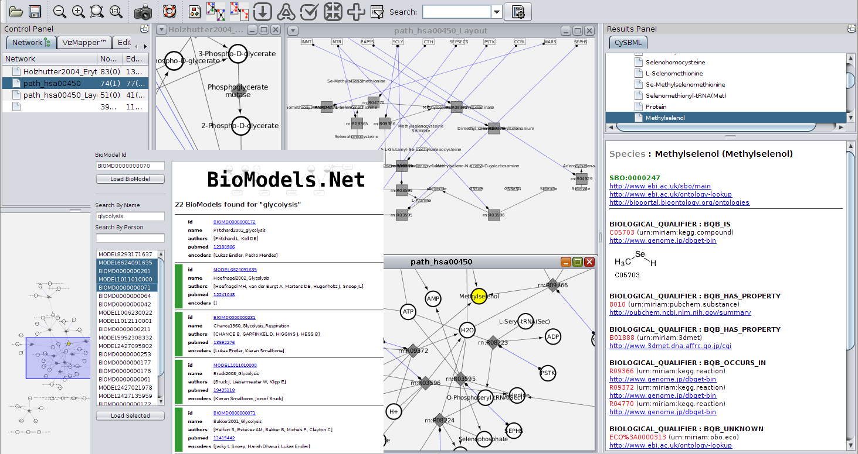
Fig. 1. CySBML interface. SBML models can be imported using the BioModels import dialog (left) via search by name, person or identifier. The example shows the search results for the glycolysis models. Visualizations for the imported models are generated in the central Cytoscape area based on information on the SBML Layout extension or generic layout algorithms. Thereby, layouts can be reused between software tools like in the example the seleno compound metabolism layout (KEGG pathway MAP00450) (middle). Direct access to SBML annotations of selected network nodes is provided via the CySBML annotation window (right). After selection of nodes in the network or the SBML structure (top right) the MIRIAM and SBO resources are loaded. In the shown example, among others, Methylselenol information from CHEBI, PUBCHEM, 3DMET and ECO with the corresponding direct links to the web pages of the original resources. Multiple models can be loaded for comparative analysis and are accessible via the Control Panel (top left).

Conclusion
CySBML combines SBML, the standard format of models of biological processes, with Cytoscape, one of the standard platforms for the visualization of biological networks. Cytoscape has already been used in numerous applications for visualization and graphical network analyses, whereas the BioModels database collects and annotates structural and mathematical models in SBML format that provide insights into the dynamic behavior of biological networks. Now, CySBML makes it possible to combine these two important systems biological resources in a convenient and easily usable way with special focus on the semantic layer defining the models.
This work now opens the door for the development of further plugins facilitating the analysis of SBML models in Cytoscape.
Acknowledgements
We want to thank Camille Laibe for implementing additional BioModel WebService functionality, the Qual Team and Finja Büchel, Florian Mittag, and Nicolas Rodriguez (Qual implementation in JSBML), Sebastian Fröhlich and Clemens Wrzodek (Layout support in JSBML) as well as Michael Weidlich and Christian Bölling for testing CySBML.

Funding: This work was supported by the Federal Ministry of Education and Research (BMBF, Germany) within the Virtual Liver Network [grant numbers 0315756 and 0315741].

Conflict of Interest: none declared
References
Courtot, M., Juty, N., Knüpfer et al. (2011) Controlled vocabularies and semantics in systems biology, Mol Syst Biol, 7, 543.
Dräger, A., Rodriguez, N., Dumousseau, M., Dörr, A., Wrzodek, C., Le Novère, N., Zell, A. and Hucka, M. (2011) JSBML: a flexible Java library for working with SBML, Bioinformatics, 27, 2167--2168.
Gauges, R., Rost, U., Sahle, S. and Wegner, K. (2006) A model diagram layout extension for SBML, Bioinformatics, 22, 1879-1885.
Hucka, M., Finney, A., Sauro, H.M., Bolouri et al. (2003) The systems biology markup language (SBML): a medium for representation and exchange of biochemical network models, Bioinformatics, 19, 524--531.
Laibe, C. and Le Novère, N. (2007) MIRIAM Resources: tools to generate and resolve robust cross-references in Systems Biology, BMC Syst Biol, 1, 58.
Li, C., Donizelli, M., Rodriguez, N., Dharuri, H., Endler, L., Chelliah, V., Li, L., He, E., Henry, A., Stefan, M.I., Snoep, J.L., Hucka, M., Le Novère, N. and Laibe, C. (2010) BioModels Database: An enhanced, curated and annotated resource for published quantitative kinetic models, BMC Syst Biol, 4, 92.
Le Novère, N. (2006) Adding semantics in kinetics models of biochemical pathways. . In Hicks, K. (ed), 2nd International ESCEC Workshop. ESEC. Beilstein Institut, Rüdesheim, Germany, Rüdessheim/Rhein, Germany, p. 137-153.
Le Novère, N. (2006) Model storage, exchange and integration, BMC Neurosci, 7 Suppl 1, S11.
Shannon, P., Markiel, A., Ozier, O., Baliga, N.S., Wang, J.T., Ramage, D., Amin, N., Schwikowski, B. and Ideker, T. (2003) Cytoscape: a software environment for integrated models of biomolecular interaction networks, Genome Res, 13, 2498-2504

