|  |
| --- |
| *Systems biology*  **cy3sbml: a Cytoscape app for SBML**  Matthias König1,*, Nicolas Rodriguez2 and Andreas Dräger3  1Institute for Theoretical Biology, Humboldt University Berlin, Berlin, Germany  2  3Center for Bioinformatics Tuebingen (ZBIT), University of Tuebingen, Tübingen, Germany  Received on XXXXX; revised on XXXXX; accepted on XXXXX  Associate Editor: XXXXXXX |

**ABSTRACT**

**Summary:** cy3sbml is a Cytoscape 3 app for the work with SBML following features: SBML import; support of the SBML Layout, Qualitative Model, Groups, Hierachical Model Composition and Flux Balance Constraints packages, navigation in network layouts based on SBML structure, access to MIRIAM and SBO-based annotations, and SBML validation. cy3sbml includes importer for BioModels and BiGG models to load SBML from standard repositories.

**Availability and implementation:** Freely available for non-commercial purposes from the Cytoscape App Store <http://apps.cytoscape.org/apps/cy3sbml>**.**

**Contact:** [konigmatt@googlemail.com](mailto:konigmatt@googlemail.com)

**Supplementary information:** Source code and additional information at <https://github.com/matthiaskoenig/cy3sbml/>.

# **INTRODUCTION**

The SBML (Systems Biology Markup Language) is a free and open interchange format for computer models of biological processes {Hucka2003} currently supported by over 280 software tools [July 2016]. SBML is used to represent models for a wide range of cell biology, including cell signaling, metabolism and gene regulation. SBML provides a common standard of interoperability and exchange allowing several researchers to work with diverse tools on building, curation, annotation, simulation, analysis, and visualization of the same model. Standard repositories of SBML models such as BioModels {Li2010, Juty2015} have been established, providing annotated models on a molecular level for a wide range of biological questions with access to their resources via web services {Li2010}. However, preserving models without the semantic layer of information needed for an unambiguous identification and interpretation of model components is meaningless {Courtot2011}. To this end, SBML can be annotated based on MIRIAM (Minimum Information Required for the Annotation of Models) {Laibe2007} and SBO (Systems Biology Ontology) {Novere2006}, a set of controlled vocabularies in systems biology.

Cytoscape {Shannon2003}, a widely used open-source platform for complex network analysis and visualization, currently only provides rudimentary SBML capabilities: Its application to SBML models is limited to a subset of SBML: The SBML document structure is inaccessible for visualization, validation of SBML files is not possible, and neither the information from SBO or MIRIAM annotation nor SBML packages for layout information or qualitative models are supported.

Important developments in SBML and Cytoscape have taken place since the initial release of CySBML for Cytoscape 2 {Koenig2012}:

SBML

* release of package for Hierachical Model Composition (comp) {REF}
* release of package for Groups (groups) {REF}
* release of package for Flux Balance Constraints (fbc) {REF}

With the release of Cytoscape 3

* major update in infrastructure (OSGI, service model, maven)
* New features, including new user interfaces, advanced visualization functions, headless (command-line) distribution, RESTful API, and GPU support. Cytoscape v3, which refactored major internal data models and greatly improved support for third party plugin applications (via the App Store, semantic versioning disciplines, published APIs, and code management via OSGi). Visual styles (VizMapper), fast node filtering, network capacity, and overall speed and UI consistency and new Network Viewer.

Here, we report cy3sbml an app for SBML in Cytoscape 3. In addition to porting all functionality to the new Cytoscape 3 architecture a multitude of new features have been implemented since the initial release for Cytoscape 2

* support of the additional released SBML packages comp and groups, and support for fbc v2 and latest SBML specification (L2V5 and L3V1)
* Implementation of a kinetic network graph giving access not only to the species-reaction graph, but the full SBML information
* Integration with additional annotation information using annotation information
* integration with additional apps and systems biology workflows via OSGI APIs and commands available via CyREST
* BiGG integration
* redesign of GUI using web technology (JavaFx WebView)
* Simple installation via app store

# **DESCRIPTION**

We present cy3sbml, a Cytoscape 3 app for SBML based on JSBML {Draeger2011, Rodriguez2015}, a free, open-source Java™ library for SBML. cy3sbml ports all major features from Cytoscape 2 to Cytoscape 3, i.e. supports all versions and levels of SBML, handles models in SBML and the SBML Qualitative Model format, includes validation of imported SBML files, and easy access to BioModels and BiGG via web services.

Many additional features have been implemented: comp, groups and fbc v2 support, full kinetic networks providing access not only to species and reactions but to parameters and kinetics. A full set of examples is now included with cy3sbml directly accessible from the menu.

*layout & networks*

cy3sbml utilizes layout information encoded via the SBML Layout extension {Gauges2006}or alternatively applies standard layouts based on visual styles optimized for the bipartite species/reaction model underlying SBML. Species and reactions are assigned to different visualization classes with nodes being color coded according to their SBML compartment.

* now full kinetic graph with access to parameters, kinetic laws, function definitions, compartments, ...
* cofactor nodes
* additional visual styles (SBML information available as node and edge attributes which can be used in the VisualMappings)

cy3sbml was successfully tested with all networks from the SBML Test Suite [version 3.1.1], BioModels [release 30], and BiGG models [release v1.2] {King2016}.

*fbc, groups, comp*

*annotation*

Special focus was put on making annotation information and the semantic layer accessible to the user and linking these data to additional web resources. cy3sbml reads RDF-based MIRIAM annotations of the SBML elements and provides access to the annotated resources within the network visualization (**Figure 1**). Clicking at links to online annotation resources and databases opens additional information in the browser. In this way, information from a wide range of resources and databases can be integrated within the visualization. Key information for the RDF annotations are retrieved via the REST interface of the Ontology Lookup Service (OLS) {Jupp2015}, like terms and term definitions.

*model import*

SBML files from BioModels can be imported either by their identifier or searched via name or authors. Multiple models can be imported at once for comparative analysis. In addition BiGG models can now be imported directly via the BiGG web service.

*model validation*

Validation of the imported and loaded SBML is available via the menu bar. Validation results can be filtered with respect to warnings and error types.

*API & integration*

cy3sbml is now implemented as an OSGI bundle providing an API for other apps to consume (or via python/R and CyREST). This provides easy integration with additional functionality, like using it for the visualization of kinetic information from SABIO-RK {Wittig2012} {Koenig2016} via the cy3sbml API.

*GUI redesign*

Redesign and implementation of the information display based on JavaFX.

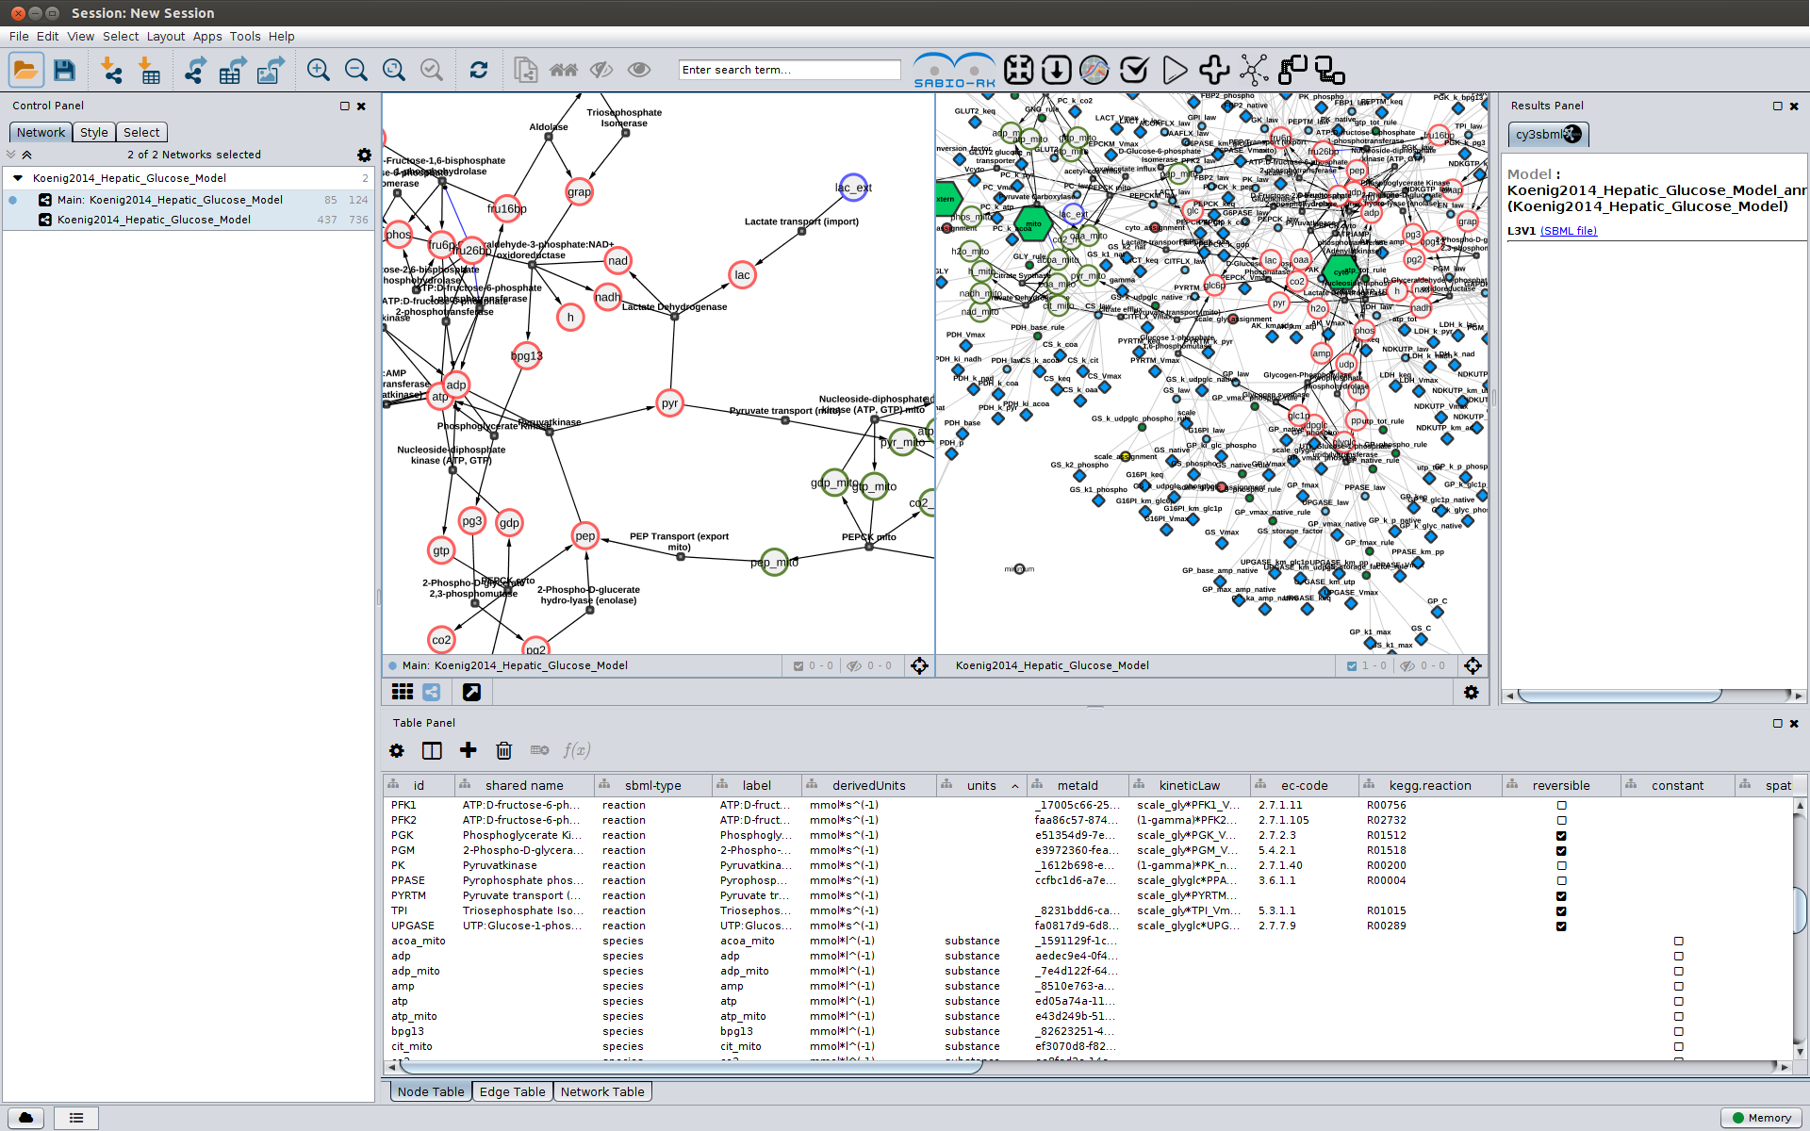

**Fig. 1.** CySBML interface. Example SBML for hepatic glucose metabolism of the Human liver from {Koenig2012}. SBML file is provided as **Supplementary File 1**.

# CONCLUSION

cy3sbml combines SBML, the standard format of models of biological processes, with Cytoscape, one of the standard platforms for the visualization of biological networks. With this release all functionality from the original plugin {Koenig2012}, like support for SBML groups, fbc and comp model.

The provided API/OSGI allows ...

# ACKNOWLEDGEMENTS

We thank the SBML community for their help and support.

*Funding*: MK is supported by the Federal Ministry of Education and Research (BMBF, Germany) within the research network Systems Medicine of the Liver (LiSyM) (grant number 031L0054) and Virtual Liver Network (grant number 0315756), and by the National Resource for Network Biology (NRNB) within the NRNB Academy Summer Session 2015.

NR is supported …

AD is supported ...

*Conflict of Interest*: none declared

# REFERENCES

Courtot, M., Juty, N., Knüpfer et al. (2011) Controlled vocabularies and semantics in systems biology, Mol Syst Biol, 7, 543.

Dräger, A., Rodriguez, N., Dumousseau, M., Dörr, A., Wrzodek, C., Le Novère, N., Zell, A. and Hucka, M. (2011) JSBML: a flexible Java library for working with SBML, Bioinformatics, 27, 2167--2168.

Gauges, R., Rost, U., Sahle, S. and Wegner, K. (2006) A model diagram layout extension for SBML, Bioinformatics, 22, 1879-1885.

Hucka, M., Finney, A., Sauro, H.M., Bolouri et al. (2003) The systems biology markup language (SBML): a medium for representation and exchange of biochemical network models, Bioinformatics, 19, 524--531.

Jupp, S., Burdett, T., Malone, J., Leroy, C., Pearce, M., McMurry, J., & Parkinson, H. (2015). A New Ontology Lookup Service at EMBL-EBI. In *Proceedings of SWAT4LS International Conference*.

King, Z. A., Lu, J., Dräger, A., Miller, P., Federowicz, S., Lerman, J. A., et al. (2016). BiGG Models: A platform for integrating, standardizing and sharing genome-scale models. *Nucleic acids research*, *44*(D1), D515-D522.

König, M., Bulik, S., & Holzhütter, H. (2012). Quantifying the contribution of the liver to glucose homeostasis: a detailed kinetic model of human hepatic glucose metabolism. *PLoS Comput Biol*, *8*(6), e1002577.

König, M., Dräger, A., & Holzhütter, H. (2012). CySBML: a Cytoscape plugin for SBML. *Bioinformatics*, *28*(18), 2402-2403.

König, M. (2016) cy3sabiork: A Cytoscape app for the visualization of kinetic data from SABIO-RK [submitted]

Laibe, C. and Le Novère, N. (2007) MIRIAM Resources: tools to generate and resolve robust cross-references in Systems Biology, BMC Syst Biol, 1, 58.

Li, C., Donizelli, M., Rodriguez, N., Dharuri, H., Endler, L., Chelliah, V., Li, L., He, E., Henry, A., Stefan, M.I., Snoep, J.L., Hucka, M., Le Novère, N. and Laibe, C. (2010) BioModels Database: An enhanced, curated and annotated resource for published quantitative kinetic models, BMC Syst Biol, 4, 92.

Le Novère, N. (2006) Model storage, exchange and integration, BMC Neurosci, 7 Suppl 1, S11.

Rodriguez, N., Myers, C., Hucka, M., & Dräger, A. (2015). JSBML 1.0: providing a smorgasbord of options to encode systems biology models

Shannon, P., Markiel, A., Ozier, O., Baliga, N.S., Wang, J.T., Ramage, D., Amin, N., Schwikowski, B. and Ideker, T. (2003) Cytoscape: a software environment for integrated models of biomolecular interaction networks, Genome Res, 13, 2498-2504

Wittig, U., Kania, R., Golebiewski, M., Rey, M., Shi, L., Jong, L., et al. (2012). SABIO-RK—database for biochemical reaction kinetics. *Nucleic acids research*, *40*(D1), D790-D796.

# OPEN ISSUES

[Milestone 0.2.5](https://github.com/matthiaskoenig/cy3sbml/milestones/0.2.5) for manuscript

* RDF annotation via REST  
  <https://github.com/matthiaskoenig/cy3sbml/issues/8>
* full comp support  
  <https://github.com/matthiaskoenig/cy3sbml/issues/34>
* groups support  
  <https://github.com/matthiaskoenig/cy3sbml/issues/70>
* layout support  
  <https://github.com/matthiaskoenig/cy3sbml/issues/71>
* BiGG access  
  <https://github.com/matthiaskoenig/cy3sbml/issues/104>
* API (commands, cyREST, OSGI)  
  <https://github.com/matthiaskoenig/cy3sbml/issues/18>
* JavaFX console  
  <https://github.com/matthiaskoenig/cy3sbml/issues/72>
* cofactor nodes  
  <https://github.com/matthiaskoenig/cy3sbml/issues/47>
* Documentation  
  <https://github.com/matthiaskoenig/cy3sbml/issues/82>  
  <https://github.com/matthiaskoenig/cy3sbml/issues/33>