A Reduced Model of Hepatic Glucose Metabolism for Incorporation in Tissue-Scale Liver Models
M. König & H.G. Holzhütter
Institute of Biochemistry, University Medicine Charité Berlin, Virchowweg 6, 10117 Berlin, Germany, E-mail: matthias.koenig@charite.de, hergo@charite.de

Abstract
——

Introduction
The liver is a vital organ in vertebrates and some other animals and plays a key metabolic role for the whole body. Main metabolic functions are detoxification, protein synthesis and metabolic homeostasis. Of special importance is the homeostasis of blood glucose due to the ability of the liver to store glucose as hepatic glycogen and to switch between hepatic glucose production (HGP) under hypoglycemic conditions and hepatic glucose utilization (HGU) under hyperglycemia . Hepatocytes, the main cell type of the liver, are the central place of metabolism. The processes of hepatic metabolism on the microscale (cell level) are modeled via a system of ordinary differential equations. The reduced model was developed originally developed for a continuum multiphasic model (i.e., a solid filled with fluid, both phases containing multiple concentrations) for the description of perfusion and metabolism in the liver.

Incorporation of the cell metabolism
As a proof of principle for the integration of cellular metabolism into a tissue-level model of blood perfusion and substrate supply we combined a reduced model of hepatic glucose metabolism with the 3D-FEM model for anisotropic perfusion (Ricken et al, 2013; in preparation).
The reduced metabolic model has been derived from a detailed kinetic model of hepatic glucose metabolism (König, et al., 2012). It fully replicates the quasi-stationary behaviour of the detailed model i.e. uptake or release rate of glucose depending on the blood glucose concentration (see Figure M1). The reduced model comprises as variables the 3 central metabolites of hepatic glucose metabolism:blood glucose (glc_{ext}), blood lactate (lac_{ext}) and hepatic glycogen (glyc). The levels of these metabolites are governed by effective reactions: v_{HGU} (hepatic glucose utilization/hepatic glucose production), v_{GS} (glycogen synthesis/glycogenolysis) and v_{GLY} (glycolysis/gluconeogenesis). The kinetics of the effective reactions is described by polynomial regression functions of third order p(glc_{ext}, glyc, lac_{ext}) which were fitted to the steady state response of the detailled kinetic model (Figure M2).

=
The resulting ordinary differential equations are
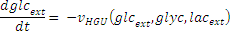
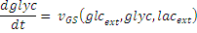
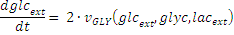
The polynomial fit of the steady-state responses is possible because the detailed kinetic model reaches quasi steady-state within minutes, much faster than the simulated timescales of rapid changes on the tissue/organ scale model.
Interestingly, the reduced model is able to reproduce the main model features and behavior of the full model in the physiological range,like the ability to switch between hepatic glucose production (HGP) and hepatic glucose utilization (HGU), beween glycolysis and gluconegenesis and between glycogen storage and glycogenolysis depending on the external conditions and the internal state (hepatic glycogen) (Figure M2).
Owing to the model reduction approach, the mathematical complexity of the integrated model and hence the simulation runtime for the ordinary differential equation system of the metabolic sub-module could be significantly reduced.

Additional References
Gerich, J.E. (1993) Control of glycaemia, Baillieres Clin Endocrinol Metab, 7, 551--586.

König, M., Bulik, S. and Holzhütter, H.-G. (2012) Quantifying the contribution of the liver to glucose homeostasis: a detailed kinetic model of human hepatic glucose metabolism, PLoS Comput Biol, 8, e1002577.

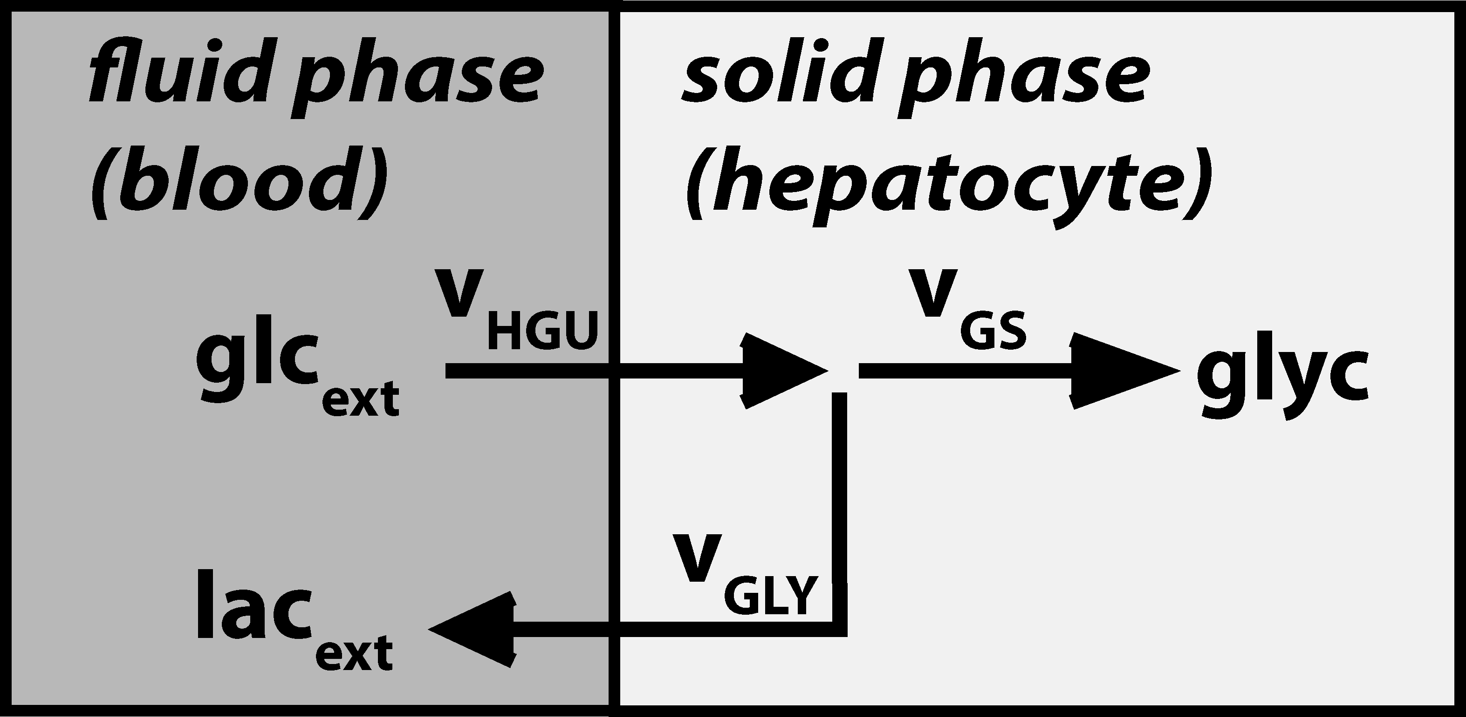
Figure M1 - Reduced metabolic model. The reduced model of hepatic glucose metabolism comprises the variables glucose (glc_{ext}) and lactate (lac_{ext}) in the fluid phase (blood) and glycogen (glyc) in the solid phase (hepatocyte). The effective reactions v_{HGU}, v_{GLY} and v_{GS} are modeled by polynomial regression function which were fitted to a large set of the steady state responses of the full model with v_{HGU}<0 hepatic glucose production, v_{HGU}>0 hepatic glucose utilization, v_{GLY}<0, gluconeogenesis, v_{GLY}>0 glycolysis, v_{GS}<0 - glycogenolysis, v_{GLY}>0 –glycogen synthesis).

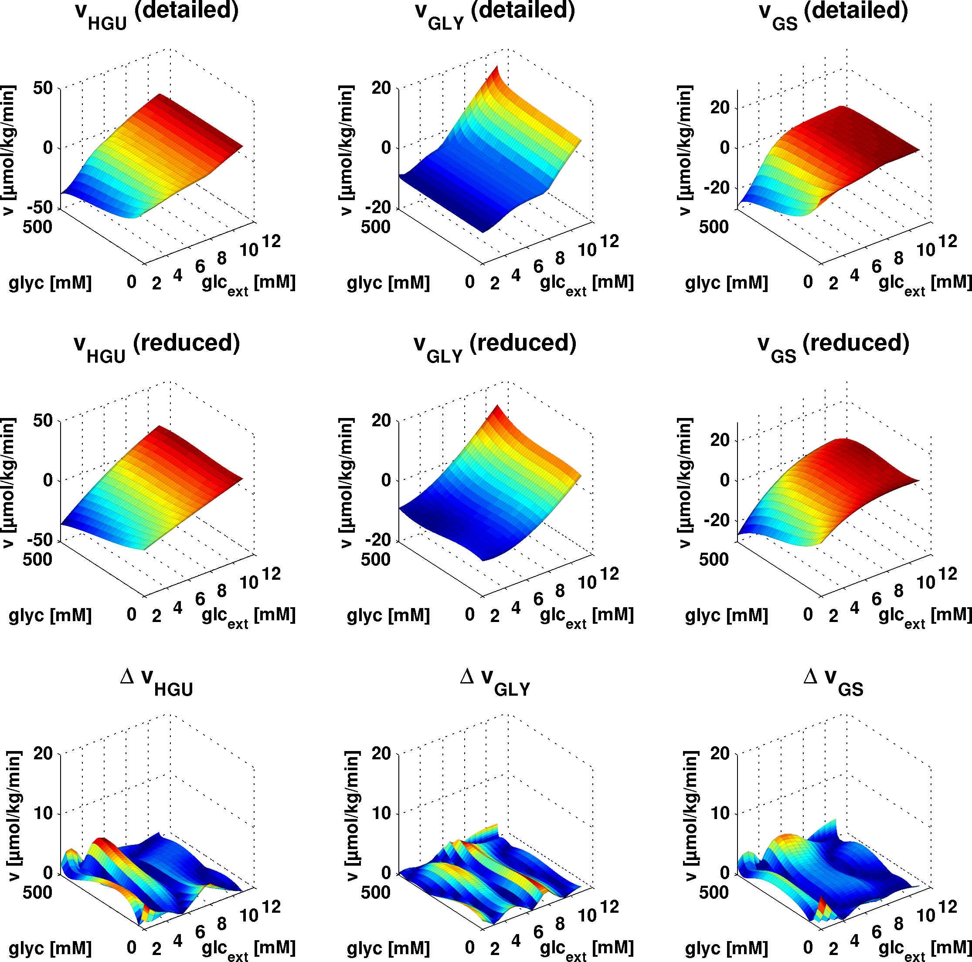
Figure M2: Evaluation of the reduced metabolic sub-model. HGP/HGU (v_{HGU}), gluconeogenesis/glycogenolysis (v_{GLY}) and glycogenolysis/glycogen synthesis (v_{GS)} depending on blood glucose (glc_{ext}) and glycogen (glyc) for the detailed kinetic model (top row), the reduced model via polynomial fitting (middle row) and the absolute difference between detailed model and reduced model (third row). The reduced model is able to describe the behavior of the full kinetic model for a wide range of different model inputs.
Supplemental information model reduction
 | 1.5 l | liver volume in full kinetic model
 |  | liver volume for simulation in liter
 | 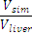 | relative volume for adaptions of model fluxes and properties like the glycogen storage capacity to the actual simulated liver volume
, |  | coefficients for polynomial approximation of quasi steady state
 | 75 kg | body weight used for conversion of fluxes given per body weight in concentration changes
 | 0.05 [mM] | Saturation parameter accounting for substrate limitation: HGU and glycolysis are limited by the available. HGP and gluconeogenesis are limited by available gluconeogenic substrate (handles the border conditions for integration in the polynoms).



