# Daily glucose profile as model input

### Matthias König

Glucose profiles (humans) based on published daily profiles of blood glucose (Stanhope, et al., 2008; Yuen, et al., 2012) have been created. These profiles will be used as periportal glucose input. The 3-meal profile corresponds to normal daily blood glucose variation with breakfast, lunch and dinner, the 1-meal profile is an adapted profile corresponding to one large meal during the day (can be used to simulate 24h glycogen cycles).

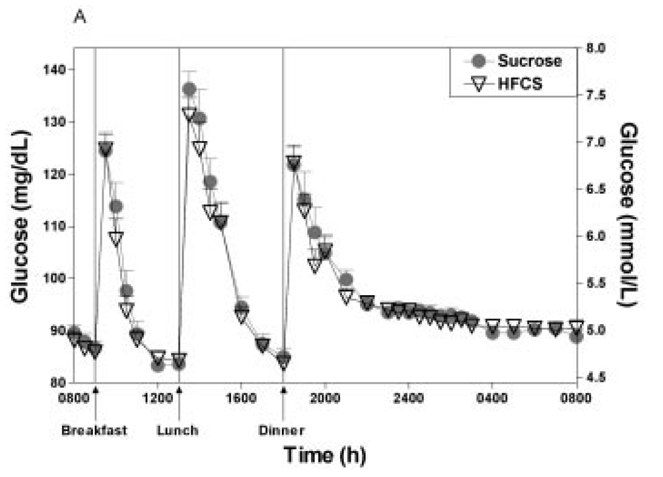



|  |  |  |  |
| --- | --- | --- | --- |
| **3 Meals** |  | **1 Meal** |  |
| **time [h]** | **glucose [mmol/L]** | **time [h]** | **glucose [mmol/L]** |
| 0 | 5 | 0 | 3.9 |
| 0.55468 | 4.891391111 | 0.55468 | 3.9 |
| 1.07862 | 4.812352222 | 1.07862 | 3.85 |
| 1.64674 | 6.942371667 | 1.64674 | 3.85 |
| 2.16743 | 6.324215556 | 2.16743 | 3.8 |
| 2.65573 | 5.449657222 | 2.65573 | 3.75 |
| 3.17714 | 4.949843889 | 3.17714 | 3.7 |
| 4.19315 | 4.620835 | 4.19315 | 3.7 |
| 5.27296 | 4.640262778 | 5.27296 | 3.7 |
| 5.84591 | 7.572385 | 5.84591 | 7.572385 |
| 6.33758 | 7.256668333 | 6.33758 | 7.256668333 |
| 6.82719 | 6.599072778 | 6.82719 | 6.599072778 |
| 8.42317 | 5.250839444 | 8.42317 | 5.250839444 |
| 9.46975 | 4.875799444 | 9.46975 | 4.875799444 |
| 10.48679 | 4.71773 | 10.48679 | 4.71773 |
| 11.02362 | 6.775437778 | 11.02362 | 4.65 |
| 11.57655 | 6.387383889 | 11.57655 | 4.6 |
| 12.00633 | 6.038811667 | 12.00633 | 4.5 |
| 12.56029 | 5.821697778 | 12.56029 | 4.45 |
| 13.54573 | 5.538719444 | 13.54573 | 4.4 |
| 14.68561 | 5.288571111 | 14.68561 | 4.3 |
| 15.61058 | 5.209422778 | 15.61058 | 4.25 |
| 16.32013 | 5.215802778 | 16.32013 | 4.25 |
| 16.75216 | 5.241982778 | 16.75216 | 4.25 |
| 17.27631 | 5.195816667 | 17.27631 | 4.24 |
| 17.83146 | 5.175941111 | 17.83146 | 4.22 |
| 18.29402 | 5.149515556 | 18.29402 | 4.2 |
| 18.91095 | 5.142772222 | 18.91095 | 4.15 |
| 19.37367 | 5.142645556 | 19.37367 | 4.15 |
| 19.89774 | 5.083330556 | 19.89774 | 4.1 |
| 20.97675 | 4.971266667 | 20.97675 | 4.05 |
| 21.96378 | 4.951272222 | 21.96378 | 4 |
| 22.98217 | 5.016739444 | 22.98217 | 3.95 |
| 23.96935 | 5.023043333 | 23.96935 | 3.9 |

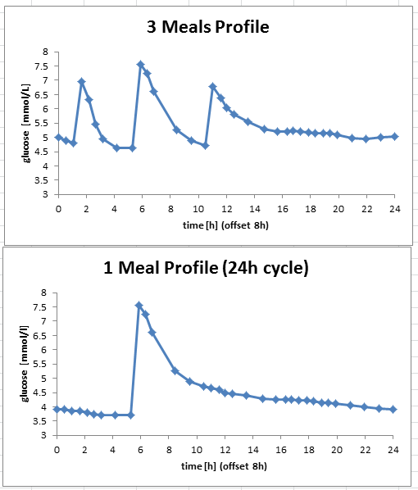

## References

Stanhope, K.L.*, et al.* (2008) Twenty-four-hour endocrine and metabolic profiles following consumption of high-fructose corn syrup-, sucrose-, fructose-, and glucose-sweetened beverages with meals, *Am J Clin Nutr*, **87**, 1194-1203.

Yuen, K.C., McDaniel, P.A. and Riddle, M.C. (2012) Twenty-four-hour profiles of plasma glucose, insulin, C-peptide and free fatty acid in subjects with varying degrees of glucose tolerance following short-term, medium-dose prednisone (20 mg/day) treatment: evidence for differing effects on insulin secretion and action, *Clinical endocrinology*, **77**, 224-232.