Model Embedding  
Combining Constraint-based & Kinetic Networks

Wolfram Liebermeister & Matthias König

# Introduction

The main idea is the coupling of kinetic and constraint-based models. Main test case will be the coupling of a kinetic model of hepatic glucose metabolism {Koenig2012a, Koenig2012b} into a highly curated subnetwork of HepatoNet1 {Gille2010}.

### Github

<https://github.com/matthiaskoenig/model-embedding>

git clone https://github.com/matthiaskoenig/model-embedding.git

### Google Doc

<https://docs.google.com/document/d/10PNdH9KWvYQ4uMHNNM0UOEW_3d5U81kVyczS1OuSHLk/edit#>

### SBML models

model-embedding/models/hepatocore/**HepatoCore2_v1.xml**

model-embedding/models/gluconet/**Koenig2014_Hepatic_Glucose_Model.xml**

model-embedding/models/gluconet/**Koenig2014_Hepatic_Glucose_Model_annotated.xml**

# Methods (model embedding)

See manuscript

<https://drive.google.com/?authuser=0&usp=gmail#folders/0B53SD0wZtwprYmgyaGJSaE1relk>

# Model Description

## GlucoNet - Human Hepatic Glucose Model

Kinetic model of the hepatic glucose metabolism comprising gluconeogenesis, glycolysis and glycogen metabolism integrated with the hormonal response via insulin and glucagon {Koenig2012a, Koenig2012b} (Figure 1). The model will be referred to as GlucoNet.

### Simulations

The model can simulate the switch between hepatic glucose production (HGP) and hepatic glucose utilization (HGU) under varying external glucose concentrations. The set of test simulations will comprise the kinetic simulations under varying glucose concentrations.

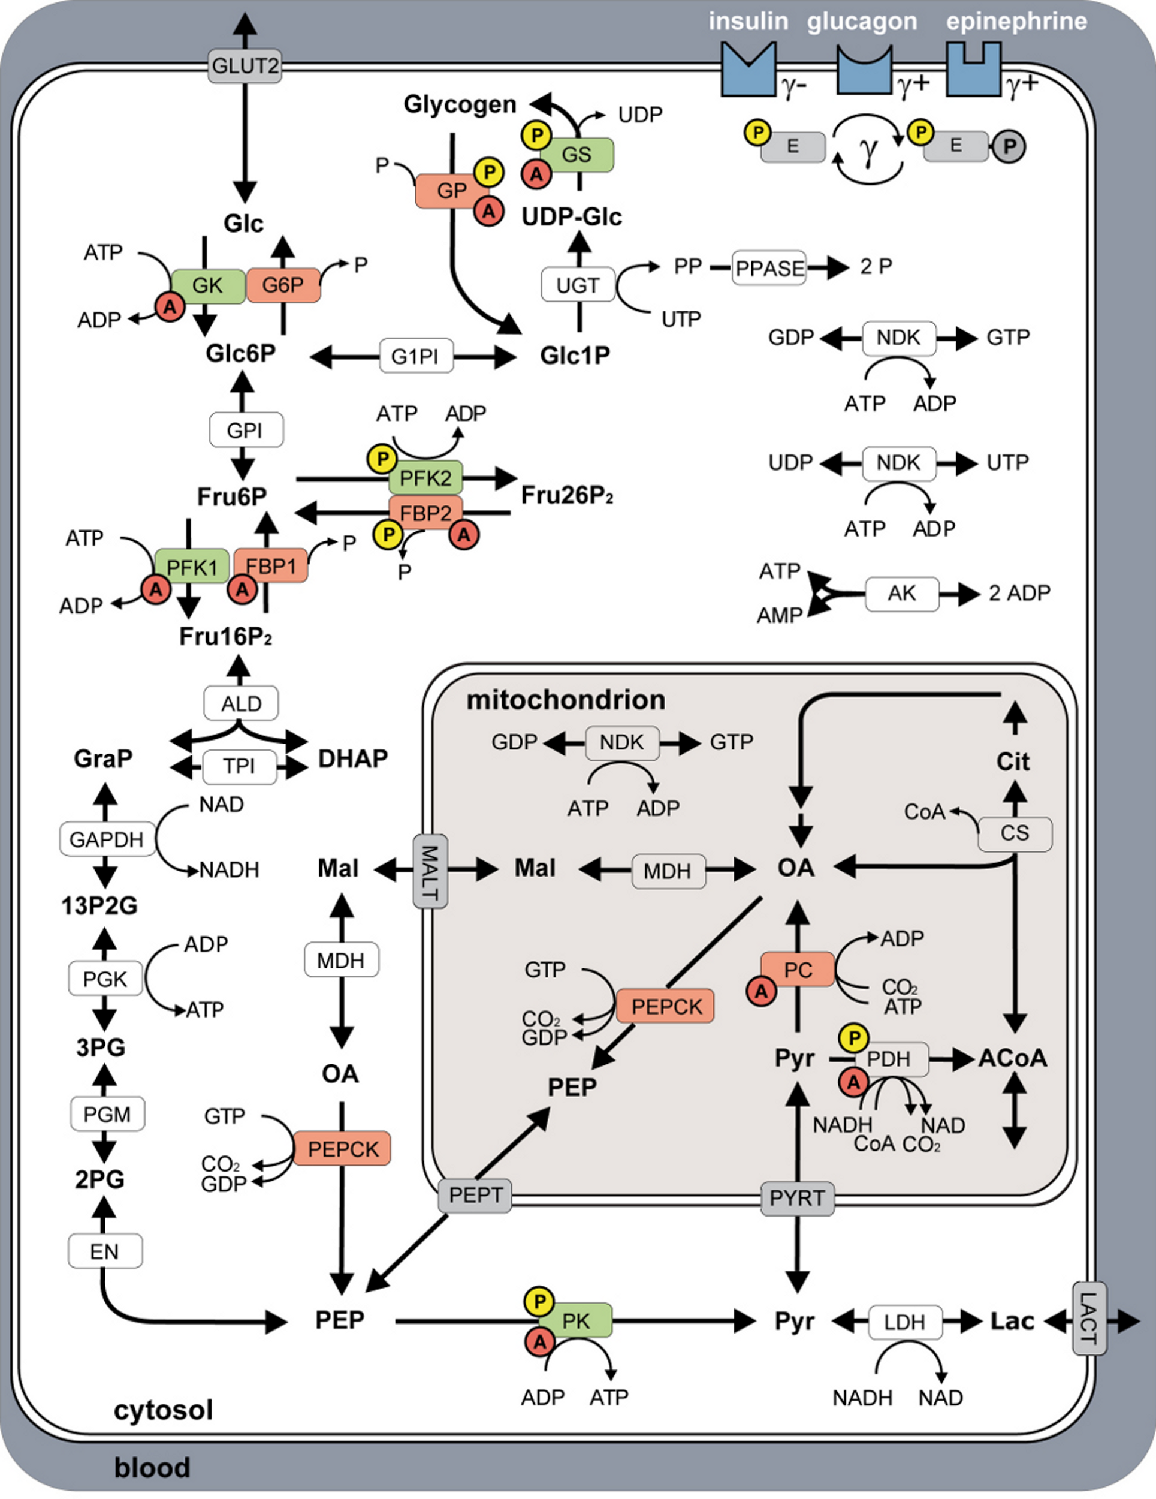

Figure 1 - GlucoNet model overview.

## HepatoCore - Human Hepatic Core Metabolism

Highly curated subnetwork of HepatoNet1 {Gille2010} described in {Koenig2009}. The model will be referred to as HepatoCore.

The reconstruction contains the central metabolic pathways and functionality of the liver (Figure 2):

* glycolysis and gluconeogenesis
* glycogen metabolism
* pentose phosphate pathway (PPP)
* purine and pyrimidine metabolism
* TCA cycle
* synthesis and β-oxidation of fatty acids
* metabolism of amino acids
* glutathione and folate reactions
* NH3 fixation and detoxification (urea cycle)
* ketone body synthesis

An overview over the network components is provided in Table 1.

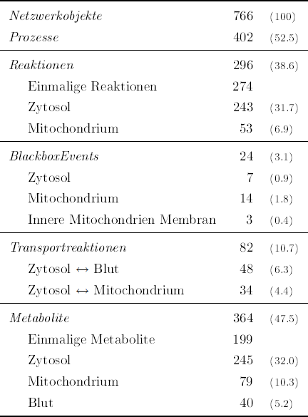

Table 1 - Overview network reconstruction of human core hepatocyte metabolism. Singular metabolites and reactions are network objects occuring only in a single compartment. BlackBox events are processes which combine multiple reaction steps into a single replacement process.

### Simulations

HepatoCore was functionaly curated via testing the central metabolic functions associated with these pathways via FBA based simulations (see simulations list). Different functional aspects of the core metabolism are tested.

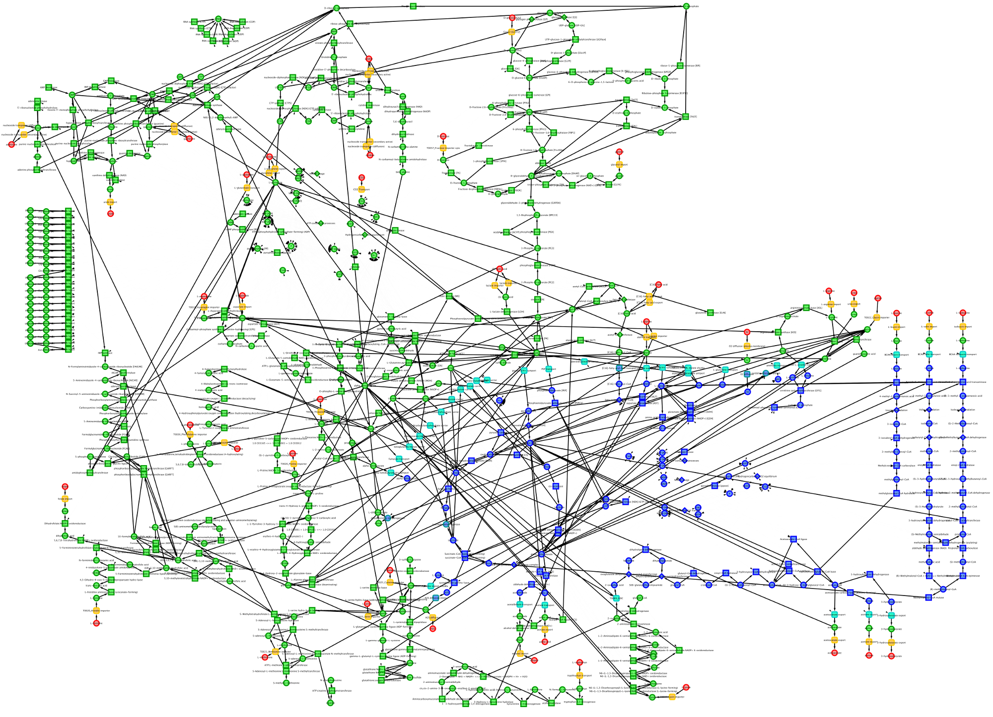

Figure 2 - HepatoCore model overview.

Flux rates

|  |  |  |
| --- | --- | --- |
| **Process** | **Value** | **References** |
| albumin synthesis rate (synthesis of proalbumin)  + ID_22334_cyto | Mr(albumin) = 66500 g/mol  131±8 mg/day (rat, liver weight 8.18±0.14g) {Ruot1999}  **v(alb) = 0.167nmol/min/g_lw ~ v(alb) ~ 0.167nmol/min/ml_lw**  Albumin is manufactured in the liver at a rate 9-12g/day. The normal serum albumin is 30 to 40 grams per litre.  9-12g/day (human, liver weight 1500g)  **v(alb) = 0.063-0.084nmol/min/g_lw ~ 0.063-0.084nmol/min/g_lw** | {Ruot1999} |
| hepatic glucose production (HGP)  - GLUT2 | Mr(glucose) = 180 g/mol  0-18µmol/min/kgbw (human, liver weight 1500g, bodyweight 70kg) {Koenig2012a}  **v(HGP) = 0 - 0.84 µmol/min/glw = 840nmol/min/g_lw ~ 0.063-0.084nmol/min/ml_lw** | {Koenig2012a} & references within |
| hepatic glucose consumption (HGU)  + GLUT2 | 0-20µmol/min/kgbw (human, liver weight 1500g, bodyweight 70kg) {Koenig2012a}  **v(HGP) = 0 - 0.93 µmol/min/glw = 930nmol/min/g_lw ~930nmol/min/ml_lw** | {Koenig2012a} & references within |
| hepatic oxygen uptake (O2I)  - ID_13638_extern | 2.62 mmol/min (in vivo pig liver, liver weight 1.05kg, total liver blood flow 1.07L/min) {Tygstrup1970}  1.9µmol/min/glw (human liver with estimated liver weight) {Tygstrup1962}  **v(O2I) = 1.9-2.5 µmol/min/glw = 1900-2500nmol/min/g_lw** | {Tygstrup1970}  {Tygstrup1962} |
| ethanol consumption  acetate production  ID_14769_extern |  | {Lundquist1961} |

Exchange Sets

**+** [lb=0, ub=∞]

flux in direction of reaction (import or export depending on definition of reaction direction)

**-** [lb=-∞,ub=0]

flux against direction of reaction (import or export depending on definition of reaction direction)

**=** [lb=-∞,ub=∞]

import and export allowed

### A Minimal Exchange Set

Core exchange for model consisting of uptake of essential amino acids, glucose, lactate, O2, folate and basic exports like urea, urate, and ketone bodies

|  |  |  |  |
| --- | --- | --- | --- |
| **process** |  |  |  |
| ID_13886_extern | **+** | detox | urea export allowed |
| ID_15523_extern | **+** | detox | urate export allowed |
| ID_13809_extern | **+** | ketone body | acetoacetate export allowed |
| ID_13810_extern | **+** | ketone body | acetone export allowed |
| ID_13832_extern | **+** | ketone body | beta-hydroxybutyrate export allowed |
| ID_14035_extern | **+** | detox | H2S export for cysteine degradation |
| ID_15668_extern | **=** |  | lactate can be imported and exported |
| ID_13640_extern | **=** |  | CO2 exchange |
| ID_14769_extern | **=** | ketone body | acetate exchange |
| ID_13638_extern | **-** |  | O2 uptake |
| ID_14148_extern | **=** |  | glucose exchange |
| ID_15924_cyto | **=** |  | glycogen storage/usage |
| ID_14250_extern | **-** | essential cofactor | folate uptake |
| ID_14614_extern | **-** | essential AA | phenylalanine uptake |
| ID_14028_extern | **-** | essential AA | valine uptake |
| ID_13868_extern | **-** | essential AA | threonine uptake |
| ID_14082_extern | **-** | essential AA | trypthophan uptake |
| ID_15249_extern | **-** | essential AA | isoleucin uptake |
| ID_13695_extern | **-** | essential AA | methionine uptake |
| ID_14832_extern | **-** | essential AA | leucin uptake |
| ID_14958_extern | **-** | essential AA | lysin uptake |
| ID_13649_extern | **+** | nonessential AA | glutamine export allowed |

### B Full Exchange Set

In addition the nonessential amino acids and nucleotides.

|  |  |  |  |
| --- | --- | --- | --- |
| ID_13885_extern | **-** | nonessential AA | arginine uptake |
| ID_13663_extern | **-** | nonessential AA | alanine uptake |
| ID_13795_extern | **-** | nonessential AA | cysteine uptake |
| ID_13704_extern | **-** | nonessential AA | serine uptake |
| ID_13787_extern | **-** | nonessential AA | histidine uptake |
| ID_13781_extern | **-** | nonessential AA | tyrosine uptake |
| ID_14131_extern | **-** | nonessential AA | glycine uptake |
| ID_14215_extern | **-** | nonessential AA | proline uptake |
| ID_15065_extern | **-** | nonessential AA | asparagine uptake |
| ID_14072_extern | **-** | nonessential AA | aspartate uptake |
| ID_13649_extern | **-** | nonessential AA | glutamine uptake |
| ID_13650_extern | **-** | nonessential AA | glutamate uptake |

### C Extended Exchange Set

Full exchange set and nucleotides

|  |  |  |  |
| --- | --- | --- | --- |
| ID_13948_extern | **-** | nucleotide | uridine uptake |
| ID_14258_extern | **-** | nucleotide | cytidine uptake |
| ID_15327_extern | **-** | nucleotide | guanosine uptake |
| ID_13981_extern | **-** | nucleotide | adenosine uptake |

TODO Matthias:

## FBA

* Setup FBA simulations corresponding to {Koenig2009} (CobraPy, CBMPy)
* Literature research uptake & excretion rates + production of metabolites/bile, …  
  Currently abstract function tests, make more physiological
* Integrate knockout information

## Kinetic simulations

* Setup kinetic simulations, i.e. full range of HGP - HGP simulations

## Visualization

* Get CySBML & CyFluxViz visualization running (interactive evaluation CyRest & Cy3)

## Mapping

* fix rates between models & use identical time units, substance units and flux units
* fix the handling of compartments (especially the Vcell = Vcyto + Vmito part)
* consistent scaling to complete liver in both models

## Model extension

* extend HepatoCore via insulin/glucagon constraints, i.e. integrate information about hormonal regulation (interconvertible enzymes) in Fat metabolism

## Model annotation & integration of information

* get database with model information running & old code base
* add irreversibility and flux bound information to model & collect additional flux constraints (uptake rates, oxygen consumption, …) (see FBA)
* get all the annotation information for the model components from
* add the Delta G were available
* Annotate the units! in Hepatocore and make units consistent between networks

# References

Gille, C., Bölling, C., Hoppe, A., Bulik, S., Hoffmann, S., Hübner, K., et al. (2010). HepatoNet1: a comprehensive metabolic reconstruction of the human hepatocyte for the analysis of liver physiology. *Molecular systems biology*, *6*(1).

König, M., Bulik, S., & Holzhütter, H. (2012a). Quantifying the contribution of the liver to glucose homeostasis: a detailed kinetic model of human hepatic glucose metabolism. *PLoS computational biology*, *8*(6), e1002577.

König, M., & Holzhütter, H. (2012b). Kinetic modeling of human hepatic glucose metabolism in type 2 diabetes mellitus predicts higher risk of hypoglycemic events in rigorous insulin therapy. *Journal of Biological Chemistry*, *287*(44), 36978-36989.

König, M (2009). Metabolic network reconstruction of the human hepatocyte core metabolism. Diploma thesis, Humboldt University Berlin

Lundquist, F., Tygstrup, N., Winkler, K., Mellemgaard, K., & Munck-Petersen, S. (1962). Ethanol metabolism and production of free acetate in the human liver. *Journal of Clinical Investigation*, *41*(5), 955.

Ruot, B., Breuillé, D., Rambourdin, F., Bayle, G., Capitan, P., & Obled, C. (2000). Synthesis rate of plasma albumin is a good indicator of liver albumin synthesis in sepsis. *American Journal of Physiology-Endocrinology And Metabolism*, *279*(2), E244-E251.

Tygstrup, N., Winkler, K., Mellemgaard, K., & Andreassen, M. (1962). Determination of the hepatic arterial blood flow and oxygen supply in man by clamping the hepatic artery during surgery. *Journal of Clinical Investigation*, *41*(3), 447.

Tygstrup, N., Funding, J., Juul-Nielsen, J., Keiding, S., Koudahl, G., Ramsöe, K., et al. (1970). The function of the isolated perfused and the in vivo pig liver. *Scandinavian journal of gastroenterology. Supplement*, *9*, 131-138.