Feb 23, 2015
Dear Matthias,
I am very pleased to be able to write a letter in support of your proposal ‘Multi-scale model of human liver’ being submitted to the Systems Medicine of the Liver (LiSyM) Program for young investigators from the BMBF.
We have worked together for almost two years through our collaboration in developing libRoadRunner, the high performance simulator. You were an early adopter and tester of the library. I was very pleased you were able to be a contributor and author of the libRoadRunner paper which was recently submitted to bioinformatics. From our joint work I know that you have extensive experience in the modeling of biological systems, especially in the area of metabolic modeling of the liver. You have considerable insight into modeling techniques and your involvement in the development of libRoadRunner greatly improved the software. I know you are fully committed to the application of standards of modeling in computational biology (SBML, SEDML) and you are actively involved in the community developing these standards. I also know that you developed software and workflows supporting the visualization and work with SBML (CySBML).
In conclusion, I fully support your efforts as he seeks external funding to support a program designed to model the complex interplay of metabolism, structure and perfusion in the liver. The resulting models available in reproducible standard representation (SBML) will benefit the scientific community, provide a better understanding of liver function and has considerable potential in the evaluation of liver function tests and drug clearance.
I wish you success with your application
Sincerely.
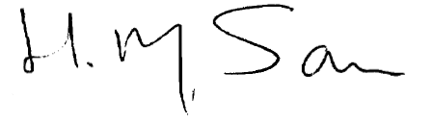
Herbert M Sauro
Associate Professor
Department of Bioengineering
University of Washington

