Developers Guide for networkSimDB

Getting the source
Source code is available via sourceforge:
http://networksimdb.svn.sourceforge.net/viewvc/networksimdb/
and can be checkouted via
svn co https://networksimdb.svn.sourceforge.net/svnroot/networksimdb networksimdb

Setting up Eclipse with SVN source
- checkout the SVN as new project (file → new project → SVN → Project from SVN)
  - URL: https://networksimdb.svn.sourceforge.net/svnroot/networksimdb
  - User and password from sourceforge account
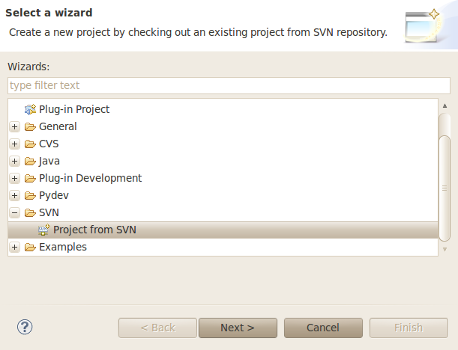

Directory structure
svnroot
bin
src
nsdb
cytoscape
db (database content)
hibernate (hibernate entity and xml definitions)
test (test data for the source code)
web (web interface content)
db
doc
documentation
examples
lib (

Setting up the database
- For testing a local postgreSQL database system (http://www.postgresql.org/) has to be used.. Postgres has to be installed and a database 'netsimdb_test' with user 'test_user' should be generated. Postgres should run on port 5432 on localhost. These settings can be changed in the 'hibernate.cfg.xml'
<property name="connection.url">jdbc:postgresql://localhost:5432/netsimdb_test</property>
<property name="connection.username">test_user</property>
<property name="connection.password">1234</property>

Setting the buildpath in eclipse
- include all jars in lib into the buildpath
- add all jar files in folder lib to the buildpath. If additional jars are needed, these jars should also be copied to the lib folder.

Eclipse Cytoscape integration
- install Cytoscape for your platform
- copy 'networkSimDBvx.xx.jar' from 'lib/cytoscape/-plugin' into the Cytoscape plugin folder.
- Select CytoscapeSQL.java from nsdb.cytoscape and create application runner (Run → Run configurations)
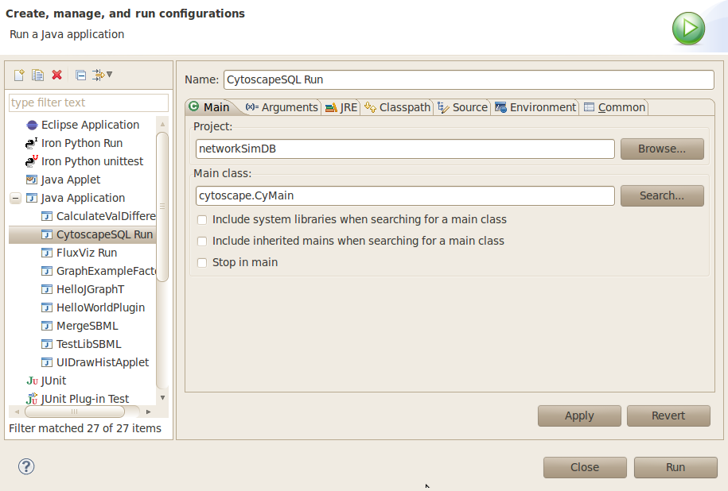
- Create new run configuration: Main class: cytoscape.CyMain; Name CytoscapeSQL Run
- arguments: -p /home/mkoenig/Programs/Cytoscape_v2.7.0/plugins -P libSBMLPath=/usr/local/share/java/libsbmlj.jar (replace with installation directory to Cytoscape plugin directory of installation)
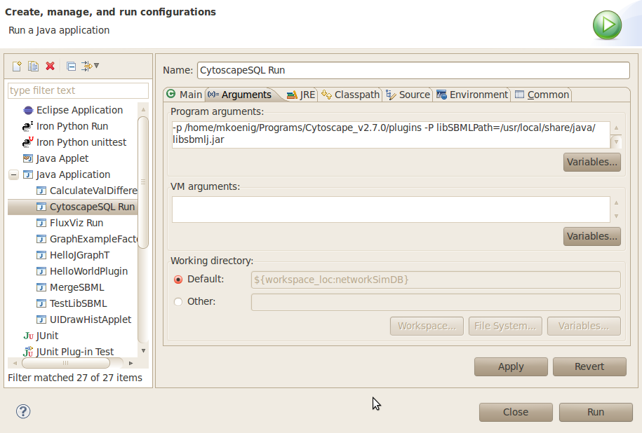
- run starts Cytoscape (changes in source code are reflected in the interface)

