omeprazole

**Overview document**

<https://docs.google.com/document/d/1FeJEUab_fw6VqMjL7dzAHibu0_pRTkKty1eBw3Y5Aq8/edit#>

**Literature omeprazole**

* PDF of interesting articles and bibliography
* <https://github.com/matthiaskoenig/omeprazole>

**Curated data**

* <https://github.com/matthiaskoenig/pkdb_data>
* Omeprazole data: <https://github.com/matthiaskoenig/pkdb_data/issues?q=is%3Aissue+is%3Aopen+label%3Aomeprazole>

# Project

## Overview

**Title: Computational Modelling of omeprazol - pharmacokinetics and pharmacodynamics**

* pharmacokinetic model of omeprazol and main metabolite
* pharmacodynamic model of i) irreversible inhibition of proton pump (PP) and ii) PP protein turnover
* biological application of model:
  + **dose-potentiation in repeated dosing** due to positive feedback of pH on omeprazol absorption
  + **study acid output depending on dose and treatment interval;** analysis of interaction of fast half-life of omeprazol (~2-3hr) and protein turnover half-life (3-5 days)

## Tasks

* Literature research & review omeprazol
* Digitization of omeprazol datasets for computational modeling (pharmacokinetics & pharmacodynamics). Data will be included in the pharmacokinetics database <https://pk-db.com>
* Review of pharmacokinetics & pharmacokinetics data
* Construct a physiologically based pharmacokinetics model of omeprazole
  + ordinary differential equations (ODE) model encoded in the Systems Biology Markup Language (SBML)
* Model simulations & analysis (dose-dependency, parameter sensitivity)
* Write thesis

# Introduction

<https://en.wikipedia.org/wiki/Omeprazole>

**Omeprazole**, sold under the brand names **Prilosec** and **Losec** among others, is a medication used in the treatment of [gastroesophageal reflux disease](https://en.wikipedia.org/wiki/Gastroesophageal_reflux_disease) (GERD), [peptic ulcer disease](https://en.wikipedia.org/wiki/Peptic_ulcer_disease), and [Zollinger–Ellison syndrome](https://en.wikipedia.org/wiki/Zollinger%E2%80%93Ellison_syndrome).[[1]](https://en.wikipedia.org/wiki/Omeprazole#cite_note-AHFS2015-1) It is also used to prevent [upper gastrointestinal bleeding](https://en.wikipedia.org/wiki/Upper_gastrointestinal_bleeding) in people who are at high risk.[[1]](https://en.wikipedia.org/wiki/Omeprazole#cite_note-AHFS2015-1) Omeprazole is a [proton-pump inhibitor](https://en.wikipedia.org/wiki/Proton-pump_inhibitor) (PPI) and its effectiveness is similar to other PPIs.[[7]](https://en.wikipedia.org/wiki/Omeprazole#cite_note-TI2016-7) It can be taken by mouth or by [injection into a vein](https://en.wikipedia.org/wiki/Intravenous).[[1]](https://en.wikipedia.org/wiki/Omeprazole#cite_note-AHFS2015-1)[[8]](https://en.wikipedia.org/wiki/Omeprazole#cite_note-UK2016-8)

#### Wallmark1986

* good correlation between PPI activity and acid secretion

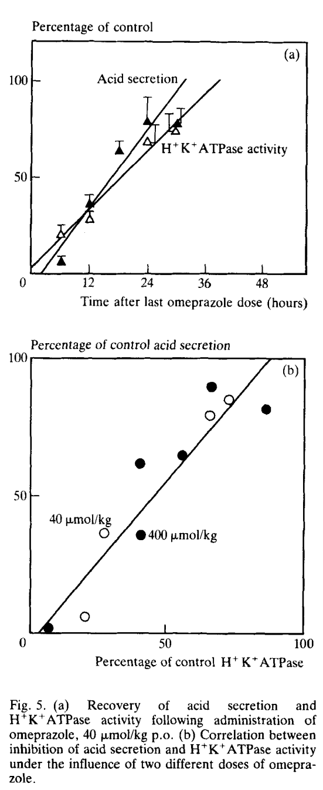

## reviews

* Howden CW. Clinical pharmacology of omeprazole. Clin Pharmacokinet. 1991 Jan;20(1):38-49. doi: 10.2165/00003088-199120010-00003. PMID: 2029801.
* McTavish D, Buckley MM, Heel RC. Omeprazole. An updated review of its pharmacology and therapeutic use in acid-related disorders. Drugs. 1991 Jul;42(1):138-70. doi: 10.2165/00003495-199142010-00008. PMID: 1718683.
* Olbe L, Cederberg C, Lind T, Olausson M. Effect of omeprazole on gastric acid secretion and plasma gastrin. J Gastroenterol Hepatol. 1989;4 Suppl 2:19-25. PMID: 2491358.
* Oosterhuis B, Jonkman JH. Omeprazole: pharmacology, pharmacokinetics and interactions. Digestion. 1989;44 Suppl 1:9-17. doi: 10.1159/000200098. PMID: 2691315.
* Massoomi F, Savage J, Destache CJ. Omeprazole: a comprehensive review. Pharmacotherapy. 1993 Jan-Feb;13(1):46-59. PMID: 8437967.

# pharmacokinetics

[Bioavailability](https://en.wikipedia.org/wiki/Bioavailability) 35–76%[[4]](https://en.wikipedia.org/wiki/Omeprazole#cite_note-4)[[5]](https://en.wikipedia.org/wiki/Omeprazole#cite_note-5)

[Protein binding](https://en.wikipedia.org/wiki/Plasma_protein_binding) 95%

[Metabolism](https://en.wikipedia.org/wiki/Drug_metabolism)[Hepatic](https://en.wikipedia.org/wiki/Liver) ([CYP2C19](https://en.wikipedia.org/wiki/CYP2C19), [CYP3A4](https://en.wikipedia.org/wiki/CYP3A4))

[Elimination half-life](https://en.wikipedia.org/wiki/Biological_half-life) 1–1.2 hours

[Excretion](https://en.wikipedia.org/wiki/Excretion) 80% (urine); 20% (bile via feces)

## dosing

* Omeprazole can be taken by mouth, as a capsule, tablet, or suspension, or by [injection into a vein](https://en.wikipedia.org/wiki/Intravenous).[[1]](https://en.wikipedia.org/wiki/Omeprazole#cite_note-AHFS2015-1)[[8]](https://en.wikipedia.org/wiki/Omeprazole#cite_note-UK2016-8)
* Omeprazole is available in **strengths of 10, 20, 40**, and in some markets **80 mg**; and as a powder (omeprazole sodium) for [intravenous](https://en.wikipedia.org/wiki/Intravenous) injection. Most oral omeprazole preparations are [enteric-coated](https://en.wikipedia.org/wiki/Enteric_coating), due to the rapid degradation of the drug in the acidic conditions of the stomach. This is most commonly achieved by formulating enteric-coated granules within capsules, enteric-coated tablets, and the multiple-unit pellet system (MUPS).[[62]](https://en.wikipedia.org/wiki/Omeprazole#cite_note-62) An immediate release formulation was approved by the FDA in the United States,[[63]](https://en.wikipedia.org/wiki/Omeprazole#cite_note-63) which does not require enteric coating.
* It is also available for use in injectable form (IV) in Europe, but not in the U.S. The injection pack is a combination pack consisting of a vial and a separate ampule of reconstituting solution. Each 10 ml clear glass vial contains a white to off-white lyophilised powder consisting of omeprazole sodium 42.6 mg, equivalent to 40 mg of omeprazole.

## absorption

* The absorption of omeprazole takes place in the small intestine and is usually completed within 3 to 6 hours. The systemic [bioavailability](https://en.wikipedia.org/wiki/Bioavailability) of omeprazole after repeated doses is about 60%.[[49]](https://en.wikipedia.org/wiki/Omeprazole#cite_note-49) Omeprazole has a volume of distribution of 0.4 L/kg. It has high plasma protein binding of 95%.[[47]](https://en.wikipedia.org/wiki/Omeprazole#cite_note-Omeprazole-47)
* Omeprazole, as well as other PPIs, are only effective on active H+/K+-ATPase pumps. These pumps are stimulated in the presence of food to aid in digestion. For this reason, patients should be advised to take omeprazole with a glass of water on an empty stomach.[[50]](https://en.wikipedia.org/wiki/Omeprazole#cite_note-50) Additionally, most sources recommend that after taking omeprazole, at least 30 minutes should be allowed to elapse before eating[[51]](https://en.wikipedia.org/wiki/Omeprazole#cite_note-51)[[52]](https://en.wikipedia.org/wiki/Omeprazole#cite_note-52) (at least 60 minutes for immediate-release omeprazole plus sodium bicarbonate products, such as Zegerid),[[53]](https://en.wikipedia.org/wiki/Omeprazole#cite_note-53) though some sources say that with delayed-release forms of omeprazole, waiting before eating after taking the medication is not necessary.[[54]](https://en.wikipedia.org/wiki/Omeprazole#cite_note-54)
* Omeprazole is completely metabolized by the [cytochrome P450](https://en.wikipedia.org/wiki/Cytochrome_P450) system, mainly in the liver, by [CYP2C19](https://en.wikipedia.org/wiki/CYP2C19) and [CYP3A4](https://en.wikipedia.org/wiki/CYP3A4) [isoenzymes](https://en.wikipedia.org/wiki/Isozyme).[[9]](https://en.wikipedia.org/wiki/Omeprazole#cite_note-Dav2015-9) Identified metabolites are the [sulfone](https://en.wikipedia.org/wiki/Sulfone), the [sulfide](https://en.wikipedia.org/wiki/Sulfide), and hydroxy-omeprazole, which exert no significant effect on acid secretion. About 77% of an orally given dose is excreted as metabolites in the urine, and the remainder is found in the feces, primarily originating from bile secretion.[[46]](https://en.wikipedia.org/wiki/Omeprazole#cite_note-:1-46) **Omeprazole has a half life of 0.5 to 1 hour.**[**[46]**](https://en.wikipedia.org/wiki/Omeprazole#cite_note-:1-46) **The pharmacological effects of omeprazole last longer as it is covalently bonded to proton pump on parietal cells to induce effects.**
* “**Omeprazole is very unstable at a low pH** and will degrade unless protected against the acid in the stomach. Key pharmacological data are given in table I. For oral intake, omeprazole is available as encapsulated enteric-coated granules, causing the drug to released only when reaching the small intestine. tmax is delayed by this formulation, relative to a buffered solution of the drug, but has been found to be reached within 3 to 4 hours)[104] The rate and extent of absorption of omeprazole given as enterocoated granules is highly variable. Systemic bioavailability after an oral dose of omeprazole 20mg is 35%, increasing to 60% on repeated dose administration, indicating that suppression of gastric acidity reduces preabsorption degradation of the drug.[104]”{Hatlebakk1996}
* “**Omeprazole is rapidly eliminated from plasma, with a t1/2 ~ of 2.8 hours, not significantly longer after repeated administration.**[104] Metabolism in the liver gives **hydroxyomeprazole and a sulphide derivative** of the molecule, neither of which are pharmacologically active. Genetic differences in CYP2C (S-mephenytoin hydroxylase) activity result in a group of slow metabolisers with a t1/2 ~ for omeprazole more than 2 hours”{Hatlebakk1996}

## dose-dependency

* “Several studies have demonstrated very effective inhibition of gastric secretion and acidity by the proton pump inhibitor omeprazole, showing a **dose-response relationship in the range of 5 to 80mg in groups of healthy volunteers**, with the highest doses resulting in virtual anacidity (>95% suppression), but with wide interindividual variation in the response to each dose.[107] When compared with ranitidine 300mg 4 times daily, a significantly more effective suppression of daytime (but not nighttime) acidity was found after only 2 days of omeprazole 40mg each morning.[45] Whereas the antisecretory effect of ranitidine decreased significantly between day 1 and 7, that of omeprazole increased during the first week.”{Hatlebakk1996}
* “**omeprazole increases its own oral bioavailability with repeated dosing**. Significant increase in AUC with repeated dosing. The elimination half-life did not significantly change, but there was a marked increase in the absorption rate constant suggesting that the increased availability is secondary to enhanced absorption of the drug. It is partly known that omeprazole is partly destroyed by gastric acid[5]”{Howden1984}

#### Howden1984

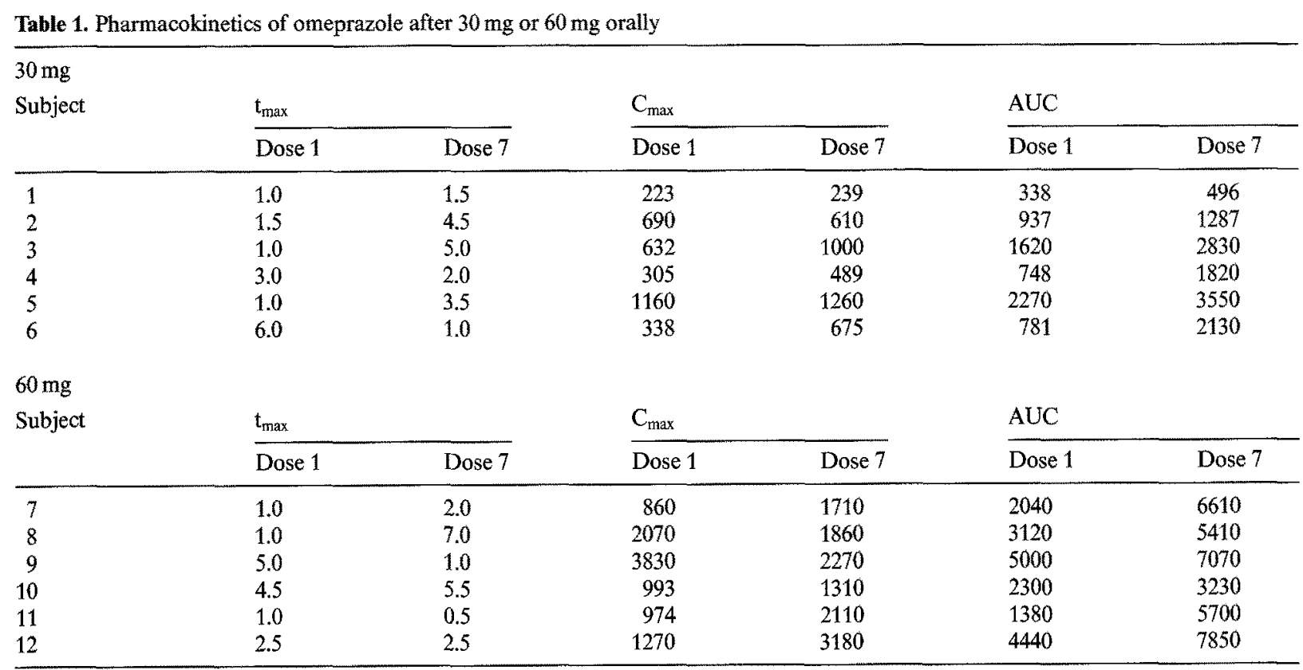

#### VazdaSilva2005

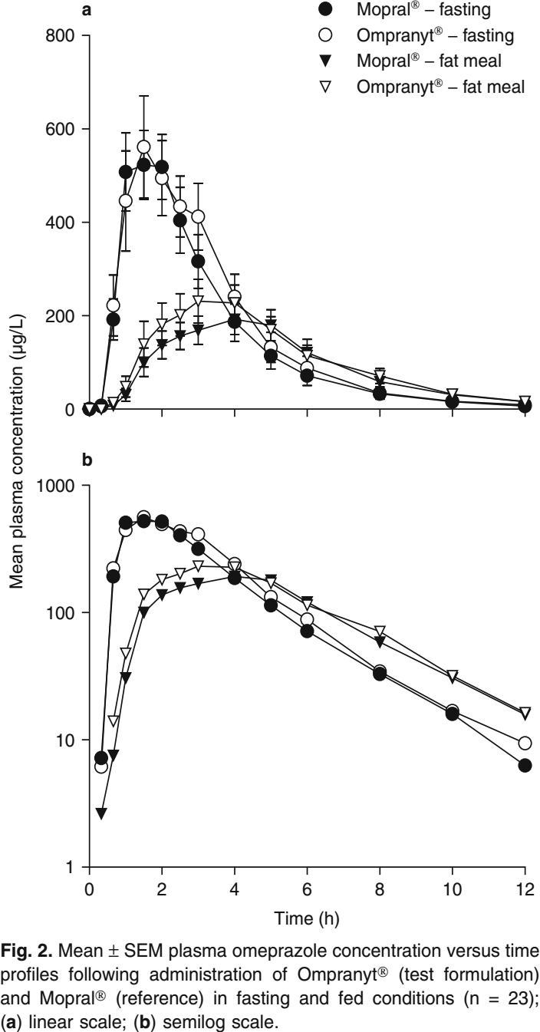

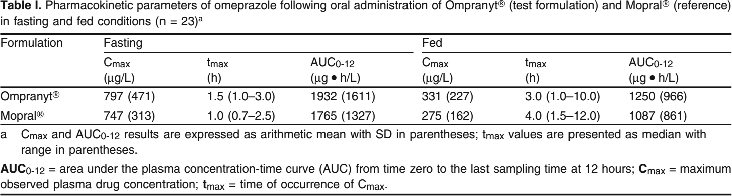

#### Cederberg1989

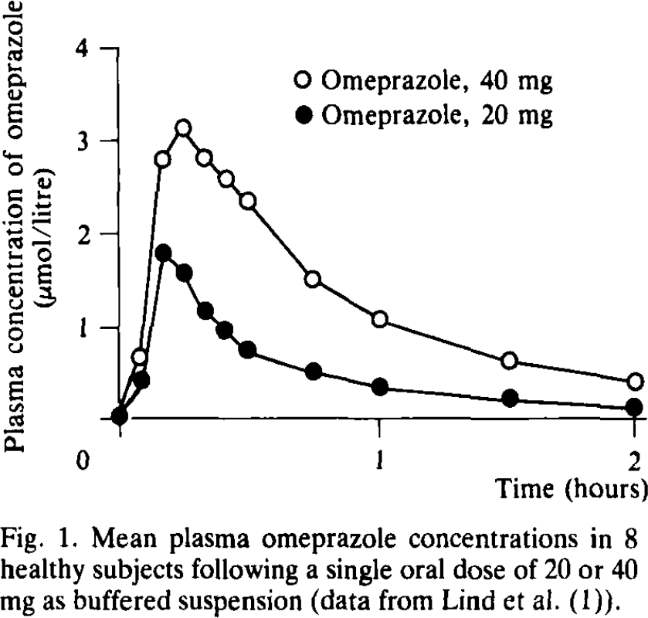

## formulations

* different formulations of omeprazole exists with different dissolution time curves, e.g., **Losec** and **Omepradex**

#### Elkoshi2002

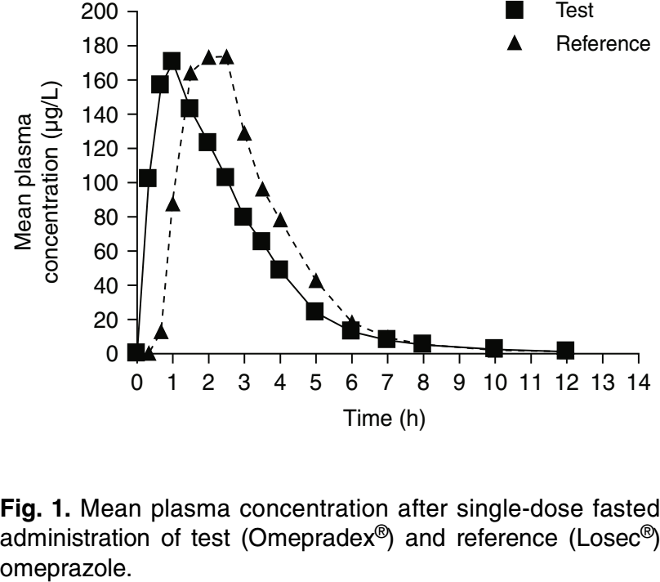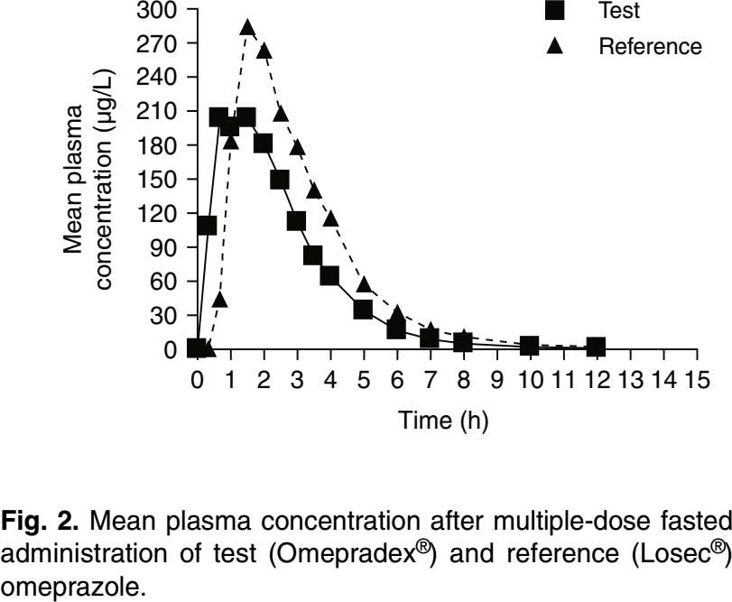

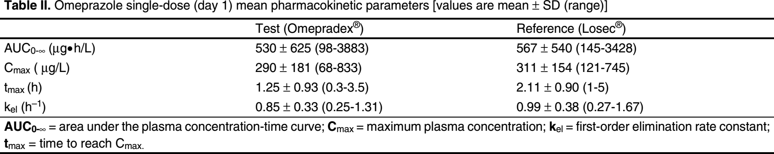

# 

# pharmacodynamics

* Omeprazole is a **selective and irreversible proton pump inhibitor**. It suppresses stomach acid secretion by specific inhibition of the H+/K+-ATPase system found at the secretory surface of gastric [parietal cells](https://en.wikipedia.org/wiki/Parietal_cells). Because this enzyme system is regarded as the acid (proton, or H+) pump within the [gastric mucosa](https://en.wikipedia.org/wiki/Gastric_mucosa), omeprazole inhibits the final step of acid production.[[45]](https://en.wikipedia.org/wiki/Omeprazole#cite_note-:0-45)
* Omeprazole also **inhibits both basal and stimulated acid secretion irrespective of the stimulus**[**[46]**](https://en.wikipedia.org/wiki/Omeprazole#cite_note-:1-46) as it blocks the last step in acid secretion.[[46]](https://en.wikipedia.org/wiki/Omeprazole#cite_note-:1-46) The drug binds [**non-competitively**](https://en.wikipedia.org/wiki/Non-competitive_inhibition) **so it has a dose dependent effect.**[[47]](https://en.wikipedia.org/wiki/Omeprazole#cite_note-Omeprazole-47)
* The inhibitory effect of omeprazole occurs within 1 hour after oral administration. The maximum effect occurs within 2 hours. The duration of inhibition is up to 72 hours. **When omeprazole is stopped, baseline stomach acid secretory activity returns after 3 to 5 days.** The inhibitory effect of omeprazole on acid secretion will plateau after 4 days of repeated daily dosing.[[48]](https://en.wikipedia.org/wiki/Omeprazole#cite_note-48)

#### Howden1984a

* dose dependency of pharmacodynamics;
* single & multiple dose comparison

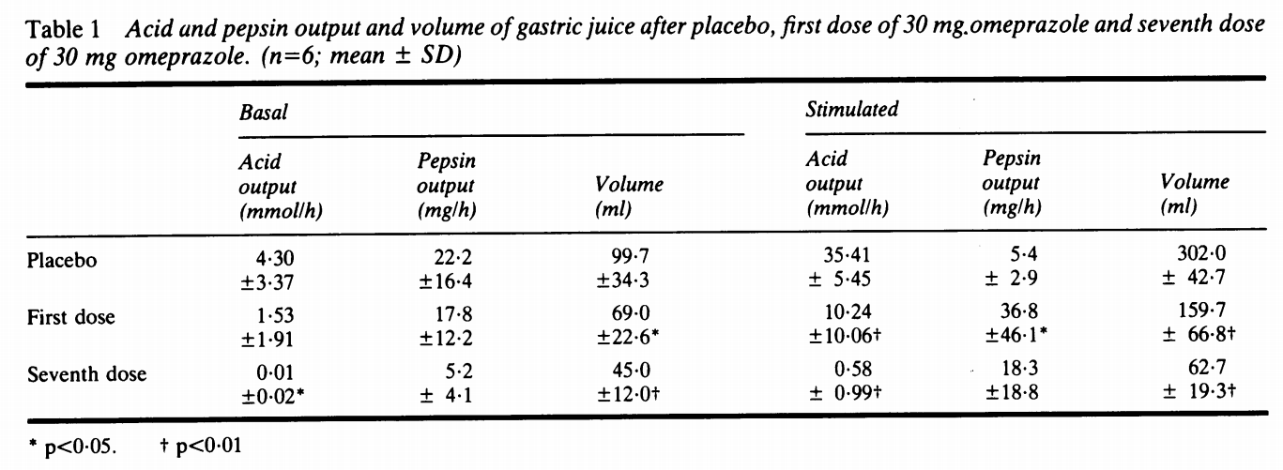

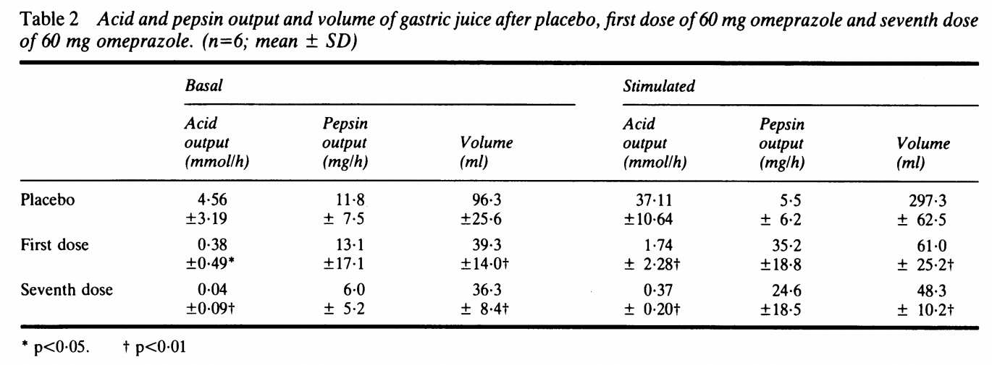

#### Olbe1989

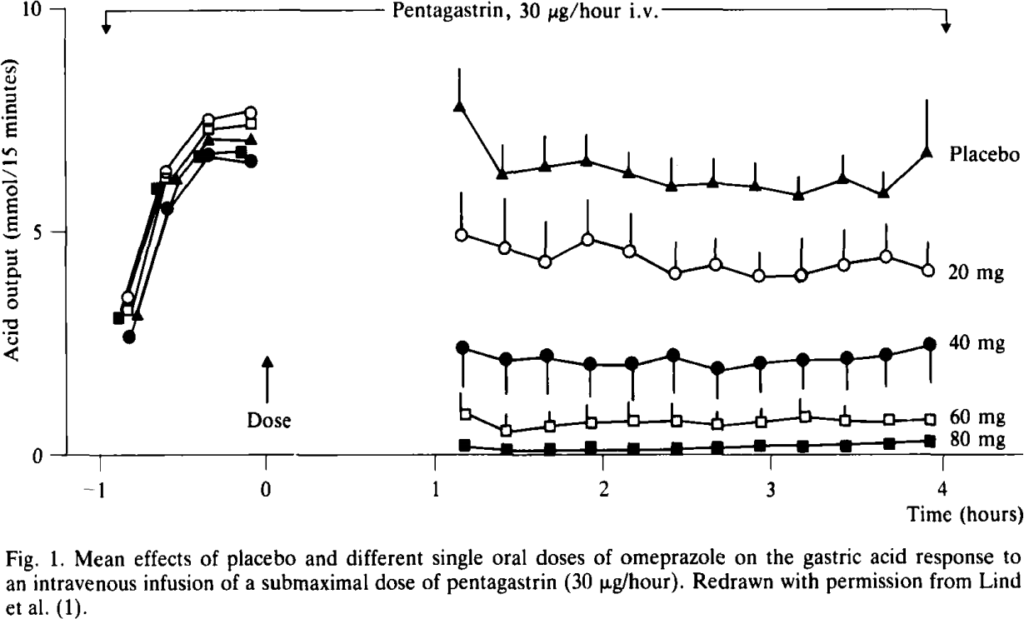

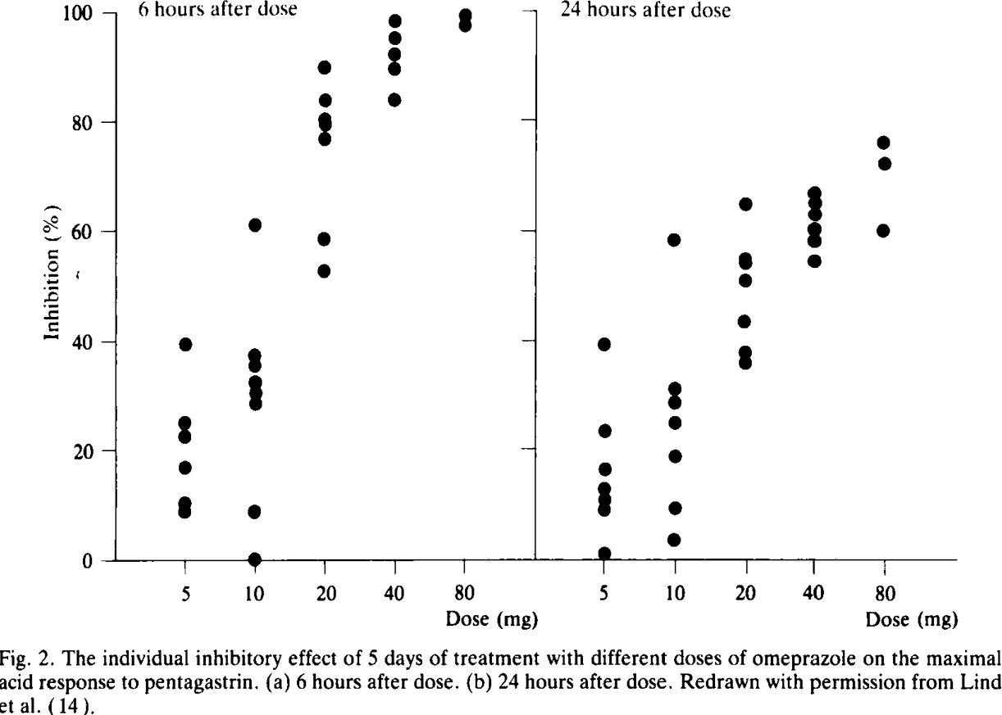

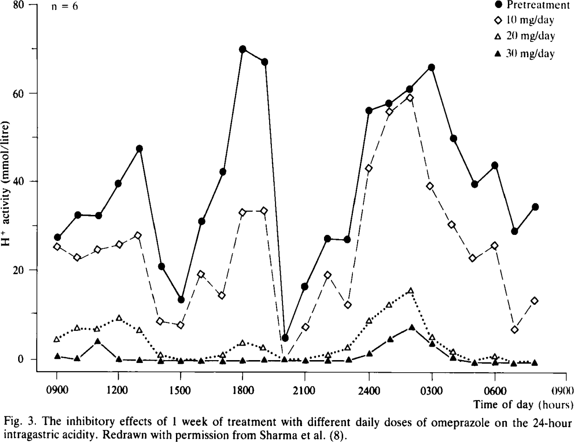

# genotypes

* Dean L. Omeprazole Therapy and *CYP2C19* Genotype. 2012 Oct 1 [updated 2016 Mar 8]. In: Pratt VM, McLeod HL, Rubinstein WS, Scott SA, Dean LC, Kattman BL, Malheiro AJ, editors. Medical Genetics Summaries [Internet]. Bethesda (MD): National Center for Biotechnology Information (US); 2012–. PMID: 28520353.

#### Pratt2012

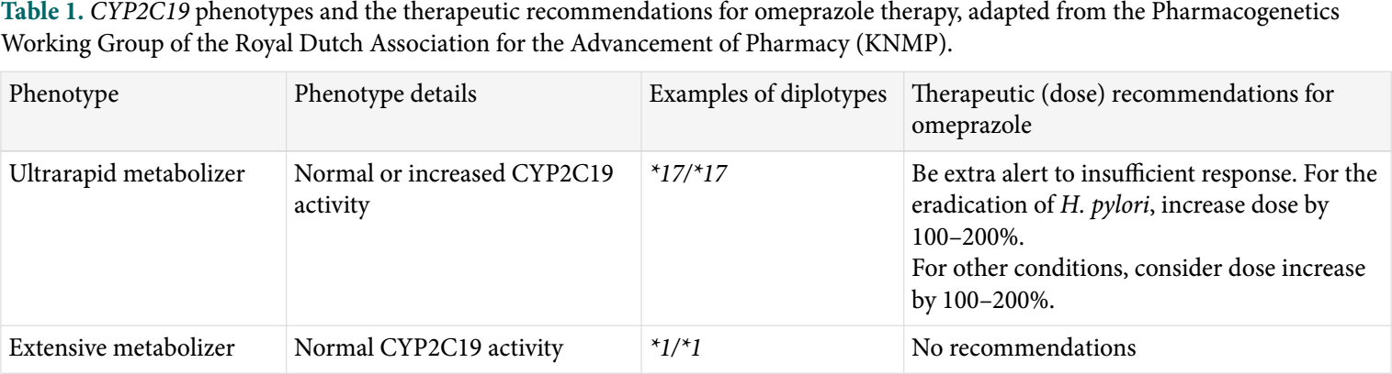

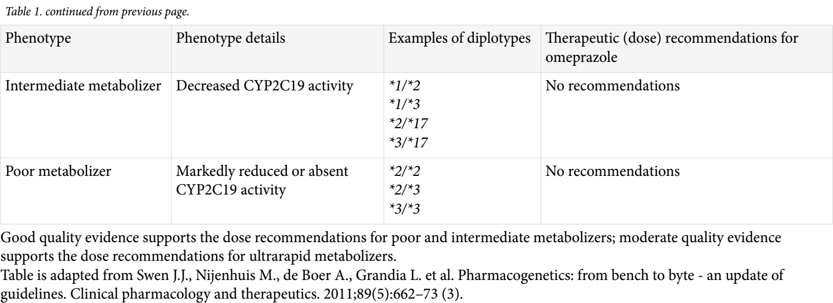

# drug-drug interactions

* Andersson T. Omeprazole drug interaction studies. Clin Pharmacokinet. 1991 Sep;21(3):195-212. doi: 10.2165/00003088-199121030-00004. PMID: 1764870.

This interaction is possible because omeprazole is an [inhibitor](https://en.wikipedia.org/wiki/Enzyme_inhibitor) of the enzymes [CYP2C19](https://en.wikipedia.org/wiki/CYP2C19) and [CYP3A4](https://en.wikipedia.org/wiki/CYP3A4).[[36]](https://en.wikipedia.org/wiki/Omeprazole#cite_note-36)

Important drug interactions are rare.[[32]](https://en.wikipedia.org/wiki/Omeprazole#cite_note-32)[[33]](https://en.wikipedia.org/wiki/Omeprazole#cite_note-33) However, the most significant major drug interaction concern is the decreased activation of [clopidogrel](https://en.wikipedia.org/wiki/Clopidogrel) when taken together with omeprazole.[[34]](https://en.wikipedia.org/wiki/Omeprazole#cite_note-34) Although still controversial,[[35]](https://en.wikipedia.org/wiki/Omeprazole#cite_note-35) this may increase the risk of stroke or heart attack in people taking clopidogrel to prevent these events.

This interaction is possible because omeprazole is an [inhibitor](https://en.wikipedia.org/wiki/Enzyme_inhibitor) of the enzymes [CYP2C19](https://en.wikipedia.org/wiki/CYP2C19) and [CYP3A4](https://en.wikipedia.org/wiki/CYP3A4).[[36]](https://en.wikipedia.org/wiki/Omeprazole#cite_note-36) [Clopidogrel](https://en.wikipedia.org/wiki/Clopidogrel) is an inactive [prodrug](https://en.wikipedia.org/wiki/Prodrug) that partially depends on CYP2C19 for conversion to its active form. Inhibition of CYP2C19 may block the activation of clopidogrel, which could reduce its effects.[[37]](https://en.wikipedia.org/wiki/Omeprazole#cite_note-37)[[38]](https://en.wikipedia.org/wiki/Omeprazole#cite_note-38)

Almost all [benzodiazepines](https://en.wikipedia.org/wiki/Benzodiazepines) are metabolised by the CYP3A4 and [CYP2D6](https://en.wikipedia.org/wiki/CYP2D6) pathways, and inhibition of these enzymes results in a higher [AUC](https://en.wikipedia.org/wiki/Area_under_the_curve_(pharmacokinetics)) (*i.e.*, the total effect over time of a given dose). Other examples of drugs dependent on CYP3A4 for their metabolism are [escitalopram](https://en.wikipedia.org/wiki/Escitalopram),[[39]](https://en.wikipedia.org/wiki/Omeprazole#cite_note-39) [warfarin](https://en.wikipedia.org/wiki/Warfarin),[[40]](https://en.wikipedia.org/wiki/Omeprazole#cite_note-pmid12724615-40) [oxycodone](https://en.wikipedia.org/wiki/Oxycodone), [tramadol](https://en.wikipedia.org/wiki/Tramadol), and [oxymorphone](https://en.wikipedia.org/wiki/Oxymorphone). The concentrations of these drugs may increase if they are used concomitantly with omeprazole.[[41]](https://en.wikipedia.org/wiki/Omeprazole#cite_note-Stedman-41)

Omeprazole is also a competitive inhibitor of [p-glycoprotein](https://en.wikipedia.org/wiki/P-glycoprotein), as are other PPIs.[[42]](https://en.wikipedia.org/wiki/Omeprazole#cite_note-42)

Drugs that depend on an acidic stomach environment (such as [ketoconazole](https://en.wikipedia.org/wiki/Ketoconazole) or [atazanavir](https://en.wikipedia.org/wiki/Atazanavir)) may be poorly absorbed, whereas acid-labile antibiotics (such as [erythromycin](https://en.wikipedia.org/wiki/Erythromycin) which is a very strong CYP3A4 inhibitor) may be absorbed to a greater extent than normal due to the more alkaline environment of the stomach.[[41]](https://en.wikipedia.org/wiki/Omeprazole#cite_note-Stedman-41)

[St. John's wort](https://en.wikipedia.org/wiki/St._John%27s_wort) (*Hypericum perforatum*) and [*Gingko biloba*](https://en.wikipedia.org/wiki/Gingko_biloba) significantly reduce plasma concentrations of omeprazole through [induction](https://en.wikipedia.org/wiki/Enzyme_induction_and_inhibition) of CYP3A4 and CYP2C19.[[43]](https://en.wikipedia.org/wiki/Omeprazole#cite_note-43)

Proton-pump inhibitors like omeprazole have been found to increase the plasma concentrations of [methotrexate](https://en.wikipedia.org/wiki/Methotrexate).[[44]](https://en.wikipedia.org/wiki/Omeprazole#cite_note-MD-44)

# disease

* “In patients with renal insufficiency, the elimination of omeprazole is unchanged, while renal excretion of its metabolites is reduced, partly compensated for by increased biliary excretion. Liver cirrhosis with a decreased hepatocellular tissue mass is followed by an increased t1/2 in excess of 3 hours. In elderly individuals, hepatic metabolism is also decreased.”{Hatlebakk1996}

## Zollinger-Ellison Syndrome

* …..
* what is different in this disease?
* McArthur KE, Collen MJ, Maton PN, Cherner JA, Howard JM, Ciarleglio CA, Cornelius MJ, Jensen RT, Gardner JD. Omeprazole: effective, convenient therapy for Zollinger-Ellison syndrome. Gastroenterology. 1985 Apr;88(4):939-44. doi: 10.1016/s0016-5085(85)80011-1. PMID: 3972233.

#### Bardram1986

* omeprazole reduces basal acid secretion in Zollinger-Ellison Syndrome

