Pancreas minimal model

* minimal metabolic model
* glucose uptake and lactate production
* insulin and c-peptide secretion (equimolar)

# Data

## Glucose dose-response

#### Jones1997

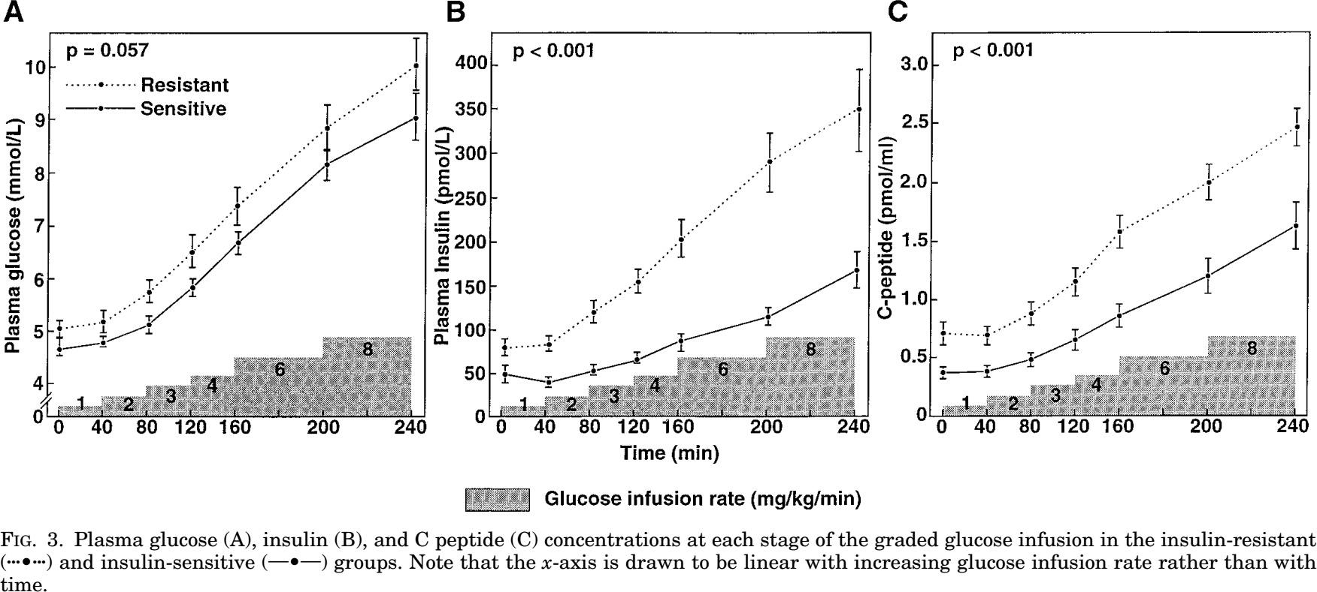

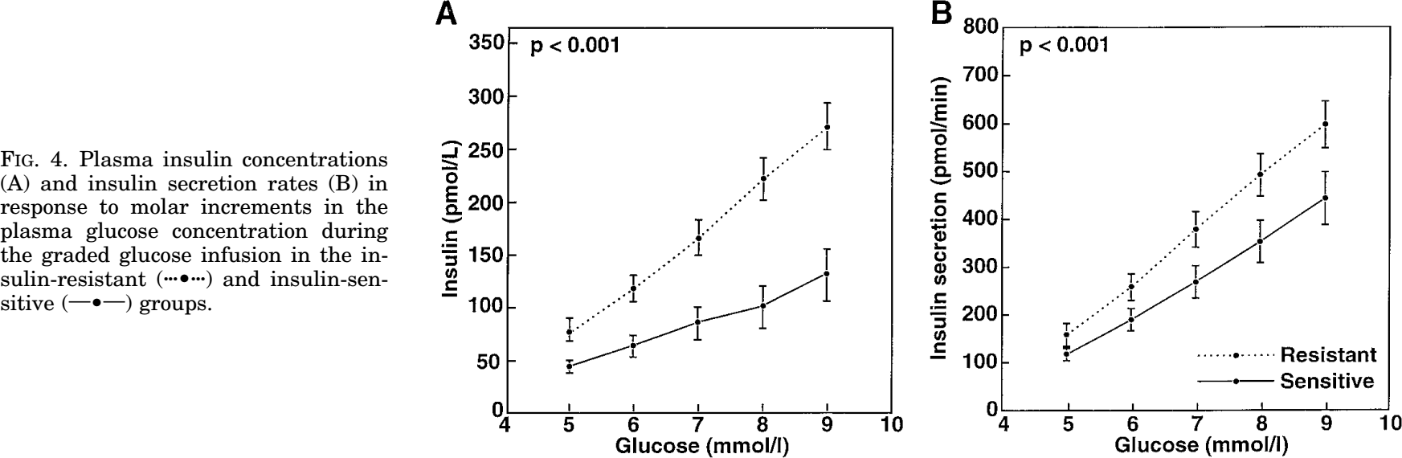

#### 

#### Cerasi1972

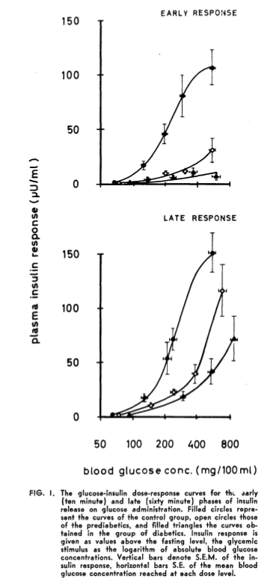

#### Grodsky1972

* **perfused rat pancreas (?!)**

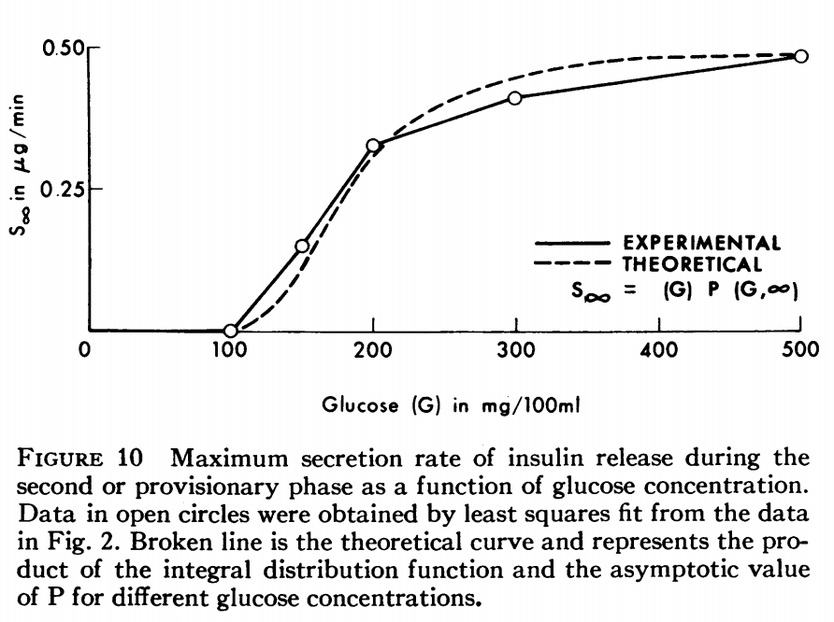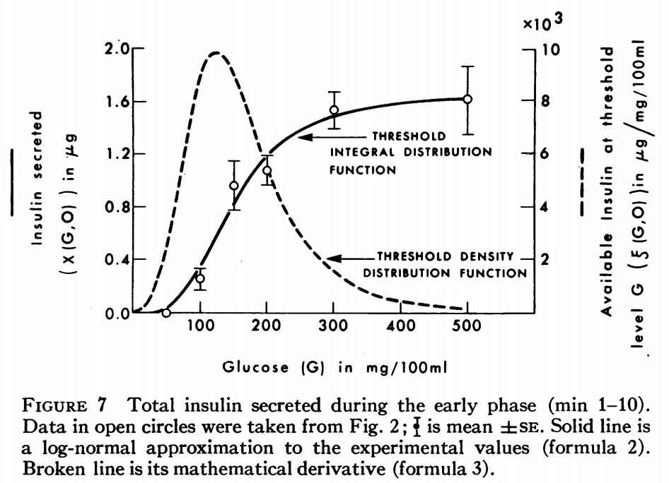

#### Lorenz2013

* **mouse beta-cell, cell line**

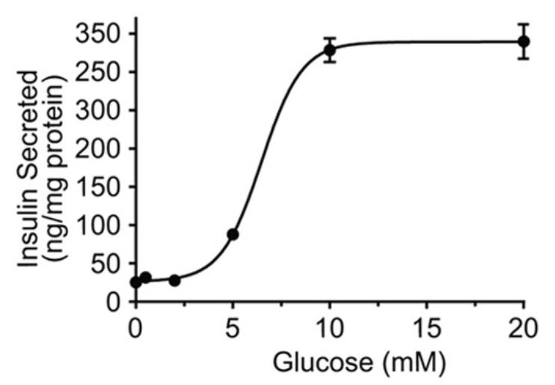

## Metabolism

#### Detimary1996

* **mouse, pancreatic islets**

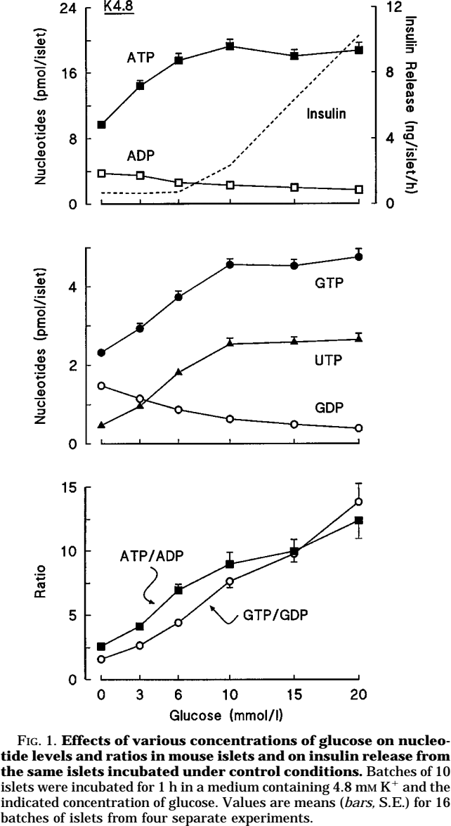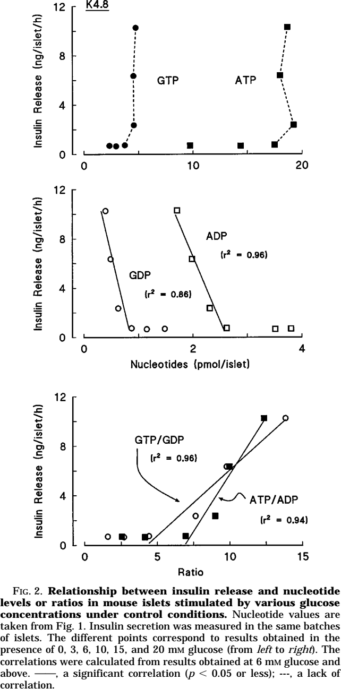

#### Lorenz2013

* **mouse beta-cell, cell line**

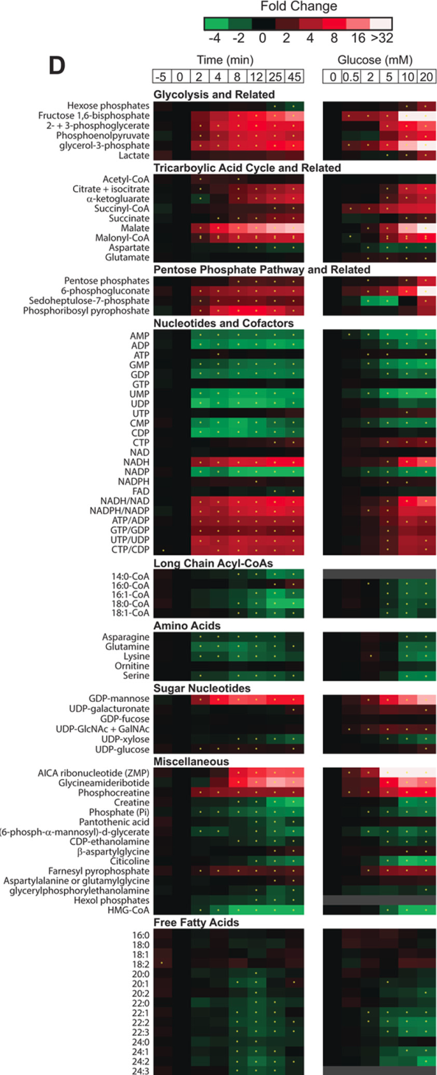

## Pancreas volumes