# Presentation of the company

EY (Ernst & Young) is a worldwide known accounting firm and is proud member of the “Big four”. EY is spread around the world with more than 700 offices in more than 150 countries offering jobs to more than 200.000 employees. The Belgian offices are located in **Diegem** (office where the internship took place), Ghent, Antwerp, Bruges... For a total of twelve different locations in Belgium. The 1335 Belgian employees are spread between these locations. [1]



Figuur 1: Logo EY (2017) [6]

## History

Throughout the years EY was formed by merging with other organizations several times. The oldest originating partnership was founded in 1849 in England. In 1989 the fourth largest accountancy firm (Ernst & Whinney) merged with the fifth largest (Arthur Young) to create Ernst & Young. [2]



Figure 3: Logo Arthur Young [8]

Figure 2: Logo Ernst & Whinney [7]

At one point in time there were even plans to merge with KPMG (current member of the big four), but those plans were abandoned due to the difficulty of merging two diverse companies and cultures.

Today EY is still looking for opportunities to further expand and improve the quality of its services. One of the fastest expanding sectors is the cybersecurity, especially with the recent announcement of the General Data Protection Regulation (GDPR)[1] [3]. These regulations are effective from May 2018. These are intended to unify data protection for enterprises within the EU. Organizations all over the EU are rushing to meet these requirement and ask companies like EY to accompany them in this process.

## Structure

### Geographical

EY groups their offices by geographical location into four areas. Each of these areas is then divided into more local areas. [2]

* **EMEIA (Europe, Middle East, India and Africa)**
  + Africa

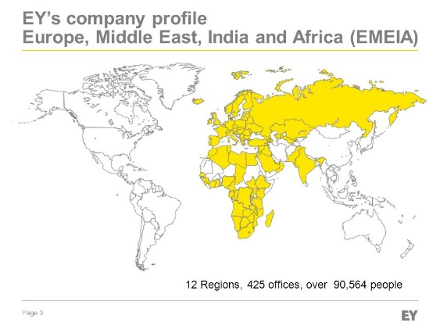

Figure 4: EY’s company profile (EMEIA) [5]

* + **BeNe (Belgium and The Netherlands)**
  + CIS
  + CSE
  + FraMaLux
  + GSA
  + India
  + Ireland
  + Mediterranean
  + MENA
  + Nordics
  + UK
* Americas
* Asia-Pacific
* Japan

### Organizational

EY offers multiple services to companies world-wide. These services are grouped into four major service-lines:

* **Tax**: provide information about (global) tax infrastructure.
* **Transaction advisory services**: provides information regarding raising, investing, preserving and optimizing the organizations capital.
* **Assurance**: provides general financial information.
* **Advisory**: provide clients with information regarding risk management and performance improvement.

The advisory service-line facilitates the cybersecurity service in which this internship took place. The cybersecurity service is officially split into multiple services (business resilience, data privacy, cyber threat management) but members of the cyber security team can take assignments in any of these services.

Other services provided by the advisory branch are:

* IT Transformation
* Data Analytics
* Finance
* Supply Chain
* Customer & Strategy
* People Advisory Services
* Risk Management
* Internal Audit & Controls
* Risk Transformation
* **Cybersecurity**
  + Cyber Program Management
  + Cyber Threat Management
  + Identity & Access Management
  + Data Protection & Privacy
  + Business Resilience
  + Business Continuity
  + Incident Response (IR)
* IT Assurance

### Financial sector

EY has clients from very varying sectors, the financial sector covers the most part of the clients.

The whole above mentioned structure exists in duplicate. Once for clients in the financial sector (FSO) and once for clients of non-financial sectors (NON-FSO). This internship took place in the NON-FSO branch of EY.

### Summary

To get a better perspective where the internship took place within the complex organizational structure of EY the following flowchart was created.

## Big four

This is a group of the world largest professional service networks. EY is accompanied in this group by PwC, DeLoitte and KPMG. The group originally consisted of eight members but the group was reduced to four members after several merges and scandals. [4]

EY differs itself from the other members of the big four by being the most globally managed firm of the four. EY has defined a set of policies to assure consistency of services globally. This globalization is clearly visible in the daily working of the company. Desks are shared between colleagues of various nationalities, all employees get the chance to work together with colleagues with a complete different culture which results in a very dynamic, coherent and educational work experience.

## Students

EY invests a lot into the potential of students, throughout the year there are numerous internships offered in all the different services offered by EY. This is why EY is in the top of several rankings like: “best places to launch a career”, “Ideal employers” etc.

# References

|  |  |
| --- | --- |
| [1] | EY, „EY,” EY, [Online]. Available: http://www.ey.com/be/en/home. [Geopend 07 February 2017]. |
| [2] | Wikipedia, „Ernst & Young,” Wikipedia, 07 February 2017. [Online]. Available: https://en.wikipedia.org/wiki/Ernst_%26_Young. [Geopend 07 February 2017]. |
| [3] | Wikipedia, „General Data Protection Regulation,” Wikipedia, 24 January 2017. [Online]. Available: https://en.wikipedia.org/wiki/General_Data_Protection_Regulation. [Geopend 08 February 2017]. |
| [4] | Wikipedia, „Big Four accounting firms,” Wikipedia, 06 February 2017. [Online]. Available: https://en.wikipedia.org/wiki/Big_Four_accounting_firms. [Geopend 07 February 2017]. |
| [5] | EY, „EY Corporate Presenation,” May 2015. [Online]. Available: http://images.slideplayer.com/24/7228379/slides/slide_3.jpg. [Geopend 1 March 2017]. |
| [6] | EY, „EY Logo,” [Online]. Available: http://www.ey.com/ecimages/EY.gif. [Geopend 1 March 2017]. |
| [7] | Erns & Whinney, „Erns & Whinney Logo,” [Online]. Available: http://userscontent2.emaze.com/images/86dbf6c2-1ab1-4300-b458-0e0c31ce5ac3/635348645831478302_EWlogo.jpg. [Geopend 1 March 2017]. |
| [8] | Arthur Young, „Arthur Young Logo,” [Online]. Available: https://res.cloudinary.com/crunchbase-production/image/upload/v1457147586/eve4v8gr0liwkkhbvtqw.jpg. [Geopend 1 March 2017]. |

1. The primary objective is to give citizens back the control of their personal data. Enterprises that are not complied with this new regulations will risk a fine of 4% of their annual revenue.