Nijmegen School of Management
Department of Economics and Business Economics
Project: Financial Instruments

Analysis of TSMC’s Financial and Strategic Risks

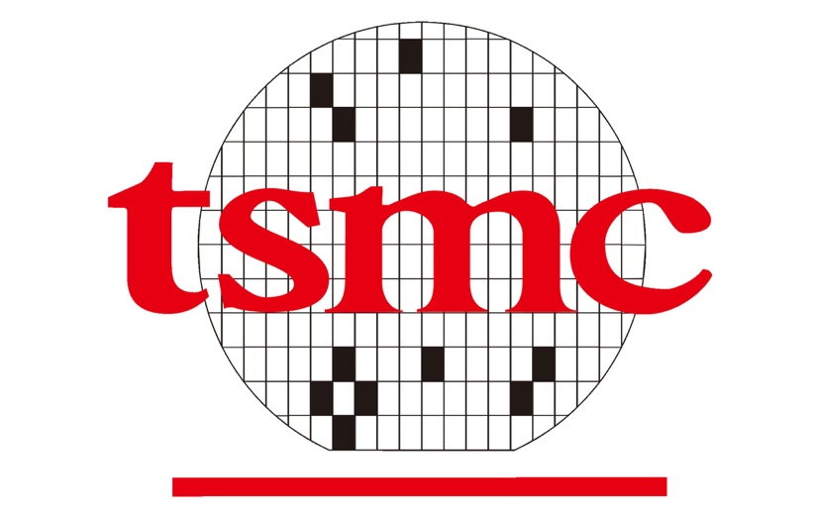

Author:
Mátyás Varga-Etele s1121420

matyas.varga-etele@ru.nl
Table of Contents
1.Introduction 3
2. Theoretical Framework 5
2.1. Financial risks and Corporate Hedging 5
2.2. Interest rate risk 6
2.3. Exchange rate risk 6
2.4. Inflation rate risk 7
2.5. Geopolitical Risk 8
3. TSMC’s Financial Exposure and Risk Management 10
3.1. Overview of TSMC’s Financial Position 10
3.2. Analysis of Interest rate risk 15
3.3. Analysis of Exchange rate risk 16
3.4. Analysis of Inflation rate risk 18
4. Conclusions 20
Appendix 21
References 22

1.Introduction
In recent years, the global semiconductor industry became one of the most important industries for the world economy. Advances in fields such as cloud computing, consumer electronics and artificial intelligence (AI) systems made it so that the demand for semiconductors has exponentially increased (Hyatt et al., 2024; Liu et al., 2025). Specifically, AI has increasingly become a significant factor contributing to economic growth in major economies such as China, the United States, and various countries within Europe (Gonzales, 2023).
At the center of this innovational transformation stands the world’s most advanced semiconductor manufacturer, the Taiwan Semiconductors Manufacturing Company (TSMC), which produces almost all the world's supply of high processing units. In addition, the company was founded in 1987 in Taiwan and went public on the Taiwan Stock Exchange 7 years later. The firm was funded in its early days by wealthy Taiwanese families with private businesses. High initial investments put the company on a path of rapid growth, specializing quickly in the production of the smallest, and therefore fastest, processing units worldwide. They acquired Apple as their most important client in 2014, establishing stability in their previously demand cycle dependent sales (TSMC, 2025). Currently, it also manufactures chips for several other major leading tech companies in the global economy such as Nvidia, AMD and Qualcomm.
The geopolitical tensions between Taiwan and China have played a big role in the geographic diversification of the company (Reuters, 2025). Since 2020, Taiwan has chosen to open subsidiaries around the world, while at the same time pledging to use 100% renewable energy by 2050 (TSMC, 2025). Furthermore, increasing tensions between the two superpowers, the USA and China made semiconductors a strategically relevant good and therefore the US introduced the CHIPS Act in 2022, which made TSMC even more motivated to open subsidiaries in the US and shift some of its manufacturing processes to other countries that implemented similar subsidies for semiconductor manufacturers (Hyatt et al., 2024).
TSMC continues to push the boundaries in the manufacturing of processing units, being the first to produce 3nm chips in 2022 and 2nm chips in 2025. This resulted in the foundry also dominating the market for chips below the 10nm process level, making the company an even more dominant player in its industry (van der Steen, 2022). TSMC’s estimates state that the worldwide semiconductor market has reached 611 billion USD in revenues in 2025, this is approximately a 19 percent increase from the previous year. Out of this global market, the size of the company’s reachable market is estimated to be 305 billion USD, which is 16% increase from the previous period (TSMC, 2025). This strategic importance of TSMC makes the whole industry for semiconductors vulnerable to any disruptions or issues that the company faces. In other words, a negative shock affecting TSMC will have a major effect on the whole market (Liu et al., 2025).
At the same time, the industry for semiconductors slowly became more vulnerable to changes in energy prices and inflation fluctuations. The manufacturing of these strategic goods requires stable access to electricity, natural gas, water and highly specialized materials. Therefore, even small changes in energy prices or inflationary pressures can cause increased operational costs, which in turn affects TSMC’s profitability directly (Wang et al., 2023). Moreover, the continuous advances in the field of AI technologies creates further pressure on TSMC to invest in new manufacturing plants, this increases the company’s financial needs, therefore it makes borrowing cost go up as well (TSMC, 2025).
Interest rate risk was traditionally not as important since the 2010s had relatively low interest rates. However, in recent years, central banks increased rates more suddenly and sharply in response to several global disruptions and crises, such as the COVID-19 pandemic or the Ukraine war. Higher interest rates affect financing costs, since the cost of borrowing goes up, this has a major effect on firms such as TSMC (Alvarez et al., 2001). Another important risk that TSMC faces is exchange rate risk. This is because most of TSMC’s revenues come in the form of US dollars, while most of its operational costs are still in New Taiwanese Dollars (NTD). Fluctuations in currency markets therefore influences TSMC’s export competitiveness and profitability (TSMC, 2026).
To summarize, for the company to fully take advantage of its economic position, it has to hedge against these many different financial and strategic risks. Therefore, this analysis of the financial instruments employed by TSMC aims to highlight the various forms of hedging techniques it already employs, with a special focus on geopolitical risk, interest rate risk, exchange rate risk and inflation risk. Furthermore, the paper combines understanding the theory behind these financial risks and a practical overview of the financial processes of TSMC.

2. Theoretical Framework

2.1. Financial risks and Corporate Hedging
Financial markets can influence a company’s cash flows, firm valuation and profitability in general, this type of risk that economic agents face is called financial risk. There are several forms of financial risks such as interest rate risk, exchange rate risk, inflation risk or commodity price risk. Multinational corporations such as TSMC are influenced by many types of financial risks including the above-mentioned ones. These risks can negatively affect firm’s earnings and investment stability. In addition, they can create increased volatility for these companies. In order to mitigate these risks, most companies use several hedging techniques and strategies to decrease this uncertainty (Smith & Stulz, 1985).
Specifically, firms use hedging tools to reduce expected operational costs that are associated with taxes, the lack of investments and financial disruptions. Hedging stabilizes company cash flows, this makes future earnings more predictable and can increase the overall economic value of the firm (Smith & Stulz, 1985). Multinational companies and leading market players are more likely to use more hedging tools, since they face larger uncertainty around financial risks and they have higher growth opportunities. Implementing several hedging strategies can be a way to improve long-term investment planning (Nance et al., 1993). These strategies are especially important to consider for firms operating in the semiconductor manufacturing industry, since manufacturing these goods require high levels of long-term borrowing commitments and capital expenditure (TSMC, 2026).
Furthermore, there are several specific hedging tools that are used in industries such as chip manufacturing. Firstly, when a company buys long-term energy contracts and other financial instruments to reduce exposure to price fluctuations and geopolitical disruptions is called financial hedging. A different form of hedging is the concept called operational hedging, which is when firms engage in several forms of diversification of production and suppliers or when a company secures its access to strategic goods that are critical for its production processes (Ivanov & Dolgui, 2020; Liu et al., 2025).
In addition to implementing hedging strategies such as the ones mentioned above, companies combine these with policy-oriented measures. This essentially means that they cooperate with governments, lobby for subsidies and invest in long-term investments in differing countries to reduce their dependence on a particular country, where they operate primarily. The CHIPS Act in the USA in 2022 is a good example of this, where a country in this case the United States decided that it wants to have more of its semiconductors made domestically and TSMC was influenced by this policy measure, so it shifted some of manufacturing processes to the US (Hyatt et al., 2024).
A combination of the strategies mentioned above contributes to supply chain resilience, cost stability and production continuity. Firms use various tools to reduce financial risks, such as financial and operational hedging, and policy related financial tools. Decisions about using these tools have to be made carefully to match the costs associated with implementing the particular strategy and the added benefits it brings to the company (Liu et al., 2025).

2.2. Interest rate risk
Interest rate risk is the risk that is associated with the possible value fluctuations of investments or financial obligations due to changes in market interest rates. Interest rate risk theory predicts that this risk can affect economic performance and the value of financial assets. Interest rates influence bond prices, loan costs, company profits and exchange rates (Alvarez et al., 2001). In financial economics, there are many concepts that are connected to interest rate risk theory.
Duration for example measures the sensitivity of a bond’s price to interest rate fluctuations, an increase in duration means an increase in the sensitivity of the bond. Another concept is convexity, which refers to the idea that interest rate changes do not correlate with bond prices in a linear way, in other words the same changes in interest rates do not translate to the same movements in bond prices entirely. Therefore, convexity predicts how much bond prices will change better than what duration alone would predict. Duration and convexity as tools are regularly used by financial risk managers to calculate the effects of an interest rate change on financial assets and liabilities (2.2
The semiconductor industry is especially exposed to interest rate changes. This is because manufacturing these products requires extremely large capital expenditures. In other words, semiconductor manufacturing factories cost tens of billions of dollars to fund and maintain, therefore these companies need to borrow at a high rate to fund their operations (TSMC, 2026). Increased interest rates can increase borrowing costs and in turn this could reduce a firms future profitability.
Interest rates also present other risks, which are liquidity and funding risks. The central bank sets interest rates and these rates determine borrowing costs for individuals, businesses, governments and other banks. Potential interest rate hikes can increase borrowing costs and create problems with funding in an economy (Alvarez et al., 2001). In addition, liquidity preference theory suggests that investors demand a premium for holding long-term assets, because of the risks associated with possible interest rate movement. This strongly relates to the concept of interest rate risk.
Hedging against interest rate risk is a common practise in the financial world. The most common forms include interest rate swaps, forward rate agreements, interest rate options and interest rate futures. Moreover, a more complex way of hedging is to use Asset-Liability Matching (ALM), which is the practise of matching the underlying characteristics of the firm’s assets and liabilities, these characteristics include maturities and interest rates (Smith & Stulz, 1985).

2.3. Exchange rate risk
Exchange rate risk refers to the exposure of changes in the currency exchange markets that companies face when they conduct their operations and engage in financial transactions. For multinational corporations such as TSMC, this type of risk is especially significant, because they operate in many different countries at the same time and therefore, they use many different currencies as well. This results in a scenario that even small movements in exchange rates can have serious effects on a company’s profitability and competitiveness.
Furthermore, there are many types of exchange rate risks. Firstly, transaction risk refers to the risk that companies have to take into consideration when they have payment obligations or financial contracts denominated in a foreign currency. Another form is called translation exposure, which is specifically the risk that exchange rate fluctuations can have massive effects on a company’s financial statement. Lastly, economic risk is associated with long-term exchange rate changes that effect the company’s overall economic value in the future (Smith & Stulz, 1985).
Specifically, TSMC sells most of its semiconductors to the US market, and therefore most of their revenues come in the form of USD, while most of its operations are still conducted in Taiwan in New Taiwan Dollars (NTD) (TSMC,2026). This creates exchange rate risk, because if NTD and the USD currency exchange rate fluctuates and for example the US dollar depreciates, then this results in a relative decrease in revenues compared to company costs. On the other hand, if the USD suddenly appreciates than the revenues of TSMC increase relative to costs.
To hedge against exchange rate risks, companies usually use financial tools such as foreign exchange forwards, currency swaps or options. Moreover, a company can also try to match its costs and revenues inside any particular currency area that it operates it, this is an operational hedging technique. While these hedging tools can provide some protection against exchange rate risk, they cannot fully protect these companies against unpredictable currency exchange market fluctuations (Smith & Stulz, 1985; Ivanov & Dolgui, 2020).

2.4. Inflation rate risk
Inflation rate risk is focused on how changes in the price level can have a negative effect on a firm’s aggregate costs. Inflation increases the price of required resources, electricity, wages, transformation costs and much more. Therefore, a negative inflationary shock puts pressure on companies, and it can create more uncertainty about a company’s financial performance, this is especially true for multinational firms in capital-intensive markets.
Macroeconomc theory suggests that inflation is closely connected to monetary policy and changing interest rates. Specifically, central banks (CB) can raise interest rates to bring down the level of inflation in the domestic economy (Alvarez et al., 2001). However, as it was already stated in the interest rate risk section above higher interest rates increase borrowing costs as well. Therefore, inflation rate risk is closely related to interest rate risk, because corporations can face higher operational costs and borrowing expenses at the same time, when the CB decides to raise rates to fight inflation, but inflation takes some time to go down, while interest rates increase quickly.
In addition, the semiconductor manufacturing industry is heavily exposed to changes in inflation rates. Semiconductor factories require large amounts of water, electricity and specialized materials to properly function. As a result, the effects of rising commodity and energy prices increase overall operational costs, which in turn decreases the profitability of the company (Wang et al., 2023). Producing technologically advanced chips also requires technicians and highly skilled workers. Inflation increases the wage expenses for these workers, which is an additional risk that companies have to take into consideration TSMC, 2025).
Firms use hedging techniques to reduce inflation related risks. These tools include long-term supply contracts, commodity hedging instruments and geographic diversification (Tang & Musa, 2011). Moreover, companies can choose to make their supply chains less exposed to disruptions in order to reduce the negative effects of a possible future negative inflationary shock (Ivanov & Dolgui, 2020).

2.5. Geopolitical Risk
Geopolitical risk refers to the idea that political events, instability or conflicts are able to compromise a company’s strategy, profitability or operations in places where it operates. This risk can originate from regulatory changes, war, political instability or terrorism. In the current geopolitical climate, where the semiconductor industry is increasingly being seen as a critical industry for the development of new technologies and innovations that countries want to produce domestically, the industry itself became more exposed to the possibility for geopolitical tensions or escalations (Hyatt et al., 2024).
An example of geopolitical risk is the invasion of Ukraine by Russia in 2022, which made companies like McDonald’s, Ikea and BP exit the Russian markets due to sanctions and public pressure. Hung (2024) was able to determine bidirectional Granger causal relationships between major exchanges during the Covid-19 pandemic and the beginning of the Russia-Ukraine war, this supports the idea that is geopolitical shocks do cause market volatility and instability. In addition, the European Central Bank (ECB) also published a paper on geopolitical fragmentation and how increased tensions have pushed “allies” to hedge in each other’s currencies (European Central Bank, 2023).
TSMC is in Taiwan, which is a nation that remains unrecognized by many major countries around the world, for example one of these countries is China. This can be further emphasized by the fact that in the financial statements for 2024, Taiwan is mentioned to be in the Republic of China by the independent auditor (Deloitte, 2025). Furthermore, China still has the so called “One China Policy”, which means that China considers Taiwan to be part of the country (Bush, 2017). However, since Taiwan became a strategically important region due to its significance in the production of semiconductors globally, the USA increasingly views Taiwan as a key economic partner. This creates the potential for a military escalation in the region, which is a massive supply chain vulnerability, caused by this geopolitical exposure. In other words, the risk for military escalation and war with China is a possible scenario that investors take into consideration, and they consider this a major long-term risk for the future of TSMC (Liu et al., 2025).
Multinational corporations usually handle geopolitical risks with a diverse set of hedging tools. The most used strategy is diversification. This strategy is used to mitigate risks that are associated with specific regions. Diversification involves spreading the supply chain, investments, and even production of plants or offices across different locations in multiple countries and regions. Corporations can also choose to build local relationships to mitigate geopolitical risks. Moreover, strong local partnerships with governments can ensure that these countries will remain cooperative even in a potential economic crisis or recession. Using diversification strategies can strengthen supply chain resilience and therefore can positively impact a company’s overall economic performance (Ivanov & Dolgui, 2020).
Moreover, another one of these tools are financial hedging mechanisms, such as buying long-term energy contracts or management tools for hedging against sudden changes in commodity prices (Tang & Musa, 2011). A strategy that was already mentioned in the above sections is operational hedging, which involves keeping key supply chain resilience concepts in mind. It includes geographic diversification of production, supplier diversification, and securing access to critical inputs (Ivanov & Dolgui, 2020; Liu et al, 2025).

3. TSMC’s Financial Exposure and Risk Management

3.1. Overview of TSMC’s Financial Position
This section is about analyzing the financial position of TSMC between the years 2020 and 2025. The analysis features many illustrations and numbers that are derived from TSMC’s financial statements, sustainability reports and statistics about interest rates and inflation (TSMC, 2022 ; TSMC, 2023; TSM, 2026). All the sources are in the references and in the appendix section, there is a brief explanation about how data was collected. The code itself and the files used to make these illustrations are available through the GitHub link provided in the references.
The analysis’s main focus is on assessing the TSMC’s financial risks and the firm’s ability to withstand possible economic shocks. This section includes analysis on liquidity, liabilities, profitability and capital expenditure trends. Knowing these indicators is particularly important when looking at companies in the semiconductor industry, since this market requires continuous long-term investments and this could only be managed if companies are highly capital intensive. Furthermore, the figures presented in this section are meant to illustrate the company’s financial statistics and it’s ability to manage various financial and strategic risks that were discussed in the theoretical framework section of this paper.
Firstly, Figure 3.1.1 shows TSMC’s current assets and current liabilities. The figure demonstrates a significant upward trend with rising current assets and current liabilities each year. While current assets increased from NT$ 1.09 trillion in 2020 to just over NT$ 3.8 trillion by the end of 2025, current liabilities increased too, going from NT$ 617 billion to NT$ 1.46 trillion during the same period. This means that current assets always remained much higher than current liabilities. Therefore, the figure suggests that TSMC had enough liquid positions to meet its payment obligations in this period of analysis. This finding is further showed by Figure 1.1.2, which demonstrates how the current ratio, which is all current assets divided by all current liabilities has changed during this time and it increased substantially, which suggests that the company’s financial position became more stable during the period between 2020 and 2025.

Figure 3.1.1: TSMC Current Assets and Current Liabilities
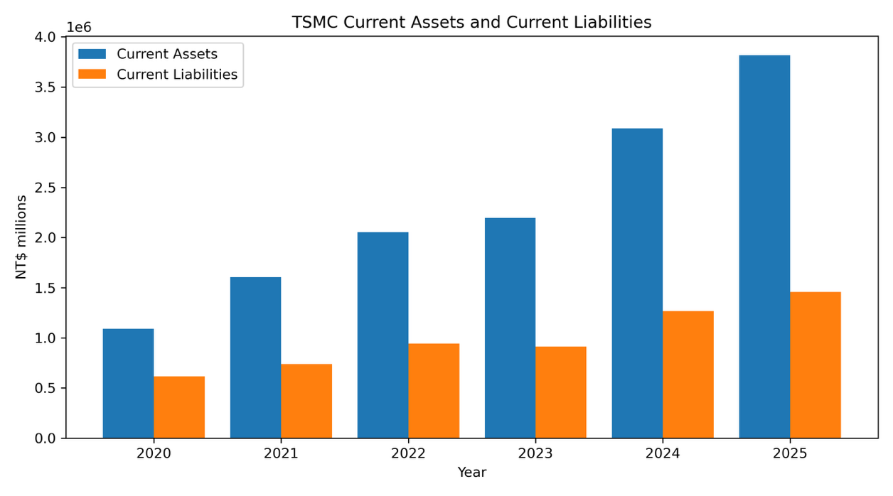(Note: 1.0=1,000,000 NT$ million)

Figure 3.1.2: TSMC Current Ratio
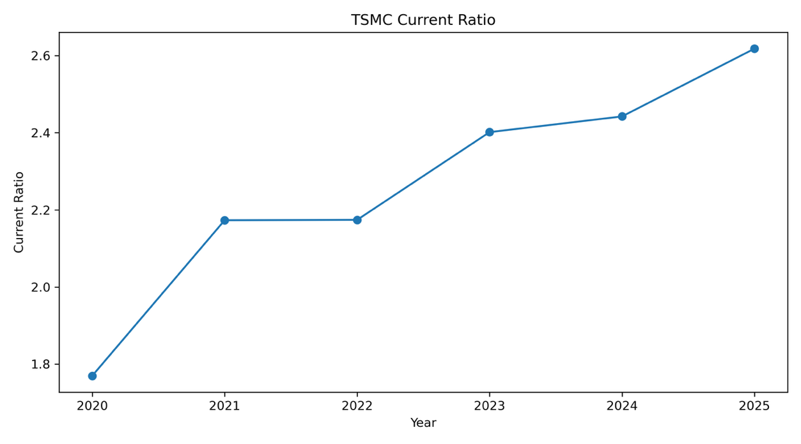

Figure 3.1.3. illustrates how TSMC’s revenues and net income has changed during the given period. Revenues increased from NT$ 1.34 trillion to NT$ 3.8 trillion by the end of 2025. Moreover, net income also increased from approximately NT$ 518 billion to 1.7 trillion in the same period. The figure also shows a small slowdown period for both net income and revenues between 2022 and 2023, which can be attributed to less semiconductor demand in that period (TSMC, 2023). After this brief slowdown period, net income and revenues continued to significantly increase mostly due to increasing demand for AI-technology related semiconductor chips during this time (TSMC, 2026).

Figure 3.1.3: TSMC Revenue and Net Income
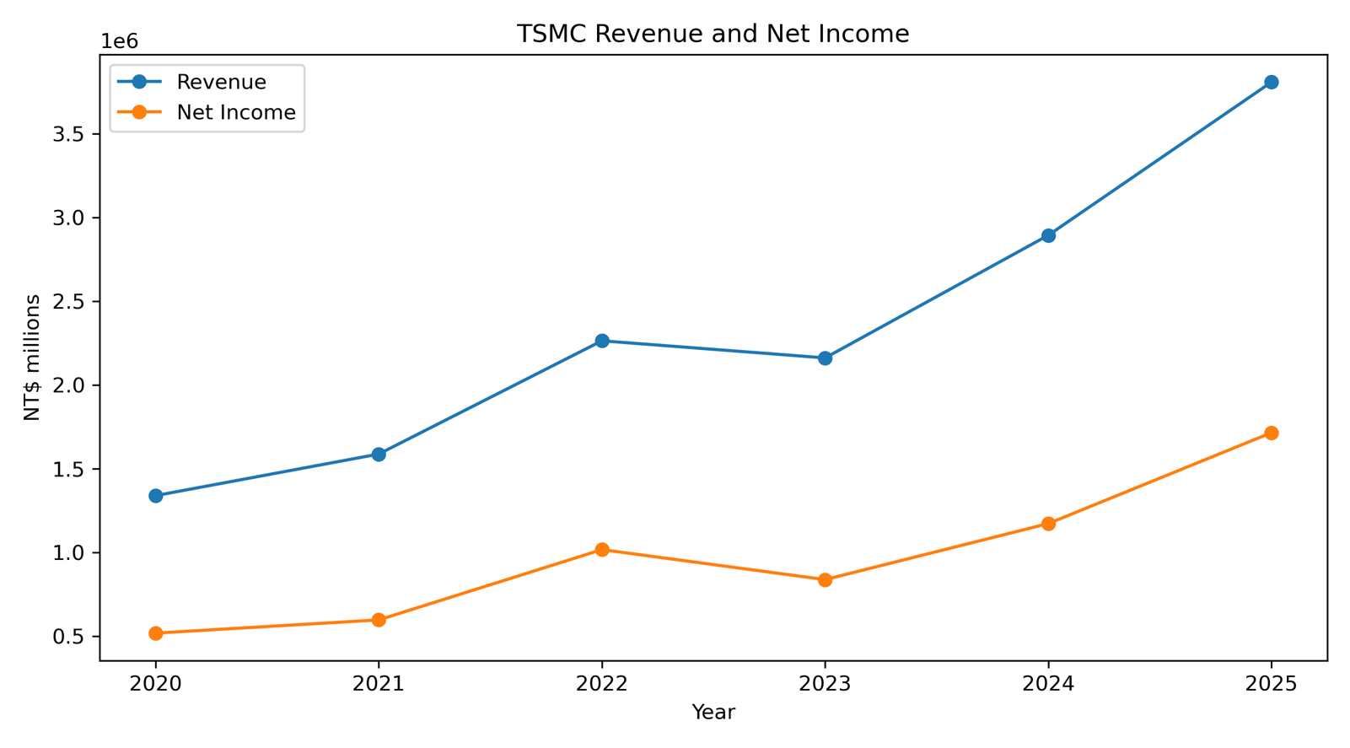(Note: 1.0=1,000,000 NT$ million)

Furthermore, Figure 3.1.4 shows how TSMC’s capital expenditure (CapEx) has changed during the period of analysis. In this figure, there is clear increase in CapEx overall from NT$507 billion to over NT$1.27 trillion. The substantial increase can be attributed to a change in TSMC’s financial strategy during this time, which essentially concerned significantly expanding their semiconductor manufacturing capabilities to respond to increased demand from firms that are engaging in producing new AI-related technologies. Moreover, this trend also reflects the fact that TSMC has been investing more abroad due to its desire to diversify its manufacturing locations globally (TSMC, 2026).
However, this increase in CapEx also means that the company faces more financial risk when conducting its operations. Semiconductor manufacturing facilities have to have extremely large initial investments, and they have very long construction periods. Therefore, this means that the company is exposed to changes in interest rates, inflation and the worsening of borrowing conditions in general. Rising interest rates can increase the cost of borrowing and reduce profitability for the company. On the other hand, inflation can increase the overall cost of production, wages, energy and raw materials. TSMC’s ability to be flexible and be able to adjust its semiconductor production volume during periods of weaker demand depends on partially its capital expenditures. The reason for this is that while higher capital expenditure can drive long-term growth, it also increases the financial and operational risks for the company.

Figure 3.1.4: TSMC Capital Expenditure
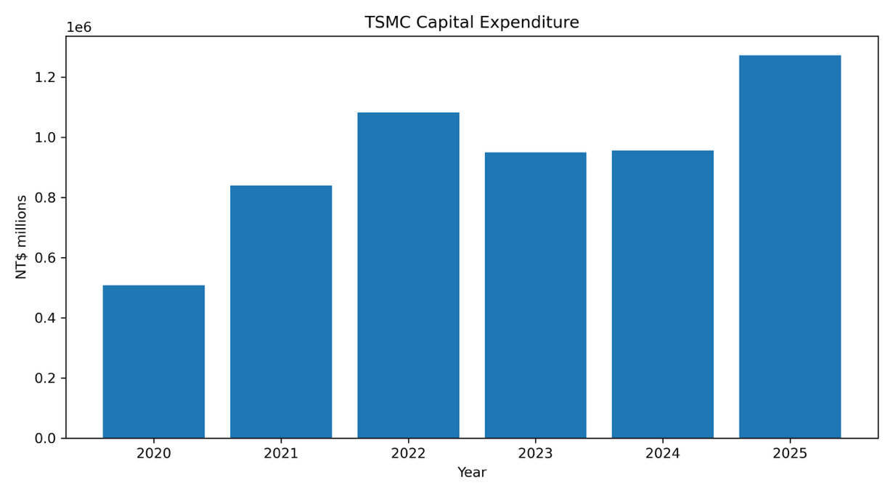(Note: 1.0=1,000,000 NT$ million)

TSMC’s liquidity position can be seen in Figure 3.1.5, where it shows the company’s cash reserves and total liabilities. Cash holdings increased from NT$ 660 billion to NT$ 2.7 trillion during the period of between 2020 and 2025. Moreover, total liabilities substantially increased too from NT$ 910 billion to NT$ 2.47 trillion. While the total liabilities grew, the amount of cash reserves steadily matched this increase and by 2025 cash reserves overtook the total liabilities. This means that TSMC could maintain a stable financial buffer, while engaging in more investment activities and increasing operational expenditures. This stability is very important for a firm in the semiconductor industry, because of cyclical demand fluctuations and rising financing costs.
The rapid rise of TSMC’s total liabilities can be explained by the company’s decision to expand aggressively its production capacities and also increase investments. The company does this to prepare for the potential scenario that new technological advancements in AI, Deep learning or other related technologies will increase the demand for semiconductors and further grow the semiconductor market.
Figure 3.1.5: TSMC Cash and Total Liabilities
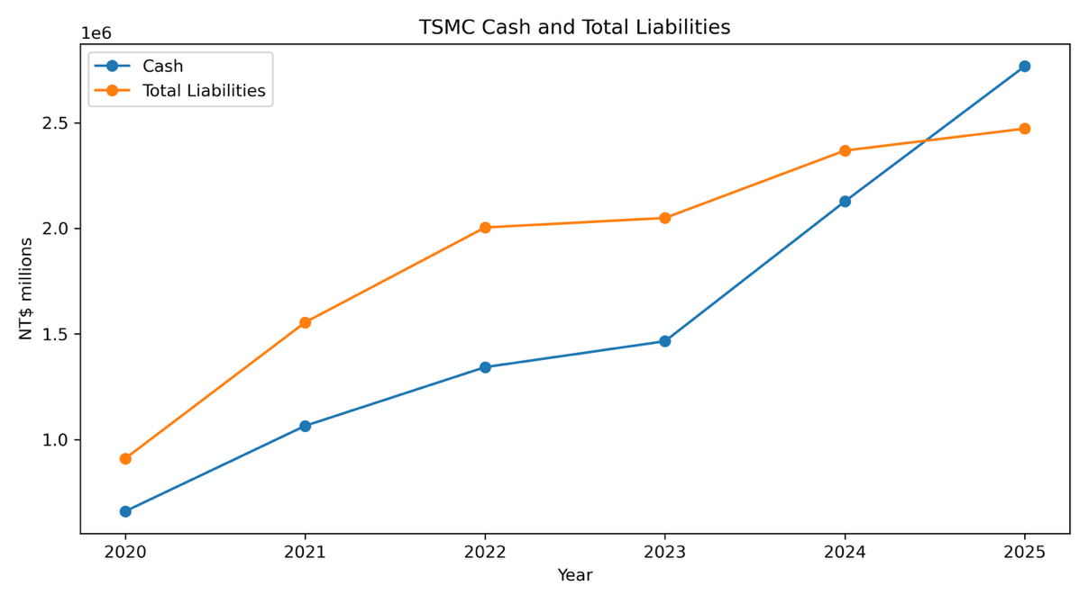(Note: 1.0=1,000,000 NT$ million)

Figure 3.1.6 represents how TSMC’s net profit margin, which is the value calculated by dividing net income by revenues. This estimate remained significantly strong, especially considering that the period between 2020 and 2025 had many geopolitical crises, inflationary pressures and rising interest rates that could have affected the company’s profitability more. As the net profit margin remained inside the 37% and 45% range, the company could internally finance its investments, at the same time relying less on borrowing externally.

Figure 3.1.6: TSMC Net Profit Margin
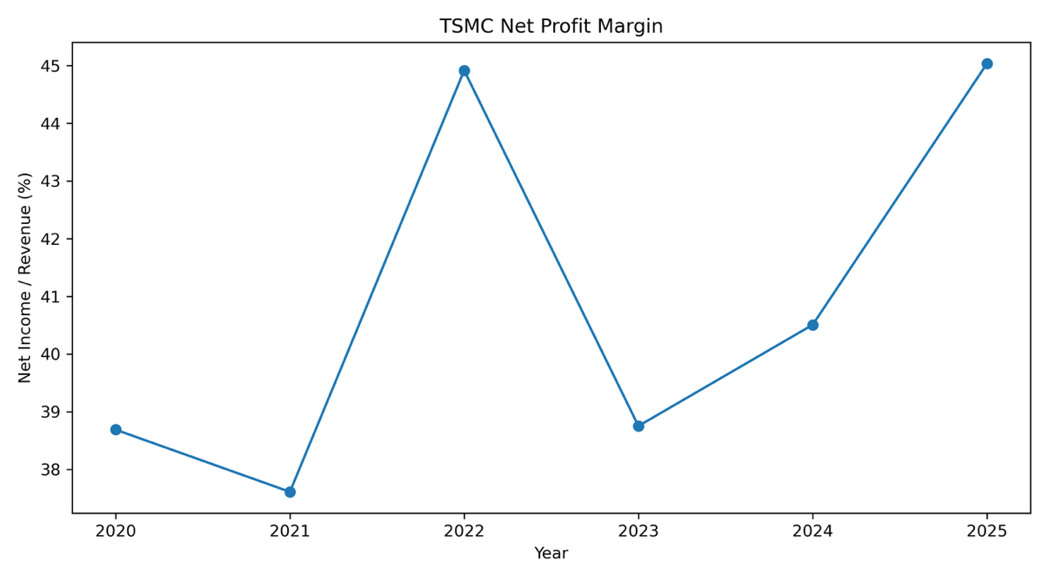

To summarize, all of these figures show that TSMC remained in a strong financial position between the period of 2020 and 2025, despite facing increasing financial and strategic risks. TSMC managed to increase its liquidity, revenues, profitability and also its cash reserves. However, while these numbers show a very positive picture at this current moment, it is important to note that TSMC is more exposed to interest rate risk, exchange rate risk, inflation risk and geopolitical risk than it was in previous periods.

3.2. Analysis of Interest rate risk
The period between 2020 and 2025 was characterized by several economic shocks that came from unexpected developments, these include the COVID-19 pandemic and geopolitical conflicts, such as the war in Ukraine. This increased uncertainty created inflationary pressures in most of the world’s economies and central banks responded with raising interest rates relatively sharply. As it was previously discussed in the theoretical framework, these higher interest-rates make the cost of borrowing go up and hurt firm’s profitability, such as TSMC (Alvarez et al., 2001).
Specifically, in the case of TSMC, interest rate fluctuations not only have an impact on the company’s fixed income investments, but also on the cost of capital and future investment decisions. In order to manage this interest rate risk, TSMC uses fair value hedging, which is a hedging strategy that is used as protection against the possibility that the company’s assets value can be impacted by interest rate fluctuations. In other words, the company’s fixed income investment is highly dependent on fluctuations in the CB’s interest rate. By making use of fair value hedging, the losses and the gains are offset by the effects of each other. Overall, fair value hedging applied on the interest rate for TSMC, and this is part of a broader strategy for the purpose of decreasing the effects of earnings volatility and exposure to economic risk.
Figure 3.2.1 represents how TSMC’s reported interest expenses has developed throughout the period between 2020 and 2025. These expenses for the company went from NT$ 2081 million to NT$ 12370 million by the end of 2025. This increase is dramatic and it greatly illustrates what higher interest rates mean for a company’s finances. Furthermore, this finding also proves that TSMC is heavily exposed to interest rate risk coming from changes in global interest rates. If this trend of rising interest rates continues and capital expenditure requirements remain high, the company might find it difficult to finance its operations long-term.

Figure 3.2.1: TSMC Interest Expense Over Time
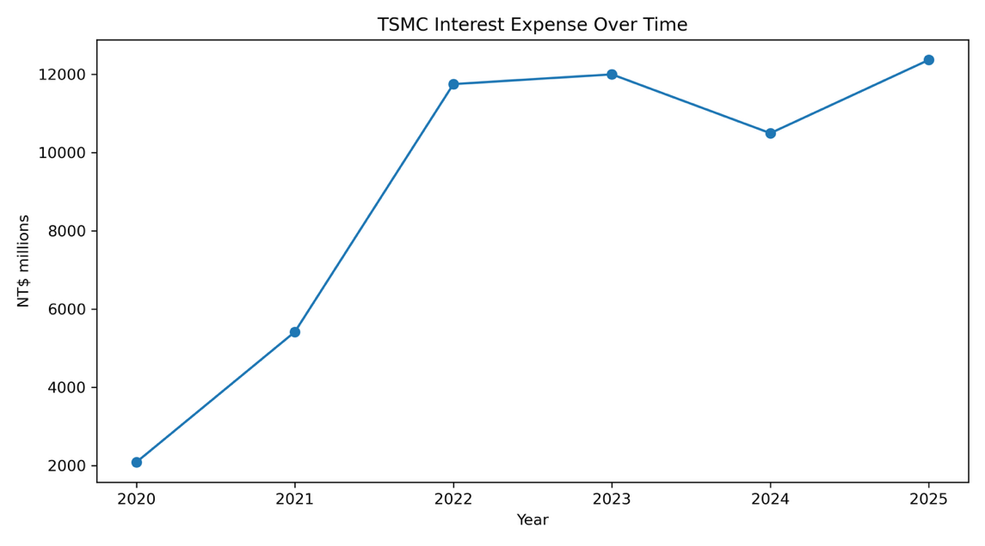
Moreover, another interesting illustration connected to this is Figure 3.2.2, which shows TSMC’s capital expenditure as a percentage of company revenues. The figure depicts a sharp increase in this ratio between 2020 and 2021, which went down from 52.5% in 2020 to around 33% in 2025. This showcases TSMC’s commitment to investing in long-term project, while also demonstrating a relatively safe allocation of company revenues in a financially sustainable way.

Figure 3.2.2: TSMC CapEx as a Percentage of Revenue
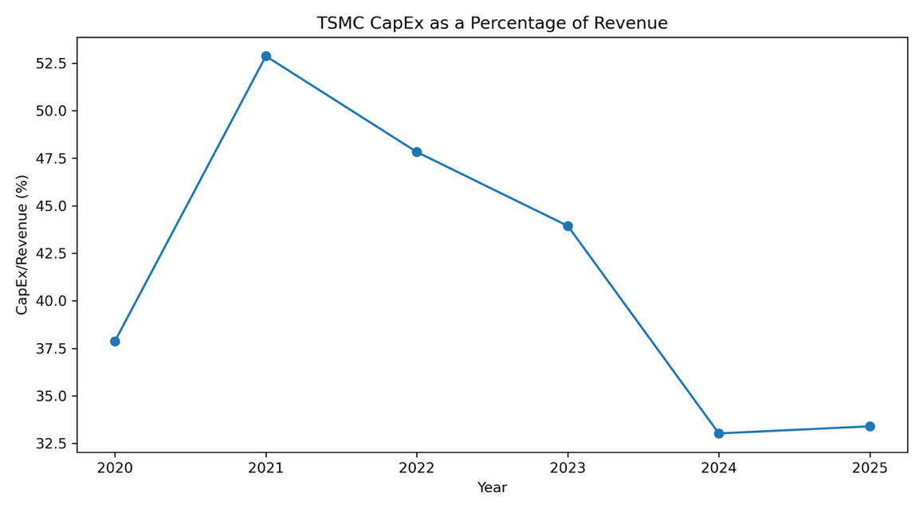

To summarize, TSMC has managed to perform relatively well, despite the increasing uncertainties that were present during the observed period. While its interest rates expenses rose, the company still maintained strong liquidity positions, which was demonstrated by the previous section’s finding that the company’s cash reserves remained high. This is probably the reason why TSMC could still spend a relatively high percentage of its revenues on long-term investments.

3.3. Analysis of Exchange rate risk
Multinational corporations are heavily exposed to exchange rate risks, because they operate globally in many different markets at the same time. TSMC is primarily headquartered in Taiwan, and it mostly produces to global markets and especially to the US market. This means that a very large percentage of its revenues are denominated in US dollars and its operational expenses are largely in NT$s. As it was discussed in the theoretical framework, this creates exchange rate risk for the company.
Figure 3.3 illustrates how the USD and NT$ exchange rate moved between 2020 and 2025. This shows the USD has appreciated during this period compared to the NT$. This appreciation can be seen especially from the period of 2021, where the exchange rate hovered around 27 USD/NT$, by 2024, this value increased to approximately 32 USD/NT$.
From the perspective of TSMC this appreciation of the dollar can be seen positively and negatively at the same time. On one hand, this makes the values of the company’s export revenues that are in USD increase, which in turn creates better financing conditions for the company, since most of its operational costs are still in NT$s. On the other hand, the period is also characterized by increased exchange rate volatility, which creates a more unstable business environment for TSMC. While the change during this period turned out to have largely positive results for the company, sudden movements in interest rates can also affect the company negatively in the future, this is why exchange rate risk is measured in exchange rate volatility and how much a company is actually exposed to these fluctuations.

Figure 3.3: USD/TWD Exchange Rate
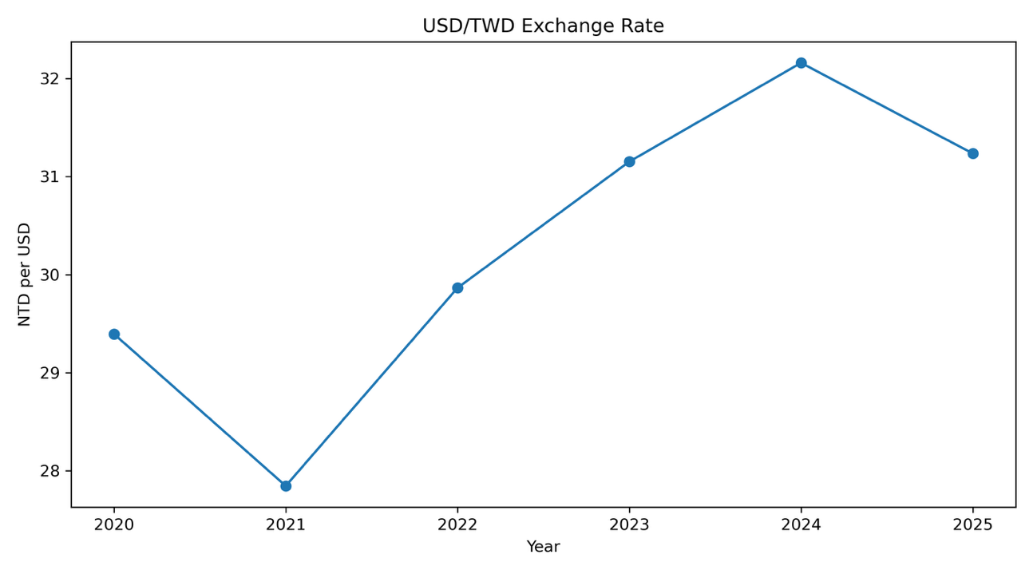

Furthermore, to decrease its exposure to exchange rate risk, TSMC uses some hedging strategies. According to TSMC’s financial statements, the firm uses foreign exchange forward contracts to reduce risks attributed to possible exchange rate movements (TSMC, 2026). In addition, as it was also discussed in previous sections, the company’s strategy to expand to other markets, such as the US or Japanese markets, decreases its exchange rate risks due to the fact that TSMC can spread its revenues and costs more evenly per currency area, which decreases their risks.

3.4. Analysis of Inflation rate risk
As it was stated in previous sections the observed period of analysis between 2020 and 2025 was full of many geopolitical and financial crises. Rising energy prices, supply chain disruptions and increasing operational costs made many industries including the semiconductor manufacturing industry more turbulent, unpredictable and more exposed to inflationary pressures. These inflationary shocks then directly affect a company’s profitability (Wang et al., 2023). Specifically, the semiconductors market depends on electricity prices, water and specialized materials. Therefore, TSMC is even more exposed to these risks.
In addition, Figure 3.4.1 illustrates the change Taiwan’s inflation rate measured by the annual change of the consumer price indices specifically in the Taiwan area, which are national statistics from the Republic of Taiwan, since there is no Taiwanese entry in the World Bank’s achieves. The figure shows that after a brief period of deflation in 2020, inflation increased rapidly to an around 3 percent high in 2022, then it slightly went down each year and by 2025, it reached 1.66 percent. Overall, looking at these numbers from a western perspective, they seem to remain between the usually desired range of inflation and even a 3 percent inflation is usually considered to be normal from a western point of view. However, even this increase in the inflation rate means that operational costs also increased for TSMC, such as wages or input prices.

Figure 3.4.1: Taiwan Inflation Rate
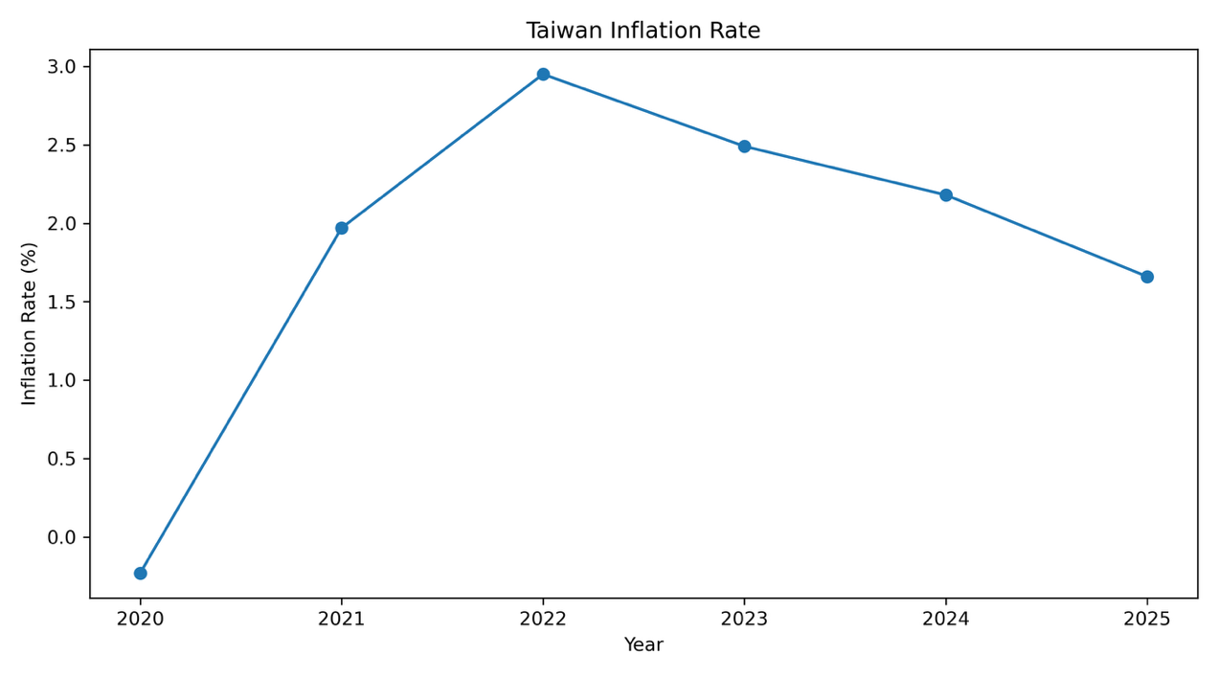

Furthermore, Figure 3.4.2 shows TSMC’s energy consumption in GWh (Giga Watt hours) between the period from 2020 until 2024 (since data from 2025 was not available by the writing of this paper). These numbers come from the company’s sustainability reports. The figure depicts a very rapid increase of the overall energy consumption of the company. This can largely be explained by the expansion of TSMC’s production capacity in this period. This shows how dependent TSMC actually is on fluctuating energy prices.

Figure 3.4.2: TSMC Energy Consumption Over Time
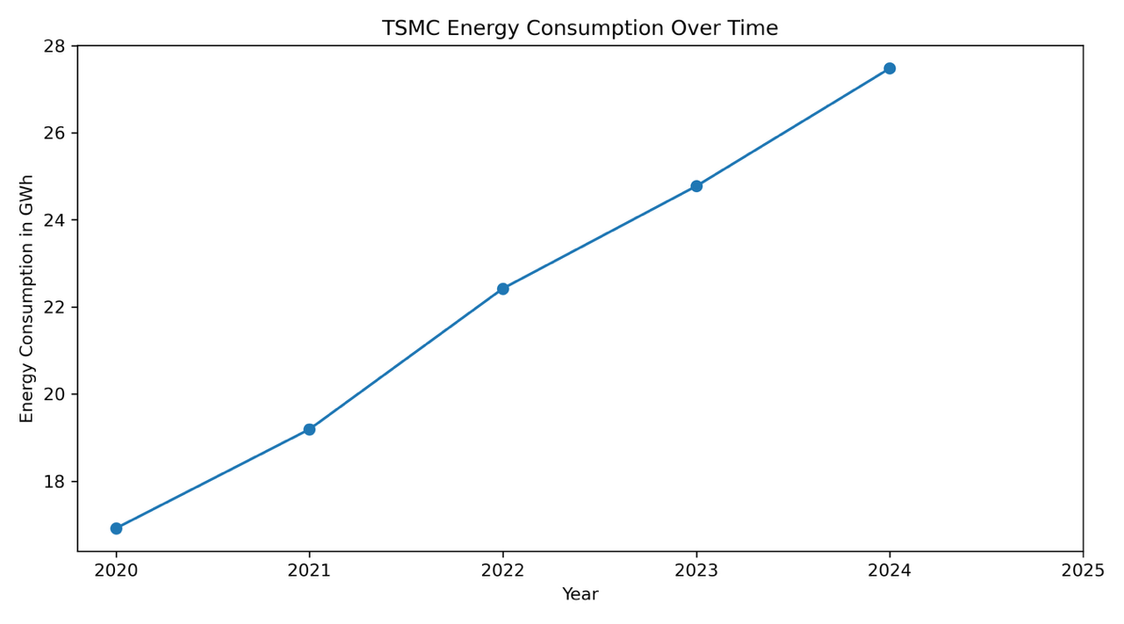

To counter the possible effects of inflationary shocks, the company employs some hedging tools. Some of them were talked about in previous sections, such as using operational and financial hedging, and strategically expanding to other regions as part of a plan to geographically diversify operations. In addition to these tools, TSMC invests in renewable energy to reduce its main inflationary exposure, which is to energy prices (TSMC, 2025). Furthermore, long-term supply contracts and agreements and diversification can decrease TSMC’s exposure to inflation rate risk.

4. Conclusions
This paper conducted financial analysis on TSMC’s financial and strategic risks, specifically focusing on interest rate risk, exchange rate risk, inflation rate risk and geopolitical risk. Moreover, the text also explored the various hedging strategies that TSMC uses to hedge against these exposures. The combination of the overview of financial risks theories in the theoretical framework and the empirical analysis into TSMC’s finances through looking at the company’s annual reports, financial statements and sustainability reports between 2020 and 2025 shows an extensive summary of how TSMC operates in real life and it uses different hedging tools to create a better financial outcome for the company.
Despite a challenge of the first half of the 2020s and a rapidly evolving geopolitical environment, TSMC has managed to remain in a strong financial position with increased cash reserves and investing in large new production facilities. Specifically, revenues and liquidity increased, profitability improved and capital expenditures rose. This could largely be a consequence of increasing demand for semiconductors from technological companies, especially from AI-related innovations. The company is rapidly investing in new facilities and technologies to match this rising demand from global markets.
On the other hand, the paper also shows that TSMC is becoming more exposed to several forms of financial and strategic risks. Interest rate risk became more relevant for the company, as demonstrated by its increasing interest expenses (Figure 3.2.1). Exchange rates between the USD and NT$ fluctuated relatively more than in the 2010s, in other words exchange rate volatility has increased, and this makes the company’s exchange rate risk higher (Figure 3.3). Furthermore, inflation also increased in Tawain, which made wages and input prices go up, in turn increasing the company’s operational costs (Figure 3.4.1). In addition, the expansion of TSMC into other markets and building new facilities has led to its energy consumption to increase exponentially between 2020 and 2024, this increases the company’s exposure to fluctuations in energy prices (Figure 3.4.2). Growing tensions and uncertainty between the two world superpowers, the USA and China have also affected TSMC due its being headquartered in Taiwan, which China sees as its own territory. This also increases the firm’s geopolitical risks, since a possible military escalation between the countries became more likely.
At the same time, TSMC uses many different hedging techniques to reduce its exposure to these risks. These include using foreign exchange forward contracts, long-term investment planning, several forms of diversification and fair value hedging. The company also invests more into renewable energy sources to further reduce its exposure to fluctuation energy prices. Furthermore, the firm combines financial and operational hedging techniques to have the most optimal hedging strategy possible.
In conclusion, the findings of this paper show that TSMC has managed to remain in a stable financial position, despite the ever-increasing geopolitical uncertainties in the observed period of analysis. This resilience can be seen by how TSMC’s profit margins have developed (Figure 3.1.6). While these results show a largely positive future outlook for TSMC, the firm’s financial stability and profitability will large depend on how it can balance the increasing risks in the semiconductor manufacturing industry.

Appendix
In this section, the code for the illustrations in the analysis section will briefly be explained. In Table 1 there is an overview of the variables used and where and how the data was gathered and founded. Also, the table includes the measurement unit that was used. For more details, the paper’s GitHub repository link is available in the references and in there are the coding file and the complete data frame for the analysis. All coding for this paper was done in Python.

Table 1. Variables Information Table
Name | Measurement Unit | Source
Year | Years (2020-2025) | No sources.
Current Assets | New Taiwanese Dollar millions | TSMC Financial Statements  (TSMC, 2022 ; TSMC, 2023; TSM, 2026)
Current Assets | New Taiwanese Dollar millions | TSMC Financial Statements  (TSMC, 2022 ; TSMC, 2023; TSM, 2026)
Cash | New Taiwanese Dollar millions | TSMC Financial Statements  (TSMC, 2022 ; TSMC, 2023; TSM, 2026)
Total Liabilities | New Taiwanese Dollar millions | TSMC Financial Statements  (TSMC, 2022 ; TSMC, 2023; TSM, 2026)
Revenue | New Taiwanese Dollar millions | TSMC Financial Statements  (TSMC, 2022 ; TSMC, 2023; TSM, 2026)
Net Income | New Taiwanese Dollar millions | TSMC Financial Statements  (TSMC, 2022 ; TSMC, 2023; TSM, 2026)
Capex | New Taiwanese Dollar millions | TSMC Cash Flow Statements  (TSMC, 2022 ; TSMC, 2023; TSM, 2026)
Interest Expense | New Taiwanese Dollar millions | TSMC Financial Statements  (TSMC, 2022 ; TSMC, 2023; TSM, 2026)
USD/TWD | Annual monthly average value | Investing.com yearly data
Inflation Rate | Percentage change | DGBAS Taiwan Statistics (DGBAS)
Energy Consumption | In GWh  (no value for 2025 yet) | TSMC climate sustainability report (TSMC Sustainability report, 2025)

References
Alvarez, F., Lucas, R. E., Jr., & Weber, W. E. (2001). Interest rates and inflation. American Economic Review, 91(2), 219–225. https://doi.org/10.1257/aer.91.2.219
Bush, R. C. (2017). A One-China policy primer (East Asia Policy Paper No. 10). Brookings Institution.
Deloitte. (2025, February 12). Taiwan Semiconductor Manufacturing Company Limited and subsidiaries consolidated financial statements for the years ended December 31, 2024 and 2023 and independent auditors’ report. https://www.deloitte.com
Directorate-General of Budget, Accounting and Statistics. (n.d.). Annual change of consumer price indices in Taiwan area. Executive Yuan, Taiwan. Retrieved May 24, 2026, from https://eng.stat.gov.tw/ct.asp?xItem=37408&ctNode=5347&mp=5
European Central Bank. (2023). Geopolitical fragmentation and the international role of the euro. https://www.ecb.europa.eu/pub/html/index.en.html
Gonzales, J. T. (2023). Implications of AI innovation on economic growth: A panel data study. Journal of Economic Structures, 12(1), Article 13. https://doi.org/10.1186/s40008-023-00307-w
Hull, J. C. (2018). Options, futures, and other derivatives (10th ed.). Pearson Education Limited.
Hung, N. T. (2024). Relationship of global geopolitical risk and exchange rates: Evidence from Covid-19 and Russia–Ukraine crisis. Regional Statistics, 14(1). https://doi.org/10.15196/RS140102
Hyatt, K., Ryle, P. M., & McKnight, M. A. (2024). Semiconductor production, geopolitics and the CHIPS Act of 2022: A theoretical analysis. Digital Policy, Regulation and Governance, 27(1), 1– 16. https://doi.org/10.1108/DPRG-12-2023-0184
Investing.com. (n.d.). USD/TWD historical data. https://www.investing.com/currencies/usd-twd-historical- data
Ivanov, D., & Dolgui, A. (2020). A digital supply chain twin for managing disruption risks and resilience in the era of Industry 4.0. International Journal of Production Research, 58(12), 3590– 3609. https://doi.org/10.1080/00207543.2020.1790580
Liu, R. C., Tang, H., Kao, Y., & Chou, Y. (2025). From vulnerabilities to resilience: Taiwan’s semiconductor industry and geopolitical challenges. Telecommunications Policy, 49(4). https://doi.org/10.1016/j.telpol.2025.102951
Nance, D. R., Smith, C. W., Jr., & Smithson, C. W. (1993). On the determinants of corporate hedging. The Journal of Finance, 48(1), 267–284. https://doi.org/10.1111/j.1540-6261.1993.tb04709.x
Reuters. (2025). Xi says no one can stop China’s reunification with Taiwan. https://www.reuters.com
Smith, C. W., & Stulz, R. M. (1985). The determinants of firms’ hedging policies. Journal of Financial and Quantitative Analysis, 20(4), 391–405. https://doi.org/10.2307/2330757
Tang, C. S., & Musa, S. N. (2011). Identifying risk issues and research advancements in supply chain risk management. International Journal of Production Economics, 133(1), 25– 34. https://doi.org/10.1016/j.ijpe.2010.04.003
TSMC. (2022). TSMC 2021 Q4 consolidated financial statements. https://investor.tsmc.com/sites/ir/financial- report/2021/TSMC%202021Q4%20Consolidated%20Financial%20Statements_E.pdf
TSMC. (2023). TSMC 2022 sustainability report. https://esg.tsmc.com
TSMC. (2024). TSMC 2023 Q4 consolidated financial statements. https://investor.tsmc.com/sites/ir/financial- report/2023/TSMC%202023Q4%20Consolidated%20Financial%20Statements_E.pdf
TSMC. (2025). TSMC 2024 annual report. https://investor.tsmc.com/static/annualReports/2024/english/ebook/index.html
TSMC. (2025). 2024 TSMC climate and nature report. https://esg.tsmc.com/file/public/2024-TSMC- Climate-and-Nature-Report-e.pdf
TSMC. (2026). Taiwan Semiconductor Manufacturing Company Limited and subsidiaries consolidated financial statements for the years ended December 31, 2025 and 2024. https://investor.tsmc.com
TSMC. (2026). TSMC 2025 Q4 consolidated financial statements. https://investor.tsmc.com/sites/ir/financial- report/2025/TSMC%202025Q4%20Consolidated%20Financial%20Statements_E.pdf
van der Steen, A. (2022). Research on the next generation semiconductor industry in Taiwan. Netherlands Enterprise Agency. https://www.rvo.nl
Wang, Q., Huang, N., Chen, Z., Chen, X., Cai, H., & Wu, Y. (2023). Environmental data and facts in the semiconductor manufacturing industry: An unexpected high water and energy consumption situation. Water Cycle, 4, 47–54. https://doi.org/10.1016/j.watcyc.2023.01.004

For illustrations the paper uses Python and this is the Github repository link where all coding files are located:
https://github.com/matthiasvem/Project-Financial-Instruments-Paper.git

