

**4th Year Plan**

|  |  |
| --- | --- |
|  |  |

# Information

Student Name: Matthieu van den Berg

Student ID: 140352

Variation: PR

Home address: Epelenberg 283, breda

Mobile phone: 06-14968394

Link to portfolio: https://www.vandenberggames.com

Date: 1/16/2019

Credit status: 150 CTS

Starting block: C

Phase: P2

Supervisor 1st choice: Jeremiah van Oosten

Supervisor 2nd choice: David Horchner

# Please indicate which option you have chosen for the current semester of your Graduation year:

* Work placement
* Work placement (Year long contract)
* Personal Project
* Own company
* Exchange (First half of your 4th year)
* Minor (Block A & B only)

# Are you under NDA:

* Yes
* No

# Personalised learning plan

## Competency profile:

## Identify the objectives you wish to address during this year in order to progress your competency profile (or complete if this is your final semester):

Competency 5 conceptualising: Objective Sandbox – of the comp 5 objectives, the objective sandbox fit’s the best with my project. This is because it is sort of a sandbox game, where the player gets total freedom in what way he wants to create his casino.

Competency 6 Designing: Objective Design Documentation – Throughout my project, I will be keeping a design document about my game

## Description and Planning

Complete and update this.

# Assignment Description

I will be aiming to make a Casino simulation game, where the players build and runs a casino.

It will be a top-down view game, based on a combination of [Casino Inc.](https://store.steampowered.com/app/361320/Casino_Inc/) and [Another Brick in the Mall](https://store.steampowered.com/app/521150/Another_Brick_in_the_Mall/).

The Visual/Building style will be like Another Brick in the Mall, and the theme/activities will take inspiration from Casino Inc. and real live casinos.

# Goals

1. **Playable game:** I want to make a playable game in the 18/20 weeks that the block takes, with at least minimum features to show off a nice portfolio piece.
2. **Learn new systems of AI:** To further my portfolio, I wanted to use a GOAP AI system for the ai, as I have not used that before, and I think that would be a good thing to have used at least once, and it’s a good system for the AI in this type of games.

# Specifications

I will be making a map/building system based on the system in Another Brick in the Mall.

This system is a 2D tile system, on which the player can give orders for floors/walls/items to be build.

The building system is an indirect system, where the player gives an order to build different items, and then builder AI’s go and make those different items.

For the AI I wanted to learn how to work with a “Goal oriented action planner” because I think this would be a good system to use for these kinds of AI’s.

The main gameplay loop will consist of:

1. The player building new parts for their casino.
2. Making money in this new part.
3. Using this money to make their casino even better.
4. Repeat.

Keywords would be expansion and creativity. With as motivation for the player “bigger is better”.

The lose condition is going in a negative balance for a certain time period. And there is no specific win condition, to let the player use their own ambition for what they want to reach beyond making a stable income vs. expenses.

Through the casino will be multiple types of characters walking. Examples of this are:

* Builder: builds the different items the player wants to place
* Guests: the people coming to your casino, spending money to play games
* Bouncer: can kick out people who do stuff that isn’t allowed
* Janitor: keeps the perimeter clean, and repairs different objects.
* Receptionist: mans the receptions where the guests can trade in their money for chips and the other way around

Different kind of games the guests can play are:

* Roulette
* Poker
* Blackjack
* Slot machine
* Bingo

These games will be played as baked animations, where every game will look the same (except the person playing it) but the outcome will differ, with the guest either gaining or losing chips and happiness. The cost in chips and win chance can be set on a per-table basis, which will influence the happiness of the guests.

# Milestones

## 2D tile map system (68h or ~2 weeks)

The first milestone I have to work to is a 2d tile map system, this will entail a system with 100x100 tiles consistent of 3 layers: ground, objects, walls.

For the first part I want to make it so that I can in editor change the different tiles around to be different objects. This will entail:

Ground: change grass and concrete around

Objects: place planters and benches

Walls: place walls and doors

These objects contain both single tile objects (walls/doors) as multi tile objects (bench 1x2)

## Basic player interaction with map (30h or ~1 week)

Here I want to make it possible for the player to do the map editing while playing. This can be done by selecting the object you want to place and then clicking the tiles in the map where you want to place it.

This will also mean I need to make a start on UI where the player can select the objects, and where he can get info about the object he has selected to build.

Another thing I want in this first UI is a window that shows info about what he is hovering over.

## Pathfinding/basic AI (92h or ~2,5 week)

As 3rd milestone I will make the AI pathfinding system. I will be using a modified version of A* where I want to enhance it with pre-generated path’s through enclosed rooms in the casino.

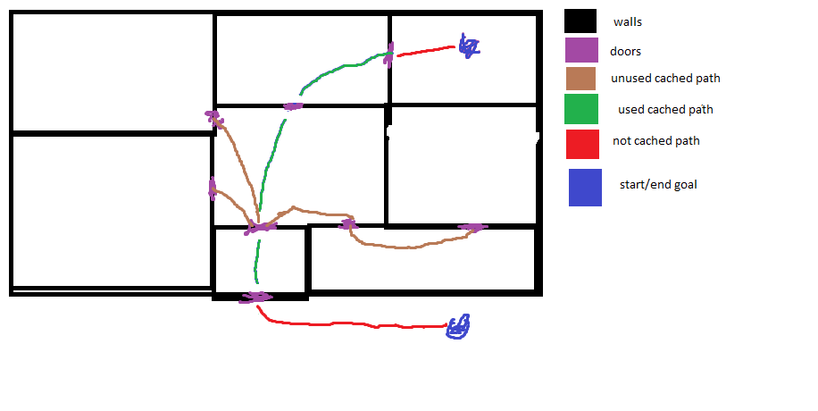

In the sketch above here you can sort of see what I mean, the green part’s of the path between the 2 goals are cached paths between rooms, this way you can easily exclude parts of the world which will never end up making a way to the goal.

## AI task manager (44h or ~1 week)

Here I will be making a Manager that manages a list of tasks the different AI’s have to do.

For this I will be creating a hybrid FIFO system, where the fist task a player creates in-game, is the first task the ai will be doing, but the player also has the ability to set some things as priority which will take the task forward in the queue or into a different “priority queue”.

Because not every AI type can do every task (a receptionist can’t build a wall) I have to write my own queue system which also allows to take the 4th or 5th task from the queue but will always give the first task that ai can do that is in the queue.

This will end up with a very simple builder prototype that asks for a new task, walks straight to that location, do the task, and that on repeat.

## GOAP planner (guess would be ~3 weeks to be enough)

The GOAP planner will me a class where an ai can send in what kind of actions it can take, in which state he is now, and what the end state is he wants to be in.

For example a builder starts with materials for a planter, and has the task to build a wall at x/y:

To build the wall at x/y he needs a hammer and building materials.

Actions he can do are: pickup/drop hammer, pickup/drop destroying tool, pickup/drop wall material, pickup/drop planter

So what he sends to the is his starting state of “material slot with planter”, his end state of “inventory with tool slot hammer, and material slot wall materials”, and the list of actions he can take.

This planner will then search through the actions to find the best possible actions to take to get to this end state and sends this back to the AI for him to carry out.

This will end up with a more sophisticated builder, who will get actual building materials and tools for the tasks it got assigned by the task manager.

## Casino Management (16h or ~0,5 week)

I will create a system few new management-systems:

A day/night cycle which you have to assign your staff to for them to decide at which times they enter and leave your casino.

Stats about your casino: money, rating, etc.

## Builders (36h or ~1 week)

Here I will be bringing together the systems I created previously to have a builder who will build all the things the player places orders for.

I will also add more things the builder would need, such as places where he can get his tools and materials.

A system where builders and other staff have work shifts, and leave/enter on the times that you tell them to.

A salary/happiness system, you have to pay your staff to keep them happy.

## Poker, Blackjack, and slot-machines (32h or ~1 week)

Here I will be making the actual casino tables that the guests will use.

The player will be able to set the odds and how much is being bet for each table.

For example, for a slot machine you have:

* Bet amount: the amount of chips a guest uses every round
* Win amount: the amount of chips a guest gets when he wins.
* Lose odds: the odds that the guest loses his bet
* Draw odds: the odds that the guest gets the same amount back
* win odds: the chance that the guests win the win amount.

Under this milestone, I will also be making a chip exchange, a place where guests can exchange money for chips, or if they decide to leave the other way around.

## Guests (1 – 1,5 week)

The guests will be the main thing that keeps your casino running, they will buy chips with their money, and spend this at the different tables.

They will have multiple personalities which change up what type of games they like to play more/less and how much money they want to spend. Examples are: low/high rollers, prefers games where there is less/more risk.

## Dealer (24h or 0,5 week)

The Dealer needs to be hired by the player to enable/disable the usage of different card tables, things like slot machines that are automated do not need this to run.

## Food/drink machines and janitor (40h or 1 week)

The food and drink machines give another possibility of income, where the guests will get food/drinks when they’re hungry/thirsty. Janitors are needed to pickup the trash that guests generate with this, and to refill the machines.

# Resource links

1. Another Brick in the Mall: <https://store.steampowered.com/app/521150/Another_Brick_in_the_Mall/>
2. Casino Inc.: <https://store.steampowered.com/app/361320/Casino_Inc/>
3. Goap quick research: [https://gamedevelopment.tutsplus.com](https://gamedevelopment.tutsplus.com/tutorials/goal-oriented-action-planning-for-a-smarter-ai--cms-20793)
4. Hack ‘n plan scrum system: <http://app.hacknplan.com> credentials: Login: 140352 Password: Teacher

(proposal can also be found: <https://swarm2.nhtv.nl:8443/l/tt81v0>)

**Background**

Currently I have been focusing on AI a lot, but don’t have examples on my portfolio of more in-depth AI systems, leading to that I want to make a game where I can show some more in-depth AI knowledge.

I am very interested in playing simulation/manager games such as [Prison Architect](https://store.steampowered.com/app/233450/Prison_Architect/), and [Another Brick in the Mall](https://store.steampowered.com/app/521150/Another_Brick_in_the_Mall/). Which genre has a lot of AI involved with almost everything running based on the AI.

## Assignment Learning outcomes and deliverables

Learning Outcomes: By the end of this assignment I will be able to:

* Show a game of I made which uses a lot of AI and is a good portfolio piece.

Final deliverables:

* A playable casino management sim, with a scope proposed in my [Project Proposal](https://swarm2.nhtv.nl:8443/l/tt81v0).
* A [learning journal](https://swarm2.nhtv.nl:8443/l/56c1v2), where I keep a record of what I do during the weeks.
* This 4th year plan.

## 

## 

# TimeLine

|  |  |  |  |
| --- | --- | --- | --- |
| Week: Day: | Task | Milestone deliverable | Feedback/Meeting |
| 1 | 2D tile map system |  |  |
| 2 | 2D tile map system |  | 25/02 meeting for mostly talking about my updates in this planning |
| 3 | Basic player interaction/UI |  |  |
| 4 | Pathfinding |  | 11/03 I’ll be showing the ability to place down walls and multiple other objects in the world done in the previous milestone.  I will also talk about what I plan on doing for the pathfinding |
| 5 | Pathfinding |  | 18/03 feedback/meeting about pathfinding what I’ve done so far |
| 6 3 | Pathfinding |  | 25/03 feedback/meeting about pathfinding what I’ve done so far, if I got stuck anywhere |
| 6 3-5 | AI Manager |  |  |
| 7 3 | AI Manager |  | 1/04 show of my pathfinding system.  Talk about what I am doing for ai manager |
| 7 3-5 | GOAP planner |  |  |
| 8 | GOAP planner |  | 8/04 feedback on AI manager,  Feedback on goap work so far |
| 9 | GOAP planner |  |  |
| 10 3 | GOAP planner |  |  |
| 10 3-5 | Casino Management |  |  |
| 11 | Builders |  | 06/05 talk about the things I did during the weeks that there was no contact. |
| 12 | Poker, Blackjack, and Slot-machines |  | 13/05 show off the builders, and explain how the machines will work |
| 13 | Guests |  | 20/05 show how the machines work, show plans for guests |
| 14 3 | Guests |  | 27/05 show progress on guests |
| 14 3-5 | Dealer |  |  |
| 15 | Food/drink dispensers  Janitor |  | 03/06 show working base game |
| 16 |  |  |  |
| 17 |  |  | 17/06 |
| 18 | Finishing loose ends |  | 24/06 end of project meeting |
| 19 |  |  | Defence |
| 20 |  |  |  |
| Etc… |  |  |  |