

**Personal Project**

|  |  |
| --- | --- |
| **Assignment Title:** | Casino Simulator |

|  |  |
| --- | --- |
| Learning Journal | |
|  |  |
| Student Name: | Matthieu van den Berg |
|  |  |
| Student ID: | 140352 |
|  |  |
| Supervisor: | Jeremiah van Oosten |
|  |  |
| Date of Submission: | 21/06/2019 |

**The Academy of Digital Entertainment,**

**Breda University of Applied Sciences.**



|  |  |  |  |
| --- | --- | --- | --- |
| 4 weekly updates *1 | | | |
|  |  |  |  |
|  |  | Week starting (date): | Feb-11 |

**Targets for this 4-week period:**

* Milestone 1: tile map system
  + I’ll be making milestone 1: 2D tile map system in my 4th year plan during the first 4 weeks.
* Milestone 2: basic player interaction:
  + I’ll be making milestone 2: basic player interaction in the first 4 weeks.
* Milestone 3: pathfinding
  + I’ll be working for the first of 3 weeks on pathfinding these first 4 weeks, I think that I will be able make the first things regarding pathing nodes and a start to actually calculating a path.

**Journal:**

I’ll be at school for 5 days a week 9-5, here I will be working on the project during the whole day.

Almost every Monday I will be having a meeting with Jeremiah about my progress.

I’m also planning to dedicate the last half an hour of the day to update my hack’n’plan management tool, and write a small thing in my daily log [(Swarm link)](https://swarm2.nhtv.nl:8443/l/5og1zr) which I use at the end of the week to write this log.

On Friday I will take between 1 and 2 hours for this, and in that time, I will also update this log to include the whole weeks log.

These first weeks went really well, I feel like I started of strong and solid doing all the planned things in the planned time, and some even a bit less.

I’ve also been very happy with my motivation, which was my biggest concern starting off, but has been really high so far because of the fact that I know in front what I want to work towards, and which tasks I will be doing next. And that so far, I did not have any setbacks and multiple successes.

I did however have some difficulties these first weeks, mostly with threading the pathfinding which I haven’t really done before and is trial and error for what I can and can’t do. I will be able to overcome this by reading tutorials and info online, and trying these different things. These kinds of problems are not really preventable, because if you never do something you don’t know yet, you will also never learn.

I think that I have achieved all my goals for this first update, I’ve got a nice tile map setup, I have basic UI and building things setup, and I am very far into pathfinding.

New goals for the next week will be finishing the pathfinding, starting on a AI manager, which keeps track of adding/removing ai’s from the world, and keeping a queue of tasks that need to be done, and making a start with a GOAP planner that makes the ai’s a plan for how to reach their goal they get from this ai manager.

**Summary and comments:**

Week 1:

First days where setting up the unreal project, setting the different settings and dependencies I think I’ll be needing.

Rest of the week I started setting up a tile map, generated as soon as you press play, with 100x100 tiles, which first started of being custom actors with a PaperSpriteComponent attached to it, which I quickly found dropped the fps really low, meaning I had to find a way to optimise the draw calls with this.

After some research I found that the separate PaperSpriteComponents did not have batching build in, and if I would get fps I either had to optimize that myself, or change it for unreals build in tile map drawer which did batching.

I chose for the second, this did not mean that I had to restart from scratch, but just that I needed to change the tile actors to set their texture to the correct location in the tile map which I managed relatively easily and got my fps back to the cap of 60 I set.

At the end of the week I had a meeting with Jeremiah about my 4th year plan and how to improve on it, out of this came that I needed to add a lot more detail to it, which is what I spend the 2nd half of Thursday and the whole of Friday doing.

Week 2:

Monday, I had another meeting with Jeremiah about the updates on my 4th year plan, which he liked and gave me some small feedback on it about referencing sources for art etc.

With the tile map working I spent the bigger part of the week making different tiles.

For most of the tiles it was as easy as changing the sprite they use, but others where more difficult.

The longest time has been on connecting walls, and objects bigger than 1x1 tile (the bench).

Wednesday and Thursday where spent on these non 1x1 tiles, and checking if all tiles where the object would end up where free.

This made it that I was done with milestone 1: tile map system at the end of Thursday. And started working on milestone 2 on Friday, during this day I started setting up the GUI that unreal uses, and made the first outline1).

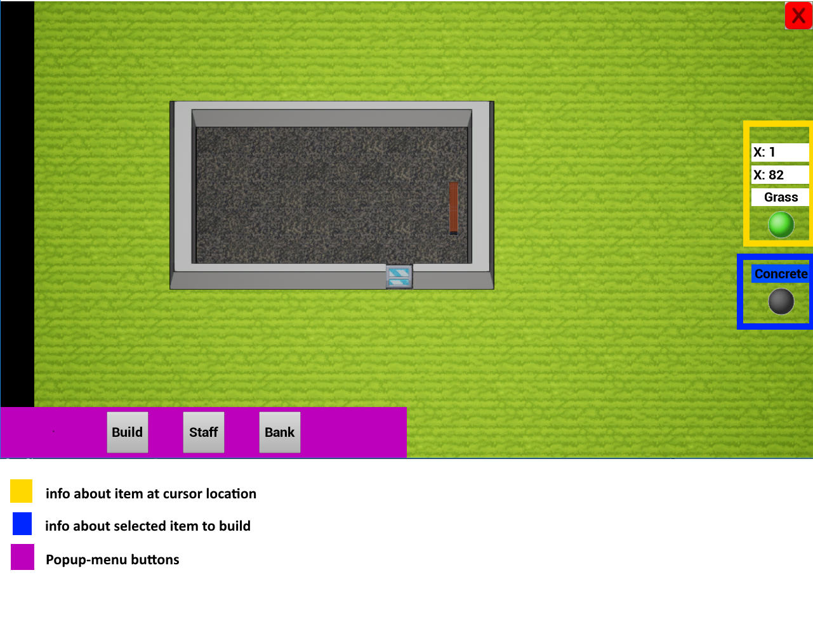

1) Outline of first UI draft

Week 3:

This week I will not have a meeting with Jeremiah, as the teachers are on holiday and I have taken mine 2 weeks prior already.

The main thing’s I’ve build this week where GUI things, and make them actually work instead of only an outline.

Work on this was not that special, as it was mostly adding an element in unreals GUI editor, and writing the function where to grab the information from that has to be shown on that element.

More “interesting” work was making the player able to build things into the world. For this I added 2 ways, a way where the player selects a single object from the build popup2) and a way where the player selects 2 corners between which there will be a default room build with walls and a concrete floor.

This all was done on Thursday so on Friday I started working on pathfinding.

For pathfinding I planned in 3 weeks, because I have not done any pathfinding myself for a very long time and expected to need a lot of time to read into it and figure out how it all worked again.

Contrary to my thought and planning however, I remembered how pathfinding worked and some of the better pathfinding algorithms again fairly quickly with a tutorial video. This made that I had a big part of pathfinding basics done on Friday 08/03 already

Week 4:

Monday, I had a meeting with Jeremiah, the feedback I got came down to that I made a lot of progress which we both are happy with, and already being this far into pathfinding after 1 day instead of a week is really nice, and gives the possibility for mistakes in tasks down the line.

Additionally I decided that instead of caching path’s through rooms, the default A* pathfinding on this scale is quick enough, and together with the fact that in this game it doesn’t stand out when a character stands still for a few seconds before going to do the next thing he wants to do, I decided to instead make pathfinding multi-threaded that it doesn’t stall the game and there can be multiple path’s calculated at the same time.

This is the first time I worked heavily with multithreading in unreal engine so this was quite a challenge and still isn’t fully working.

I started with making it a FASyncTask which is an unreal build in simple multithread thing, that takes the task out of the main game thread so the game doesn’t stall.

This I got working quite quickly, but it would crash every time if you’d quit the game, or if you’d build something.

Because this FASyncTask only unloaded to 1 separate thread, it meant that still only 1 path would be calculated at a time, while I have a hyperthreaded quad core which should be able to do at least 4 at a time.

So, I had to change the FASyncTask to my own threaded task which could queue multiple threads at a time.

For this I used the tutorial <https://wiki.unrealengine.com/Multi-Threading:_How_to_Create_Threads_in_UE4>(Rama, 2017a) which helped me a lot, and I was able to finish most of the things on Friday.

The only problem I have left is that on some occasions the engine crashes when exiting the game, and it crashes on getting the “walkable” state of a map coordinate. Which it currently feels like is all checked and done thread safe, but is for some reason not yet.

**Targets for the next 4-week period:**

* Milestone 3: tile map system
  + I’ll be finishing the planned things for pathfinding. This mostly is finishing up unloading to threads.
* Milestone 4: AI Manager:
  + In these 4 weeks I’ll be making an ai manager that keeps track of when ai’s should enter/leave the play area, and a queue for different tasks for the AI’s to do.
* Milestone 5: GOAP planner
  + In this 2nd slot of 4 weeks I will also be starting on a GOAP planner, which takes an ai and the task that he needs to do from the manager, and makes a plan which the AI uses to reach his goal.

|  |  |  |  |
| --- | --- | --- | --- |
| 4 weekly updates *2 | | | |
|  |  |  |  |
|  |  | Week starting (date): | March-18 |

**Targets for this 4-week period:**

* Milestone 3: tile map system
  + I’ll be finishing the planned things for pathfinding. This mostly is finishing up unloading to threads.
* Milestone 4: AI Manager:
  + In these 4 weeks I’ll be making an ai manager that keeps track of when ai’s should enter/leave the play area, and a queue for different tasks for the AI’s to do.
* Milestone 5: GOAP planner
  + In this 2nd slot of 4 weeks I will also be starting on a GOAP planner, which takes an ai and the task that he needs to do from the manager, and makes a plan which the AI uses to reach his goal.

**Journal:**

These 4 weeks went a bit less than the previous, with a few days of being ill. But regardless I have made lots of progress and am still on track with my planning.

Reasons for this success is that I am still really motivated, and think I found a fun project. Where I’m doing a lot of things I quite like doing. And learning new things every day.

The few difficulties I had where mostly things I couldn’t do anything about, because I can’t force my body to not become ill. I solved these problems by trying to do what I could on these days, and doing some extra work in the weekends.

During this time period I have achieved all the goals I had planned for myself.

I finished the Pathfinding, made a fully working AI Manager, and started a big chunk of progress on the GOAP planner. So, I don’t think I’ve not achieved anything that I had planned to do during this time.

For the next time period I will be finishing the GOAP planner, and make the last essential things for a management game like: stats, time cycle, leaving/entering of AIs. And I will be starting to really make the builder in which all previous work comes together.

**Summary and comments:**

Week 1:

This week I’ve struggled a lot with the final things for multithreading the pathfinding.

I had a lot of issues with getting the data safely back from the separate threads, in the end I figured out that the documentation on threads and in [this](https://wiki.unrealengine.com/Using_AsyncTasks)(Krillin6, 2016) tutorial where incorrect in saying that returning data through delegates is thread safe which it isn’t and you instead have to use a thread safe (as long as you only use 1 consumer) TQueue and check that every tick to see if it has gotten returned new data.

After having finally fixed this, I wrote some debug for showing the actual paths in-game

I also made base characters and controllers, and for the characters added first child classes with starting changed behaviour regarding them waiting different times between getting new paths.

Week 2:

Monday and Tuesday, I was not able to do too much, as I was ill. This also made me have to cancel the meeting with Jeremiah. However, I did try to work wherever I could.

During these days I made a “singleton” pattern actor as AI manager that gives errors and warnings when placed in the level multiple times. This actor will manage the different tasks that are made for AI’s to do, examples for this are building of different objects (walls/doors/different floors). I started on these tasks.

From Wednesday onward I was healthy again, and could focus fully again.

I was able to finish a task queue which will keep a queue of these tasks, and functions for it to prioritize different tasks and give out tasks depending on which character type asks for one.

I did this by making my own double linked list, so I have references to re-order from the middle of the list.

I also written the tasks for builders, where the ai will go toward the thing to be build/destroyed, stand there for a few seconds and change the tile.

I also started on a tile registry, where I will register all the types of objects that the ai might need, which for now will only entail a world entry/exit point.

Week 3:

Started of badly, on Monday I didn’t feel great because of the change to summer time messing with my head.

I had more annoyances with my pc overcorrecting making me have lunch and preparing for a meeting with Jeremiah an hour early. After finding this I wanted to start working again with the limitation of not wanting to break anything to show during the meeting. but after a bit of work I checked my mail and saw that Jeremiah was not at campus because of illness. This made me decide to stop for that day, and instead work some more hours on Saturday.

Over Monday morning and Tuesday I finished up the tile registry, and made a simple usage of it with “world entrances” which will be the place where ai’s will spawn in. for now this spawning is done with a simple button, but in the end the system of ai’s entering and leaving at different times of the day will also use this system to decide where ai’s will go. This finished my next milestone “AI task manager”

Wednesday and Thursday, I spent all day reading about GOAP, how it works, and examples of where/how it’s used.

Friday, I started on a state container, which will be added to any character that needs to have state for the GOAP planner.

For this I want to make different types of value types that have comparison/testing ways, for example a bool state can’t check if it’s more or less than another bool, but just has “equal/not equal” checks.

For Booleans and integers this was done fairly quickly, and I’ve had more difficulty with object states, which are for example an inventory slot with building tools. For this I store a ref to UObject which is an unreal class that every blueprintable class has to inherit from and has a way to get which end class the object is.

This went fairly well, but the ref to the end class was difficult to get correctly, as when you make it a ref to anything in the content browser, it would always return a generic “class” or “blueprint” type.

Week 4:

On Monday I had a meeting with Jeremiah about my progress again in the last 3 weeks.

From this came that I made a lot of progress, and we’re very happy with that.

I showed off the fully working Pathfinding, tasks and AI manager. And builders that go around a build the things the player wants to be build. Including giving priority to tasks.

A few things that came out of this that weren’t fully working correctly was that AI’s do not recalculate their path if they find there’s something being built on their path after they found it. Which I had to fix asap.

We also spoke about citing sources for the GOAP research I did. Which I can do via either the build in references tool, or using a citing tool such as Citation machine. (“Citation Machine: Format & Generate Citations – APA, MLA, & Chicago,” n.d.)

After this meeting I started on fixing this problem in the AI pathfinding directly. In the code the AI’s already need to get the new node every time they reach another tile, so in this I added a check if the next tile is still walkable, and if not made them recalculate their paths. Which makes it work like a charm.

During the Monday I also finished up work on GOAP state nodes for floats and strings, which wasn’t that difficult a task.

Tuesday and Wednesday, I’ve been working on the action nodes. These are data-assets with both pre-conditions and effect checked on the state. The actions can both take in a state where it starts, or a state where it ends, and will return the other state.

On Thursday and Friday, I’ve been writing the actual planner, which you give in a current state, a desired state, and a list of actions that can be taken. With which it will use a A* like algorithm to find the cheapest way to reach the end state.

For each step it takes the goal state, and applies reverse of an action to it to find the next best action to take.

A problem which I have with this is how to debug it, as I don’t have a way to “just show” the plan object in the unreal editor window, but have to write something for this myself.

In the end I made a nice way to print it to the log.

With this however I found some problems with the planning making it not create a correct plan. And potentially crashing the game. Which I have to solve next week.

**Targets for the next 4-week period:**

* Milestone 5: GOAP planner
  + During these weeks I’ll be finishing the GOAP planner, where it will fully plan out list of actions for an ai to take to get whatever they need for their task gotten from the AI manager.
* Milestone 6: Casino Management
  + I will also add most of the essential management things, this include a time cycle, stats tracking, etc.
* Milestone 7: Builder
  + In the last part of this block I’ll be making the builder, which will make everything from before really come together. They will have time’s which they are on property, and times they’ll leave. They will be using the AI manager to decide what to do, and the GOAP planner to create a plan how they can finish this task.

|  |  |  |  |
| --- | --- | --- | --- |
| 4 weekly updates *3 | | | |
|  |  |  |  |
|  |  | Week starting (date): | April-15 |

**Targets for this 4-week period:**

* Milestone 5: GOAP planner
  + During these weeks I’ll be finishing the GOAP planner, where it will fully plan out list of actions for an ai to take to get whatever they need for their task gotten from the AI manager.
* Milestone 6: Casino Management
  + I will also add most of the essential management things, this include a time cycle, stats tracking, etc.
* Milestone 7: Builder
  + In the last part of this block I’ll be making the builder, which will make everything from before really come together. They will have time’s which they are on property, and times they’ll leave. They will be using the AI manager to decide what to do, and the GOAP planner to create a plan how they can finish this task.

**Journal:**

These four weeks went a better than the last 4. I did not have the time sink of being sick for multiple days, (only 1) and made lots of progress, to the point where I’ve gotten most foundation things in there.

Besides the progress I’m proud that I am still very motivated to continue and finish this project.

Struggles I had this time-block where that packaged builds where crashing after about a minute.

This problem did make me lose about a week of working time, which I have counteracted by simplifying the way I am making the casino games work.

This problem came because of the way I have been using UDataAssets, which are unreal assets that you can use to store and edit data to be used by the other parts of the game.

In the task and pathfinding system I was duplicating these classes to use, but the way unreal engine keeps track of them made them be garbage collected at unknown moments.

To solve this, I’ve rewrote parts of the task system to not duplicate them anymore, but purely use the base versions for reading purposes.

In the future I’ll be able to avoid this problem because I now know how this works, and not use them this way again.

I haven’t worked too much on the competencies specifically, and will be making sure to do this in the next period.

**Summary and comments:**

Week 1:

I started the week of with updating my logs which I had forgotten to do last Friday. I had to combine all the 4 weeks together and finish up the update 2 part of this journal.

After having finished that I’ve spend the afternoon gathering all the used sources so far, for this I’ve been using Zotero (“Zotero | Your personal research assistant,” n.d.) which is a program which can keep a database of different sources, and easily create citations and a source list in your documents using the database.

The rest of the week I’ve spend on writing a nice debug output for the GOAP plan and state’s which lists the different things it has.

After that was finished, I started on the flow that the GOAP component uses to perform the different actions it has planned.

Week 2:

The week started off by me finishing the GOAP working component, the only real thing that still needed to be done for this was the ai finding a location to do the planned action. For this I’m again using the AI manager’s register for getting the closest entry to the AI’s current location. To make this happen quick here it doesn’t yet take path in account, so It just takes literal the closest item.

I also made tool and material storages where the builder goes to collect the things he needs for building.

On Wednesday I’ve added a day/night cycle and indication which time it is in game2). And buttons to the UI to speedup/slowdown the game. For which I had the code implementation mostly ready already.

On Thursday I went and added a stats manager which keeps track of the money AI count for staff and guests and other things.

For this I also added UI elements to show it to the player3).

On Friday I spent most of my time cleaning out the different textures I’ve used, and combining it into my own made tile set.

Difference between day and night time 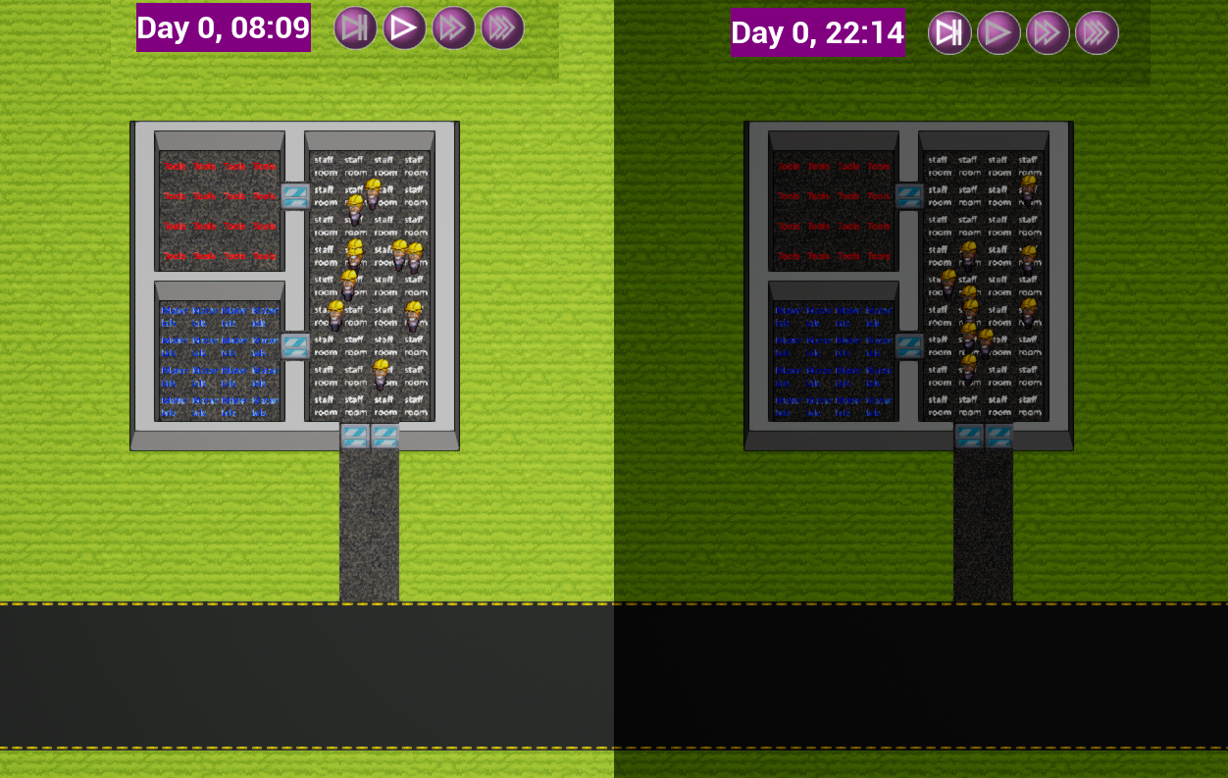

2) Difference between day and night time



3) Stats UI from left to right: happiness, guest count, staff count, balance, daily balance.

Week 3:

I started on the builders this week, for them I made a staff manage menu where each staff member you have has an entry where you can set their working time, and when they start.

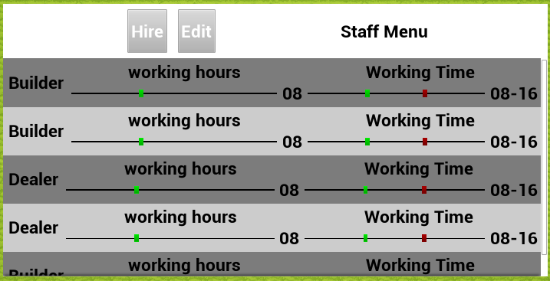

4) Staff Management Menu

The Monday meeting with Jeremiah was really positive, we’re both happy with all the progress I’ve made, and that the foundations are really here now.

Jeremiah also liked the tool I found for keeping track of resources/references.

Only negative point is that the building/destroying has worked all the time, but I broke something right before the meeting, which made the ai’s freeze when they can’t find a path to their goal.

After the meeting I unfortunately had to go home, as I became quite sick.

On Tuesday I’ve been busy the whole day fixing this found problem, which ended up being a thing in unreal that garbage collected used data, which I only had there for debug anyway, so I removed completely.

On Wednesday I’ve been connecting the staff management UI with the AI’s, where the data does actually go through to the ai, and set’s their leave/enter time.

The first part was quite easy to figure out, but getting it from the AI to the UI was more difficult, as it had to scale back from the range 0-24 to 0-1. Which I couldn’t figure out.

This ended up being a problem in casting, where it instantly casted everything to integers, ending up with the slider always being on either 0 or 1, and nowhere in the middle.

After having fixed that I implemented the ai’s leaving and entering the world outside of the times they need to, this was quite easy, as most of the logic was done, and I only needed to make the algorithm for when to leave/enter.

Thursday Morning I’ve been busy with adding indicators for if the builders have different items in their inventory, for which I added a call-back when an AI’s state changes.

In the afternoon I’ve added more objects to the game, 4 floors, wooden walls, and a fence.

Last part I’ve been trying to package the game, which ended up looking like I have something wrong with my unreal install, and I’ve been trying to fix that.

On Friday I’ve used all my time on fixing the packaging, there were quite some errors in there about functions that are allowed in engine, but not in a packaged build.

It was quite clear when this was the case, but it only showed 1 of these issues each build, meaning it costed me a lot of time.

In end of the day I got this all working, and made a first build which does work without the engine. https://www.dropbox.com/s/4pp7wu83m1xwfmz/CasinoInc0_0_1.zip?dl=0

A problem with this is that it crashes after some time when you actually build stuff, which I have to try and fix next.

Week 4:

This week I’ve mostly been busy fixing the crash in the packaged game. After lots of testing it looked to be crashing after garbage collection.

After trying and looking at a lot of things where the tasks and paths could possibly lose their link to the root that UE uses to decide what has to be garbage collected or not.

After spending a lot of time trying to find this, I could not see where the link was broken, so I decided on rewriting parts of the pathfinding and GOAP to get rid of the parts that indicate to unreal that it needs to do garbage collection on it, and double checked if I do my own memory freeing correctly and at all times.

This has taken me till Thursday to figure out and find. But now I ended up with a working build which can be downloaded at: <https://drive.google.com/open?id=1UXKK2AeDnuOhsjUyBTcce9LL9_JLPW5u>

On Friday I started working on the slot machine, poker table, and blackjack table.

For this I made a struct with the different stat’s that guests have, and that the games change. And implemented functions for doing those changes.

**Targets for the next 4-week period:**

* Milestone 8: casino games
  + I’ll be finishing off the different casino games that the guests can play. Which I started on Friday 17/05 and made into a simplified version because of the lost time for the packing crash.
* Milestone 9: Guests
  + I’ll be making the guest behaviour, how they choose what to do, and when they enter/leave the casino.
* Milestone 11: food/drink dispensers
  + I’m also going to make food/drink machines for the casino, here guests can eat/drink when needed

|  |  |  |  |
| --- | --- | --- | --- |
| 4 weekly updates *4 | | | |
|  |  |  |  |
|  |  | Week starting (date): | 20/05/19 |

**Targets for this 4-week period:**

* Milestone 8: casino games
  + I’ll be finishing off the different casino games that the guests can play. Which I started on Friday 17/05 and made into a simplified version because of the lost time for the packing crash.
* Milestone 9: Guests
  + I’ll be making the guest behaviour, how they choose what to do, and when they enter/leave the casino.
* Milestone 11: food/drink dispensers
  + I’m also going to make food/drink machines for the casino, here guests can eat/drink when needed

**Journal:**

These 4 weeks went really good again, I’ve finished the project, done most preparation for my defence, and overall am really happy with how everything turned out.

Of course, with the project coming to an end there were also times where it became difficult to decide what to do next, what was important to do, or what I’d be better of scrapping.

For the competency objectives I’ve finished documents for all of them, with this journal and a defence presentation being the last documentation I need to finish in the last week.

over this time period all goals/targets except milestone 11 have been reached, in the 3th week of this period we decided that making sure I have time for the last balancing and writing we found the food/drink dispensers not important/impactful enough to make, and would be just as good without it.

**Summary and comments:**

Week 1:

Started the week of with a good feedback session, where no real problems came up besides that a limit on the amount of ai’s would be a good thing to add.

First thing I did after the meeting was add this limit.

On Tuesday I’ve made stats and personality structures for the guests.

These personalities are stored in a data-table (which can be opened with excel) and has different values for how much they like different kind of games.

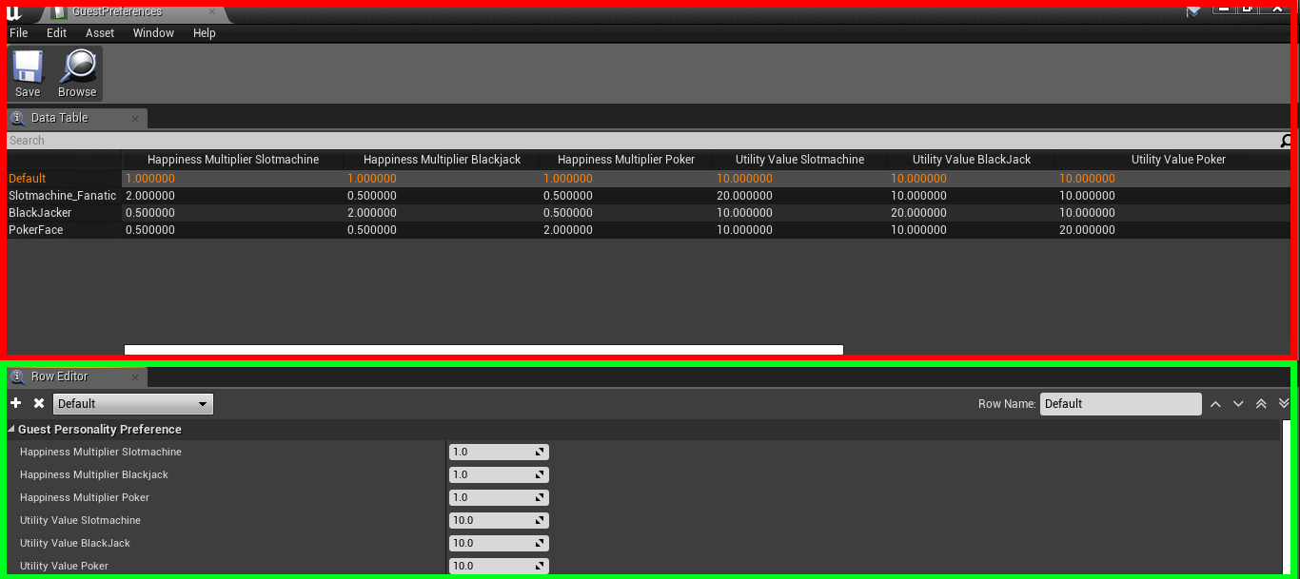

5) personality table. Red = table view Green = Row editor

Wednesday and Thursday, I’ve started making the decision making of guests for where they want to go, this directly included the personalities. For this I’ve used a utility theory-based system, where each kind of interactable gets a score based on the personality, current stats, and base score, to calculate an end score and gets a weighted interaction to do next based on that.

On the last day of the week I’ve made functionality for the guest to decide when they’ll enter/leave the casino. And implementation of how they’ll leave/enter the casino. Which is mostly the same as staff members, but they’ll get destroyed when they’re gone, instead of just turned invisible.

Week 2:

The meeting with Jeremiah went mostly great, a few points where to use data-tables for the interactable results to instead of the struct-assets. Which was a very valid point in making them more easily usable.

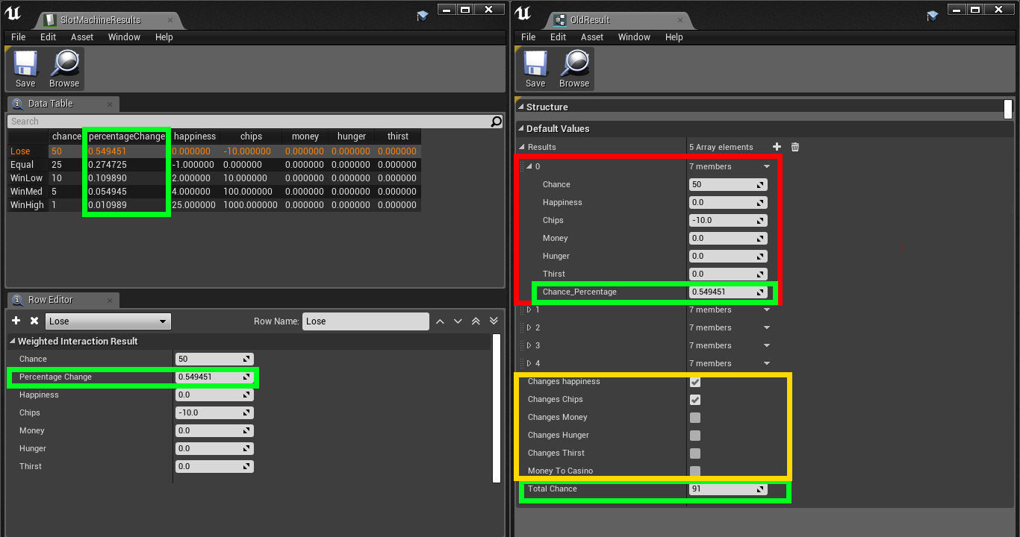

6) different types of data-tables: left excel table type, right data-structure type.  
Green noted variables are calculated automatically  
Red noted part is repeated for every result type (so 5 times in this example, 2nd till 5th element is collapsed)  
Yellow noted part is moved into the tile type itself, if the stat type is needed to be changed.

After doing this I’ve started a bit on updating the “Project Proposal” document which will be used as part of the design objective.

On Tuesday I’ve implemented the interactable having more than 1 slot for guests to use it, and tried multiple ways of making sure the guests wouldn’t end up in the walls or unreachable places, including making the locations fully part of the machine, making it difficult for ai’s to walk around it. So, I ended up letting the game check the locations every so often to see if the locations are walkable or not.

On Wednesday and Thursday, I’ve made dealers that enable/disable games to be played, meaning when there’s a dealer on a poker table guests can use it, and if there’s not then guests cannot play poker on that table.

Friday I’ve spent time on updating my documents in preparation for the last few weeks of the project.

Week 3:

This week I started with implementation of the average guest happiness, every time the happiness of a guest is changed, the average happiness gets a fraction of this same change.

With this I could make an automated way to spawn guests, where the guests are spawned with a delay dependent on the average happiness. With higher happiness equals guest spawn quicker, and lower happiness means there’s a longer delay between guest spawns.

Meaning that the full gameplay loop is now finished, and I mostly need to go ahead and fix and balance stuff.

This is also what I’ve done for the rest of the week, firstly I had found a crash when you destroy an interactable while a guest is using it, which was an easy fix by adding a check/cancel on destroy.

I’ve also fixed the following things: multi tile interactable won’t visually disappear; door sprites don’t spawn at the correct location; staff didn’t cost money over time; and a road only map + money balance.

All of these where quite easy fixes and not worth it to go into, I think.

On Thursday and Friday, I’ve been trying to fix a new crash with random null pointers which I have not yet been able to figure out why they happen as they happen even right after a check for it.

Week 4:

On Monday I fixed the last crashes I got in the build, which were shown to be on a different place than it actually was crashing at, meaning I had to put another null check in a different place to solve it.

After I had a fully non-crashing build, I spent a lot of time on Monday and Tuesday testing and writing a tutorial to send in my final build deliverable, and was able to send this on Tuesday afternoon.

On Wednesday after more testing and not finding anything I got some feedback on my tutorial that it wasn’t fully completable, making me find out that I put a build where my last balancing was reverted to a state where the tutorial was indeed unfinishable, which I fixed, and then started on the presentation for my defence.

On Thursday and Friday, I’ve spent all my time on writing a presentation and script for said presentation for my defence. Which I’ve got about 50% done.

Week 5:

On Monday I have finished the last parts of this journal.

**Targets for the next 4-week period:**

* After these 4 weeks there is only 1 week left before the deadline, which I have added as week 5 in the above section.
* During this week I’ll be finishing my defence presentation, and the last bits of my different documents

|  |
| --- |
| End of Project Overview |

Over the course of this project I’ve made a game called Casino Inc.

This is a game where the player is in charge of managing a casino.

I’ve been making this from scratch in unreal engine in multiple milestones explained in the project proposal: <https://swarm2.nhtv.nl:8443/l/tt81v0>

In a short list they are:

1. 2D tile map system
2. Basic player interaction
3. Pathfinding/basic AI
4. AI task manager
5. GOAP planner
6. Casino Management
7. Builders
8. Poker, Blackjack, and Slot-Machines
9. Guests
10. Dealers

During the course I’ve managed really good to stay on track with the proposed planning, and proposed milestones

The most difficult things I came by where Multi-Threading of the Pathfinding which gave me a lot of problems with semi-random garbage collection, and invalid pointers. But in the end, I have managed to solve this problem and now have really good and threaded pathfinding working.

Another semi-difficult thing that I’ve came around was the GOAP planner, as I have never worked with this. Again, with some work I have been able to make this work and am quite proud of how it turned out.

|  |
| --- |
| Self-Assessment and Conclusion |

My success this project has been my ability to stay motivated, and the total experience I’ve gained from doing such a big project fully.

The reason for this is mostly to do with planning and the sight of being done with university after. But also, with all the help I’ve gotten from others.

From this I’ve learned that I shouldn’t be afraid to ask for help, and that planning is a very important thing to do.

The difficult areas where multi-threading and knowing where to start.

Multi-threading was a thing I’ve never really done before, and was a bit of a puzzle to get working correctly, but with a lot of research I have managed to do it.

Knowing where to start has always been a problem for me, as I want to have something as soon as possible, but that’s quite difficult if you’re doing planning. I did manage this by making lots of notes about what’s needed for what, and what’s depending on other parts.

I’ve now fully completed the required competency profile, which I feel like I have all reached correctly, and I’m more than capable of functioning in the real game development industry after this.

To improve further I will need to start working, because as the saying goes: real knowledge only starts when you start your actual job.

All together I think the project was a huge success, I made a playable game to the specs I’ve set at the start.

I have been able to keep to the scheduled plan from basically start to finish. And think I’m having a project good enough to graduate.

# Sources:

A* search algorithm. (2019). In *Wikipedia*. Retrieved from https://en.wikipedia.org/w/index.php?title=A*_search_algorithm&oldid=888983628

Ambastha, V. (2019). *A work-in-progress Unity3D solution for intellignt NPCs for use in video games, simulations and similar media.: adrenak/UniGOAP* [C#]. Retrieved from https://github.com/adrenak/UniGOAP (Original work published 2017)

Anne. (2019). *My silly Unity/C# game that uses GOAP for combat AI.: anneomcl/HappieGOAPGame* [C#]. Retrieved from https://github.com/anneomcl/HappieGOAPGame (Original work published 2016)

Casino Manager Inc. - HacknPlan. (n.d.). Retrieved May 6, 2019, from https://app.hacknplan.com/p/84596/kanban?categoryId=0&boardId=215862

Digital image of blackjack table. - stock photo free. (n.d.). Retrieved May 13, 2019, from http://www.photo4design.com/stock-photo-digital-image-of-blackjack-table.-38491

Epic Games. (2004). Unreal Engine (Version 4.21) [Windows]. Retrieved from https://www.unrealengine.com/

Epic Games. (n.d.-a). Unreal Engine API Reference. Retrieved February 11, 2019, from https://api.unrealengine.com/INT/API/

Epic Games. (n.d.-b). Unreal Engine Programming Documentation [Wiki, documentation]. Retrieved February 11, 2019, from https://docs.unrealengine.com/en-us/Programming/UnrealArchitecture

Ferraro, L. (2019). *Generic C# GOAP (Goal Oriented Action Planning) library with Unity3d examples: luxkun/ReGoap* [C#]. Retrieved from https://github.com/luxkun/ReGoap (Original work published 2016)

hacknplan.com. (n.d.). Project management for game development. Retrieved April 15, 2019, from HacknPlan website: https://hacknplan.com/

Hothouse Creations Ltd. (2003). *Casino Inc.* [Windows]. Retrieved from https://store.steampowered.com/app/361320/Casino_Inc/

Introversion. (2015). *Prison Architect* [Windows]. Retrieved from https://store.steampowered.com/app/233450/Prison_Architect/

Jeff Orkin. (n.d.). Goal-Oriented Action Planning (GOAP) [Source collection]. Retrieved April 4, 2019, from http://alumni.media.mit.edu/~jorkin/goap.html

Model, S. (2018, July 12). How To Do a Proper Thesis Defense Using the Right PowerPoint Presentation. Retrieved June 12, 2019, from SlideModel website: https://slidemodel.com/proper-thesis-defense-using-right-powerpoint-presentation/

Orkin, J. (2003). *Applying Goal-Oriented Action Planning to Games*. Retrieved from http://alumni.media.mit.edu/~jorkin/GOAP_draft_AIWisdom2_2003.pdf

Owens, B. (2014, April 23). Goal Oriented Action Planning for a Smarter AI. Retrieved January 28, 2019, from Game Development Envato Tuts+ website: https://gamedevelopment.tutsplus.com/tutorials/goal-oriented-action-planning-for-a-smarter-ai--cms-20793

Rama. (2017b, December 13). Structs, USTRUCTS(), They’re Awesome - Epic Wiki. Retrieved April 15, 2019, from https://wiki.unrealengine.com/Structs,_USTRUCTS(),_They%27re_Awesome

Rama. (2018a, January 30). Logs, Printing Messages To Yourself During Runtime - Epic Wiki. Retrieved April 15, 2019, from https://wiki.unrealengine.com/Logs,_Printing_Messages_To_Yourself_During_Runtime#Log_Message

Rama. (2018b, March 29). Interfaces in C++ - Epic Wiki. Retrieved April 15, 2019, from https://wiki.unrealengine.com/Interfaces_in_C++

Rama. (2018c, April 29). Delegates In UE4, Raw Cpp and BP Exposed - Epic Wiki. Retrieved April 15, 2019, from https://wiki.unrealengine.com/Delegates_In_UE4,_Raw_Cpp_and_BP_Exposed#UFUNCTION.28.29_.21

slotmachine on | Pixel Art Maker. (n.d.). Retrieved May 13, 2019, from http://pixelartmaker.com/art/c84284e0a11b334

Squeaky Wheel Studio Inc. (2017). *Academia: School Simulator* [Windows]. Retrieved from https://store.steampowered.com/app/672630/Academia__School_Simulator/

Stack Overflow - Where Developers Learn, Share, & Build Careers [Programming Q&A Site]. (n.d.). Retrieved April 15, 2019, from Stack Overflow website: https://stackoverflow.com/

Stolk, B. (2019). *General Purpose Goal Oriented Action Planning. Contribute to stolk/GPGOAP development by creating an account on GitHub* [C]. Retrieved from https://github.com/stolk/GPGOAP (Original work published 2012)

The Coding Train. (2017). *Coding Challenge 51.1: A* Pathfinding Algorithm - Part 1*. Retrieved from https://www.youtube.com/watch?v=aKYlikFAV4k

The Quadsphere. (2016). *Another Brick in the Mall* [Windows]. Retrieved from https://store.steampowered.com/app/521150/Another_Brick_in_The_Mall/

TheHappieCat. (n.d.). *Combat AI for Action-Adventure Games Tutorial [Unity/C#] [GOAP]*. Retrieved from https://www.youtube.com/watch?v=n6vn7d5R_2c

Will Wright. (2000). *The Sims* [PC]. Retrieved from https://www.ea.com/games/the-sims

Zotero | Your personal research assistant. (n.d.). Retrieved April 15, 2019, from https://www.zotero.org/