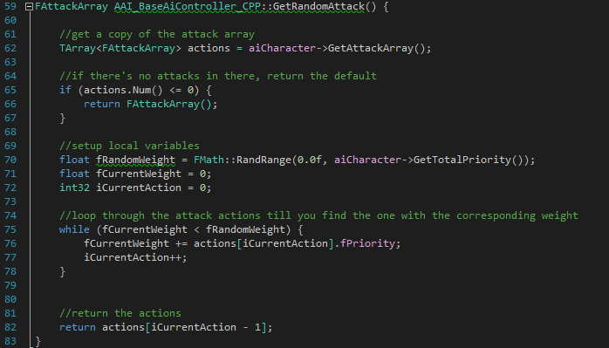

This code is for a VR project where you are supposed to catch projectiles that the enemies shoot, and use these to attack the enemies back. The project is done in unreal engine.

The code is for the enemy to select a random attack that the AI can do.

This way designers can use excel/data-tables to easily create different attacks, and assign them to the different types of enemies.

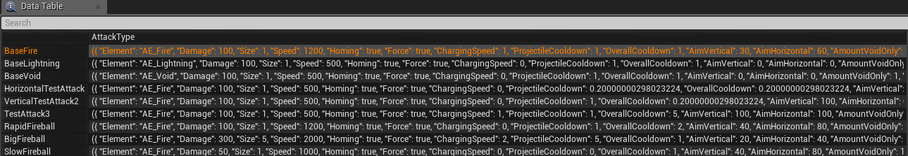Which in unreal engine look like:

*Data-table*

*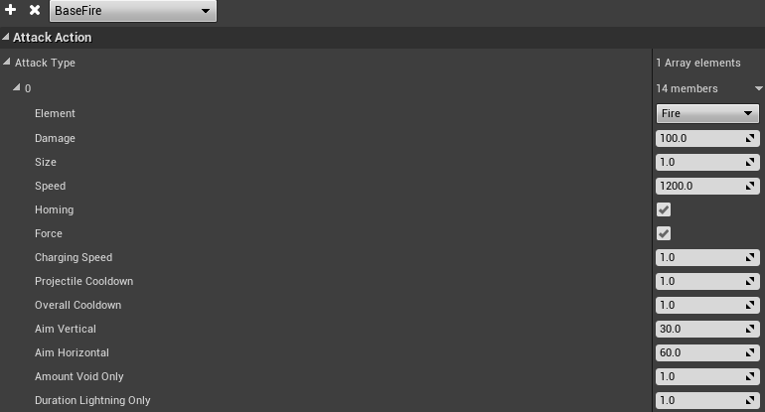data-table entry*