“Together against COVID19” www.repidemicsconsortium.org

----------------------------------------------------------------------------------------------------------------------------
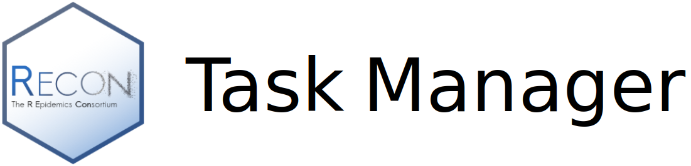
Create a task | Explore tasks | Learn | About | Review/My tasks Log in
----------------------------------------------------------------------------------------------------------------------------

Be part of the global response to COVID19

Join a community of field epidemiologists, infectious disease modellers and volunteer R programmers and contribute to develop free and open source R tools used in the response to the COVID19 epidemic.

Button: [You are a field agent with a request](link to “create a task” page)
Button: [You know R and wish to contribute](link to “explore tasks” page)

Tools developed by the R epidemics consortium (RECON) are essential in helping professionals design outbreak analytics pipelines in response to COVID19.

The tasking manager is a direct communication channel between field agents actively working on the response to COVID19 and the R community.

Your R programming skills can help field agents around the world.

RECON packages have been used in many outbreaks such as the Ebola outbreaks in West Africa (2014-2016) and Eastern Democratic Republic of the Congo (2018-2020), and are currently used by various public health institutions and academic modelling groups in the COVID-19 response.

Add contacts, links to social media,

