The near field absorption is the small area close to antenna. Inside the magnetic and electric field are merged.
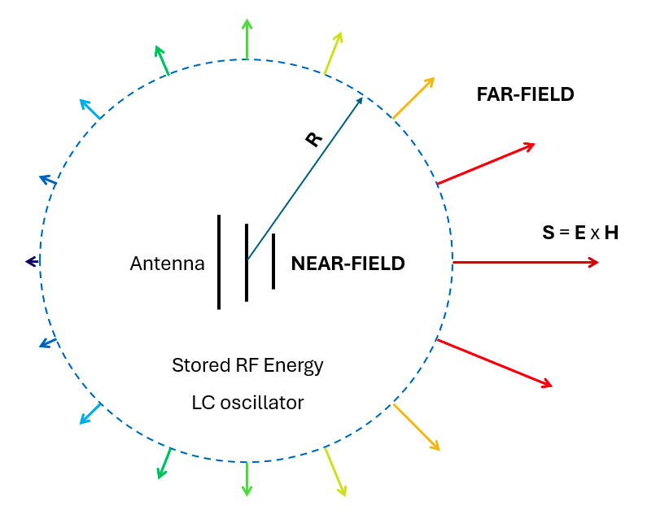 | Diagram of the near field from source 1  The energy is separate in one stocked in electric (condensateor behavior) and magnetic (inductance behavor) fiel or ddissipate by material or skin effect.
Skin effect in dB :Absorption=8.69 *tδ with t is the barrier thickness and skin depth : δ = 2wμσ

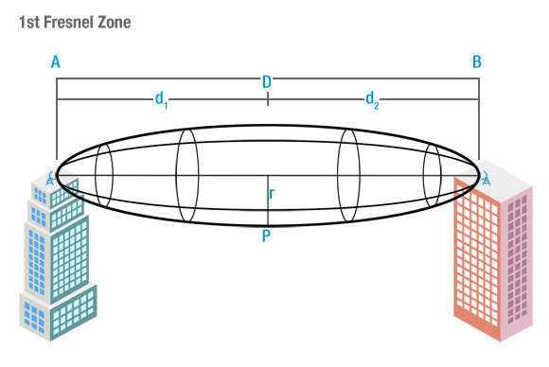 | Fresnel zone are elliptical area around a direct line-of-sight between transmitter and receiver. They represent zones where the signal constructively or destructively interfere du diffraction and reflection between each zone.

