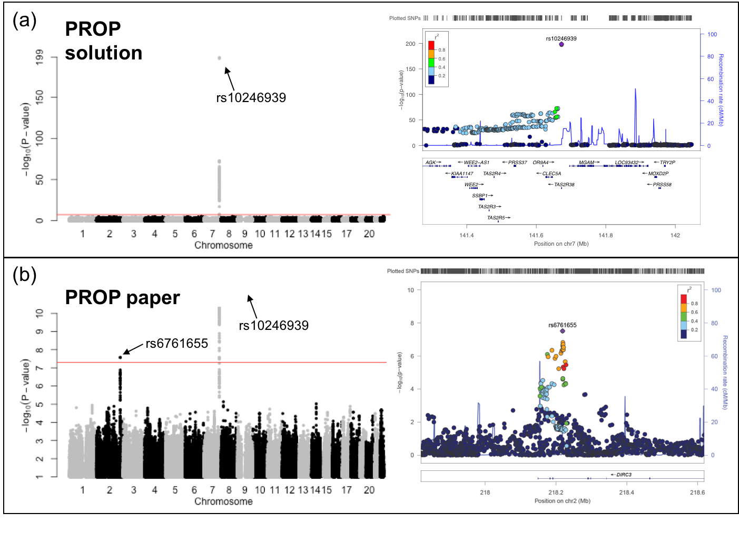

**Figure S2. Univariate GWAS for the perception of (a) PROP solution (n = 1757) and (b) PROP paper (n = 1999).** Left part are Manhattan plots displaying the association P-value for each SNP in the genome (displayed as –log10 of the P-value). The red line indicates the genome-wide significance threshold of P = 5.0e-8. Right part are regional plots ±400kb from the top SNPs on chromosome 7 for PROP solution and chromosome 2 for PROP paper with the gene model below.