M. KNIGGE
INTERPLAY BETWEEN GUT MICROBIOME AND IMMUNE SYSTEM
IMPORTANT TERMS & CONCEPTS

-parameter ×  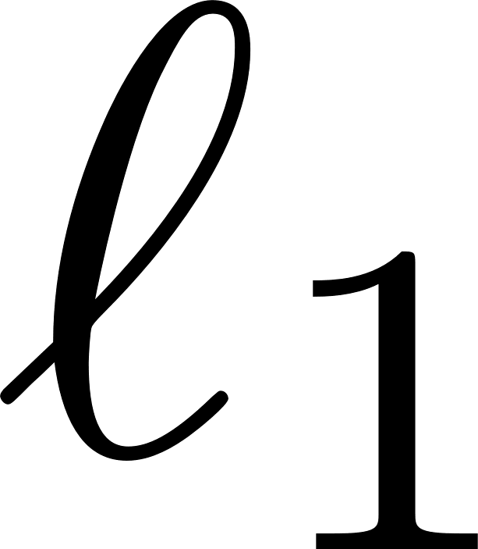-norm×  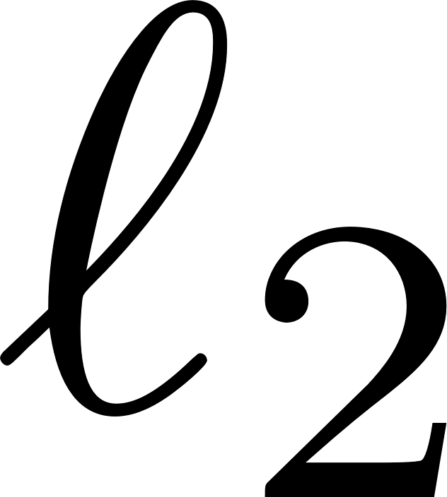-norm×   ×  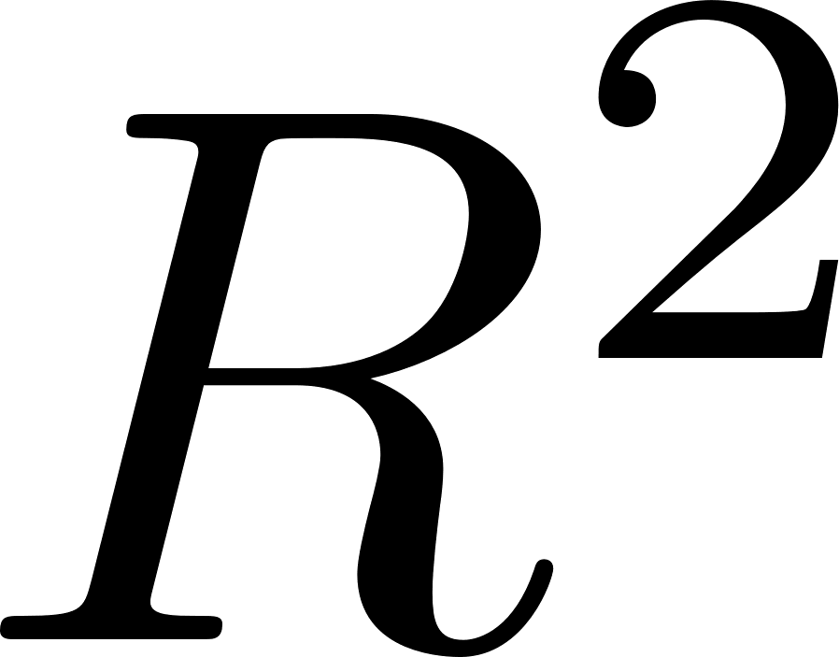 √  Adjusted √  ANOVA √  Bias ×  Coefficient ×  Collinearity √  Degrees of freedom ×  Dependent Variable √  Differentiation ×  Elastic Net Regularization ×  Error ×  Error due to Bias √  Error due to Variance √  Estimator ×  F-distribution ×  F-test √  Gauss Markov Theorem ×  Genetic Variant ×  Heteroscedasticity √  High-Dimensional Data ×  Independent Variable √  Interaction Terms √  Intercept ×  K-fold Cross-Validation ×  Least Absolute Shrinkage and Selection Operator (LASSO) × | Level-Level Regression Specification ×  Linear Regression √  Log Transformations ×  Logistic Regression ×  Log-Level Regression Specification ×  Log-Log Regression Specification ×  Mean Square Error (MSE) √  Multiple Linear Regression √  One-Sample Mendelian Randomization (MR) √  Ordinary Least Squares (OLS) √  Outlier Detection ×  Population mean √  Population variance ×  Prediction Error ×  Residuals √  Ridge Bias Constant ×  Ridge Regression ×  Ridge Trace ×  Sample mean √  Sample Variance ×  Scale in Ridge Regression ×  Shrinkage Estimators √  Standard Deviation (SD) ×  Standard Error of the Mean (SE) ×  Two-Stage Least Squares (2SLS) Regression ×  Variable Selection ×  Variance ×  Variance inflation factors (VIF) √
-parameter

-norm
Manhattan Distance or L1 norm.

-norm
Euclidean Distance or L2 norm.

The coefficient of determination. This is a measure of the goodness of fit for a linear regression model. It is the percentage of the dependent variable variation that is explained by a linear model. = explained variation / total variation. The is always between 0 and 100%. Zero percent indicates that the model explains none of the variability of the dependent variable around its mean. 100 percent indicates that the model explains all the variability of the dependent data around its mean.

Low values are not inherently bad. In some fields it is expected that the values will be low. For example in predicting human behavior. If the is low, but the still the predictors are significantly it is still possible to draw conclusions in how changes in the predictor values are associated with changes in the response value. And regardless of the , the significant coefficients still represent the mean change in the response for one unit change in the predictor. The number of independent variables in the model will increase the value of , regardless whether the variables offer an increase in explanatory power.

Adjusted
In response to the phenomena where the number of independent variables will increase the , no matter if these bring an increase in explanatory power, the adjusted metric can be utilized to penalize a model for having to many variables.

ANOVA
This method is used to compare differences between means of more than two groups. This is done by looking at the variation in the data and where that variation lies. ANOVA compares the amount of variation between groups with the amount of variation within groups. When samples are taken from a population, it is expected that each sample mean is different because samples are taken instead of the whole population: this is called the sampling error, or the effects of chance. It is always expected to find differences between means from different samples. With ANOVO it is tested if there is true difference in the population mean and sample mean. Is the difference between groups greater than expected to occur by chance?

ANOVA: 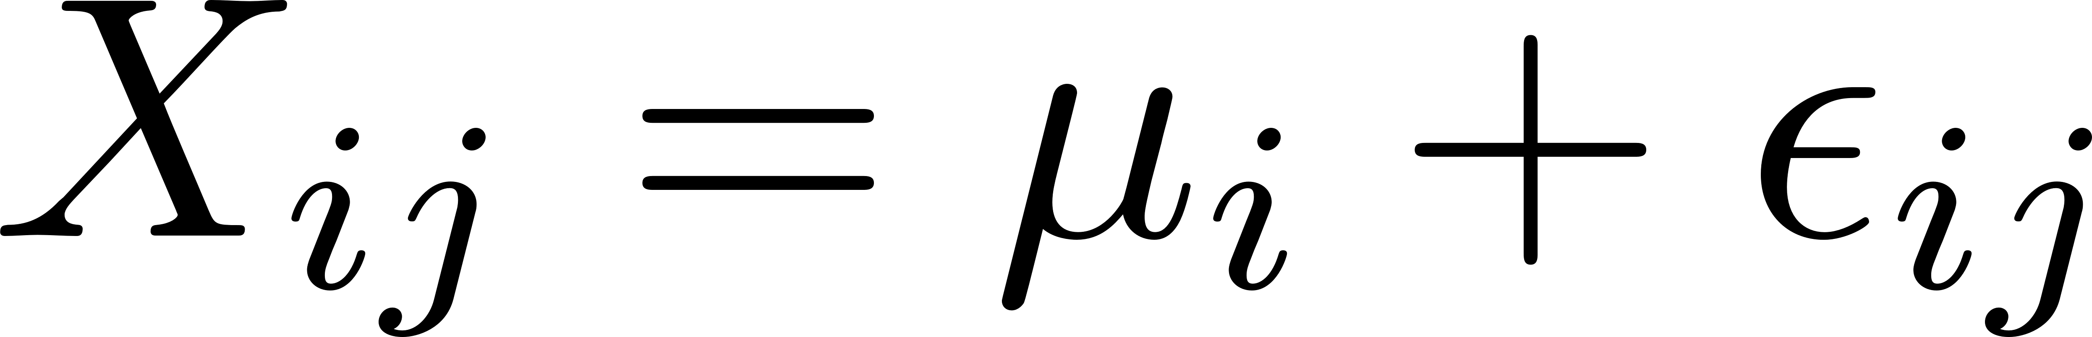. Here 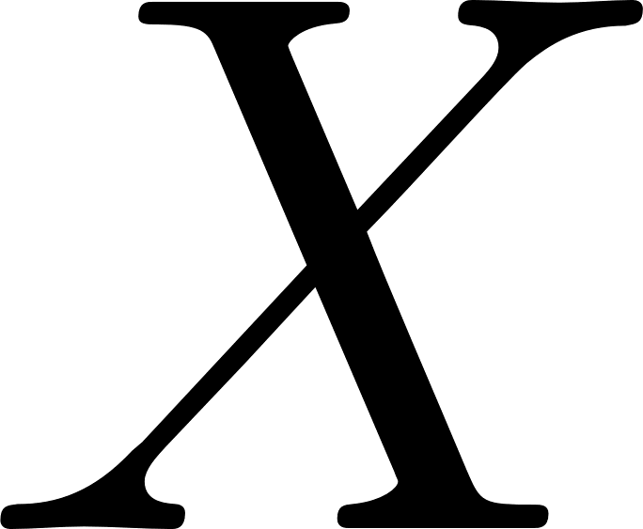 are the individual data points in the sample. , and  denote the group and the individual observations.  is the unexplained variation and the parameters of the model () are the population means of each group. Each data point (, ) is its group mean plus error. ANOVA is used to calculate a statistic called the F-ratio with which the probability of obtaining the data assuming the null hypothesis. A significant P-value suggest that at least one group mean is different from the others.
-- Null hypothesis: all population means are equal.
-- Alternative hypothesis: at least one population mean is different from the rest.

ANOVA splits the variation from the data sets into two parts: between-group and within-group. This variation is called the sums of squares, which is done in three steps: (I) variation between groups, (II) variation within groups, and (III) the F ratio. To test that all population means are equal or that at least on is different the F ratio must be considered. For this the following terms are important: Grand Mean (GM), Total Variation (), Between Group Variation (Sum of Squares Between: SSB), Within Group Variation (Sum of Squares within: SSW), F statistic, Mean Square Between groups (MSB), Mean Square Within groups (MSW).

Grand Mean
The grand mean of a set of samples is the total of all the data values divided by the total sample size. This requires all of the sample data available, which is usually the case, but not always. It turns out that all that is necessary to find perform a one-way analysis of variance are the number of samples, the sample means, the sample variances, and the sample sizes: 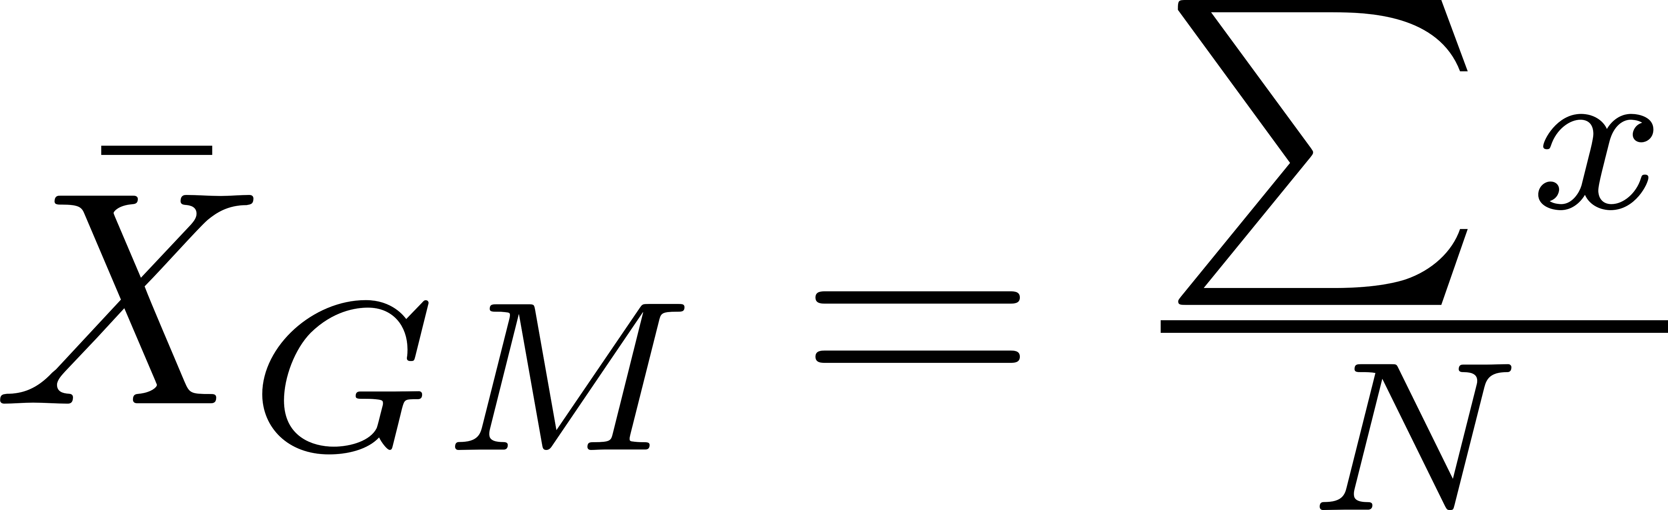. Here, 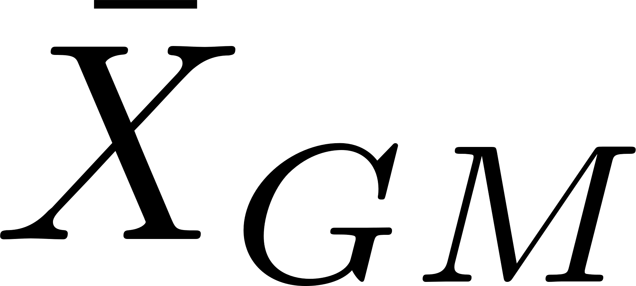 is the grand mean,  is the total sample size, and  individual observations. Another way to find the grand mean is to find the weighted average of the sample means. The weight applied is the sample size: 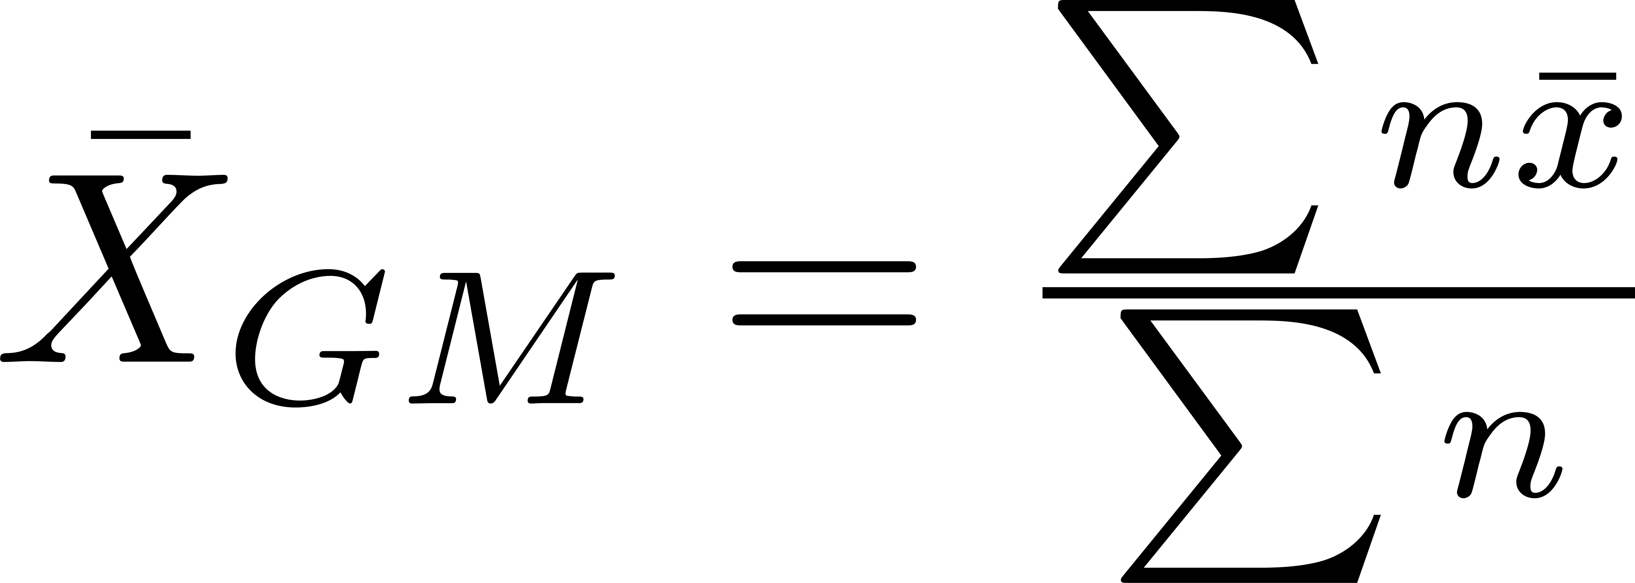. Here,  is the sample mean, and  is the sample size.

Total Variation
The total variation (not variance) is the sum of the squares of the differences of each mean with the grand mean. There is the between group variation and the within group variation. The whole idea behind the analysis of variance is to compare the ratio of between group variance to within group variance. If the variance caused by the interaction between the samples is much larger when compared to the variance that appears within each group, then it is because the means are not the same. 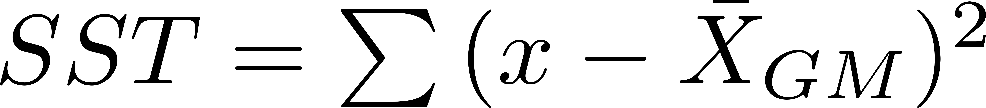

Between-group variation, or between-group sums of squares (SSB) is calculated by comparing the mean of each group with the overall mean of the data: 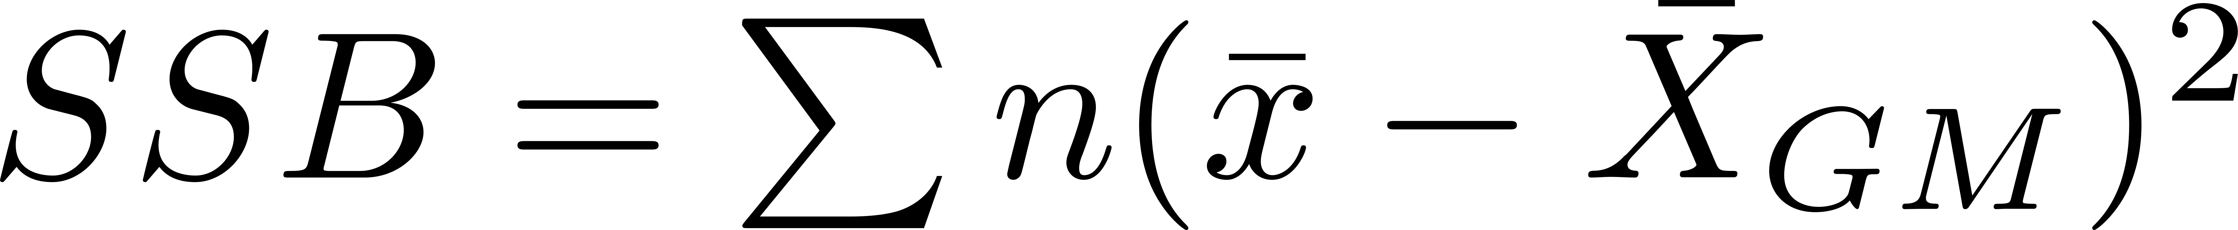. Here is the sample size, and is the sample mean. This is the variation due to interaction between the samples. If the sample means are close to each other this will be small. There are k samples involved with one data value for each sample (sample mean), so there are k-1 degrees of freedom. The variance due to the interaction between the samples is denoted MSB for Mean Square Between groups. This is the between group variation divided by its degrees of freedom. It is also denoted by 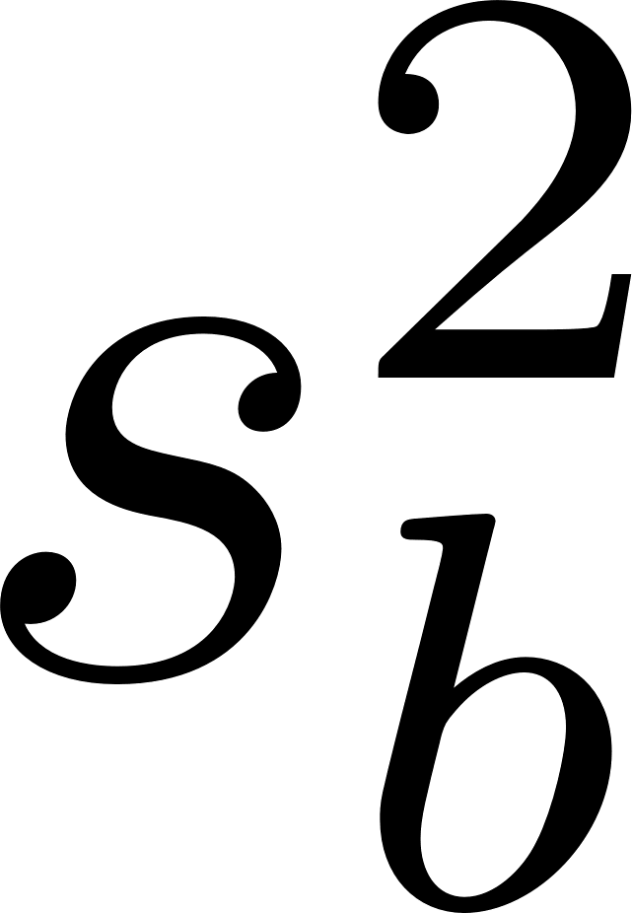.

Within-group variation is used in ANOVA tests. It refers to variations caused by differences within individual groups (or levels). In other words, not all the values within each group are the same. These are differences not caused by the independent variables. Each sample is considered independently, no interaction between samples is involved. The degrees of freedom is equal to the sum of the individual degrees of freedom for each sample. Since each sample has degrees of freedom equal to one less than their sample sizes, and there are k samples, the total degrees of freedom is k less than the total sample size: 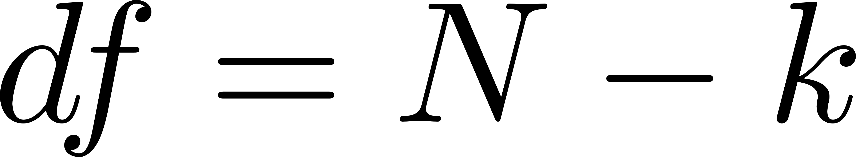.  can be calculated as follows: 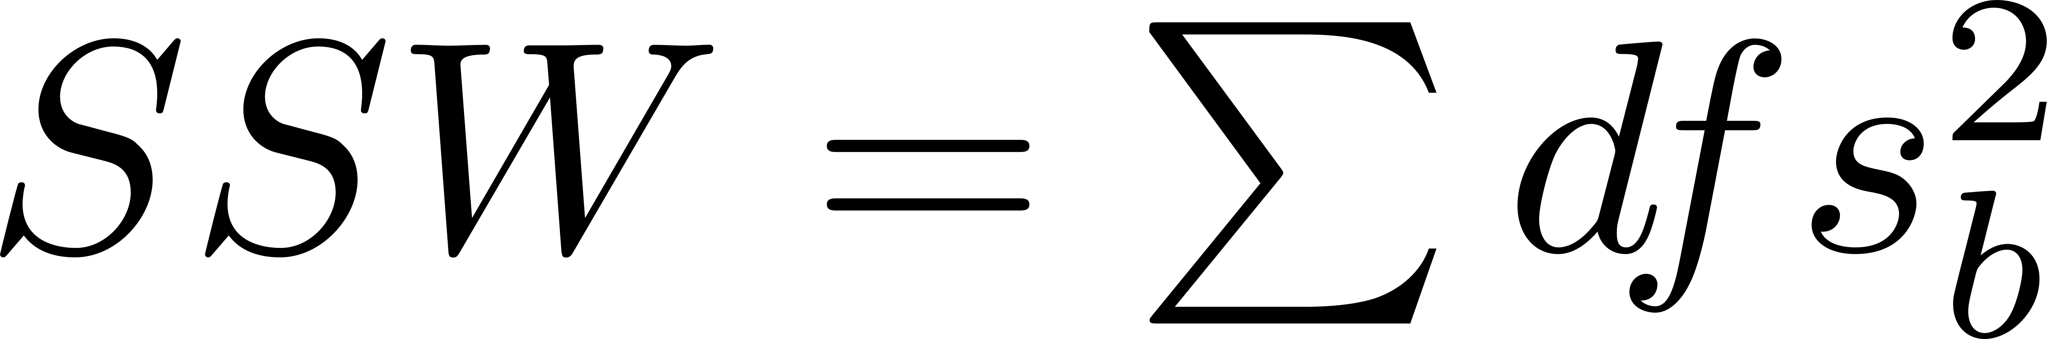. The variance due to the differences within individual samples is denoted MSW for Mean Square Within groups. This is the within group variation divided by its degrees of freedom. It is also denoted by 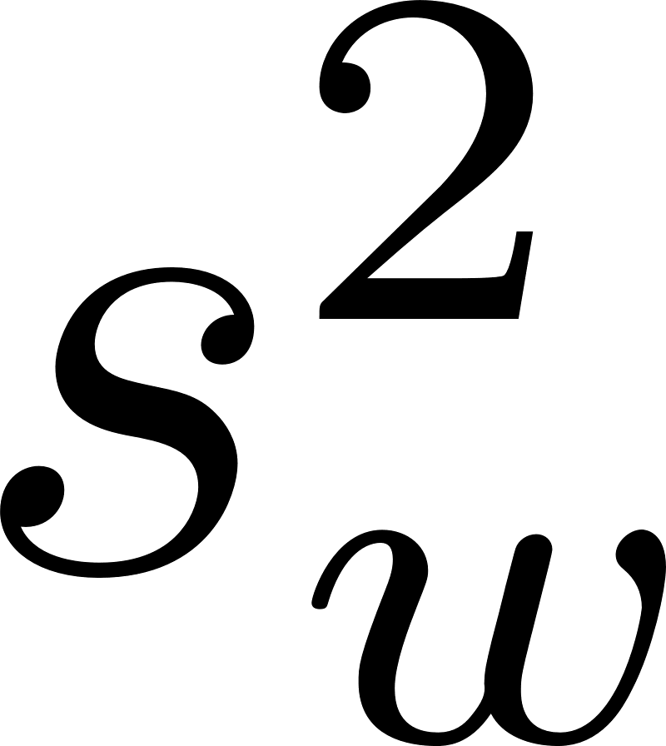. It is the weighted average of the variances (weighted with the degrees of freedom).

F statistic
The F test statistic is found by dividing the between group variance by the within group variance. The degrees of freedom for the numerator are the degrees of freedom for the between group (k-1) and the degrees of freedom for the denominator are the degrees of freedom for the within group (N-k). If the average difference between SSB is similar to SSW the F ratio is close to one. If the difference becomes larger between SSB and SSW the F ratio will be greater than one. Thus, variables with a higher F ratio have higher explanatory power: 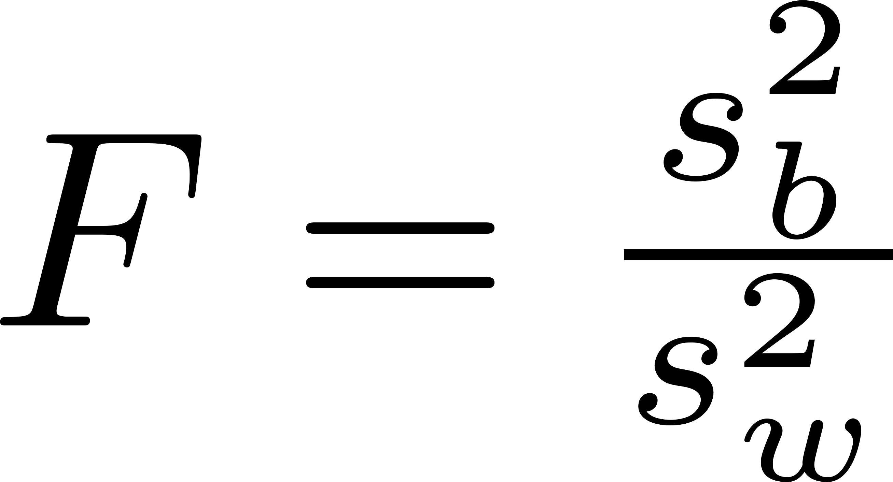. This can be tested by obtaining a p-value, this can be tested against F-distribution of a random variable with the degrees of freedom associated with the numerator and denominator of the ratio. The p-value describes the probability of getting that F ratio or a greater one. Large F ratios gives smaller p-values.

Bias

Coefficient

Collinearity
This is the not favored situation where the correlations among the independent variables are strong. In some cases, multiple regression can reflect a significant relation when there is none. For example, the model can fit the data very well, when even none of the X variables have a significant impact on explaining Y. This is possible when two X variables are highly correlated, they both bring the same information, and when this happens, the X variables are collinear and the results show multicollinearity. This is a problem because it inflates the standard errors of the coefficients, which makes some variables not significant when they should be.

Degrees of Freedom

Dependent Variable
Dependent variables depend on the values of independent variables. The dependent variables represent the output or outcome whose variation is being studied.

Differentiation

Elastic Net Regularization

Error
The error of an observed value is the deviation of the observed value from the true value of a quantity of interest (for example, a population mean). For example, if the mean height in a population of 21-year-old men is 1.75 meters, and one randomly chosen man is 1.80 meters tall, then the error is 0.05 meters; if the randomly chosen man is 1.70 meters tall, then the error is −0.05 meters. The expected value, being the mean of the entire population, is typically not observable, and the statistical error cannot be observed either.

Error due to Bias
Error because of bias is taken as the difference between the expected or average prediction of the model and the correct value which the model tries to predict.

Error due to Variance
Error because of variance is taken as the variability of a model prediction for a given data point. The entire model building process is repeated multiple times for example, then the variance is how much predictions for a given data point vary between different realizations of the model.

Estimator

F-test

Gauss Markov Theorem

Heteroscedasticity
Linear regression using OLS has the assumption that residuals are identical distributed across every X variable. If this condition holds true, the error terms are homogeneous, which means that the errors have the same scatter regardless of the value of X. When the scatter of the errors is different, varying depending on the value of one or more of the independent variables, the error terms are heterogeneous.

A collection of random variables is heteroscedastic if there is a sub-population that has different variabilities from others. Here "variability" could be quantified by the variance or any other measure of statistical dispersion. Thus heteroscedasticity is the absence of homoscedasticity. The existence of heteroscedasticity is a major concern in the application of regression analysis, including the analysis of variance, as it can invalidate statistical tests of significance that assume that the modeling errors are uncorrelated and uniform—hence that their variances do not vary with the effects being modeled.

High-Dimensional Data

Independent Variable
The independent variables represent inputs or causes, potential reasons for variation or, in the experimental setting, the variable controlled by the experimenter. Models and experiments test or determine the effects that the independent variables have on the dependent variables.

Interaction Terms
Adding interaction terms to a regression model can improve the understanding of the relationship among variables in the model and allows for more hypotheses to be tested. The presence of a significant interaction indicates that the effect of one independent variable on the dependent variable is different at different values of the other independent variables. This is tested by adding a term to the model in which the two independent variables are multiplied:

Intercept

K-fold Cross-Validation
A K-fold partition of the sample space is created. The original sample is randomly partitioned into K equal sized (or almost equal sized) subsamples. Of the K subsamples, a single subsample is retained as the test set for estimating the PE, and the remaining K-1 subsamples are used as training data. The cross-validation process is then repeated K times (the folds), with each of the K subsamples used exactly once as the test set. The K error estimates from the folds can then be averaged to produce a single estimation. The advantage of this method is that all observations are used for both training and validation, and each observation is used for validation exactly once.

Least Absolute Shrinkage and Selection Operator (LASSO)

Level-Level Regression Specification

Linear Regression
Regression analysis is the science of fitting straight lines to patterns of data, it used for prediction and forecasting. In a linear regression model, the variable of interest is (dependent variable) predicted from a single or more variables (independent variable) using a linear formula. Regression analysis is also used to understand to find out which among the the independent variables are related to the dependent variables, and to explore the forms of these relations. The simple regression model can be represented as follows: 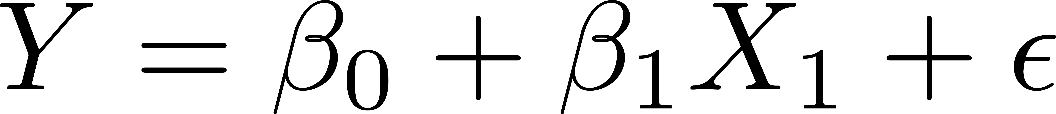. The  is the  intercept value, the coefficient  is the slope of the line, the 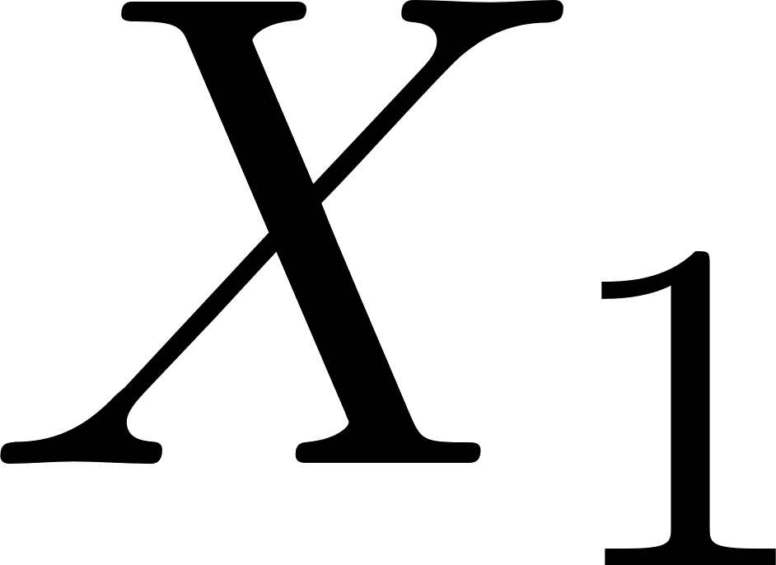 is an independent variable and is the error term. The error term is used for correcting a prediction error between the observed and predicted value. This can be interpreted as for each unit increase in , will increase by some value.

Log Transformations

Logistic Regression

Log-Level Regression Specification

Log-Log Regression Specification

Mean Square Error (MSE)
Measures the average of the squares of the errors, that is, the difference between the estimator and what is estimated. MSE is a measure of the quality of an estimator—it is always non-negative, and values closer to zero are better.

Multiple Linear Regression
A multiple linear regression is the same as a simple linear regression but, there can be multiple coefficients and independent variables:

One-Sample Mendelian Randomization (MR)
This is the basic implementation of MR on SNPs, exposure, and outcome from a single data set, with the addition of genetic data from participants. The causal effect of the exposure on the outcome can be estimated by a two-step regression analysis: Two-Stage Least Squares (2SLS) regression. In the first step, a linear regression is fitted on the genetic variants from the exposure. In the second step,the genetic variants from the outcome are regressed over the predicted values from step one by linear or logistic regression. The coefficient from the second stage can be interpreted as the change in the outcome per unit increase in the exposure. If this coefficient is significant, than the exposure is causal (or protective, depending on the sign of the coefficient) for the disease.

Ordinary Least Squares (OLS)
This is a method for estimating/predicting parameters that are unknown in a linear regression model. OLS chooses the parameters of a linear function in a set of independent variables by minimizing the sum of the squares of the differences between the observed dependent variable (values of the variable that will be predicted) in the given data set and those predicted by the linear function. This can be seen as a square drawn between the predicted and observed (dependent variable). The sum of Squares are a representation of the error in the OLS regression model. In linear regression models, prediction errors can be decomposed into two main sub-components: error due to bias, and error due to variance. Understanding bias and variance is key to understanding the behavior of prediction models. It is important to understand how different sources of error lead to bias and variance and this can help improve data fitting. There is a trade-off between a models ability to minimize bias and variance. The best model is at the level of complexity where the increase in bias is equivalent to the reduction of variance. Bias is reduced and variance is increased in relation to the complexity of a model. As more parameters are added to the model, the complexity of the model rises and the variance becomes the primary concern, and the bias falls. The Gauss Markov Theorem states that among all linear unbiased estimates, OLS has the smallest variance. What implies that OLS estimates have the smallest MSE among linear estimators.
-- But, is it possible that there can be a biased estimator with a smaller MSE?
--This is where Shrinkage Estimators are used.

Outlier Detection

Population mean
The population mean is an average of a group characteristic. The group could be a person, item, or thing, like “all the people living in the United States” or “all dog owners in Georgia”. A characteristic is just an item of interest. It is actually rare that the population mean can be calculated. That’s because asking an entire population about something is usually cost prohibitive or too time consuming. For example, one veterinary practice probably keeps weight records of all the pets that come in the door, enabling you to calculate the average weight of a dog for that practice (i.e. the population mean for that practice). But if you were working for a pet food company who wanted to know the average weight of a dog, you wouldn’t be able to track down all the 70 to 80 million dogs in the US and weigh them.

Prediction Error

Residuals
The residual of an observed value is the difference between the observed value and the estimated value of the quantity of interest (for example, a sample mean). A residual, is an observable estimate of the not observable statistical error. Consider the example with men's heights and suppose we have a random sample of n people. The sample mean could serve as a good estimator of the population mean. Then we have: the difference between the height of each man in the sample and the not observable population mean, this is the statistical error, whereas the difference between the height of each man in the sample and the observable sample mean is a residual.

Residual plot
This is a scatterplot of the residuals (difference between the actual and predicted value) against the predicted value. A good model will show a random pattern of the residuals with no shape. Residual plots can be used for diagnostics and assumption testing in linear regression.

Ridge Bias Constant

Ridge Regression

Ridge Trace

Sample Mean
Simply the mean or average when the context is clear, is the sum of a collection of numbers divided by the number of numbers in the collection.

Sample Variance

Scale in Ridge Regression

Shrinkage Estimators
This an estimator that, either explicitly or implicitly, incorporates the effects of shrinkage. This means that a raw estimate is improved by combining it with other information. The term relates to the concept that the improved estimate is made closer to the value supplied by the 'other information' than the raw estimate. Estimators can be improved, in terms of MSE, by shrinking them towards zero (or any other fixed constant value). Assume that the expected value of the raw estimate is not zero and consider other estimators obtained by multiplying the raw estimate by a certain parameter. A value for this parameter can be specified so as to minimize the MSE of the new estimate. For this value of the parameter, the new estimate will have a smaller MSE than the raw one. Thus it has been improved. An effect here may be to convert an unbiased raw estimate to an improved biased one.

The standard estimator of the population mean is the sample mean, which is not biased. Building an estimator by shrinking the sample mean results in a biased estimator, with an expected value less than the population mean. Shrinkage always reduces the estimator’s variance and reduce the MSE. For example, a variable , which has a population of values. When taken a sample from , the observations drawn are 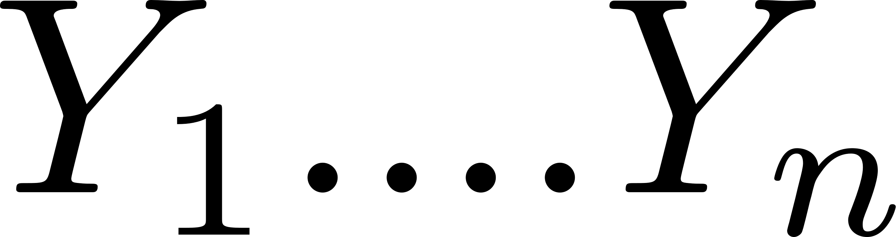. The population mean is the “true value”  (the estimand): the thing to be estimated. The sample mean is 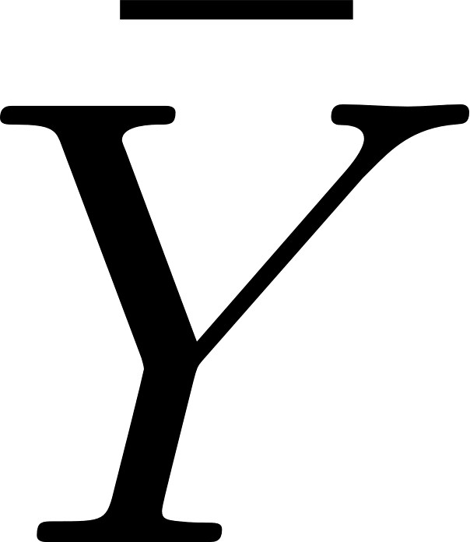. The population variance is 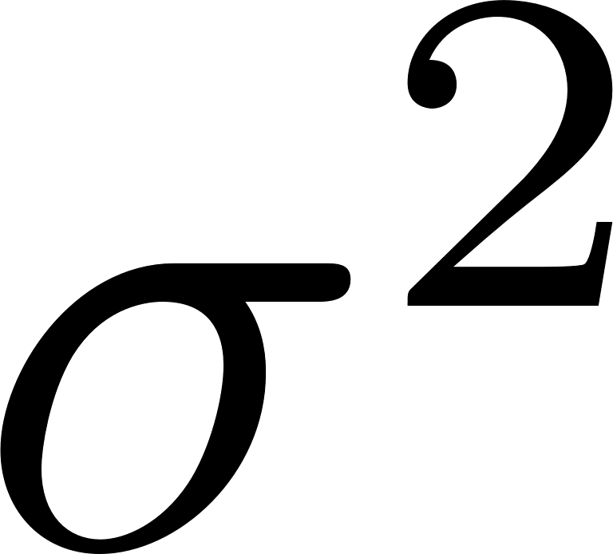. There can be more than more than one estimate (multiple dimensions), the number of estimates are denoted by 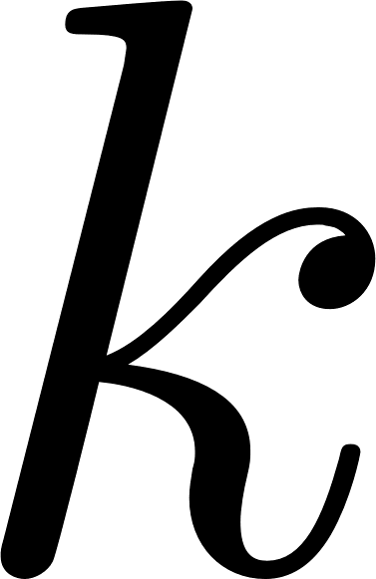. For example three dimensions with independent variables , 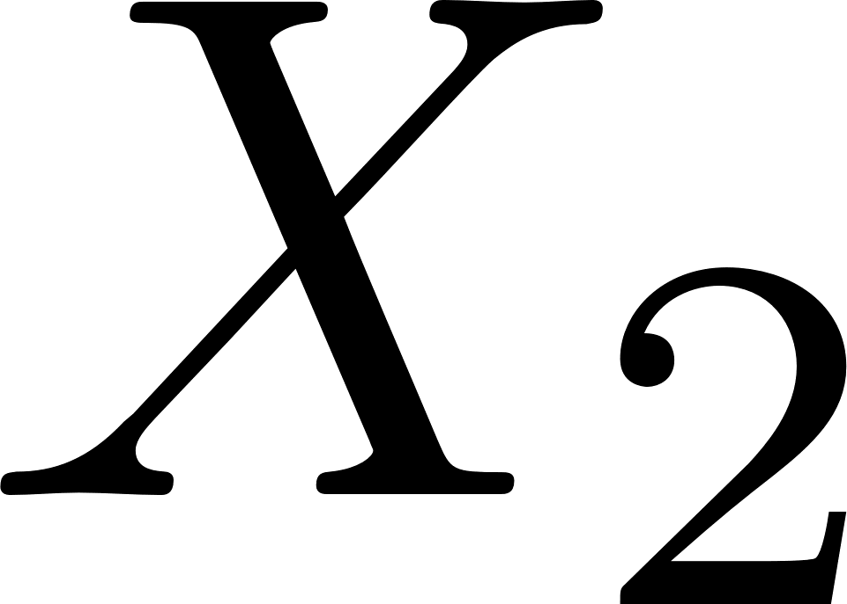, and 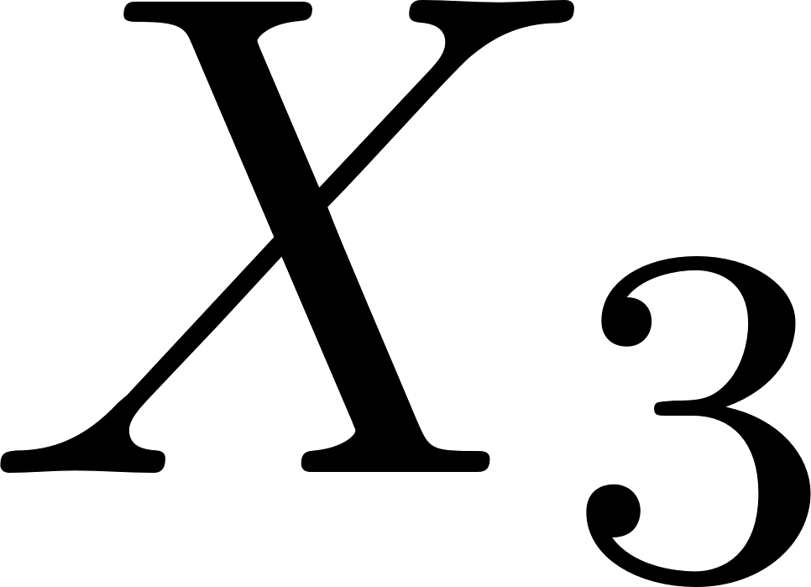.

Standard Deviation (SD)

Standard Error of the Mean (SE)

Two-Stage Least Squares (2SLS) Regression

Variable Selection

Variance

Variance inflation factors (VIF)
This measures how much variance of the estimated coefficients are increased over the case of not having correlation between X variables. If there are two variables correlated, how to decide which one should be removed? To determine the best one to remove, remove each one separately from the model en perform regression and select the regression equation that explains the most variance: the highest .

