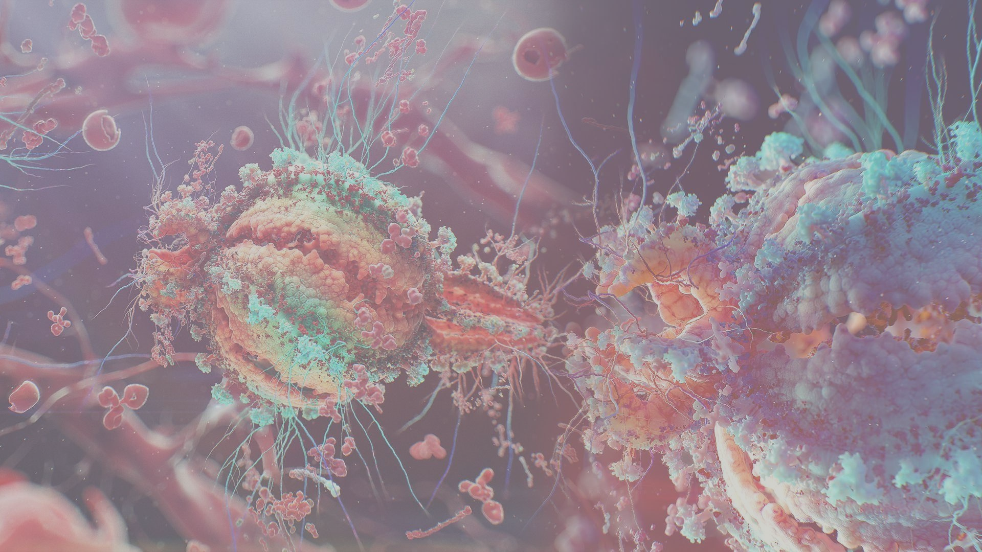
`

ARBO
AUTHOR
M. Knigge

INSTITUE
Hanze University
Life Science and Technology

ORGANIZATION
Eriba
Department of Genetics

DATE
3, May2018



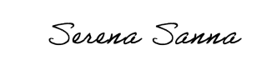
`

ARBO
AUTHOR
M. Knigge

SUPERVISORS
Asst. Prof. Dr. S. Sanna
Asst. Prof. Dr. Y. Li

LECTURER
Dr. M. A. Noback

INSTITUE
Hanze University
Life Science and Technology

ORGANIZATION
Eriba
Department of Genetics

DATE
3, May2018

Supervisor’s signature
TABLE OF CONTENTS

INTRODUCTION 3
THE COMPANY 3
THE PROJECT 3
WORKING CONDITIONS 6
THE “ARBEIDSOMSTANDIGHEDENWET” 6
POLICY OF ARBO 6
SAFETY 7
WORKING ENVIRONMENT 7
CALAMITIES 8
RISK ASSESSMENT 9
RSI 9
STRESS 9
EYESTRAIN 10
CARPAL TUNNEL SYNDROME 10
REFERENCES 11

INTRODUCTION

THE COMPANY
This internship was provided and guided by the immuno-genetics research group in the department of Genetics at the University Medical Center Groningen (UMCG). The hierarchy can been seen as a structure divided in multiple sections (A-F), each with its own director (figure 1). Above these directors is a main director. All sections are divided into departments, and each department has a head. For the Department of Genetics this is prof. Richard Sinke. Under his coordination, several associated and full professors lead different research groups.[]

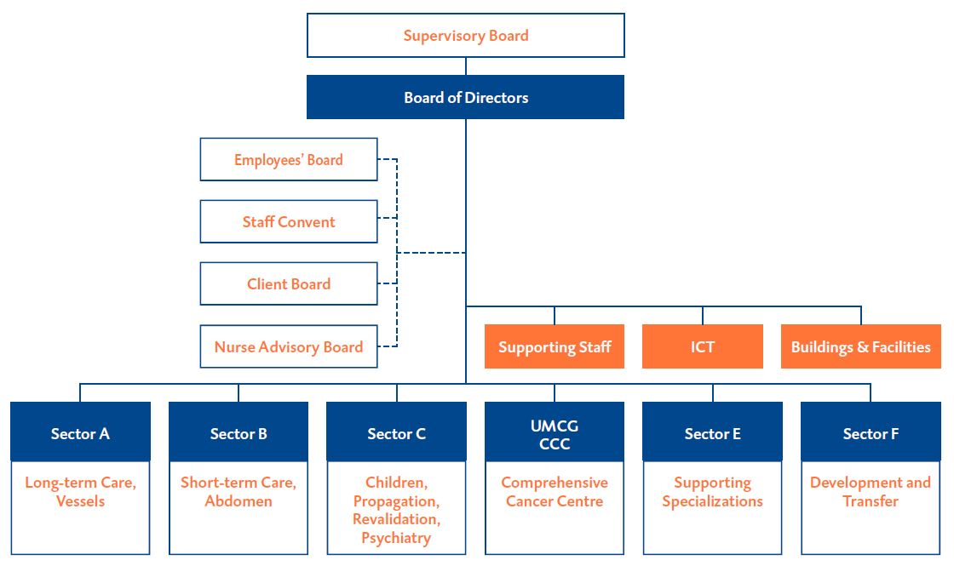
Figure 1: Organogram of the UMCG organizational structure.

THE PROJECT
Evidence suggests that the human gut microbiome plays an important role in metabolic and immune function.[] Empirical evidence of Microbiome-Wide Association Studies (MWAS) in population cohorts show significant associations identified systematically between the gut microbiome and multiple complex traits and intrinsic factors, like Inflammatory Bowel syndrome (IBD), body mass index (BMI), food allergies and blood cells composition.[] Discovery of these links is key to understanding disease, and potentially disease treatment.

The body of a human is a complex interconnected ecosystem, and the gut is where the body acts as a first line of defense. Where it interacts with the “outside world”, functioning as a frontline of the immune system, which is constantly exposed to new microbes and molecules.[] The whole collection of microbes and molecules that are present in and on the human body is known as the microbiota.[] The microbiome refers to the whole set of genes within these microbes. The role of the microbiome composition/function is considered as an acting organ in the body’s operation. It is presumed that it has an effect on aging, digestion, mood, cognitive function, and immune system.[] The immune is a defensive system from the host entailing many biological structures and processes within an organism to protect against diseases, and infection. The function of the immune system relies on the ability to detect and distinguish a wide arrange of agents known as pathogens, viruses, and parasites from self and non-self.[]

The aim of this research is the identification of causality links between the microbiome composition/function and immune system: does the microbiome influence the immune system (cell counts, cytokines, globulin levels), or/and does the immune system influence the microbiome. We have access to the largest population cohort with gut metagenomic sequencing (LL-DEEP), but this cohort has not been characterized in depth for immune traits.And we have access to another cohort, the human function genome project 500FG[] which was specifically designed to assess the immune and metabolic system (500 phenotypes available), and also microbiome, but it is very small. This cohort has also genetic and gene expression available. By using gene expression data, genetic data, and transcriptomic data from the 500 Functional Genomic (500FG) cohort a linear model is constructed that explains immune traits/functions between gene expression data, genetic data, genetic data combined gene expression data and the 500FG cohort with Elastic Net Regularization.[] This constructed model, that is based on genetic data and gene expression data is used to predict immune traits/functions in LL-Deep data which contains genetic, and gene expression data from a large number of individuals which lacks immunogenic information. These predicted immune phenotypes will be used to forecast a causal link with microbial composition/function, with one-sample Mendelian Randomization (MR), see figure 1.

We expect to find causal links between microbiome composition/function and the immune system that can help us understand the interplay between the gut microbiome and the immune system, and ultimately help understand disease, and develop disease treatment; restoring microbiome composition and/or function through personalized nutrition or treatments. However, to efficiently translate findings into clinical practice, it is essential to discriminate between microbiome features that are on the causal pathway to disease from those that are a consequence.

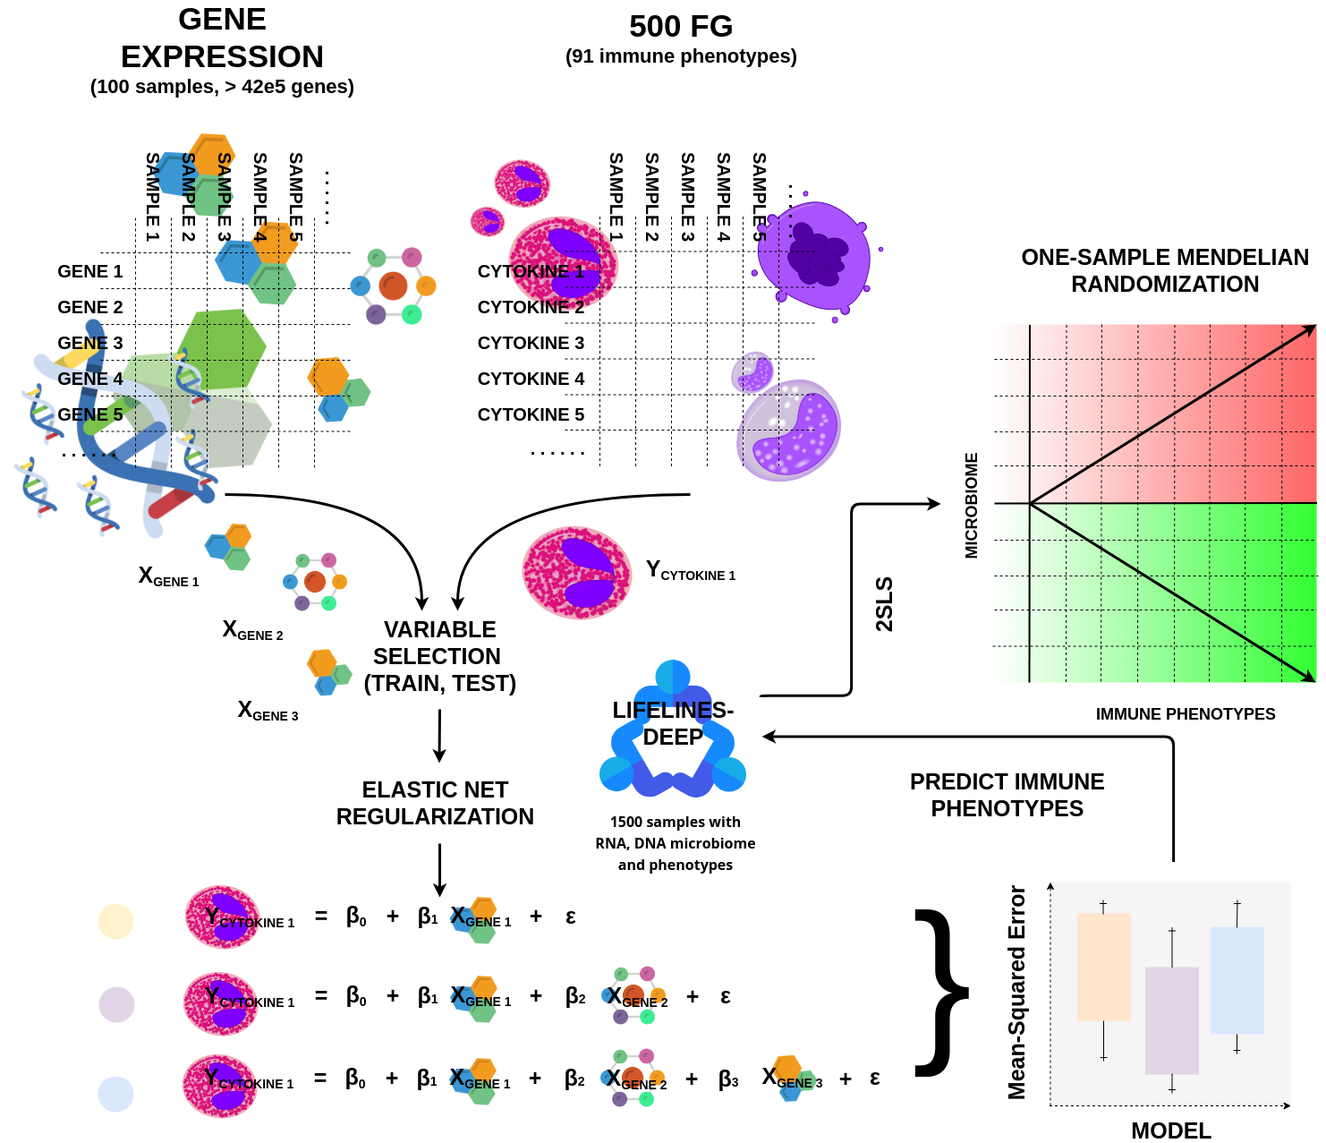
Figure 2: Overview of the computational infrastructure. For every immune phenotype in the 500FG cohort, multiple models will be build with a different set of genes that tries to explain a certain immune phenotype with the Elastic Net approach. After the model creation, these will be evaluated and the best one will be used to predict immune phenotypes in LL-Deep, which in turn, are going to be used to access causality links between the gut microbiome and immune system.

WORKING CONDITIONS

THE “ARBEIDSOMSTANDIGHEDENWET”
The “Arbeidsomstandighedenwet”, further known as the “Arbowet” stands for nothing more or less than for the abbreviation of the word employment conditions. The working conditions are: "the conditions under which the employees perform their work: in the area of safety, health and whether, as an employer, take sufficient account of the well-being of the employees in the workplace".[]

The “Arbowet” is a framework law containing general provisions. These have been further elaborated in the Working Conditions Decree and the Occupational Health and Safety Regulations that contain concrete regulations. In an occupational health and safety catalog, employers and employees define how they can meet the target requirements of the Working Conditions Act per company or branch. A few other laws that are important: the Working Hours Act, the Gatekeeper Improvement Act, the Work and Income according to Labor Capacity Act (WIA), the Work and Care Act, the Equal Treatment Act and the equal treatment on the grounds of age at work.^{[10]}

POLICY OF ARBO
The practical implementation of the ARBO regulation at the UMCG is a collaboration of the UMCs in the Netherlands. This health and safety catalog is compiled by the Dutch Federation of UMCs (NFU) and employee organizations. This catalog contains many aspects employees have to deal with, and the goal of this implementation is to reduce health risk, and the caption of a healthy and work friendly environment. The combined effort the Dutch Federation of UMCs addresses the following risk factors[]:

• Cytostatics (tumor suppressing drugs)
• Physical stress (lifting heavy objects etc)
• Repetative strain injury (RSI)
• Inhalational anesthetics
• Dangerous substances (gasses, glues, disinfectants etc)
• Skin reactions (allergies due to soap etc.)
• RI&E (risk inventorization and evaluation)
• Agression and violence (verbal and non verbal violence)
• MRI (for people working with MRI scanners)
• Infection prevention
• Unwanted behavior (discrimination or bullying)
• Pregnancy
• Stress

SAFETY
Safety at work is not only about working with safe and approved means (such as the use of machines, tools, equipment and installations), but safe behavior is just as important. Clear information, clear work instructions, the correct use of resources and regular maintenance and inspection - often required - increase safety. Employers and employees are jointly responsible for this. Most subjects related to safety described by the ARBO are related to manual labor environments, and not the environment that is set at the office desk, which do not pose any hazardous potentials as working with for example with pneumatic drills, construction sites, or lab work (for the sake of clarity, see figure 3, which shows the difference between a pneumatic drill and a laptop, since these objects are both items used in professions so there can be some confusion about the potential risks in using them, and distinguishing them). Since I am working as a Bioinformatician my environment summarizes a desk, laptop, writing material, and that is it.

But there is an import part in safety that is not incorporated in the ARBO, and that is cyber safety, which is a difficult subject to give boundaries in terms of preventing or protecting against. The UMC’s in the Netherlands have the responsibility to handle private data, like patient generated data. This type of data has to be stored and processed in the right way, at the right moment and by the right person, the researcher. Cohort based studies like LifeLinesDeep, BIOS, 500FG, and 200FG are examples of very deep detailed patient based data cohorts, with which I am working on with my project. These type of data is very expensive to generate, and must hold to the law of privacy, which when is violated, will give rise to a very high fee, but also damages the image of the company.

Genotype, or phenotype, can potentially lead back to specific individuals, and in the wrong hands this can be very hazardous. The UMC’s maintain a strong communication and plan in keeping this data safe and from the “streets”. It is not allowed to have patient data on a non-company computer product, and real patient identifiers are never used, instead some random generetad sequence is used that can link back to the patient, but this sequence normally only makes sense to the research team. And if a employee has a portable product with patient data, the UMC requires the laptop to be encrypted.

WORKING ENVIRONMENT
The ARBO policy on the working environment, describes in the “ARBObesluit” details what the working environment should look like. It defines standards like the space that must be available per employee or object, furthermore there are statements about factors that could help lover the risk for RSI, like that desks and chairs must be adjustable. The UMC handles this by having a contract with the manufacturer who passes by over an pre-stated sequence to check chairs and desk to maintain quality. Another important part of the working environment is the atmosphere among colleagues, there should be no bullying, discrimination, any form of sexual intimidation. These are things that could result in a stressed environment and could break down the quality of the research and the well being of a person. From personal experience there is no form whatsoever that has a negative impact on the atmosphere among colleagues. As mentioned, stress is a really important factor, and with being a researcher this is a silent killer because the level, pace, and pressure that is put on and expected from an employee can be considered heavy. It is important to take regular breaks, discuss problems, talk about problems, and do proper activities during spare time instead of working, for example exercise.

CALAMITIES
The most likely calamity to take place within the UMC is a fire. The government has lined out very strict rules in how the design and to fire proof buildings. There several several actions that can be undertaken to ensure a fire does not break out and that all persons can get out safely. There are fire extinguishers available at multiple locations, and there are lots of smoke detectors which are checked regularly. Exit routes are defined by signs. There are always multiple exit routes from a building. The doorways between buildings are fireproof blast doors which can close automatically in order to prevent the fire from spreading by making sure that there is little air transport. Every department has responders that are trained to deal with these kind of situations and aid in the process of helping people getting safely out of the building. There are also regular fire drills in which these protocols are tested and evaluated. For minor injuries at the workplace, at several points are first aid kits should they be needed, this way responders can help out someone who needs help quickly.

RISK ASSESSMENT

RSI
A repetitive strain injury (RSI, further known as Work-Related Musculoskeletal Disorders (WRMSDs), this an injury to the musculoskeletal and nervous systems that may can be caused by repetitive tasks, forceful exertions, vibrations, mechanical compression, or sustained or awkward positions.

Repetitive strain injury (RSI) and associative trauma disorders are terms used to refer to discrete conditions that are associated with repetitive tasks, forceful exertions, vibrations, mechanical compression, or sustained/awkward positions. Extreme temperatures have also been reported as risk factor for RSI by different investigators. From the 1970s onward there has been reportedly a worldwide increase in RSIs of the arms, hands, neck, and shoulder which correlates with use of computers, or the more desk-jobs.[, ]

For RSI there are no quick fixes , early diagnosis in onset is critical to reducing potential damage. RICE is method that is used as the first treatment for many people who suffer muscle strains, ligament sprains, or other bruises and injuries. R.I.C.E is short for: Rest, Ice, Compression, and Elevation. RICE is used directly after an injury is conflicted and for the first 24 to 48 hours after the injury. There is medication that can be used often, and are for early stages of RSI. Some examples of Medications: analgesics, myofeedback, biofeedback, physical therapy, relaxation, and ultrasound therapy. General exercise has been proven/shown, and from empirical evidence can be suggested that it leads to decrease the risk of developing RSI. Doctors often recommend that RSI sufferers engage in specific strengthening exercises, for example to improve sitting posture. Modifications of posture and arm use (human factors and ergonomics) are often recommended.[, , ]

The UMCG recognizes this potential problem and counterattacks this by having a wide office, so that employees can take a walk now and then, so they don’t very long in the same posture. The are so called “24/7 chairs” that can be adjusted to everyone's body to improve body posture.

STRESS
Physiological or biological stress is the response of an organism's to a stressor like environmental factor. The method of the body of reacting to a condition such like a threat or challenge is stress.There are multiple effects that alter an organism's environment are responded to by several systems in the body. There is the autonomic nervous system and the hypothalamic-pituitary-adrenal (HPA) axis, which are mechanisms that respond to stress. This sympathoadrenal medullary (SAM) axis mechanism activates a fight-or-flight mode through the sympathetic nervous mechanism, which sends energy to more relevant systems to counter attack stress. The second major physiological stress mechanism, is the HPA axis, that regulates the release of a molecule called cortisol, which controls many functions like metabolic, psychological and immunological functions. The SAM and HPA mechanisms are regulated by multiple brain regions. Through the impact of these mechanisms, stress can have a negative effect on memory functions, immune function, metabolism and susceptibility to diseases. Stress can be defined in five categories: acute time-limited stressors, brief naturalistic stressors, stressful event sequences, chronic stressors, and distant stressors. [, , , ]

Stress is a main factor that can lead to an unhealthy work environment, that goes silent. It can ultimately lead to chronic stress which has a direct causal link to depression, illness, and many other negative factors. The Genetics Department of the UMCG is considered to be leading in the field of genetics ans is recognized for its general high impact. For sure, this department wants to maintain this impact on the world of science. So, the UMCG encourages a friendly work environment, where is possible to walk, have a break, even do sports. Besides having a good environment, you want to have friendly colleagues who bring support and the right advice when needed. And this department obligates colleagues to so.

EYESTRAIN
Eye strain, further defined as asthenopia, which is an condition to the eye that manifests itself through aspecific symptoms like fatigue, pain in or around the eyes, un-sharp vision, headache, and occasional double vision. Symptoms often occur after reading, computer work, or other close activities that involve tedious visual tasks. When performing a visually intense task, such as reading a book or working on a computer, the ciliary muscle tightens. This has the potential to cause the eyes to irritate and can get n uncomfortable. Giving the eyes a chance to focus on a distant object at least once an hour usually alleviates the problem.[, ]

The UMCG accounts for this problem by having computer monitors with a high refresh rate, and the option to filter out blue light, which gives the screens a slight yellowish look. And further is it important to take a break once a while to give the eyes some rest.

CARPAL TUNNEL SYNDROME
Carpal tunnel syndrome (CTS) is condition that is caused by compression of the median nerve which travel through the wrist at the carpal tunnel. The main symptoms by which it can be recognized are pain, numbness, and a tingling feeling in the thumb, index finger, middle finger. Symptoms typically start gradually. Pain can extend up the arm after a while. Weak grip may occur, and after a long period of time the muscles at the base of the thumb may numb.[, ]

Risk factors for CTS are overweight, repetitive wrist work, being pregnant, and rheumatoid arthritis. There is empirical evidence that hypothyroidism also increases the risk for CTS. The type of work that is associated, or causes CTS is namely computer work, but also working with vibrating tools, and work that requires a strong grip.[, , ]

REFERENCES

Organisatie . (2018). Umcg.nl. Retrieved 1 May 2018, from https://www.umcg.nl/NL/UMCG/overhetumcg/organisatie/Paginas/default.aspx
Zhernakova, A., Kurilshikov, A., Bonder, M., Tigchelaar, E., Schirmer, M., & Vatanen, T. et al. (2016). Population-based metagenomics analysis reveals markers for gut microbiome composition and diversity. Science, 352(6285), 565-569. doi:10.1126/science.aad3369
Schirmer, M., Smeekens, S., Vlamakis, H., Jaeger, M., Oosting, M., & Franzosa, E. et al. (2016). Linking the Human Gut Microbiome to Inflammatory Cytokine Production Capacity. Cell, 167(4), 1125-1136.e8. doi:10.1016/j.cell.2016.10.020
Andrew L. Kau, Jeffrey I. Gordon. 2018. "Human Nutrition, The Gut Microbiome, And Immune System: Envisioning The Future". Nature 474 (7351): 327. https://www.ncbi.nlm.nih.gov/pmc/articles/PMC3298082/.
Ursell, L., Metcalf, J., Parfrey, L., & Knight, R. (2012). Defining the human microbiome. Nutrition Reviews, 70(suppl_1), S38-S44. Retrieved from https://academic.oup.com/nutritionreviews/article-abstract/70/suppl_1/S38/1921538?redirectedFrom=fulltext
Josef Neu, J. (2011). Cesarean versus Vaginal Delivery: Long term infant outcomes and the Hygiene Hypothesis. Clinics In Perinatology, 38(2), 321. Retrieved from https://www.ncbi.nlm.nih.gov/pmc/articles/PMC3110651/
Massimo Mangino, T. (2017). Innate and adaptive immune traits are differentially affected by genetic and environmental factors. Nature Communications, 8. Retrieved from https://www.ncbi.nlm.nih.gov/pmc/articles/PMC5227062/
500 Functional Genomics Project. (2018). Human Functional Genomics Project. Retrieved 19 April 2018, from http://www.humanfunctionalgenomics.org/site/?page_id=82
Zou, H., & Hastie, T. (2005). Regularization and variable selection via the elastic net. Journal Of The Royal Statistical Society: Series B (Statistical Methodology), 67(2), 301-320. Retrieved from https://rss.onlinelibrary.wiley.com/doi/abs/10.1111/j.1467-9868.2005.00503.x
Home - Arbo Kennisplatform over veilig en gezond werken. (2018). Arbo Kennisplatform over veilig en gezond werken. Retrieved 1 May 2018, from http://www.arbo-online.nl/
Doktorhoe - Hoe bescherm ik mijn gezondheid (2018). Retrieved 1 May 2018, from https://www.dokterhoe.nl/
Verhagen, A., Bierma-Zeinstra, S., Burdorf, A., Stynes, S., de Vet, H., & Koes, B. (2013). Conservative interventions for treating work-related complaints of the arm, neck or shoulder in adults. Cochrane Database Of Systematic Reviews. doi:10.1002/14651858.cd008742.pub2
van Tulder, M., Malmivaara, A., & Koes, B. (2007). Repetitive strain injury. The Lancet, 369(9575), 1815-1822. doi:10.1016/s0140-6736(07)60820-4
D, F. (2018). VDT-related musculoskeletal symptoms: interactions between work posture and psychosocial work factors. - PubMed - NCBI . Ncbi.nlm.nih.gov. Retrieved 1 May 2018, from https://www.ncbi.nlm.nih.gov/pubmed/7832208
FD, A. (2018). Occupational repetitive strain injuries and gender in Ontario, 1986 to 1991. - PubMed - NCBI . Ncbi.nlm.nih.gov. Retrieved 1 May 2018, from https://www.ncbi.nlm.nih.gov/pubmed/7670905
Ratzlaff, C., Gillies, J., & Koehoorn, M. (2007). Work-related repetitive strain injury and leisure-time physical activity. Arthritis & Rheumatism, 57(3), 495-500. doi:10.1002/art.22610
Ulrich-Lai, Y., & Herman, J. (2009). Neural regulation of endocrine and autonomic stress responses. Nature Reviews Neuroscience, 10(6), 397-409. doi:10.1038/nrn2647
PsycNET. (2018). Psycnet.apa.org. Retrieved 1 May 2018, from http://psycnet.apa.org/doiLanding?doi=10.1037%2F0033-2909.130.4.601
Mary Ann C. Stephens, G. (2012). Stress and the HPA Axis: Role of Glucocorticoids in Alcohol Dependence. Alcohol Research : Current Reviews, 34(4), 468. Retrieved from https://www.ncbi.nlm.nih.gov/pmc/articles/PMC3860380/
Stress and Health: Psychological, Behavioral, and Biological Determinants | Annual Review of Clinical Psychology. (2018). Annualreviews.org. Retrieved 1 May 2018, from https://www.annualreviews.org/doi/10.1146/annurev.clinpsy.1.102803.144141
Andrew A. Dahl, F. (2018). Eye Strain Symptoms, Relief, Prevention, Causes & Treatment. MedicineNet. Retrieved 3 May 2018, from https://www.medicinenet.com/eye_strain/article.htm#what_is_eye_strain
Gunnarsson, E., & Söderberg, I. (1983). Eye strain resulting from VDT work at the Swedish telecommunications administration. Applied Ergonomics, 14(1), 61-69. doi:10.1016/0003-6870(83)90223-5
Burton, C., Chesterton, L., & Davenport, G. (2014). Diagnosing and managing carpal tunnel syndrome in primary care. British Journal Of General Practice, 64(622), 262-263. doi:10.3399/bjgp14x679903
Carpal Tunnel Syndrome Fact Sheet. (2018). Web.archive.org. Retrieved 3 May 2018, from https://web.archive.org/web/20160303181005/http://www.ninds.nih.gov/disorders/carpal_tunnel/detail_carpal_tunnel.htm#227043049
Osterman, M., Ilyas, A., & Matzon, J. (2012). Carpal Tunnel Syndrome in Pregnancy. Orthopedic Clinics Of North America, 43(4), 515-520. doi:10.1016/j.ocl.2012.07.020
Carpal tunnel syndrome. (2018). nhs.uk. Retrieved 3 May 2018, from https://www.nhs.uk/conditions/carpal-tunnel-syndrome/
Padua, L., Coraci, D., Erra, C., Pazzaglia, C., Paolasso, I., & Loreti, C. et al. (2016). Carpal tunnel syndrome: clinical features, diagnosis, and management. The Lancet Neurology, 15(12), 1273-1284. doi:10.1016/s1474-4422(16)30231-9

