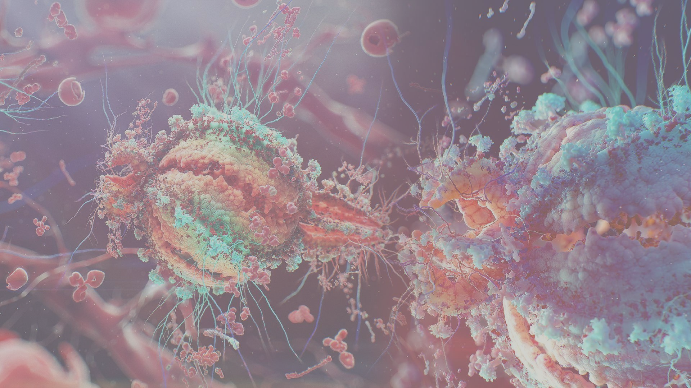
`

Understanding the Interplay Between
Gut Microbiome and Immune System
AUTHOR
M. Knigge

INSTITUE
Hanze University
Life Science and Technology

ORGANIZATION
Eriba
Department of Genetics

DATE
10, Juli 2018

Using Elastic Net to Predict Immune Phenotypes In the Gut Microbiome



`

Understanding the Interplay Between
Gut Microbiome and Immune System
Using Elastic Net to Predict Immune Phenotypes In the Gut Microbiome

AUTHOR
M. Knigge

SUPERVISORS
Asst. Prof. Dr. S. Sanna
Asst. Prof. Dr. Y. Li

LECTURER
Dr. M. A. Noback

INSTITUE
Hanze University
Life Science and Technology

ORGANIZATION
Eriba
Department of Genetics

DATE
10, Juli 2018

Matthijs Knigge¹, Serena Sanna², Yang Li²
- Hanze University of Groningen, Institute for Life Science & Technology, Bioinformatics, University of Medical Center Groningen, Department of Genetics, Groningen, The Netherlands.
- University of Groningen, University of Medical Center Groningen, Department of Genetics, Groningen, The Netherlands.

ABSTRACT

ABBREVIATIONS

GI | Gastrointestinal tract
MWAS | Microbiome wide-association study
IBD | Inflammatory Bowel Disease
BMI | Body Mass Index
500FG | 500 Functional Genomes
LL-Deep | LifeLines-Deep
MR | Mendelian Randomization
Ag | Antigen

TABLE OF CONTENTS

INTRODUCTION 5
THEORY 6
GUT MICROBIOME 6
IMMUNE SYSTEM 6
LINEAR REGRESSION 6
ORDINARY LEAST SQUARES 6
BIAS & VARIANCE 6
GUASS MARKOV THEOREM 6
SHRINKAGE ESTIMATORS 6
RIDGE REGRESSION 6
VARIABLE SELECTION 6
LEAST ABSOLUTE SELECTION AND SHRINKAGE OPERATOR 6
ELASTIC NET REGULARIZATION 6
500 FUNCTIONAL GENOMIC COHORT 6
LIFELINESDEEP COHORT 6
MATERIAL & METHODS 7
GLOSSARY 8
REFERENCES 9

INTRODUCTION
Evidence suggests that the human gut microbiome plays an important role in metabolic and immune function.[] Empirical evidence of Microbiome-Wide Association Studies (MWAS) in population cohorts show significant associations identified systematically between the gut microbiome and multiple complex traits and intrinsic factors, like Inflammatory Bowel syndrome (IBD), body mass index (BMI), food allergies and blood cells composition.[] Discovery of these links is key to understanding disease, and potentially disease treatment.

The body of a human is a complex interconnected ecosystem, and the gut is where the body acts as a first line of defense. Where it interacts with the “outside world”, functioning as a frontline of the immune system, which is constantly exposed to new microbes and molecules.[] The whole collection of microbes and molecules that are present in and on the human body is known as the microbiota.[] The microbiome refers to the whole set of genes within these microbes. The role of the microbiome composition/function is considered as an acting organ in the body’s operation. It is presumed that it has an effect on aging, digestion, mood, cognitive function, and immune system.[] The immune is a defensive system from the host entailing many biological structures and processes within an organism to protect against diseases, and infection. The function of the immune system relies on the ability to detect and distinguish a wide arrange of agents known as pathogens, viruses, and parasites from self and non-self.[]

The aim of this research is the identification of causality links between the microbiome composition/function and immune system: does the microbiome influence the immune system (cell counts, cytokines, globulin levels), or/and does the immune system influence the microbiome. We have access to the largest population cohort with gut metagenomic sequencing (LL-DEEP), but this cohort has not been characterized in depth for immune traits.And we have access to another cohort, the human function genome project 500FG[] which was specifically designed to assess the immune and metabolic system (XX phenotypes available), and also microbiome, but it is very small. This cohort has also genetic and gene expression available. By using gene expression data, genetic data, and transcriptomic data from the 500 Functional Genomic (500FG) cohort a linear model is constructed that explains immune traits/functions between gene expression data, genetic data, genetic data combined gene expression data and the 500FG cohort with Elastic Net Regularization.[] This constructed model, that is based on genetic data and gene expression data is used to predict immune traits/functions in LL-Deep data which contains genetic, and gene expression data from a large number of individuals which lacks immunogenic information. These predicted immune phenotypes will be used to forecast a causal link with microbial composition/function, with one-sample Mendelian Randomization (MR), see figure 1.

We expect to find causal links between microbiome composition/function and the immune system that can help us understand the interplay between the gut microbiome and the immune system, and ultimately help understand disease, and develop disease treatment; restoring microbiome composition and/or function through personalized nutrition or treatments. However, to efficiently translate findings into clinical practice, it is essential to discriminate between microbiome features that are on the causal pathway to disease from those that are a consequence.

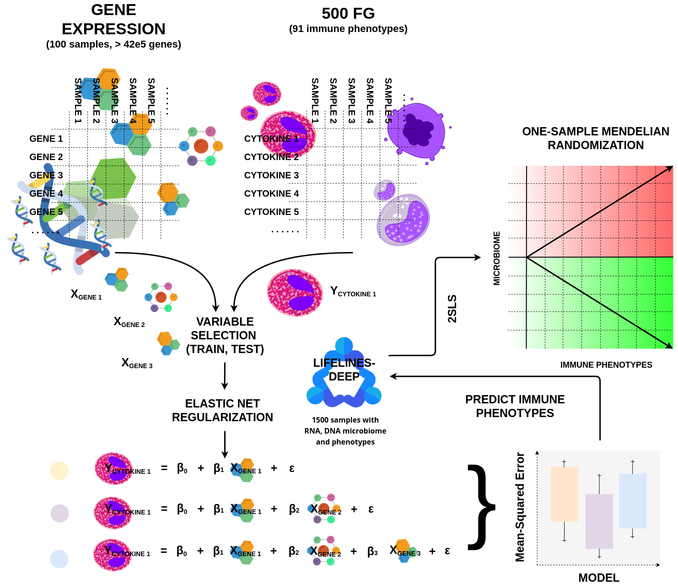
Figure 1: Overview of the computational infrastructure. For every immune phenotype in the 500FG cohort, multiple models will be build with a different set of genes that tries to explain a certain immune phenotype with the Elastic Net approach. After the model creation, these will be evaluated and the best one will be used to predict immune phenotypes in LL-Deep, which in turn, are going to be used to access causality links between the gut microbiome and immune system.

THEORY

GUT MICROBIOME
The gut microbiome is an acting barrier against harmful microbes in terms of competition for nutrients, and production of antimicrobial substances. Multiple antimicrobial compounds, like defensins[], cathelicidins[], and C-type lectins[], which are produced in the Gastrointestinal tract (GI tract)[]. The presence of bacteria or their structural components, and the presence of the products of the metabolism of bacteria has the potential to induce the expression and activation of antimicrobial substances which in turn contribute to the host protection against invading pathogens.[]

The gut microbiome is consider a key player in human health, disease and is involved in host metabolism and immune function. It supplies an important role in genetic and metabolic role to the human body as a “super organism” in the form of gene functions encoded by the metagenome which out-sums human genes by a multiplication of 100.[] Empirical evidence from a broad range of human studies and model systems suggests that the gut microbiome has a critical functional within this human “super-organism,” it regulates both metabolic and inflammatory processes which do not only mediate chronic disease (metabolic syndrome, diabetes, cardiovascular disease) but also autoimmune diseases, dementia, and it is speculated that it influences the aging processes. Diet plays a key role in shaping the gut microbiome and also in shaping the ability to regulate host metabolism and immune function through production of metabolites.[]

IMMUNE SYSTEM
The immune system function is to distinguish non-self from self to eliminate harmful non-self cells and molecules from the system. Beside self, non-self recognition, the immune system has the ability to recognize destroy abnormal cells that are derived from host tissue. Any molecule that can be recognized by the immune system is considered to be an antigen (Ag).[]

This immune system has evolved to defend the host against an universe of pathogenic microbes that are constantly evolving. The immune system helps the host with removal of toxic or allergenic compounds that enter the host through mucosal surfaces. Primarily, the immune system’s ability is to trigger a response to an invading pathogen, toxic, or allergen. The immune system uses two mechanisms to detect self from non-self: innate and adaptive mechanisms. Both these system rely on discrimination between self and non-self to eliminate pathogenic microbes.[, ]

The mechanisms contributing to recognition of microbial, toxic, or allergenic molecules can be divided into two categories: hard-wired responses that are encoded in the host’s germline that recognize molecular patterns shared by microbes and toxins that are not in the body, and responses that are encoded by elements that somatically rearrange to assemble into antigen-binding molecules with specificity for individual unique foreign structures.[]

The first response belongs to the innate immune response. Because the recognition molecules from the innate system are expressed on a large number of cells, this system acts rapidly after an invading pathogen or toxin is encountered. The second response belongs to the adaptive immune response. The adaptive system consists of small numbers of cells with specificity for any individual pathogen, toxin, or allergen. These responding cells must proliferate after recognition of an antigen in order to acquire sufficient numbers to trigger an effective response against the microbe or the toxin. The adaptive response generally expresses itself temporally after the innate response. A key feature of the adaptive system is that it produces long-lived cells that persist in an dormant state, that can be re-express their effector functions rapidly after another encounter with a specific antigen. This provides the adaptive response with the ability to manifest immune memory.[, , ]

LINEAR REGRESSION

ORDINARY LEAST SQUARES

BIAS & VARIANCE

GUASS MARKOV THEOREM

SHRINKAGE ESTIMATORS

RIDGE REGRESSION

VARIABLE SELECTION

LEAST ABSOLUTE SELECTION AND SHRINKAGE OPERATOR

ELASTIC NET REGULARIZATION

500 FUNCTIONAL GENOMIC COHORT

LIFELINESDEEP COHORT

MATERIAL & METHODS

GLOSSARY

Cathelicidins.
C-type lectins.
Defensins.
Gastrointestinal tract.

GLOSSARY
Cathelicidins
antimicrobial peptides that are a family of polypeptides primarily stored in the lysosomes of macrophages. Cathelicidins serve a critical role in mammalian innate immune defense against invasive bacterial infection.

C-type lectins
a carbohydrate-binding protein domain. The C-type notation is from their requirement for calcium for binding. Proteins that contain C-type lectin domains have multiple functions including immune response to pathogens, cell-cell adhesion, and apoptosis.

Defensins
cysteine-rich proteins in both vertebrates and invertebrates. The are and function as host defensive peptides. They actively protect against bacteria, fungi, and multiple enveloped and nonenveloped viruses. They are a type of white blood cells made by neutrophils.

Gastrointestinal Tract
is an organ system in the human body and other animals which digests food to acquire energy and nutrients, and expels the remaining waste as feces.

REFERENCES

Zhernakova, A., Kurilshikov, A., Bonder, M., Tigchelaar, E., Schirmer, M., & Vatanen, T. et al. (2016). Population-based metagenomics analysis reveals markers for gut microbiome composition and diversity. Science, 352(6285), 565-569. doi:10.1126/science.aad3369
Schirmer, M., Smeekens, S., Vlamakis, H., Jaeger, M., Oosting, M., & Franzosa, E. et al. (2016). Linking the Human Gut Microbiome to Inflammatory Cytokine Production Capacity. Cell, 167(4), 1125-1136.e8. doi:10.1016/j.cell.2016.10.020
Andrew L. Kau, Jeffrey I. Gordon. 2018. "Human Nutrition, The Gut Microbiome, And Immune System: Envisioning The Future". Nature 474 (7351): 327. https://www.ncbi.nlm.nih.gov/pmc/articles/PMC3298082/.
Ursell, L., Metcalf, J., Parfrey, L., & Knight, R. (2012). Defining the human microbiome. Nutrition Reviews, 70(suppl_1), S38-S44. Retrieved from https://academic.oup.com/nutritionreviews/article-abstract/70/suppl_1/S38/1921538?redirectedFrom=fulltext
Josef Neu, J. (2011). Cesarean versus Vaginal Delivery: Long term infant outcomes and the Hygiene Hypothesis. Clinics In Perinatology, 38(2), 321. Retrieved from https://www.ncbi.nlm.nih.gov/pmc/articles/PMC3110651/
Massimo Mangino, T. (2017). Innate and adaptive immune traits are differentially affected by genetic and environmental factors. Nature Communications, 8. Retrieved from https://www.ncbi.nlm.nih.gov/pmc/articles/PMC5227062/
500 Functional Genomics Project. (2018). Human Functional Genomics Project. Retrieved 19 April 2018, from http://www.humanfunctionalgenomics.org/site/?page_id=82
Zou, H., & Hastie, T. (2005). Regularization and variable selection via the elastic net. Journal Of The Royal Statistical Society: Series B (Statistical Methodology), 67(2), 301-320. Retrieved from https://rss.onlinelibrary.wiley.com/doi/abs/10.1111/j.1467-9868.2005.00503.x
Definition of Defensin. (2018). MedicineNet. Retrieved 20 April 2018, from https://www.medicinenet.com/script/main/art.asp?articlekey=26300
cathelicidin. (2018). TheFreeDictionary.com. Retrieved 20 April 2018, from https://medical-dictionary.thefreedictionary.com/cathelicidin
Cummings, R., & McEver, R. (2009). C-type Lectins. Cold Spring Harbor Laboratory Press. Retrieved from https://www.ncbi.nlm.nih.gov/books/NBK1943/
Gastrointestinal Tract - National Library of Medicine - PubMed Health. (2018). PubMed Health. Retrieved 27 April 2018, from https://www.ncbi.nlm.nih.gov/pubmedhealth/PMHT0022855/
Kelly, D., Yang, L., & Pei, Z. (2017). A Review of the Oesophageal Microbiome in Health and Disease. Methods In Microbiology, 19-35. doi:10.1016/bs.mim.2017.08.001
Gut Microbiota–Immune System Crosstalk: Implications for Metabolic Disease - Diet-Microbe Interactions in the Gut - Chapter 9 . (2018). Sciencedirect.com. Retrieved 20 April 2018, from https://www.sciencedirect.com/science/article/pii/B9780124078253000095
The Microbiota in Gastrointestinal Pathophysiology - ScienceDirect . (2018). Sciencedirect.com. Retrieved 20 April 2018, from https://www.sciencedirect.com/science/book/9780128040249
Overview of the Immune System - Immunology; Allergic Disorders - MSD Manual Professional Edition. (2018). MSD Manual Professional Edition. Retrieved 27 April 2018, from https://www.msdmanuals.com/professional/immunology-allergic-disorders/biology-of-the-immune-system/overview-of-the-immune-system
Chaplin, D. (2003). 1. Overview of the immune response. Journal Of Allergy And Clinical Immunology, 111(2), S442-S459. doi:10.1067/mai.2003.125
BONILLA, F., & GEHA, R. (2006). 2. Update on primary immunodeficiency diseases. Journal Of Allergy And Clinical Immunology, 117(2), S435-S441. doi:10.1016/j.jaci.2005.09.051
Thornton, C., & Morgan, G. (2009). Innate and Adaptive Immune Pathways to Tolerance. Microbial Host-Interaction: Tolerance Versus Allergy, 45-61. doi:10.1159/000235782
Wang, R., Miyahara, Y., & Wang, H. (2008). Toll-like receptors and immune regulation: implications for cancer therapy. Oncogene, 27(2), 181-189. doi:10.1038/sj.onc.1210906
WANG, R. (2006). Immune suppression by tumor-specific CD4+ regulatory T-cells in cancer. Seminars In Cancer Biology, 16(1), 73-79. doi:10.1016/j.semcancer.2005.07.009
Dabbagh, K., & Lewis, D. (2003). Toll-like receptors and T-helper-1/t-helper-2 responses. Current Opinion In Infectious Diseases, 16(3), 199-204. Retrieved from https://insights.ovid.com/pubmed?pmid=12821808

