
ARBO



AUTHOR
M. KNIGGE

INSTITUE
HANZE UNIVERSITY
LIFE SCIENCE AND TECHNOLOGY

ORGANIZATION
ERIBA
DEPARTMENT OF GENETICS

DATE
##-##-##
ARBO
AUTHOR
M. KNIGGE

SUPERVISOR
ASST. PROF. DR. S. SANNA

LECTURER
DR. M. A. NOBACK

INSTITUE
HANZE UNIVERSITY
LIFE SCIENCE AND TECHNOLOGY

ORGANIZATION
ERIBA
DEPARTMENT OF GENETICS

DATE
##-##-##

CONTENTS

INTRODUCTION

THE COMPANY
This internship was provided and guided by the immuno-genetics research group in the department of Genetics at the University Medical Center Groningen (UMCG). The hierarchy can been seen as a structure divided in multiple sections (A-F), each with its own director (figure 1). Above these directors is a main director. All sections are divided into departments, and each department has a head. For the Department of Genetics this is prof. Richard Sinke. Under his coordination, several associated and full professors lead different research groups.^{[1]}

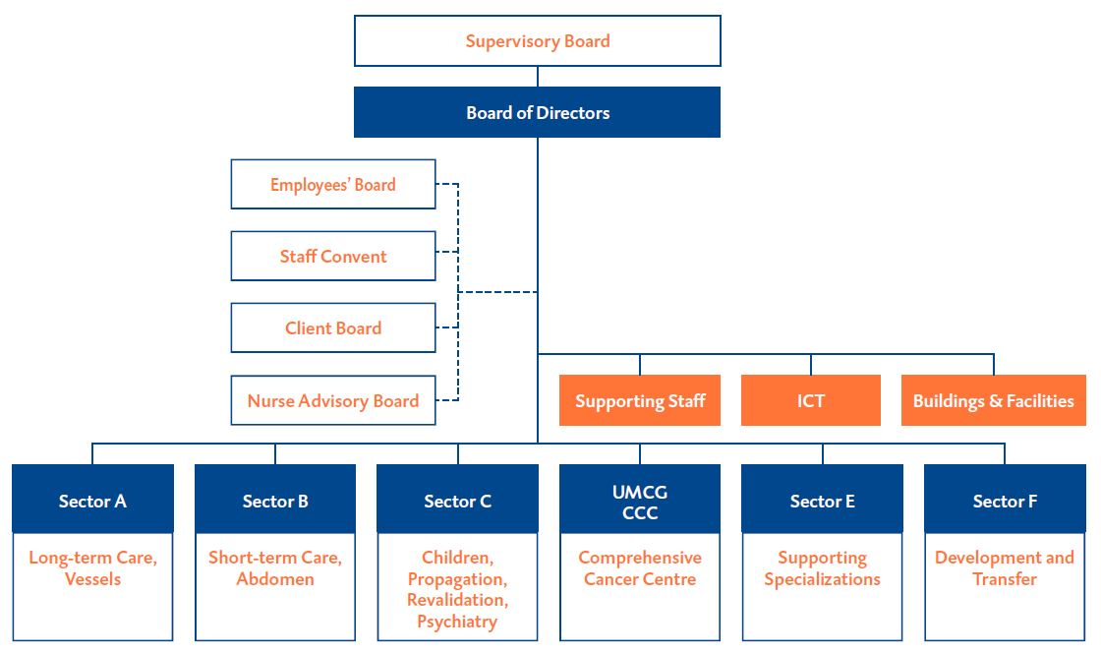
Figure 1: Organogram of the UMCG organizational structure

THE PROJECT
The body of a human is a complex interconnected ecosystem, and the gut is where the body acts as a first line of defense. Where it interacts with the “outside world”, functioning as a front-line of the immune system, which is constantly exposed to new microbes and molecules.^{[2]} The whole assortment of microbes that are present in and on the human body is known as the microbiota.^{[3]} The microbiome refers to the whole set of genes within these microbes. The role of the microbiome composition/function is considered as an acting organ in the body’s operation. It has an impact on aging, digestion, the immune system, mood, and cognitive function.^{[4]} The immune system a defensive system from the host entailing many biological structures and processes within an organism to protects against diseases. The function of the immune system relies on the ability to detect and distinguish a wide arrange of agents known as pathogens, viruses, and parasites from self and non-self.^{[5]} The aim of this research is to find causality links between the microbiome composition/function and immune system, does the microbiome influence the immune system (cell counts, cytokines, globulin levels), or/and does the immune system influence the microbiome. By using gene expression data, transcriptomic data from the 500 Functional Genomic cohort^{[6]} a model is constructed that explains immune traits/functions between gene expression data and 500FG with elastic net regularization^{[7]}, and cross-validation. The constructed model will be used to predict immune function/traits in BIOS data which contains genetic data from a large number of individuals which lacks immunogenic information. After the immune phenotypes are predicted, a causal link between microbial composition/function and immune phenotypes can be predicted with one-sample Mendelian Randomization, here microbial metagenomic data will be used and the predicted immune phenotypes, see figure 2.

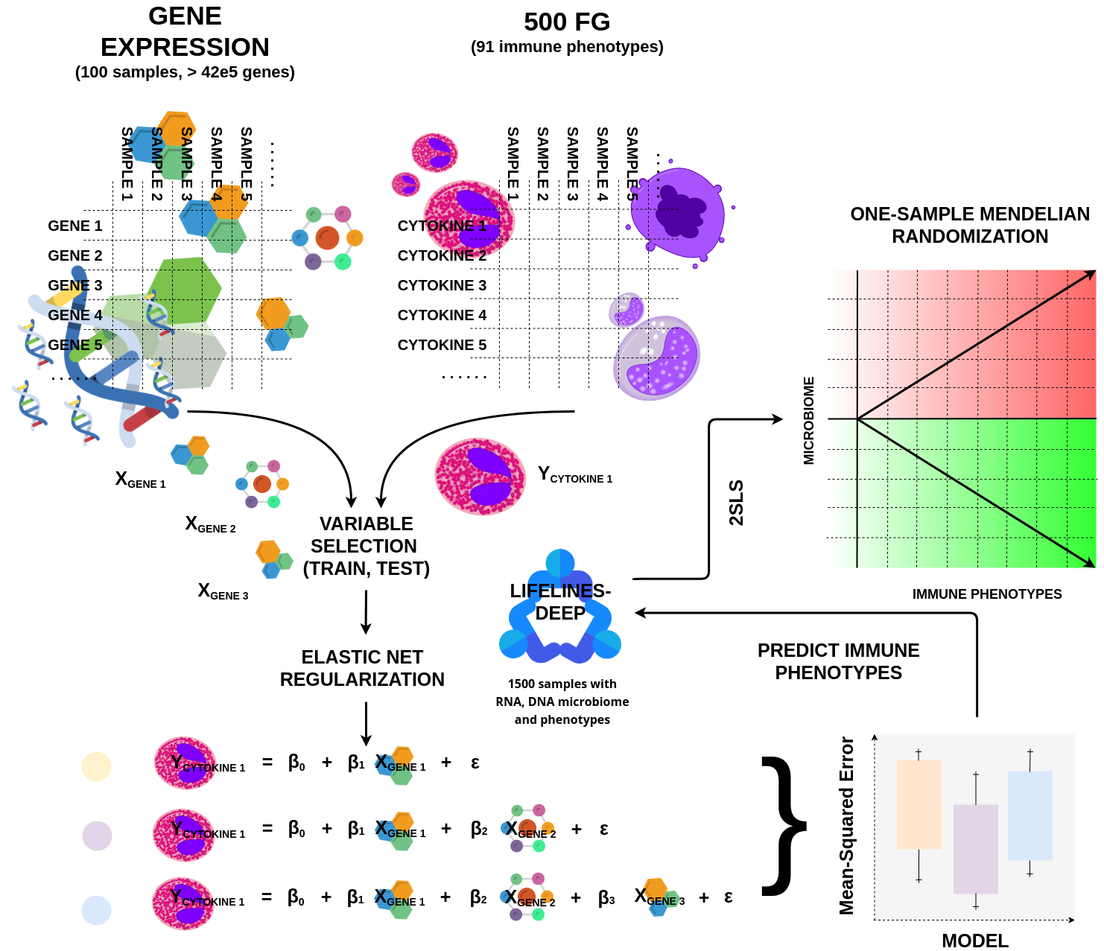
Figure 2: overview of the research workflow. A model will be constructed that explains the relation between gene expression and immune phenotypes in 500FG. This constructed model will be used to predict immune phenotypes in BIOS data, which will be used to predict causal links with the microbiome.

WORKING CONDITIONS

THE “ARBEIDSOMSTANDIGHEDENWET”
The “Arbeidsomstandighedenwet”, further known as the “Arbowet” stands for nothing more or less than for the abbreviation of the word employment conditions. The working conditions are: "the conditions under which the employees perform their work: in the area of safety, health and whether, as an employer, take sufficient account of the well-being of the employees in the workplace".^{[8]}

The “Arbowet” is a framework law containing general provisions. These have been further elaborated in the Working Conditions Decree and the Occupational Health and Safety Regulations that contain concrete regulations. In an occupational health and safety catalog, employers and employees define how they can meet the target requirements of the Working Conditions Act per company or branch. A few other laws that are important: the Working Hours Act, the Gatekeeper Improvement Act, the Work and Income according to Labor Capacity Act (WIA), the Work and Care Act, the Equal Treatment Act and the equal treatment on the grounds of age at work.^{[8]}

POLICY OF ARBO
The practical implementation of the ARBO regulation at the UMCG is a collaboration of the UMCs in the Netherlands. This health and safety catalog is compiled by the Dutch Federation of UMCs (NFU) and employee organizations. This catalog contains many aspects employees have to deal with, and the goal of this implementation is to reduce health risk, and the caption of a healthy and work friendly environment. The combined effort the Dutch Federation of UMCs addresses the following risk factors^{[9]}:

• Cytostatics (tumor suppressing drugs)
• Physical stress (lifting heavy objects etc)
• Repetative strain injury (RSI)
• Inhalational anesthetics
• Dangerous substances (gasses, glues, disinfectants etc)
• Skin reactions (allergies due to soap etc.)
• RI&E (risk inventorization and evaluation)
• Agression and violence (verbal and non verbal violence)
• MRI (for people working with MRI scanners) • Infection prevention • Unwanted behavior (discrimination or bullying)
• Pregnancy
• Stress

SAFETY

WORKING ENVIRONMENT

CALAMITIES

RISK ASSESSMENT

REFERENCES

- UMCG (2017). Organisatie. [online] available from: https://www.umcg.nl/NL/UMCG/overhetum cg/organisatie/Paginas/default.aspx [accessed: January12, 2018]

- Kau, A. L., Ahern, P. P., Griffin, N. W., Goodman, A. L. and Gordon, J. I. Kau, A., Ahern, P., Griffin, N., Goodman, A., & Gordon, J. (2011). Human nutrition, the gut microbiome and the immune system. Nature, 474(7351), 327-336. doi:10.1038/nature10213

- Luke K Ursell, Jessica L Metcalf, Laura Wegener Parfrey, Rob Knight; Defining the human microbiome, Nutrition Reviews, Volume 70, Issue suppl_1, 1 August 2012, Pages S38–S44, https://doi.org/10.1111/j.1753-4887.2012.00493.x

4. Neu, J. and Rushing, J. Neu, J., & Rushing, J. (2011). Cesarean Versus Vaginal Delivery: Long-term Infant Outcomes and the Hygiene Hypothesis. Clinics In Perinatology, 38(2), 321-331. doi:10.1016/j.clp.2011.03.008

5. Mangino, M., Roederer, M., Beddall, M. H., Nestle, F. O. and Spector, T. D. Mangino, M., Roederer, M., Beddall, M., Nestle, F., & Spector, T. (2017). Innate and adaptive immune traits are differentially affected by genetic and environmental factors. Nature Communications, 8, 13850. doi:10.1038/ncomms13850

6. 500 Functional Genomics Project 500 Functional Genomics Project. (2018). Human Functional Genomics Project. Retrieved 7 February 2018, from http://www.humanfunctionalgenomics.org/site/?page_id=82

7. Zou, H. and Hastie, T. Zou, H., & Hastie, T. (2005). Regularization and variable selection via the elastic net. Journal Of The Royal Statistical Society: Series B (Statistical Methodology), 67(2), 301-320. doi:10.1111/j.1467-9868.2005.00503.x

8. ARBO (2018). Arbo. [online] available from: http://www.arbo-online.nl/ [accessed: March 8, 2018]

9. Doktorhoe (2018). Doktorhoe bescherm ik mijn gezondheid. [online] available from: https://www.dokterhoe.nl/ [accessed March, 8 2018]

