
Celiac Disease Triggers
Using Mendelian Randomization to infer causality
Matthijs Knigge¹, Serena Sanna²
1. Hanze University of Groningen, Institute for Life Science & Technology, Bioinformatics, University of Medical Center Groningen, Department of Genetics, Groningen, The Netherlands.
2. University of Groningen, University of Medical Center Groningen, Department of Genetics, Groningen, The Netherlands.




INTRODUCTION
Celiac disorder affects up to two percent of the European population, and it is hereditary. People with a first-degree relative with celiac disease have 30 times higher risk of developing celiac disease. The inheritance model of celiac disease is oligogenic.^{[1]} In this model, HLA-DQ2 is a genetic variant in the major histocompatibility complex (MHC) region that accounts for 40% of the inheritable risk. But, this genetic variant alone is not sufficient enough to develop celiac disease. 30% of the Europeans are carriers of the variant, however 3% express celiac disease. We expect to find multiple causal or protective clinical parameters or molecular mechanisms that will be quantified to understand the impact of the causal or protective relationship, that can potentially explain what is triggering celiac disease in the 3% from the 30% of the Europeans that are carriers of HLA-DQ2.^{[2]}

A

B

C

MATERIALS AND METHODS
We investigated over 500.000 publicly available clinical parameters and molecular phenotypes, available from databases, and published genome-wide association studies (GWAS), with the Mendelian Randomization^{[3]} (MR) approach. We used two-samples MR methods: Inverse-Variance Weighted^{[4]} (IVW) method and MR-Egger method^{[5]} to infer causality links by combining summary statistics from GWAS.

D



RESULTS
We identified 1133 significant (FDR < 0.05) clinical parameters or molecular mechanisms that cause or protect for celiac disease. For example Type 1 Diabetes (T1D), which describes the co-occurrence of T1D and celiac disease.^{[6]} A shared association between celiac disease and crohn’s disease.^{[7]} The effect of eosinphils is a risk factor for celiac disease, and that lymphocytes is associated as a protective factor for celiac disease.^{[8]} These findings are consistent with literature.

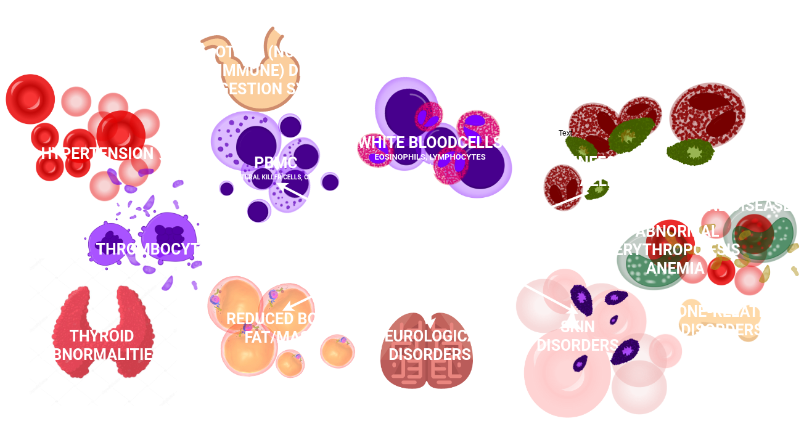
CONCLUSION & DISCUSSION
Lorem ipsum dolor sit amet, consectetuer adipiscing elit. Aenean commodo ligula eget dolor. Aenean massa. Cum sociis natoque penatibus et magnis dis parturient montes, nascetur ridiculus mus. Donec quam felis, ultricies nec, pellentesque eu, pretium quis, sem. Nulla consequat massa quis enim. Donec pede justo, fringilla vel, aliquet nec, vulputate eget, arcu. In enim justo, rhoncus ut, imperdiet a, venenatis vitae, justo. Nullam dictum felis eu pede mollis pretium.

REFERENCES. ¹Robert Di Niro, et al. High abundance of plasma cells secreting transglutaminase 2-specific IgA autoantibodies with limited somatic hypermutation in celiac disease intestinal lesions; ²Gujral, N., Freeman, H. J & Thomson, A. B. Celiac disease: Prevalence, diagnosis, pathogenesis and treatment; ³David M. Evans and George Davey Smith. Mendelian Randomization: New Applications in the Coming Age of Hypothesis-Free Causality; ⁴Debbie A. Lawlor. Commentary: Two-sample Mendelian randomization: opportunities and challenges. International Journal of Epidemiology; ⁵Stephan Burgess, Simon G. Thompson. Interpreting findings from Mendelian randomization using the MR-Egger method; ⁶William Hagopian, Hye-Seung Lee, Edwin Liu, et al. Co-occurrence of Type 1 Diabetes and Celiac Disease Autoimmunity; ⁷Festen EAM, Goyette P, Green T, Boucher G, Beauchamp C, et al. A Meta-Analysis of Genome-Wide Association Scans Identifies IL18RAP, PTPN2, TAGAP, and PUS10 As Shared Risk Loci for Crohn's Disease and Celiac Disease. ⁸William J. Astle, Heather Elding, Tao Jiang, etal. Landscape of Human Blood Cell Trait Variation and Links to Common Complex Disease.







https://bitbucket.org/MatthijsKnigge/mendelianRandomization
ma.knigge@st.hanze.nl, m.knigge@umcg.nl

