**State University of New York at New Paltz**

**Matthew Hughes**

**Project Type: In class project, Student’s “Class Key”: s23-02**

**“Library Traffic”**

**FINAL PROJECT REPORT**

**LINK: <https://cs.newpaltz.edu/p/s23-02/v2/v4-traffic/predictTraffic.php>**

**LOGIN: <Username: a, Password: a> admin for TESTING**

**Computer Science Projects**

**Spring 2023**

**(Prof. Hanh Pham)**

**TABLE OF CONTENTS**

**1. Problem Description** ….......................................................................page 03

**1.1 Business Context and Goals** ….……….…………….……. page 03

**1.2 Technical Requirements** ….………………………….....…. page 03

**1.3 Your Responsibilities** ……...………………………………. page 03

**2. Technologies**..............................................................................................page 04

**2.1 Related Technologies** ….…………………………………….. page 04

**2.2 Newly Learned Skills/Technologies …**………………………. page 04

**3. Design**..........................................................................................................page 04

**3.1 System Architecture** ………………….………………………. page 04

**3.2 Components** ………………………….………………….……. page 04 - 07

**4. Software/System Description** ………………………………………..…. page 07

**4.1 Map of Files** …………………………………..………………. page 07 - 08

**4.2 DATA Format & Description** …………………………..……. page 08

**4.3 Developer’s Guide** …..…………….…………..………………. page 09

**4.4 User’s Guide** …..…………….…………….……………..……. page 09

**5. Test Results (Functionality/Performance)**….............................................page 10

**5.1 Test Function 1/Transaction # 1** …………………………..…. ..page 10 - 11

**6. Professional and Career** **Benefits** ………..….…….……..……………. ...page 12

**6.1 Challenges and Solutions** ……….…….……..…………….……. page 12

**6.2 Other Learned Lessons** ….……..…………….…....................…. page 12

**7. Conclusions** ….................................................................................................page 12

**1. Problem Description**

**- 1.1 Business Context and Goals:**

**- Business context:**

**-** The library staff wants a website to get and view the data on how many students enter and exit the library at a given time.

- There is a camera within the library that will keep track of the number of students.

**-Goal:**

- Our goal was to improve upon this website and fix any issues we found within it.

* **1.2 Technical Requirements:**

**-** Hardware: PC, HikVision dual lens camera

- Software: HikVision, Web browser

- Data: MySQL database, HikVision

* **1.3 Your Responsibilities:**

- Organize and clean up file structure

- Create a cleaner and more consistent UI

- Reorganize page design to make it easier for users to move between pages

**2. Technologies:**

* + **2.1 Related Technologies:**
    - HTML
    - CSS
    - Python
    - MySQL
    - JavaScript
    - PHP
    - HikVision camera

**2.2 Newly Learned Skills/Technologies:**

- PHP

- HTML

- MySQL

**3. Design:**

* **3.1 System Architecture:**

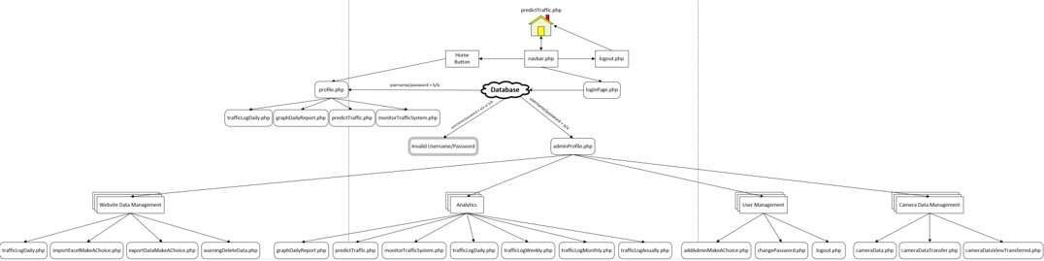

**- 3.2 Components:**

* Navbar and sidebar:

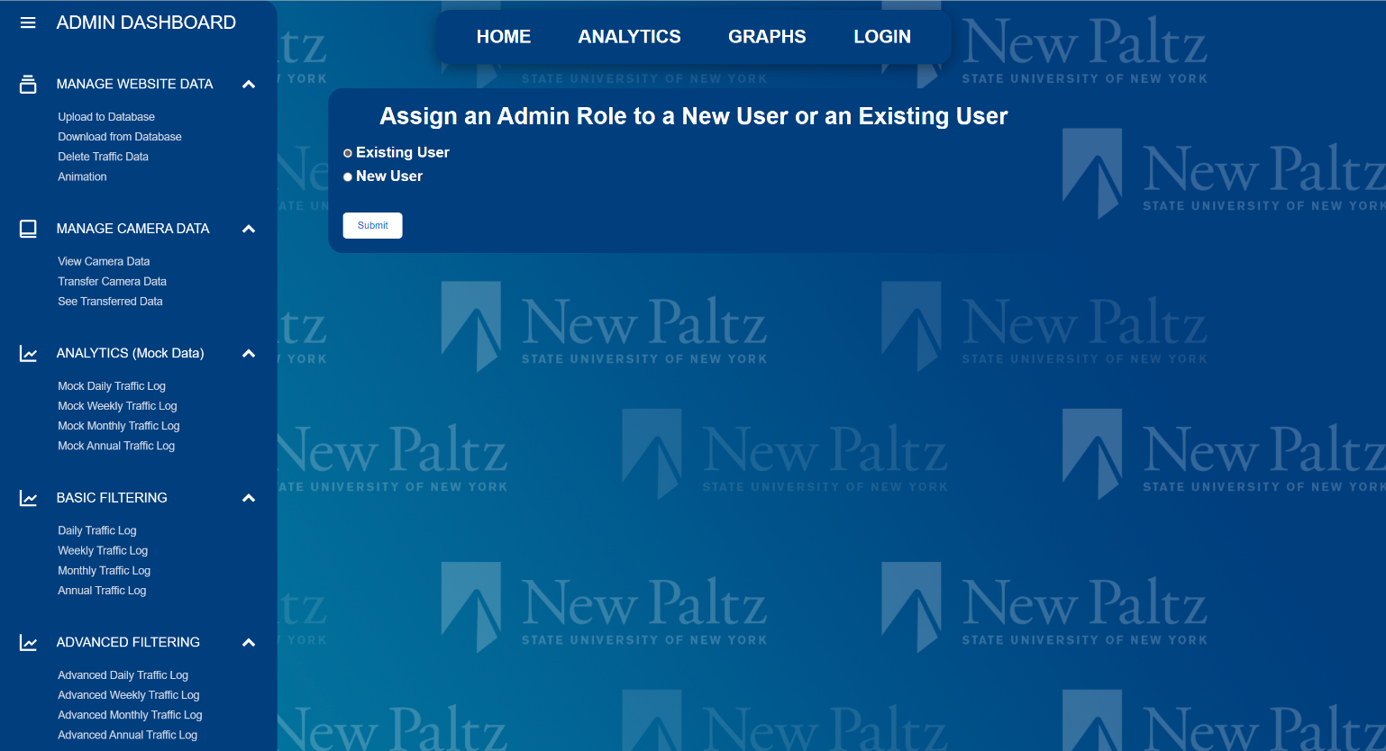

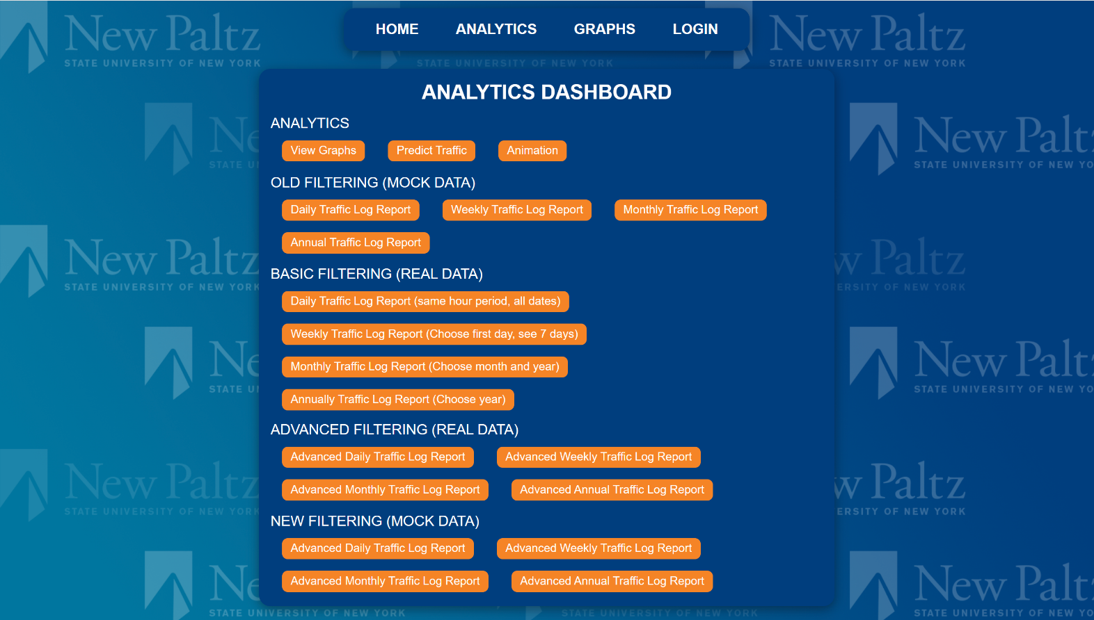- Analytics Dashboard:

* 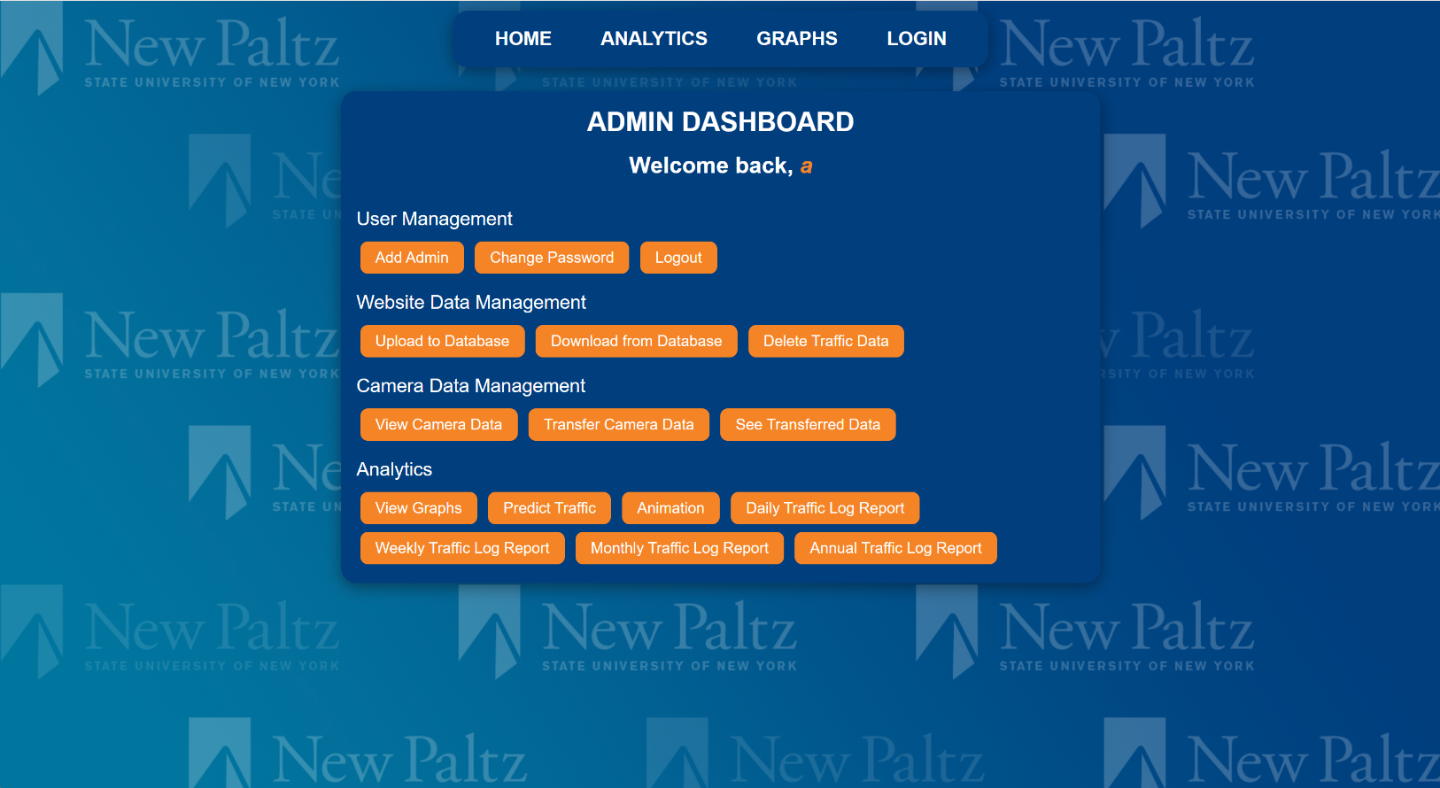Admin Dashboard:

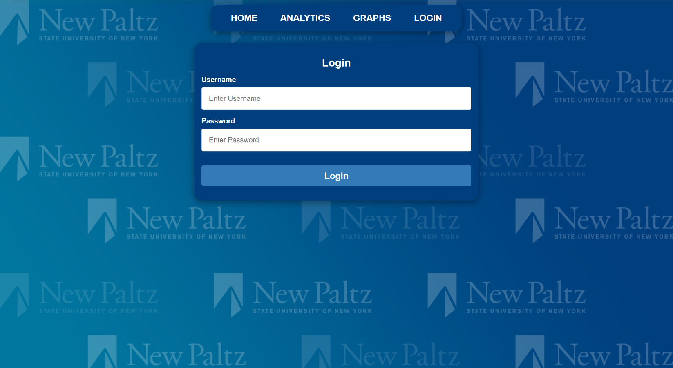 - Login page:

**4. Software/System Description:**

**- 4.1 Map of Files:**

TrafficLogDaily.php: Is the starting page for user to enter in a time to filter between data

TrafficLogWeekly.php: Starting page for the user to enter in a date and filter between the date and up to the 7th day after the entered date

TrafficLogMonthly.php: Starting page for the user to enter a 2 years and 2 months to filter the data

TrafficLogAnnually.php:Starting page for the user to enter 2 different years to filter the data

p1.php: This is the page that will be the advanced daily filter in which 2 times and a date is entered to filter the data

filtertime.php: This file is used to perform the query for TrafficLogDaily.php

filterdayweek.php: This file is used to perform the query for TrafficLogWeekly.php

filtermonthly.php: This file is used to perform the query for TrafficLogMonthly.php

filterannually.php: This file is used to perform the query for TrafficLogAnnually.php

AdvanceDailyFilter.php: This file is used to perform the query for p1.php

* **4.2 DATA Format & Description:**

traffic_Cam_Data:

Real data of the website

has four columns:

- dateStart: Format is Year-Month-Day, this is a date stamp that goes with how many people entered or exited within the day

- timeStart: Format is military time where the far-right side is the hour (Ex: 00:00:01 – 00:00:02 is from 1am to 2am and 00:00:13 – 00:00:14 is 1pm to 2pm), this is the time stamp that goes with how many people entered or exited at a given time

- enterCount: Format is an integer, this is used to keep track how many people in an hour enters the library

-exitCount: Format is an integer, this is used to keep track how many people in an hour leaves the library

Some commands:

$query = "SELECT * FROM traffic_Cam_Data WHERE dateStart='".$trueDate . "' AND timeStart BETWEEN '".$_POST["from_time"] . "' AND '". $_POST["to_time"] . "' ORDER BY timeStart";

$query = "SELECT * FROM traffic_Cam_Data WHERE dateStart BETWEEN '".$trueDate . "' AND '".$FinalDate . "' ORDER BY dateStart";

$query = "SELECT * FROM traffic_monthly INNER JOIN traffic_monthly_exited ON traffic_monthly.DayOfMonth=traffic_monthly_exited.DayOfMonth";

* **4.3 Developer’s Guide:**

- I recommend using Microsoft Visual Studio Code and using an extension called SSH. In Visual Studio Code, click the green icon in the bottom left corner and follow the prompts to connect to the server. I believe this is the easiest way to work with the code.

* Improvements:
  + Make “LOGIN” text in navbar change to “LOGOUT” when a user is logged in. This is the most important change needed to be made, as this will allow the user to easily see if they’re logged in and logout as well.
  + Put all styling in main css file. Some of the new files like the Admin Dashboard and the Analytics Dashboard have styling on the individual page instead of on the main css file. For easier maintenance, it would be ideal if this css code was relocated to the main css file.
* **4.4 User’s Guide:**

- To use the software simply go to the website (https://cs.newpaltz.edu/p/s23-02/v2/v4-traffic/predictTraffic.php) and you can login as an admin and view the data, download the camera data and transfer it as well as filter between the data too. The main page should bring you to the predictor which will show the trend along with what the site thinks the traffic in the library will be like at the time.

**5. Test Results (Functionality/Performance):**

Site: <https://cs.newpaltz.edu/p/s23-02/v2/v4-traffic/predictTraffic.php>

Username: a

Password: a

The above will grant you access to the Admin Dashboard.

To use the software simply head to the site above.

**6. Professional and Career Benefits:**

**- 6.1 Challenges and Solutions:**

**-** Challenges:

1.) The code was quite unorganized, and many pieces were hard coded in.

2.) No styling for admin dashboard pages (like “change password” or “add admin”).

3.) Website navigation flow wasn’t the same on all pages. Could not access the navbar on some random pages.

- Solutions:

1.) Removed the hard coded components and put them into their own files to be edited there then included in (for example the config, navbar, and sidebar files)

2.) Added styling that is similar to the login, analytics dashboard, and admin dashboard so that the website will have an overall better and more continuous feel to it.

3.) Some pages like the login page and the “add admin” or “change password” pages didn’t have the navbar which made the website feel inconsistent with other pages that did have it. I included the new navbar file on these pages.

- **6.2 Other Learned Lessons:**

Some of the things I learned is that communication in a group is crucial to the success of the project. Things like prioritizing skillset and the actual schedule were very important in addition to the programming lessons that were valuable. Documentation, scalable code, and efficient code were all things that I learned to incorporate in my code in the future.

**7 Conclusions:**

In general, the project taught me a lot about taking pre-existing code and improving upon it. I was exposed to new code and a new working environment, which will definitely help me in future jobs. Time management and team communication were the biggest things that I learned.