**State University of New York at New Paltz**

**Matthew Hughes**

**Project Type: In class project, k-s23-13: csp01**

**“Library Traffic”**

**PROJECT PROPOSAL**

**“Computer Science Projects”**

**Spring 2023**

**(Prof. Hanh Pham)**

**TABLE OF CONTENTS**

**1. Problem Description**

* + **1.1 Business Context and Goals**  **pg2**
  + **1.2 Technical Requirements**  **pg2**
  + **1.3 Your Responsibilities**  **pg3**

**2. Technologies**

* + **2.1 Newly Learned Skills/Technologies**  **pg3**

**3. Plan**

* + **3.1 Ideas for Solution (Architecture + Protocols)**  **pg4**
  + **3.2 Programming/Coding Components**  **pg5**
  + **3.3 Schedule**  **pg6**

**1. Problem Description**

* The Traffic Camera will count the number of people who cross its detection line.   
  Inward counts as an enter. Outward counts as an exit.
* Then the camera will store the counting data in an excel file which the user will then manually upload to our site's database.
* This data will then be propagated to our website which will display the data in our graphing dashboard.

**1.1 Business Context and Goals**

* Communicating with clients to hash out any issues that were previously known as well as obtaining feedback for the project
* Discussing the future of the project and what actions should be taken to keep the project on the right course
* Goals:
  + Allow Users and staff alike to view the current traffic of the library based on the predictions made by the software
  + Fix any bugs and have the transfer of camera data to the SUNY New Paltz database become more fluid

**1.2 Technical Requirements**

* Environment
  + Desktop web browser
  + Internet connection
* System Components
  + User Interface
    - Any desktop web browser
* Data
  + Input:
    - The camera (above the entrance of the library) captures images of people entering and exiting the library
  + Output:
    - Graphs illustrate traffic volume over a specified time to help for analysis
* Hardware
  + No additional hardware needed

Processing:

* Login
  + Input Username and Password
  + Check database for matching credentials
  + If True create a new session
* Admin
  + Website data management
  + Camera data management
  + User management
  + Analytics

**1.3 Your Responsibilities**

* Matthew Hughes:
  + Clean up user interface
  + Expand functionality of camera data transfer
* Joseph Terranova:
  + Fix the filter
  + Test downloading and uploading buttons

**2. Technologies**

* Front End/User Interface
  + HTML – main structure of the website
  + CSS – basic styling
  + Bootstrap – CSS framework for a responsive webpage
* Back End/Database
  + PHP – used to query the database and to help create a more dynamic webpage
  + MySQL – create tables and store website data

**2.1 Newly Learned Skills/Technologies**

Joseph Terranova:

* + MySQL
  + PHP, specifically for creating queries.

Matthew Hughes:

* + PHP
  + Understanding and reworking pre-existing code.

**3. Plan**

Fix all underlying bugs that are currently making it difficult to add on to the website. Improve upon the user interface and reorganize it as well as reorganize the file structure and other aspects of the code to reduce the complexity of working with the code.

**3.1 Ideas for Solution (Architecture + Protocols)**

Creating files for the config and navbar rather than hard coding the needed code into each file to cut down on code complexity as well as making the code more sustainable.

**ARCHITECTURE**

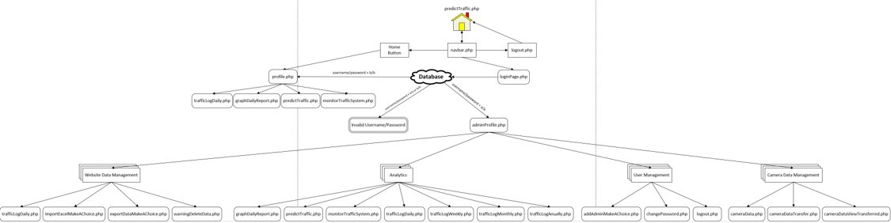

**PROTOCOLS**

**Filter protocol:**

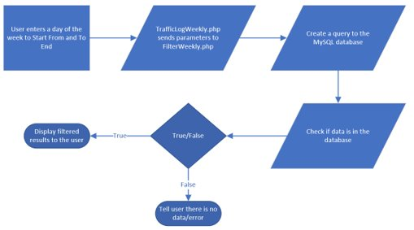

**3.2 Programming/Coding Components**

* Front End
  + HTML
  + CSS
* Back End
  + PHP
  + MySQL
* Frameworks
  + Bootstrap

**3.3 Schedule**

|  |  |
| --- | --- |
| Date  2/5  2/12  2/19 | Task  Speak with supervisor about project  Plan out necessary steps and give out tasks  Switch over to the new database |
| 2/26 | Use a config file to connect to said database and reorganize files/ file structure |
| 3/5 | Talk to clients and get more information about the system and what they need |
| 3/12 | Continue to fix UI and work on filter and work on automating the transfer of data |
| 3/19 | Work on midterm and continue fixing the website and the automatic transfer of data |
| 3/26 | Work on midterm report and slides |
|  |  |

|  |  |
| --- | --- |
| Date | Task |
| 4/2 | Speak with clients about the necessary changes that need to be made |
| 4/9 | Fix underlying foundation issues/ Change database tables |
| 4/16 | Implement new code to the filters to work with new tables |
| 4/23 | Work on transferring camera data to database/ add comments |
| 4/30 | Bug fixes/clean up |
| 5/7 | Final preparation |