# Team Members / Task Assignment

As a group, we considered various approaches and chose three relevanttopics for supporting learning and performance transfer post-Learning & Development activities:

● Setup ITI Devices and Collaborative Media Suite

● Setup Zoom extension for Microsoft Office 365

● Utilize the learned installation skills by learning how to moderate a meeting through the mentorship program.

For this assignment, we are applying these topics to emphasize Innovation and Technology Insight’s guiding principles of operational excellence and cross-departmental collaboration in a global company. Of the three learning objectives, each team member will build connect-type activities based upon ITI’s daily work operations.

Team members will communicate and collaborate via WhatsApp, cell phone SMS and calls, and Zoom.

# Scenario Title

*Improving transfer of learning and performance to various contexts (connect-type activity)*

# Learning and Performance Problem Statement

Once the initial Learning & Development has been completed for new employees, it is imperative they join their assigned departments and quickly become productive members of their respective teams. Innovation and Technology Insight stakeholders, i.e., the HRD Vice President and ITI’s global senior executive group have chosen to expand the existing online modules to promote more dynamic employee integration. In the interest of maintaining business success, the stakeholders have several conditions for the instructional design. Specifications for this portion of the technology enhanced instructional design are to:

* Provide efficient setup of technological devices and relevant software
* Develop and promote a culture of informal learning through various forms of collaborative media
* Implement a guidance system for problem solving on day-to-day issues
* Provide tools for effective communication in a changing global environment
* Provide a cohort of learners to communicate with in future assignments
* Ensure that the training is periodically reinforced and that employees apply their learning in the execution of their duties.

# Target Audience

The target audience includes newly hired full time employees and contractors in North America, Latin America, Africa, Asia, and Europe. As needed, current employees transitioning to new roles may also participate in these learning modules.

Roughly 35% of the new hires have participated in at least one online course, and 96% of the new hires have engaged in at least one type of social media (Statista, 2019). Approximately 95% of this population has earned a 4-year college degree or above.

The learning goal for the first set of objectives targets 85% of the employees, meaning, new hires working in software development roles. This group has completed the introductory onboarding and Learning & Development modules.

The audience will be broken up into cohorts representing the different geographic locations. These cohorts will be assigned by time zones in order to facilitate communication. The cohorts will contain both managers and developers.

# Learning Goal: Learners will setup ITI Devices and connect with the Collaboration Media Suite

**Objective 1.1:** Accessing the saved link and using the job aid downloaded during the ITI tools introductory module, the learner will set up their VPN authentication tool, successfully linking their company smartphone to the authenticator. (15 minutes)

**Objective 1.2:** Accessing the saved link obtained during the ITI tools introductory module, the learner will set up ITI’s portal and email application on their smart phone and send an email to their supervisor requesting access to their project team’s source control application. (15 minutes)

**Objective 1.3:** Using the quick reference document downloaded during the ITI tools introductory module and their supervisor’s email response from Objective 1.2, the learner will install the source control application and initialize a repository. (30 minutes)

**Objective 1.4:** Referring to the supervisor’s email attachment detailing user requirements for a project, the new hire will propose a build out task and share it with their assigned project team via the team’s chat channel. (30 minutes)

**Objective 1.5:** Using the company’s organizational chart made available during the project team introductory module, the learner will join the company’s microblogging application, choose a group of their choice, and respond to a post. (15 minutes)

# Objective 1 Design Rationale

The software development group segment of the target audience, made up of software and system engineers, including their managers, has participated in introductory L&D modules, learned about project team functions, and been introduced to the various tools needed to perform their responsibilities.

They’ve reached the stage where they need to set up their laptops or workstations, collaborate with their colleagues, and engage in their assigned roles. The new hires will participate in a Device Setup & Collaboration module, which will be conducted via Zoom meeting in synchronous small group learning teams. The teams will consist of other new hires in like roles, and within similar time zones. The size of the learning teams will be from 2-6 employees, depending upon hiring start dates. They will be able to chat with and support each other as they work through the setup activities.

The objectives are presented as sequential hotspots on a highway. When selected, each activity opens to a panel consisting of a brief audio guidance narrative and an activity control panel providing a link to FAQ lists, as well as an online assistant should the group begin to stall. Finally, a checkmark must be selected when the activity is completed. The assessment format for each activity is credit/no credit.



Additional information can also be accessed using the Mindflash LMS learning catalog (*see* *Design Rationale Summary* *for further information regarding Mindflash LMS*).

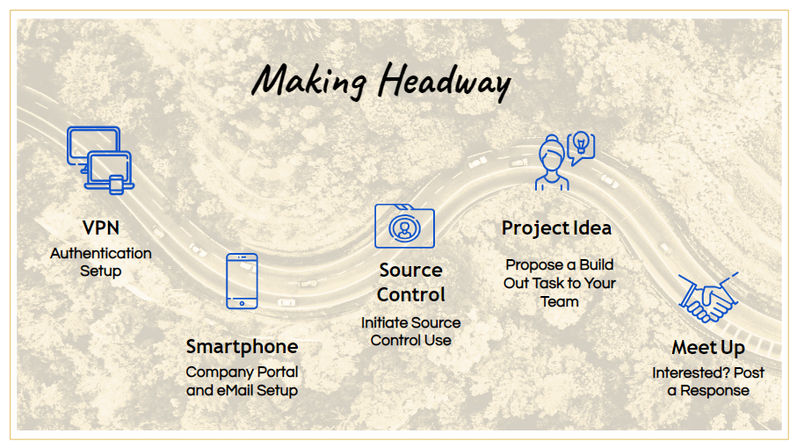 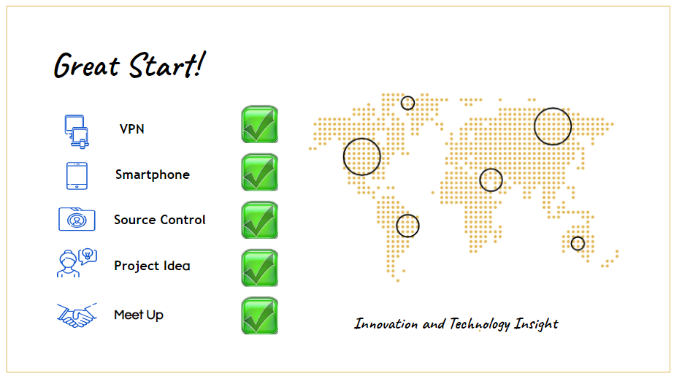

# Design Resources

# Technologies

● Mindflash LMS

* CSOFT International Software
* Jetbrains Space Software

# Resources

● Clark, R., Nguyen, F., & Sweller, J. (2006). Efficiency in learning; Evidence-based guidelines to manage cognitive load. California: Pfeiffer.

● Horton,W. (2012). E-learning by design. California: Pfeiffer.

● Online Training Software | LMS by Mindflash “Online Training Software: LMS by Mindflash.”[mindflash.com/](http://www.mindflash.com/).

● Clement, J. “Global digital population as of July 2019”.Statista, September 17, 2019, [statista.com/statistics/617136/digital-population-worldwide/](https://www.statista.com/statistics/617136/digital-population-worldwide/).

● CSOFT. “Multilingual Software Translation”. CSOFT International, Ltd, 2019,[www.csoftintl.com/localization/translation-services/multilingual-software-translation/.](https://www.csoftintl.com/localization/translation-services/multilingual-software-translation/)

● Space. “The integrated team environment”. Jetbrains s.r.o., 2000-2019, jetbrains.com/space/

● Williams, Beven. “How to Enable Cross-Continental Collaboration for Tech Teams”. OfferZen, [www.offerzen.com/blog/how-to-enable-cross-continental-collaboration-for-tech-teams](https://www.offerzen.com/blog/how-to-enable-cross-continental-collaboration-for-tech-teams).

**Objective 2**

Learning Goal: Learners will establish a zoom meeting through Microsoft Outlook 365 and demonstrate proficiency.

Objective 2.1 Accessing Outlook 365, learners will set up their zoom add in from the office store by successfully linking the extension into their existing Outlook Calendar. (15 minutes)

Objective 2.2 Accessing the Outlook Calendar, learners will utilize the calendar view to create a new meeting adding the time, location, and guest list, then assign this information to the Zoom meeting extension. (20 minutes)

Objective 2.3 Referring to the “add zoom meeting tab”, learners will choose the multimedia software preferences for their meeting choosing video and audio permissions for their meeting. (10 minutes)

Objective 2.4 Using the company Outlook calendar for the month of January, learners will be provided with a mach scenario that requires them to download the zoom extension, set up a mentoring meeting for 21 Jan from 0900-1100, invite 10 included colleagues, and set up multimedia permissions for the administrator to utilize the camera and colleagues to utilize audio with 100% accuracy. (15 minutes)

**Objective 2 Design Rationale:**

Because this group has completed the introductory onboarding and Learning and Development Modules, they are ready to collaborate with connection activities. The premise for Objective 2 is to break all of the learners up into Cohorts of 10 students. These 10 students will go through this learning activity together on the Mindflash LMS. The end result of these objectives falls into 2 parts: 1) Students will learn how to set up a Zoom meeting through the Outlook Calendar utilizing all of the options provided to them during the setup. 2) Students will download the Zoom extension into their Outlook Calendar in order to use it for future meetings.

The Mindflash LMS will use the following graphics as teaching tools for creating a Zoom meeting in Outlook:

1. 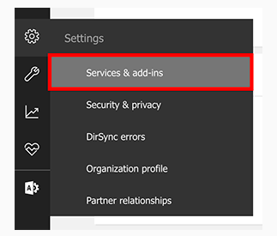
2. 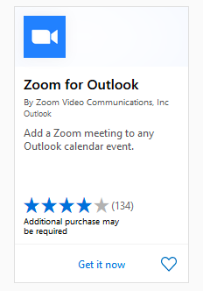
3. 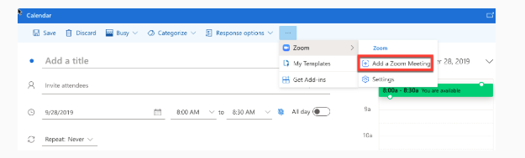
4. 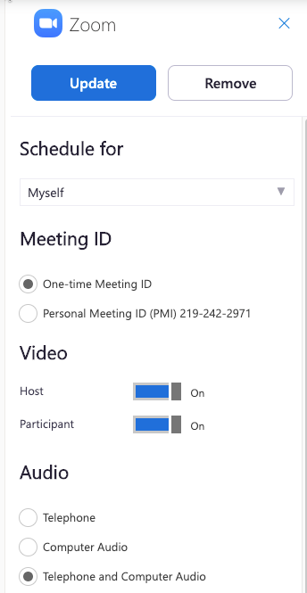

© Zoom Help Center

The objectives are designed to be completed in real time. All students in the cohort will login to their Outlook Calendar and download the Zoom extension. As stated in Objective 4, the final assessment will be completed with 100% accuracy. The evaluators of this task will be each individual within the cohort, in other words, it will be an assessment of peers. Each cohort is expected to create a Zoom meeting and invite the other 10 learners. Each of these learners will receive an invite from the other 9 students. If all students receive these 9 invites and the information is correct on the invite, then the students can check off that they completed the task. This will take a group effort, and they cannot check off that it is completed until everyone in the group does it correctly.

**Design Resources:**

**Technologies**

1. Mindflash LMS

2. Microsoft Outlook 365

3. Zoom Meeting Software

4. Logitech HD Webcam

**Resources:**

Williams, Beven. “How to Enable Cross-Continental Collaboration for Tech Teams”. OfferZen, [www.offerzen.com/blog/how-to-enable-cross-continental-collaboration-for-tech-teams](https://www.offerzen.com/blog/how-to-enable-cross-continental-collaboration-for-tech-teams).

Reyes, Gauri. “How Can “Performance Support” Support Your Organization?”. Mindflash Technologies Inc., [www.mindflash.com/blog/how-can-performance-support-organization](https://www.mindflash.com/blog/how-can-performance-support-organization)

Horton,W. (2012). E-learning by design. California: Pfeiffer.

Zoom Help Center. “Zoom for Outlook Add-In (Web and Desktop)”. Zoom Video Communications Inc. 2019, supp[ort.zoom.us/hc/en-us/articles/115005223126-Zoom-for-Outlook-Add-In-Web-and-Desktop](https://support.zoom.us/hc/en-us/articles/115005223126-Zoom-for-Outlook-Add-In-Web-and-Desktop-).

# **Objective 3**

Learning Goals: Employees will attend audio/video teleconference for quarterly meeting with senior staff and subject matter experts who will address them on specific issues and be available for questions.

Objective 3.1: Employees will log into existing Zoom meeting *(created in Objective 2.)*

Objective 3.2: Employees would attend general session moderated by by senior staff regarding housekeeping matters and company-wide issues. *(One hour)*

Objective 3.3: Employees would join breakout rooms on the Zoom according to their designated cohort. Employees would be able to interact with experts/facilitators in the relevant rooms. *(One hour)*

Objective 3.4: Employees would create a crowdsourced questions-and-answer based on procedures and protocols learned from the relevant experts.

# Design Rationale Summary

# Mindflash LMS has been selected as the preferred platform due to its scalability, multi language capabilities, mobile support, and real time learner analytics reporting. Mindflash also features the capacity to create and organize a learning catalog which can be utilized when microlearning opportunities present themselves.

# The learning modules have been designed with aspects of learner driven autonomy, reflection and ownership in mind. The instructional design addresses the six performance specifications outlined by ITI’s stakeholders (*see* *Learning and Performance Problem Statement*). The technology-enriched and enabled learning environment (TEELE) affords users opportunities to mark their own progress, consider real world outcomes, and engage with their colleagues without outweighing the pedagogy.The instructional design team has considered alignment between all elements: the learning goals and outcomes, the objectives and assessments, and the learning technologies.

For the ITI cross-continental collaborative spaces, two applications have been selected to bridge the language, time zone, and cultural gaps: CSOFT, for multilingual translation of software, and Space, a multifaceted platform for developers. Incorporating visual, textual, and multilingual features, these applications offer the flexibility needed for the required level of productive, thoughtful communication between team members. Additionally, Space collaboration software features microblogging, chats, IDE integration, and employee status. It is also accessible to mobile devices.

# Personnel

This is a comprehensive project that will need expertise from not only the instructional design department, but also key stakeholders within the organization.

|  |  |  |
| --- | --- | --- |
| **Partner** | **Role** | **Skillset** |
| **Instructional Designer (3)** | **Instructional Systems Design** | **Content Design and Outcome Assessments** |
| **Subject Matter Experts (5) for Quarterly Meetings** | **SME’s for the mentoring break out rooms** | **Leadership expertise in the subject matter** |

# 

# Budget

Specified time frame allowed for the assessment, development, and design: Allocate six months salary and labor for ITI personnel.

|  |  |  |
| --- | --- | --- |
| **Description** | **Cost** | **Extended** |
| **Senior Instructional Designer** | **$97,123 / yr - 6 months** | **$48,561.50** |
| **Associate Instructional Designer** | **$64,640 - 6 months** | **$32,320.00** |
| **Assistant Instructional Designer** | **$35,090/mo for 6 months** | **$17,545.00** |
| **Mindflash LMS** | **$999.00/mo for 12 months** | **$11,988.00** |
| **CSOFT** | **$949.00/mo for 12 months** | **$11,388.00** |
| **Space: non-developers (4,000 employees)** | **$8.00/mo per user for 12 months** | **$384,000.00** |
| **Space: developers (17,000 employees)** | **$20.00/mo per user for 12 months** | **$4,080,000.00** |
| **Nikon D 5300 DSLR** | **$478.00 per camera** | **$478.00** |
| **Logitech HD Webcam (10)** | **$22.00/per camera** | **$220.00** |
| **Total Cost** |  | **$4,586,500.50** |