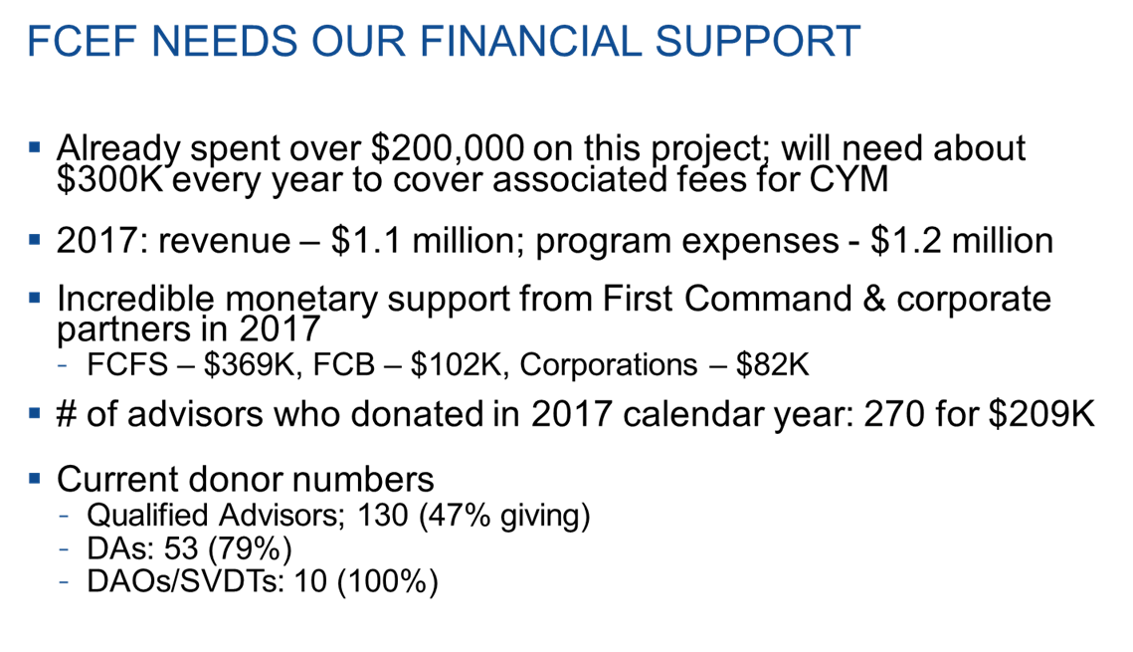

First Command Educational Foundation (FCEF) needs you to continue the great things we are accomplishing for our servicemembers and their families!

At the AAC in Orlando, you heard that FCEF is positioning itself to lead the way for online, accredited financial readiness training for all military servicemembers and their families.  For the first time since being founded in 1983 we have approval from all the services to conduct financial education on military installations.  Our newest curriculum under development, *Command Your Money*, will indeed set FCEF apart from all others who are providing online education.  Moving this direction requires costly resources to become the world leader in financial readiness education.

As you can see on the slide, our monetary need is greater than the donations we are receiving.  The donations we need to successfully execute our mission must increase for FCEF to meet current demands.  If every selling advisor for First Command were to start a donation of only a dollar a day, we would have enough funds to accomplish our mission of educating those who serve.

Our records show you are not currently supporting FCEF with a charitable donation.  You can make a huge difference in the lives of your clients by helping fund our “Mission Impossible”.   I ask that you please search your heart to see if you could start a monthly donation to support FCEF and help us fill the gap in required donations.

**Your mission should you accept, is simply to respond “yes” to this email and include the “amount” you wish to donate.**  FCEF will start your designated donation from your commissions, effective September 2018.

**This email will not self-destruct;)**

 Warmest regards,

Bill Johnson

William M. Johnson

*Director of Operations/CEO-elect, CSM(R), USA*

**First Command Educational Foundation**

Office: (817) 569-2500, Fax: (817) 569-2970

**Save the date! "Chip-in” for Education**

**11th Annual FCEF Golf Tournament on October 5th, 2018**