Exercise 1: demo-thread

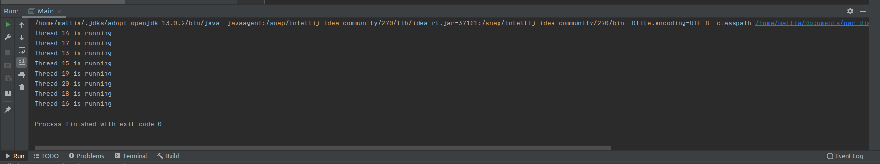

Exsercise 1: demo-runable 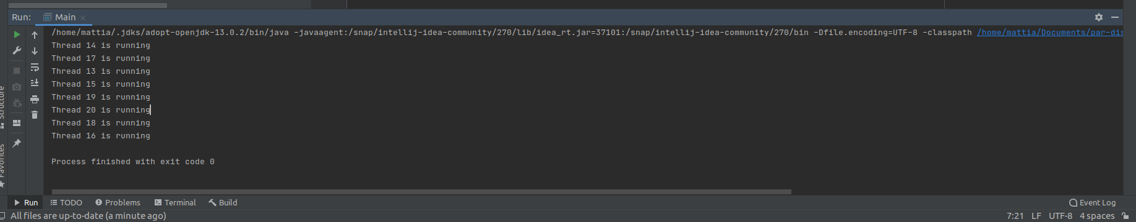

Exsercise 2:

Exsercise 4:

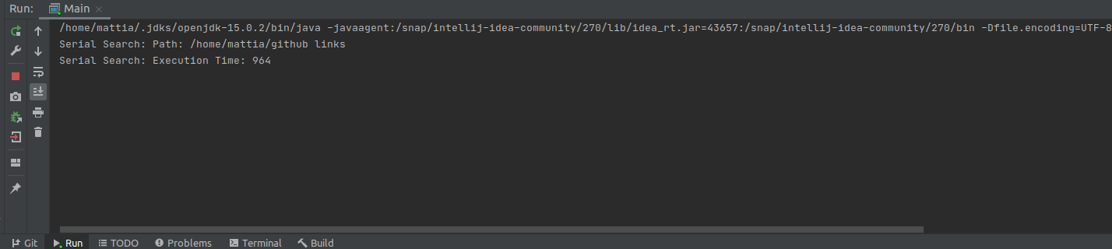

Excercise 5:

