First call to data base, shows all projects:

'SELECT ID_PY, NAME_PROYECT, MIN(DATE1), NAMESENSOR, NBANDAS, COUNT(DESC_CLASS), SUM(SIMULACIONES) FROM (SELECT ID_PY as ID_PY, NAME_PROYECT as NAME_PROYECT, MIN(DATE1) AS DATE1, NAMESENSOR as NAMESENSOR, NBANDAS as NBANDAS, COUNT(DESC_CLASS) AS DESC_CLASS, SIMULACIONES FROM MASTER GROUP BY ID_PY,ID_CLASS,ID_SIMULATION) T group by id_py order by date1,id_py

ID_PY -> Project identification, grows as the number of projects increase in that database

* [12] [13] [14]…. Etc

NAME_PROYECT -> project name, in case it was storage with a name

MIN(DATE1) -> Date of the day it was generated

NAMESENSOR -> name of the sensor

NBANDAS -> number of bands

COUNT(DESC_CLASS) -> Number of classes inside the project, if we are using the same project for make different classes

SUM (SIMULACIONES) -> sum of all the simulations inside the proyect

Second call, select one concrete class:

'SELECT ID_PY, ID_SIMULATION, ID_CLASS, DESC_CLASS, ID_MODEL, NAME_MODEL,ID_MASTER FROM MASTER WHERE ID_PY=' num2str(ID_PY) ' GROUP BY ID_PY, ID_SIMULATION, ID_CLASS, ID_MODEL;'

* Where num2str(ID_PY) is the selected project

ID_PY

ID_SIMULATION -> identifier of the simulation inside the project

ID_CLASS ->

DESC_CLASS -> description of the class

ID_MODEL -> identifier of the model (1 -> prospect 4, 8 -> 4 sail)

NAME_MODEL -> name of the model

ID_MASTER -> identifier referred to the first project that is available

Next call:

SELECT ID_MASTER, ID_PY, ID_SIMULATION, ID_MODEL, DATE1, NAME_MODEL, DESC_CLASS, SIMULACIONES,ID_CLASS FROM MASTER WHERE ID_PY=' num2str(ID_PY) ' ORDER BY ID_MODEL

* Where num2str(ID_PY) is the selected project

ID_MASTER -> identifier referred to the first project that is available

ID_PY -> Project identification, grows as the number of projects increase in that database

ID_SIMULATION -> identifier of the simulation inside the project

ID_MODEL -> identifier of the model (1 -> prospect 4, 8 -> 4 sail)

Select RN (for example)

'SELECT ' grupo1{1,6}{1,1}

' FROM aux_' grupo1{1,6}{1,4}{1,1}

' INNER JOIN ' tablasocio

' USING (' grupo1{1,3}{2,3} ');'

SELECT RN

FROM aux_PROSPECT4_T2

INNER JOIN s_PROSPECT4_T2

USING (ID_T2);

Later we select the wl:

'SELECT ' grupo1{1,6}{1,5}{1,2}

' FROM ' grupo1{1,6}{1,5}{1,1}

' WHERE ' grupo1{1,3}{1,2} '=' num2str(model_ref1{3})

' LIMIT 1;'

SELECT wl

FROM PROSPECT4_T1

WHERE ID_MASTER=4

LIMIT 1;

Inside MySQL, to show how master table is storage

use database_for_mysql

describe master;

select ID_MASTER, id_py, name_proyect from master;

select ID_MASTER, id_py, name_proyect,id_model from master;

Creation of table master

'CREATE TABLE IF NOT EXISTS MASTER'

'(ID_MASTER INT(11) NOT NULL AUTO_INCREMENT PRIMARY KEY, '

'ID_PY INT(11),

PY_TYPE TINYINT,

ID_SIMULATION INT(11),

ID_CLASS INT(11),

ID_MODEL INT(11),

NAME_MODEL CHAR(150), '

'DESC_CLASS CHAR(150),

VER_DB CHAR(8),

NAME_PROYECT CHAR(50),

COMENT_PROYECT CHAR(150),

'DATE1 DATE,

TIME_MODEL TIME,

NAMESENSOR CHAR(50),

NBANDAS INT(6),

BANDAS TEXT,

emulator LONGBLOB,

toc2toa LONGBLOB, '

'SIMULACIONES INT(11),

INDEX IDX_ID_PY(ID_PY),

INDEX IDX_SIM(ID_SIMULATION),

INDEX IDX_CLASS(ID_CLASS)) ENGINE = MYISAM;'

Storage of data in master table

command=['INSERT INTO MASTER (ID_PY,ID_CLASS,ID_MODEL,NAME_MODEL,DESC_CLASS,COMENT_PROYECT,DATE1,NAMESENSOR,NBANDAS,BANDAS,ID_SIMULATION) VALUES ('ID_PY ',' ID_CLASS ',' ID_MODEL ',' NAME_MODEL ',' DESC_CLASS ',' COMENT_PROYECT ',' DATE1 ',' NAMESENSOR ',' NBANDAS ',' BANDAS ',' ID_SIMULATION ')'];

Meaning of T1 and T2

T1 -> storage the name, description, vcount, data, WL (all the data that we select when we are selecting the range and default values of the model)

T2 -> storage the values and results of the model ([N, cab, cw], [RN, TN])

(all models have a function that is called “run” where the model is “launched” and the result of the model is storage on the data base (table T2)

How is connected MASTER with the rest of the models

Name of the data base: check_connection

select id_master from master;

is empty;

Create a model, prospect 4.

After that, we have the first model

Select id_master, id_py, id_simulation, id_model, name_model, name_proyect, simulaciones from master;

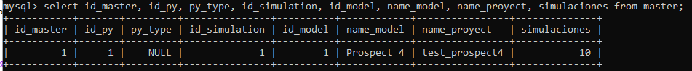

Select id_t1, id_master, name, descripcion from prospect4_t1;

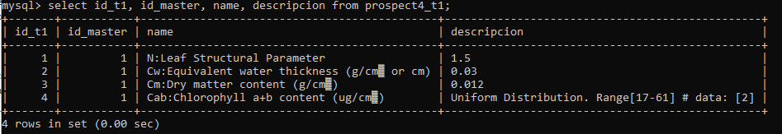

* Id_t1 is going to be as large as the number of parameters we have in the model, is going to vary
* In the description we have the information we put when we were describing the model, with the default values or the range for each one of the variables.

Select id_t2, id_master from prospect4_t2;

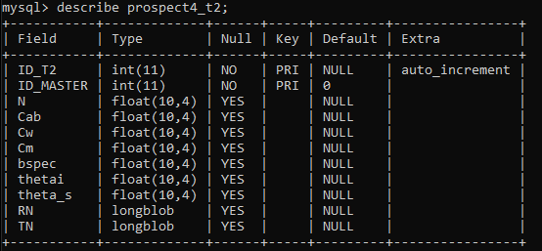

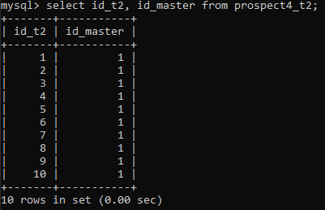

* In this table, the results of the simulation are saved (note that here, if we select LHS or random method, the number of simulations is going to depend from that number)

Now, We put in the same project a prosail4+ simulation plus a scope simulation;

Select id_master, id_py, id_simulation, id_model, name_model, name_proyect, simulaciones from master;

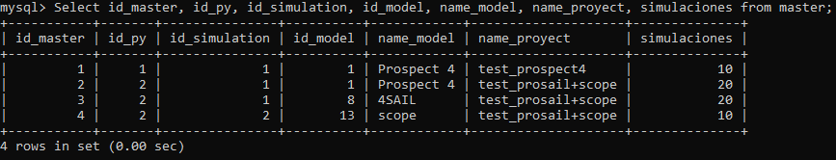

Now that we have more simulation, as we have done the prosail the 2nd one, the id_py will be the second one.

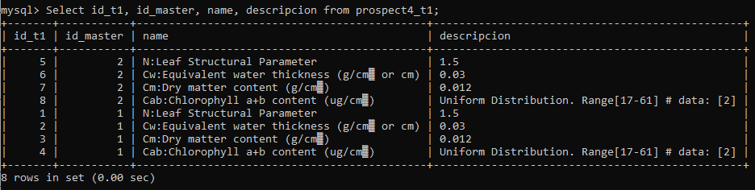

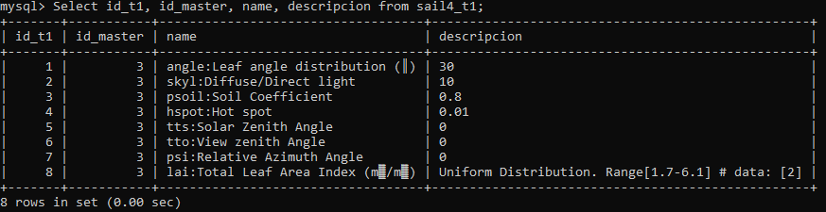

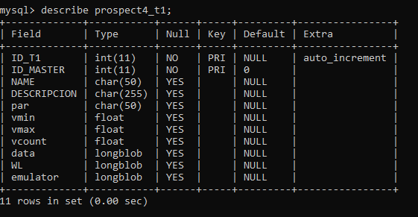

From t1 we have the data we select at the begging, when selecting the range or default values of the simulation.

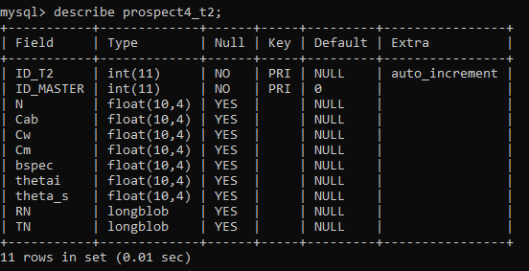

Here we have the data that will be used in the simulation with the result of it.

Connection table:

|  |  |  |  |  |  |
| --- | --- | --- | --- | --- | --- |
| Id_model | Name | Table 1 | Table conecctions | Objet in Matlab | MYSQL TABLE |
| 1 | 'Prospect 4' | 2x3 cell | [] | 'obj_prospect4' | 'prospect4' |
| 2 | 'Prospect 5' | 2x3 cell | [] | 'obj_prospect5' | 'prospect5' |
| 3 | 'Prospect D' | 2x3 cell | [] | 'obj_prospectD' | 'prospectD' |
| 4 | 'FluorMODleaf' | 2x3 cell | [] | 'obj_fmlaef' | 'fmleaf' |
| 5 | 'DLM model' | 2x3 cell | [] | 'obj_dlm' | 'dlm' |
| 6 | 'Liberty' | 2x3 cell | [] | 'obj_liberty' | 'liberty' |
| 7 | 'FluspectB' | 2x3 cell | [] | 'obj_fluspect' | 'fluspect' |
| 8 | '4SAIL' | 2x3 cell | 4x3 cell | 'obj_4sail' | 'sail4' |
| 9 | 'FLIGHT' | 2x3 cell | 4x3 cell | 'obj_flight' | 'flight' |
| 10 | 'fsail' | 2x3 cell | 1x3 cell | 'obj_fsail' | 'fsail' |
| 11 | 'inform' | 2x3 cell | 4x3 cell | 'obj_inform' | 'inform' |
| 12 | 'slc' | 2x3 cell | [] | 'obj_slc' | 'slc' |
| 13 | 'scope' | 2x3 cell | [] | 'obj_scope' | 'scope' |

To the last column, you will have to add _t1 or _t2 in access to both tables

_t1

_t2