Markers layout

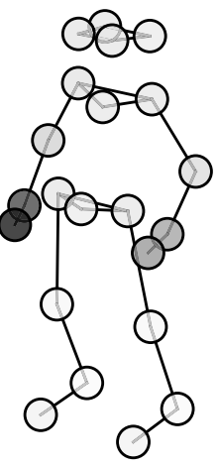
- LB Head
- LF Head
- RF Head
- RB Head
- Sternum
- L Shoulder
- R Shoulder
- L Elbow
- L Wrist
- L Hand
- R Elbow
- R Wrist
- R Hand
- Pelvis
- L Hip
- R Hip
- L Knee
- L Ankle
- L Foot
- R Knee
- R Ankle
- R Foot

