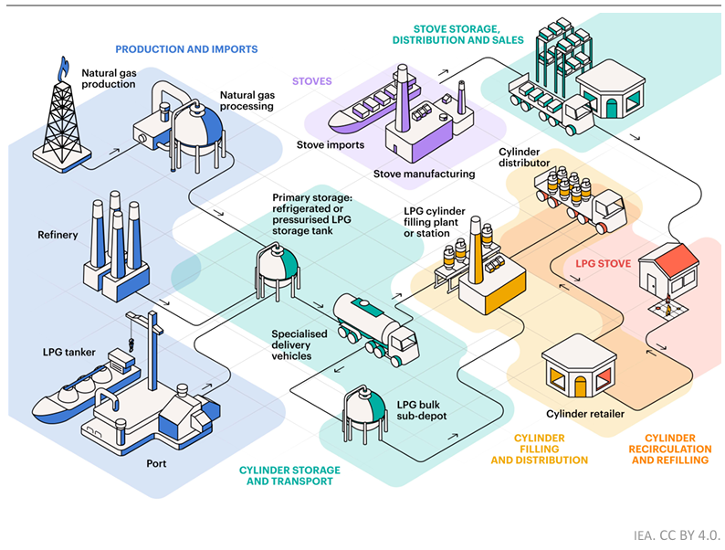
Figure 1: Universal Access to Clean Cooking in Africa, IEA, p. 62
 | Default (old) | Baseline (new) | Optimized (new)
Production and imports
Natural gas production | Cost of this step is integrated in the LPG price? (fuel_cost, default 0.73 USD/kg) | - Find current capacities and shares of local consumption/export. [già fatto qualcosa galga Nigeria + reverse eng. IEA]  - Find info about final costs or how cost accumulates | Same as baseline + estimation of cost for new capacity
Natural gas processing
Refinery
LPG tanker |  | - Find current imports [già fatto qualcosa galga] and prices (prices at the exit of the port or import prices + port handling cost)  - Face the issue of “ship to ship transfer” if the port cannot receive large vessels (+10/20% according to IEA [2]) | Same as baseline + estimation of cost for new capacity (if needed)
Port
Import by land | Cost of this step is integrated in the LPG price? (fuel_cost, default 0.73 USD/kg) | For the land-locked nations, find imported quantities and prices + other issues | Same as baseline + estimation of cost for new capacity (in the nation from which import comes from)
Cylinder storage and transport
Primary storage: refrigerated or pressurized LPG storage tank | Cost of this step is integrated in the LPG price? (fuel_cost, default 0.73 USD/kg) | In case precise storage locations and prices are found, use them. Find a way to estimate storage cost  !! according to IEA [2], “Storage facilities are often located next to ports to enable product loading or the offloading of gas carriers” | Same as baseline + estimation of cost for new capacity
Specialized delivery vehicles | Accounted for in the Traveltime calculation  - friction  - diesel_cost  - truck_capacity  - diesel_per_hour  - transport_emission | - Take a standard diesel cost, truck capacity, hourly diesel consumption, transport emission, friction and calculate the traveltime from production/import points to cylinder filling plants or, if no cylinder filling plants information are found, to cylinder retailer [già fatto qualcosa di simile in traveltime_analyis.ipynb] (! Look at the Rwanda study [1] for economic parameters about trucks and tankers)  - Take into account for seasonality issues | Same as baseline
LPG bulk sub-depot | Cost of this step is integrated in the LPG price? (fuel_cost, default 0.73 USD/kg) | Accounted for in the primary storage or in the filling stations? (according to IEA [2] “Refilling facilities and fuel distribution points tend to have their own small storage facilities”)  Few exception ex. land-locked countries? | Same as baseline
Cylinder filling and distribution / cylinder recirculation and refilling
LPG cylinder filling plant or station | Cost of this step is integrated in the LPG price? (fuel_cost, default 0.73 USD/kg) | Find cylinder filling plants if possible [sembra che tendenzialmente i filling plants siano un sottogruppo dei retailers già fatto qualcosa cinche], or estimate a single filling cost percentage or parameter | Same as baseline + (eventually) estimation of:  - Cost for new filling plants  - New plants optimal filling locations
Cylinder distributor | Accounted for in the Traveltime calculation  - friction  - diesel_cost  - truck_capacity  - diesel_per_hour  - transport_emission | - Take a standard diesel cost, truck capacity, hourly diesel consumption, transport emission, friction and calculate the traveltime filling plant to retailer (! Look at the Rwanda study [1] for economic parameters about trucks and tankers) | Same as baseline
Cylinder retailer | Cost of this step is integrated in the LPG price? (fuel_cost, default 0.73 USD/kg) | - Find retailers with Google Maps + filters also with reviews. [già fatto qualcosa cinche]  - Use Huff model to allocate people to retailers. [già fatto qualcosa cinche]  - Build the baseline considering that if people live near LPG supplier it is more likely that they cook with LPG, but always calibrate everything ensuring that the total share of people that cook with LPG in both rural and urban are respected.  - Various selling mechanisms: need to find data about % of people that currently use CCCM, CRM and PAYG.  - For CCCM and CRM, choose if to assume that people goes to the cylinder shop to take the cylinder (and if it is by car or by walk) or the cylinder is brought at home. Study [1] assumes that people travel themselves to distributor.  - Add also the cost in terms of fuel or in terms of time (similarly to how it’s done with time of collecting biomass  - Create a “mixed friction”: assign “car” or “walk” to each cell and calculate travel time by car or by walk  - To decide if in a cell LPG is delivered, or people go to take it by car or by walk we can use absolute wealth and/or ready-to-use rasters and/or statistics by region | Same as baseline (without Huff model?) + estimation of:  - Cost of new retailing shops  - New retailers optimal location (with eventual constraint that max. distance of people from retailer should be <30 minutes à so let the optimization find a compromise between opening a lot of distributors and making the people walk a lot to reach them – “concept of spatial fairness” highlighted also in [1])
LPG stove
LPG stove use | - Time of cooking  - Exposure adjustment factor  - Energy needed to cook a meal  - People too far from road are excluded from LPG  - Cylinder cost | Keep the same as default + take into account for:  - Availability  - Affordability (?) | Keep the same as default + take into account for:  - Availability  - Affordability (?)
Stoves
Stove import | - Investment cost (of the stove)  - O&M cost (of the stove)  - Efficiency (of the stove)  - PM emission (of the stove) | We will think about it later | We will think about it later

How we will find things
 | 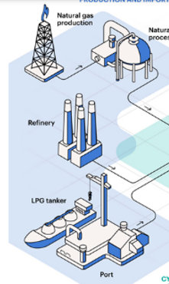 | NO TRANSPORT? | 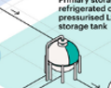 | 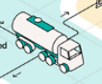 | 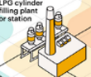 | 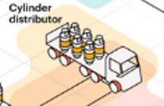 |  | 
 |  |  |  |  |  | 
 | LPG PRODUCTION |  | PRIMARY DEPOT |  | FILLING POINT |  | RESELL
BASELINE | IEA map (with check) + other source + WB import/export |  | IEA map (with check) + API search (with check) |  | API search (with check) |  | API search auto + partially controlled
N. OF POINT
OPTIMAL | prev. + new optimal |  | prev. + linked to new production |  | prev. + new optimal |  | prev. + new optimal

