TrionicCANFlasher
Users Manual



November 2015

Table of Contents
PURPOSE AND SCOPE 2
Step1 - Installing and Setting Up – TrionicCANFlasher 3
TrionicCanFlasher Screen 4
Selection of ECU Type 4
Selecting and Adapter from the Menu 4
The Flag options 6
Step 2 – Installing your hardware 7
Installation of Drivers for currently supported interface/cables: 7
Selection of COM port 9
Step 3 – Getting to know the functions of TrionicCANFlasher 10
Description of the Buttons on the TrionicCanFlasher Screen. 10
Step 4 - Using the software - The fun begins 14
Get ECU Info 14
Read ECU 14
FLASH ECU 16
RECOVER ECU 16
READ SRAM 17

PURPOSE AND SCOPE
The purpose of this document is to provide the users with all the knowledge available in the TrionicTuning.com community to allow a faster learning in the use of the tool and to ensure the correct use of the functionality of the software. The information from this document should be followed as stated and compared with expected output from the software. Shall you find any points where instructions are not easy to follow or vary to the actual performance of the software please send a note to the developers at TrionicTuning.com.

REFERENCES
This section references, by identity and title, documents that facts in this document depend upon. Those documents are not necessarily the latest version.

TrionicCANFlasher Developers:
Dilemma
Mattias Claesson
Sophie Dexter
Jacek Kędzior
Christian Ivarsson

Users manual author:
WildBoar – Carlos Irving Rojas
Mattias Claesson
Revision date: 2016-11-15
Latest TrionicCANFlasher Version covered: 0.1.44.0

Disclaimer
Before installing and using this software we recommend you to read this note carefully.
http://www.txsuite.org/disclaimer/

Step1 - Installing and Setting Up – TrionicCANFlasher

Thank you for downloading and installing TrionicCANFlasher.
Make sure that you have the latest available version of the suite at:
http://www.txsuite.org/download/trionic-can-flasher/
In this manual you will find an overview of the most commonly used functions. After starting TrionicCANFlasher a splash screen will be displayed and after all components are loaded and the application is initialized the main screen will be displayed.

TrionicCanFlasher Screen
The following picture shows a screenshot of the TrionicCanFlasher dashboard and a detailed description of each of the buttons and configuration menus.
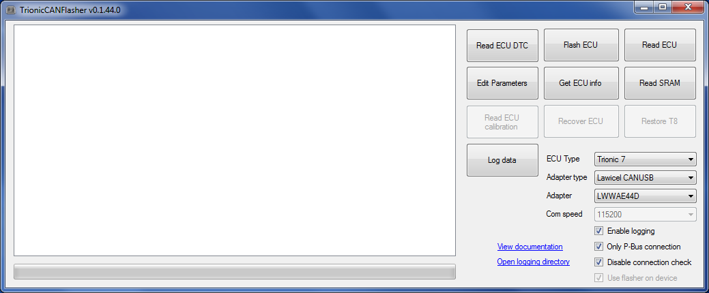

Selection of ECU Type
In this new version you can select the following ECU types:
Motronic 9.6 – on B285 - V6 Engines
Trionic 7 – SAAB 9-3OG, 9-5 2.0T and 2.3T
Trionic 8 – SAAB 93 1.8t / 2.0T / 2.0t / Opel Vectra
Trionic 8 MCP coprocessor

Selecting and Adapter from the Menu
The current options available for interfaces supported by TrionicCanFlasher - Select the one that matches your interface cable.

Lawicel CANUSB  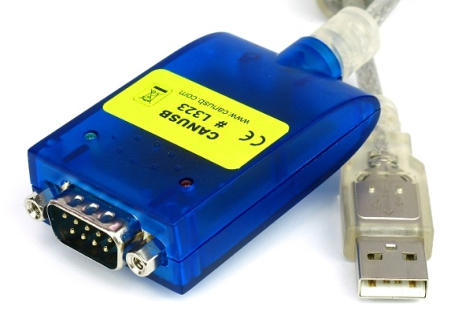 | Combiadapter – Developed by JohnC  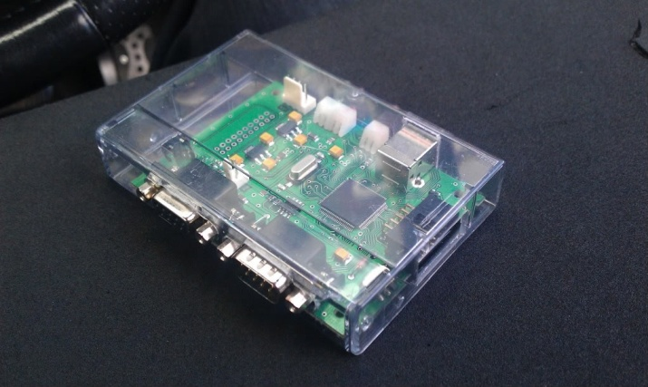
ELM327 v 1.3 or higher – (select this option for OBDLinkSX)  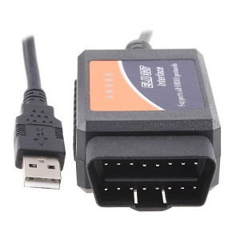 | Just4Trionic developed by Sophie Dexter  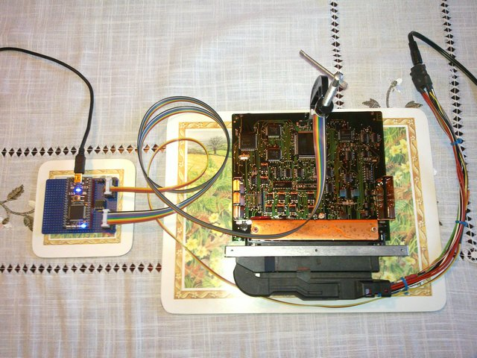
Kvaser  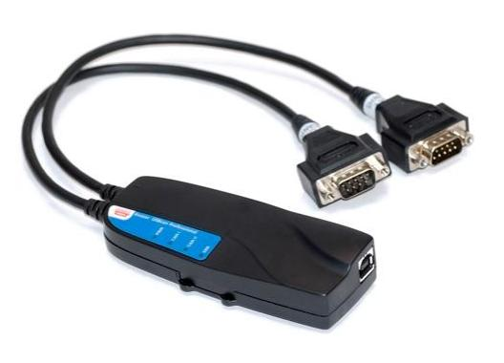  Copyright 2001-2011 Kvaser AB, Mölndal, Sweden http://www.kvaser.com | OBDLinkSX – use ELM327 Option  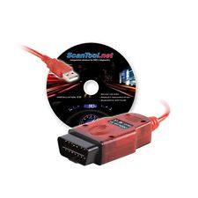

The Flag options

Select the flag options desired for your session.
Enable Logging - allows the software to record LOGs of your sessions and be able to check activity-events in case required.
Log files descriptions:
A quick link in the GUI will open a explorer window at the location where logs are saved.
The full path is %appdata%\MattiasC\TrionicCANFlasher
canLog.txt - is the raw CAN message log.
deviceLog.txt - Low level details on the device communication.
flasherLog.txt - Show information about the flasher subsystem.
kwpLog.txt - This is a Trionic7 specific log with KWP messaging.
uiLog.txt - Saves the output that is shown in the user interface.
Default all log files are rolled each day and the historic log file name will be appended with date pattern "yyyy-MM-dd". The flasher use nlog as logging framework, for the advanced user logging are fully configurable in NLog.config. The config file is located in the application installation directory.
Please upload all logs to- trionictuning.com - if a error has been encountered.
Only P-Bus connection – tells the software to connect only to P-Bus. If unchecked it will try to connect first to I-Bus and then P-Bus.
Disable Connection Check – used to force the connection to open even if the CAN Bus is inactive.
Use flasher on device – activated only on Combiadapter and Trionic 7. Turn off to use the internal TrionicCANFlasher flash implementation. Used to work around issues in the Combiadapter on device flasher.

Step 2 – Installing your hardware

Installation of Drivers for currently supported interface/cables:
It is very important to make sure that your device is installed properly BEFORE attempting any work on your ECU.
NOTE: For all adapters, if you don’t have the Microsoft Visual C++ 2010 Redistributable Package (x86) installed download and install:
http://www.microsoft.com/en-us/download/details.aspx?id=5555
Lawicel CANUSB – follow instructions on Lawicel’s web site and download the correct drivers for your device:
http://www.canusb.com/
The lawicel works best if it is using the standard FTDI PID 6001. Procedure to upgrade is here: http://www.can232.com/?p=422
Then standard FTDI drivers from here can be used (choose the 32 bit version even on 64 bit windows):
http://www.ftdichip.com/Drivers/D2XX.htm
On top of that the canusb api must be installed (choose the 32 bit version even on 64 bit windows):
http://www.can232.com/download/canusb_setup_win32_v_2_2.zip

Combiadapter
http://www.trionictuning.com/forum/viewtopic.php?f=46&t=191

ELM327 v 1.3 or higher – (select this option for OBDLinkSX) – make sure to get the latest FTDI drivers for your device and set up COM port and correct speed to allow your device to work properly. You can check latest drivers for OBDLinkSX at:
https://www.scantool.net/obdlink-sx.html
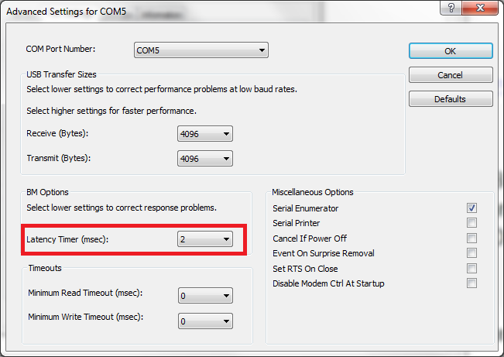
Make sure as latency parameter to 2ms on FTDI based adapters like the OBDLinkSX.
Just4Trionic
https://developer.mbed.org/users/Just4pLeisure/notebook/just4trionic/

Kvaser support
http://www.kvaser.com/software/7330130980013/V5_11_0/kvaser_drivers_setup.exe

Selection of COM port
Select the port in which you installed your interface hardware – for reference check – Control Panel → System → hardware →Device Manager → Network Adapters → Ports (COM&LPT).

Selection of COM Speed / Settings
Latency settings is very important for FTDI based ELM devices, it should be set to 2ms latency in the com port advanced settings.
This is a very important step - select the highest speed in which your interface works stable.
Usually the top speeds for each interface are:
ELM327 – 230.4 Kbps
OBDLinkSX – 1 or 2 Mbps
Just4Trionic -

You will be able to identify the limits of your cable when you select a higher speed, the CAN session will not be established, selecting the correct speed is crucial for successful – Reading, Flashing and Recovery of your ECU.

Step 3 – Getting to know the functions of TrionicCANFlasher

Description of the Buttons on the TrionicCanFlasher Screen.

Not all operations is not available for all different ECU and adapter combinations.
Read ECU DTC
This function allows you to read DTC directly from the ECU. Very useful when you buy used ECUs – just plug on-desk and read if ECU is good!

Flash ECU
This button allows you to FLASH your ECU with either original or modified BIN files.
Read ECU – this button allows you to read your current BIN file stored in the flash memory of the ECU.
- NOTE: A used ECU can be divorced from a car using Tech2. This procedure requires the use of ADD/DELETE MODULES function in TECH2 and TIS2WEB/TIS2000.
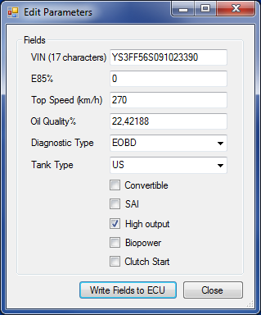
Edit Parameters
Not all parameters are available for all types of ECUs.
Set ECU VIN this option allows you to change VIN code for the ECU. Do this if you need to marry a used ECU to a new Car. The new VIN is entered first in the Set parameter field – BEFORE activating the button. For this function to work, the used/new ECU must be married to the new car using TECH2 and TIS2000.
Set E85 percent used to set the ethanol percent in biopower binaries.
Set Top Speed set the top speed limit.
Set Oil Quality set the oil quality.
Set Diagnostic Type set the diagnostic hardware type.
Set Tank Type set the tank type.
Set Convertible set if the car is a convertible.
Set SAI set if the car has a Secondary Air Injection pump.
Set High output set if the car will use the 150 hp or 175/210hp limiters.
Set Biopower set if the car is biopower capable.
Set Clutch start set clutch start.

Get ECU info - This option shows you a list of all the important data recorded in the ECU.
Read SRAM – reads the SRAM contents from the device. Work well for Trionic 7, does not give correct results for Trionic 8.
Read ECU Calibration– only reads the calibration part on Motronic 9.6.
Recover ECU – allows you to do a recovery of your Trionic 8 ECU in case of failed read or write.
Restore T8 – used to restore a bricked Trionic 8 ECU. Connect directly to the ECU and make it possible to turn on and off the power. Follow instructions in the program.
Log data – used capture CAN data. The resulting data will be written to the standard logfiles.

Step 4 - Using the software - The fun begins
Getting Started with TrionicCanFlasher
Before starting any procedure with your car it is highly recommended to perform the following actions to ensure that your session is successful:
The car must be cleared from all DTC codes especially those related to the ECU.
Car battery must be fully charged.
Turn off any other accessories that are not necessary for the purpose of ECU programming, i.e. Radio, Lights, AC, etc.
Attach a battery charger to the battery if it is not fully charged or if battery is OLD and is not retaining charge properly.

Get ECU Info
Hook up your cables to laptop and car – connect laptop to AC outlet and disable Energy Saving options from the Power Manager in the computer. This is very important to avoid interrupted CAN sessions that are potentially damaging to the ECU.
Turn your ignition to ON position
Press button Get ECU info
The screen will list ECU data recorded in the BIN file.
When the ECU has been erased NO data will be listed in the fields.

Read ECU
Follow Steps 1-4 described in Get ECU info
Press button →Get ECU info – to make sure you have communication with ECU.
The screen will list ECU data recorded in the BIN file. If data is listed and you are able to see your VIN number and other data you are ready to READ ECU.
Press button →Read ECU
A dialog box will appear asking you - where do you want to store the file and to name the file to allow easy identification of your BIN. This is especially important when reading ORIGINAL ECU BIN files – this file is recommended to be stored in a safe location and use only copies of it when making a modified BIN.
The READ process starts and you will see progress on your screen.
When you see message Starting bootloader then you turn ignition to OFF position.
When the READ ECU process is completed → Remove the ignition KEY and disconnect your interface.

FLASH ECU
For Trionic 8 – please read this document before attempting to flash.
For Trionic 7 turn key to ON wait a few seconds, turn to LOCK. Wait 15 to 20 seconds then initiate the flash operation. There is no need to pull the fuse to engine fan and the CAN bus will not be busy. The engine fan is controlled by DICE and will start if no communication to ECU the first 15 to 20 seconds.
Here is the latest recommendation flash procedure for t8.
http://www.txsuite.org/guides/trionic-can-flasher/
There is a new popup trying to help get things right just before flash start.
Follow Steps 1-4 described in Get ECU info
Press button →Read ECU – to make sure you have communication with ECU.
The screen will list ECU data recorded in the BIN file. If data is listed and you are able to see your VIN number and other data you are ready to READ ECU.
Press button → FLASH ECU
A dialog box will appear asking you for the BIN file that you want to Flash to the ECU.
The FLASH ECU process starts and you will see progress on your screen.
When you see message Starting bootloader then you turn ignition to OFF position.
When FLASH ECU is completed → press Get ECU info to check if ECU is good and communicating after flashing is completed. If all is OK go to next step, if your ECU shows NO data on the screen – go to RECOVER ECU.
Remove the ignition KEY and disconnect your interface.
Flashing times vary depending on the interface.
After a successful flash Trionic 7 must be manually rebooted. Remove the ECU fuse #17 or negative battery terminal for the duration of 10 seconds.
If the flash fail try to retry the flash operation again, do not cut power to the Trionic 7 ECU. If the ECU does not respond, use a BDM tool to fix it.

RECOVER ECU
Turn your ignition to ON position.
Press button → RECOVER ECU
A dialog box will appear asking you for the BIN file that you want to use for Recovery of the ECU, usually the original BIN file from the car is better to ensure the recovery process get your car back to life as usual!
The RECOVER ECU process starts and you will see progress on your screen.
When you see message Starting bootloader then you turn ignition to OFF position.
When RECOVER ECU is completed → press Get ECU info to check if ECU is good and communicating after Programming Flash is completed. If all is OK go to next step, if your ECU shows NO data on the screen – run RECOVER ECU again.
Remove the ignition KEY and disconnect your interface.
Flashing times vary depending on the interface.

READ SRAM
Turn your ignition to ON position.
Press button →Read ECU – to make sure you have communication with ECU.
The screen will list ECU data recorded in the BIN file. If data is listed and you are able to see your VIN number and other data you are ready to READ ECU.
Press button →Read SRAM - A dialog box will appear asking you - where do you want to store the file and to name the file to allow easy identification of your BIN.
After Read SRAM is completed remove KEY from Ignition.
CLONING a T8 ECU
The flash consists of the main Trionic 8 processor and the coprocessor MCP.
Connect to the ECU that will be cloned from.
Select ECU Type - Trionic 8 : MCP
Press button →Read ECU
Select ECU Type - Trionic 8 (Exp, Dangerous)
Press button →Read ECU
Connect to the ECU that will be written to, and write the files from the source ECU.
Select ECU Type - Trionic 8 : MCP
Press button → Flash ECU
Select ECU Type - Trionic 8 (Exp, Dangerous)
Press button → Flash ECU

