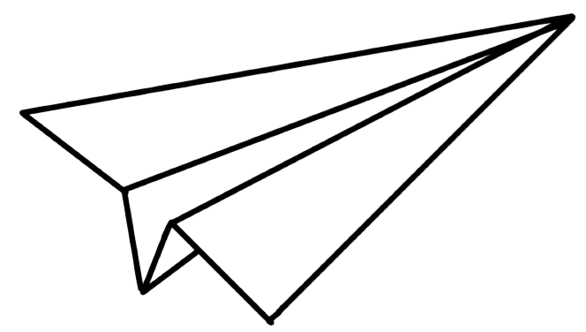

Here's a strong branding concept for **MFacture**, designed to resonate with engineers and professionals in manufacturing:

**1. Logo Design Concept**

* **Symbolism:** A sleek, geometric icon resembling a **conveyor belt, gear, or modular factory** to represent efficiency and industrial strength.
* **Typography:** Strong, modern sans-serif with **slightly rounded edges** for trust and clarity.
* **Style:** Minimalist yet powerful, inspired by precision engineering.

**2. Brand Colors**

* **Primary:** **Deep Blue (#0080FF)** – Represents trust, reliability, and precision.
* **Accent:** **Industrial Orange (#FFA200)** – Evokes energy, innovation, and action.
* **Secondary:** **Steel Gray (#5A5A5A)** – Conveys strength, professionalism, and a manufacturing feel.

**3. Typography**

* **Headlines:** **Montserrat or Inter** – Bold, readable, and engineered.
* **Body Text:** **Roboto or Source Sans Pro** – Clean and modern.

**4. Design Style**

* **Minimalist & Functional:** Just like manufacturing, clean UI and simple visuals convey efficiency.
* **Tech-Forward & Professional:** Slight gradients and **3D-inspired UI elements** for a cutting-edge feel.
* **Slight Industrial Feel:** UI components inspired by **blueprints, CAD sketches, and production line aesthetics**.

Would you like me to generate a visual logo concept for **MFacture**? 🚀

4o

Is this conversation helpful so far?

Top of Form

Search

Reason

Bottom of Form

ChatGPT can make mistakes. Check important info.