# Algorithm One

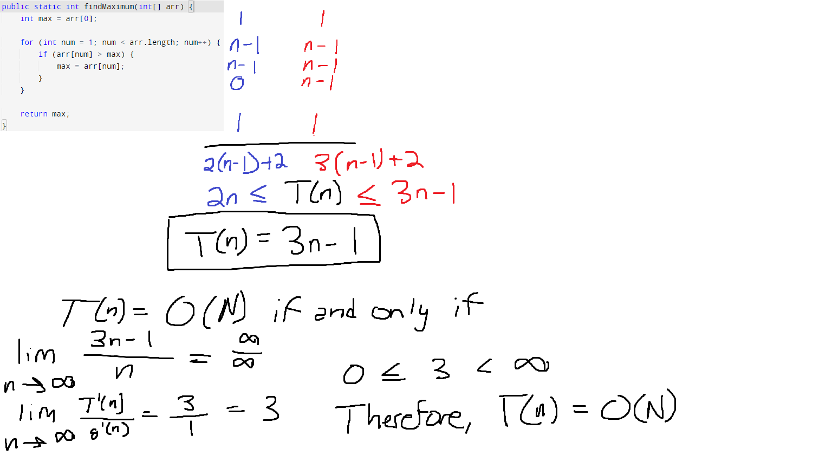  
Our growth function derived from the algorithm comes to be $T(n)=3n-1$. We can then prove this function is in the $O(n)$ runtime using the limit definition.

# Algorithm Two

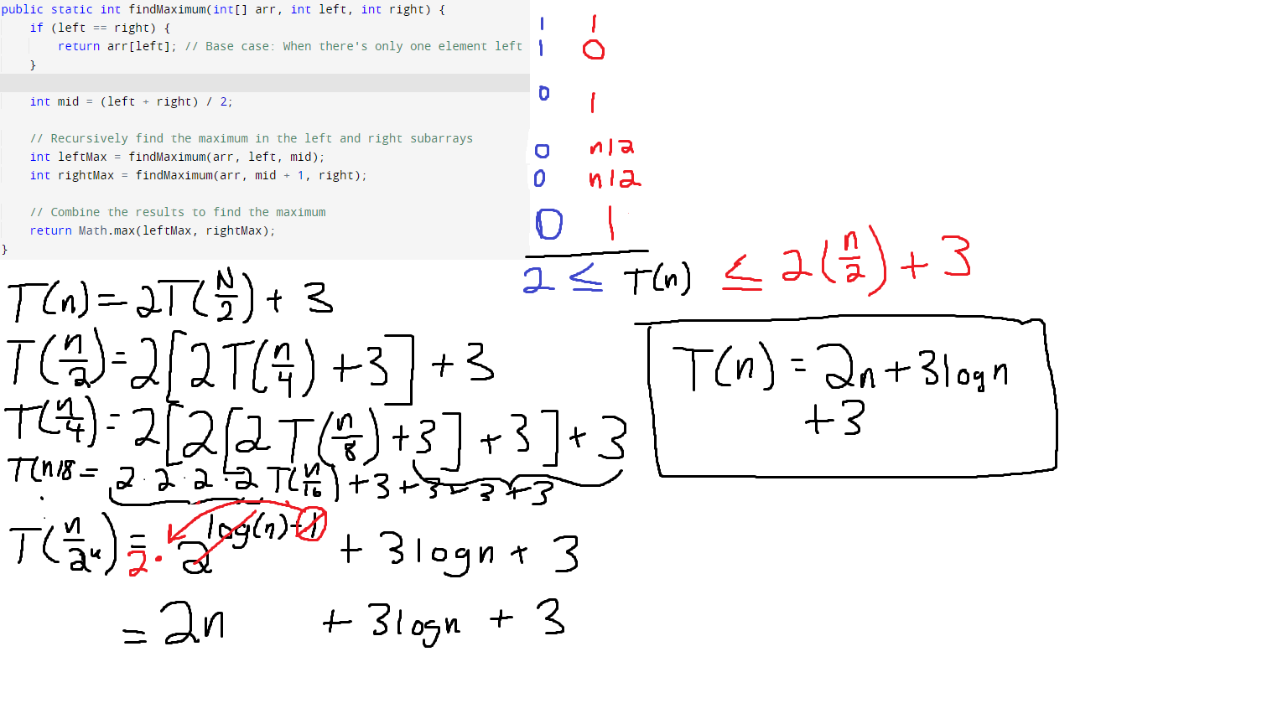

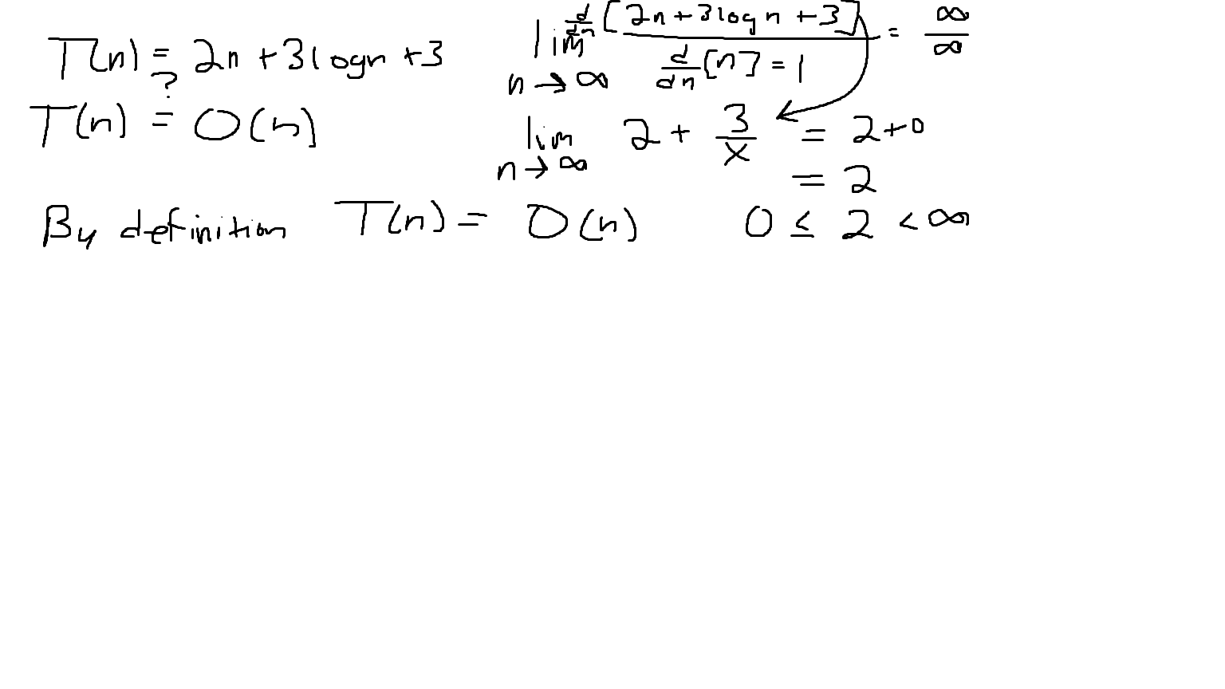

As we can see above, once we calculate the growth function, we can see it actually falls into $O(n)$ runtime. I proved it using the limit definition.

# Algorithm Three

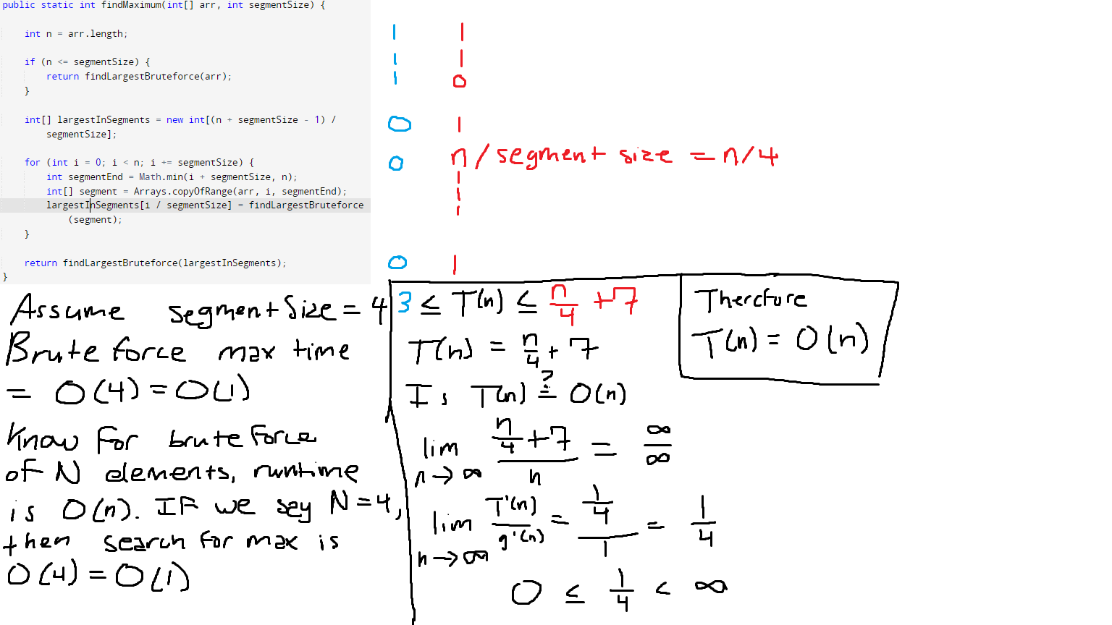

As can be seen above, I proved that the runtime of the third algorithm is once again $O(n)$. However, this function grows significantly slower than the other two functions, therefore I consider this to be the best one.