# Algorithm One

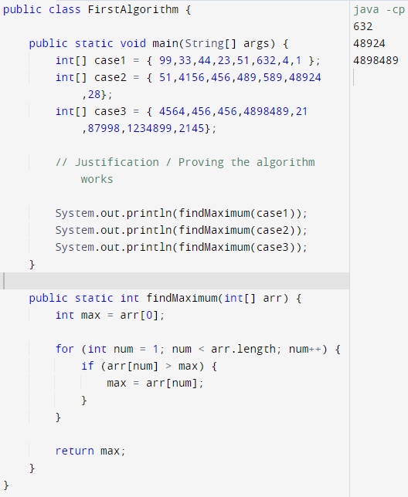

As you can see above, I have provided three test cases and they all output the correct number.

# Algorithm Two

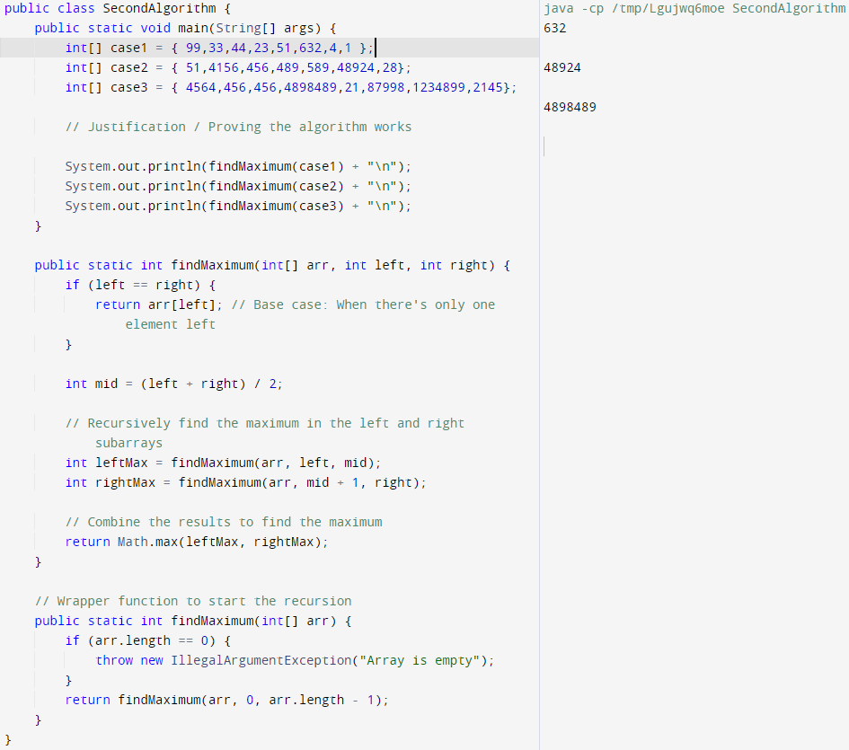

As seen above, I provided the same two test cases and it gave the correct results. I used the same cases as the first algorithm to make sure they were the correct answers.

# Algorithm Three

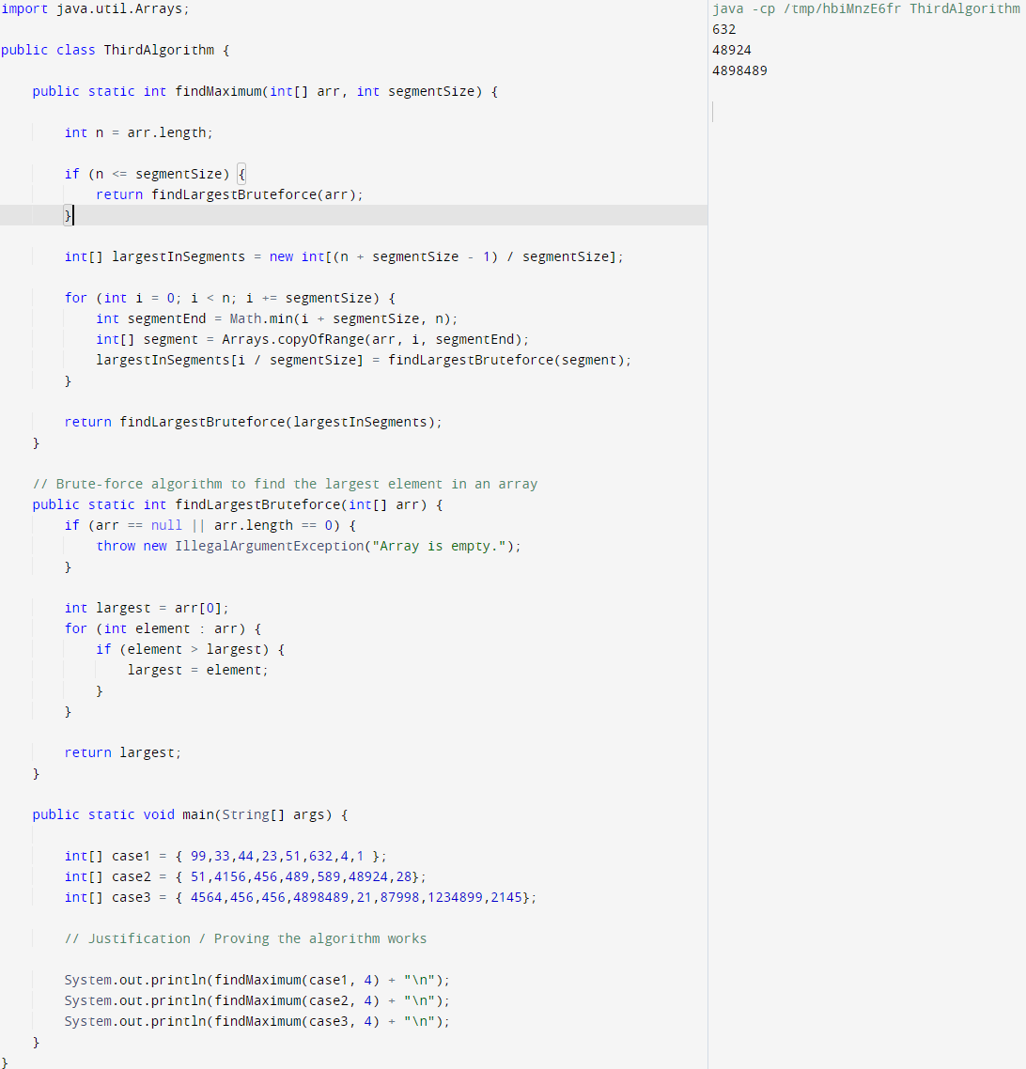

Again, I used the same test cases, and it gave us the same results for the maximum numbers in the array. This just proves that the algorithm is correct!