**Progress Report**

**TOPIC 1: INTENSITY TRANSFORMATIONS & SPATIAL FILTERING**

**Image Processing (BEJ42903)**

**Dr.** **Suhaila Binti Sari**

**Universiti Tun Hussein Onn Malaysia**

**25/05/2023**

**Semester 2 2023**

**Moritz Hoehnel (JD220004), Mattis Ritter (JD220003)**

Table of Contents

1. Group Member Task Distribution 3

1.1 Progress Report 3

1.2 GUI Development 3

1.3 Report 3

2. Minute of Meeting 4

3. Images for Database 6

4. GUI Design 6

# 1. Group Member Task Distribution

The following chapter will give an overview of the tasks and which member will execute the task. The goal is to split the work even. The members should perform the same amount of effort. The members should help each other.

## 1.1 Progress Report

|  |  |  |
| --- | --- | --- |
| No. | Task description | Responsible |
| A.1 | Create the Group Member Task Distribution. | Moritz |
| A.2 | Reports for group meetings should be created. | Moritz |
| A.3 | Images for the project should be collected, put into a folder and a details text file should be created. | Mattis |
| A.4 | A GUI design should be developed. | Mattis |
| A.5 | The results of all goals with numbers A.X shall be put into the Progress Report. | Moritz |

## GUI Development

|  |  |  |
| --- | --- | --- |
| No. | Task description | Responsible |
| B.1 | Decide which software tool should be used to develop the application. | Moritz |
| B.2 | Decide which intensity transformation to perform. | Moritz |
| B.3 | Decide which spatial filter to perform. | Mattis |
| B.4 | Create the user interface that enables the user to execute the following actions: (i) Open Image  (ii) Show image for original image  (iii) Proposed image processing technique execution button  (iv) Show image for output image from proposed method | Mattis |
| B.5 | Implement the intensity transformation method. | Moritz |
| B.6 | Implement the spatial filter method. | Mattis |

## 1.3 Report

|  |  |  |
| --- | --- | --- |
| No. | Task description | Responsible |
| C.1 | Introduction that contains a discussion about real-world problems related to the project subject. | Moritz |
| C.2 | Justify the selection of the development software. | Moritz |
| C.3 | Reason why the intensity transformation method was chosen. Find 1 recent publication in Scopus-indexed journals or conference proceedings (year 2012 to 2023) related to the method selected. From your reading, write in your own word in your report on how the technique is performed. | Moritz |
| C.4 | Reason why the spatial filter method was chosen. Find 1 recent publication in Scopus-indexed journals or conference proceedings (year 2012 to 2023) related to the method selected. From your reading, write in your own word in your report on how the technique is performed. | Mattis |
| C.5 | Analyze pictures for intensity transformation. | Moritz |
| C.6 | Analyze pictures for spatial filtering. | Mattis |

# Minute of Meeting

|  |  |
| --- | --- |
| Date: | 24 May 2023 |
| Time: | 16:00 |
| Attending: | Moritz Hoehnel  Mattis Ritter |
| Absent | - |

|  |  |
| --- | --- |
| **1. Agenda Item #1** | |
| Decisions:  Split of the topics for the progress report. | Moritz will create the group member distribution, create the progress report and create the meeting documentation.  Mattis will collect the pictures and create a documentation text document.  He is also responsible for the GUI design. |
| **2. Agenda Item #2** | |
| Decisions:  Timing | The tasks in Item #1 defined need to be performed until the next meeting. |

|  |  |
| --- | --- |
| Next Meeting: | 25 May 2023 |

|  |  |
| --- | --- |
| Date: | 25 May 2023 |
| Time: | 14:00 |
| Attending: | Moritz Hoehnel  Mattis Ritter |
| Absent | - |

|  |  |
| --- | --- |
| **1. Agenda Item #1** | |
| Decisions:  Verification group member distribution | The distribution is valid for the rest of the project. All members agreed to the distribution. |
| **2. Agenda Item #2** | |
| Decisions:  Validation of the sample pictures | Review of the chosen pictures, discussion on their usability. Agreement to use the pictures. |
| **3. Agenda Item #3** | |
| Decisions:  GUI Design | Review of GUI Design. Agreement to use the provided design. |
| **4. Agenda Item #4** | |
| Decisions:  Progress Report | Agreement on report structure. Validation of report content. |
| **5. Agenda Item #5** | |
| Decisions:  Start implementation of GUI | Until the next meeting a software will be chosen and the GUI created. |

|  |  |
| --- | --- |
| Next Meeting: | 28 May 2023 |

# Images for Database

The collected images can be found in the folder. The folder also contains a text file with descriptions for the pictures.

# GUI Design

The figure below shows the design oft he GUI.

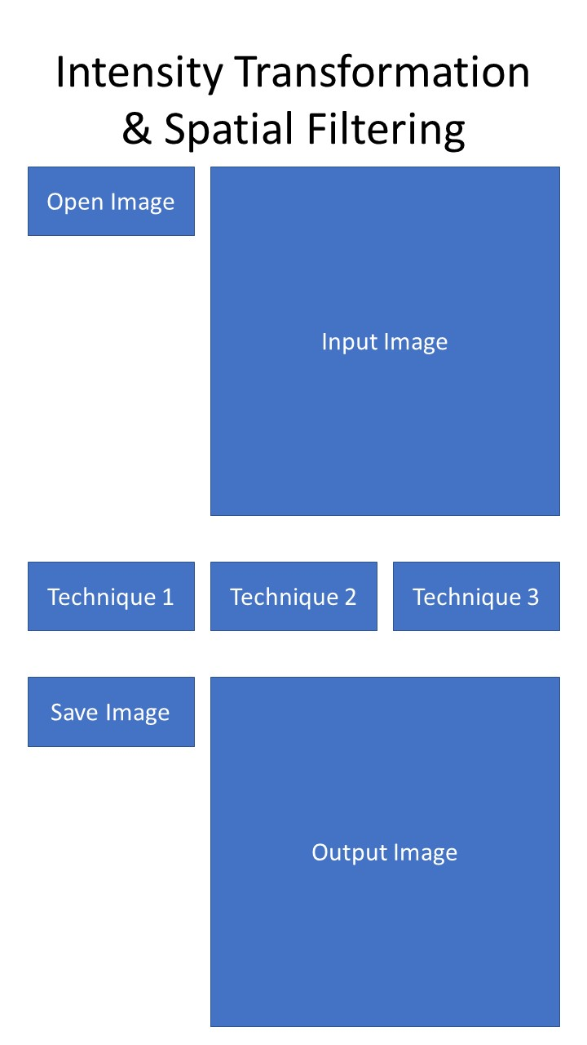

Figure 1: Design of the GUI