For the application of the trajectory planning a very simplified model of the Niryo One robot is created in the MATLAB script *robot_data*. It only contains the two main joints for reaching out with the arm and is constrained to two dimensional movements only. The offset for the shoulder joint is $0.183m$,the length of the arms $r_{1} = 0.21m$ and $r_{2} = 0.2452m$. $θ_{1}$ describes the angle between the upper arm and the ground. $θ_{2}$ is the relative angle between the upper arm and the lower arm. The coordinate origin is at the bottom of the foot.



A use case is created by adding a obstacle in front of the robot at x-position $0.2m$ and with a height of $0.1m$. The goal is to pick up a object in front of the obstacle and place it behind it. Therefore the start and end point can be defined in the coordinate system as well as a via point to avoid the obstacle. For this use case the tool center point at the beginning is $P_{0}(0.10m, 0.00m)$, at the end it is $P_{f}(0.30m, 0.00m)$ and the via point is $P_{1}(0.15m, 0.15m)$. Furthermore, the type of trajectory can be defined.

To find the corresponding joint coordinates a inverse kinematic function has to be applied. The function *joint_coordinates* takes the x and y coordinates, the arm lengths and the sign of $θ_{2}$, which is -1 for the robot as inputs and returns the joint angles. Now the trajectory for the joints can be calculated as described in the previous chapter.

To visualize the respective trajectory of the tool center point a plot of it with the start, via and end point as well as the obstacle is created. With quintic polynomials it looks like shown in figure x.x with the previous settings.

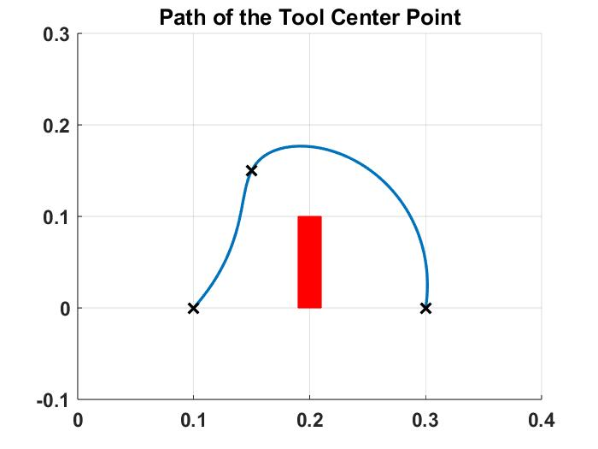

As the path of the tool looks like it does not hit the obstacle the simulation for the robot can be made by executing the MATLAB Simulink file *robot*. The animation shows the movement of the whole robot for every time step. Figure x.x displays the end position.

