## 2.2 Artificial Intelligence

So far, the factory is controlled by a PLC software. This software allows the developer to set clear instructions what the factory and each machine does. Instructions are worked through precisely.

However, for a neuronal network that’s not the case. A program receives a set of data that reflect small entities of the factory. The program then needs to find connections and recognize patterns between the entities.

The factory is supposed to be monitored and controlled by Artificial Intelligence. While AI comprehend many ways of implementations, this project is supposed to use neuronal networks. This chapter will review neuronal networks.

### 2.2.1 Neuronal Network in general

When talking about neuronal network it is meant to have an artificial neuronal network. The idea is to create software that works similar like a human brain, a natural neuronal network. This network gives us our intelligence. It helps us to train our abilities, physically and more important mentally. We can adopt to situations and changes.

But how to build such a system? A computer has an architecture not matching with the brain. It is basically a calculator that can execute software which is based on mathematics. The attempt is to analyze human brain and to create models that reflect the brain. The network consists of many small entities, that are similar like the neurons. They are working like single information storages, powered by electric voltage. As messages reach a neuron, also electrical energy is sent. The voltage level is rising. At some point there is too much energy in a neuron and it will reach out and sends its information. But where to?

**“What fires together, wires together”** (Hebb, 2002) is a quote describing that neurons often reach out to each other will connect. The more often they communicate the stronger their connection will be. For an artificial neuronal network it should work similar. When raw data is put in a new system, there is no connection between the entities. The computer then need to find connections. Hebb is describing the idea of how it’s done: Data often colliding, will have some kind of link. This is how the computer can derive clusters. Once this clusters are established it can be used to solve tasks. The more tasks it solves, the more information the system can collect. This information can also lead to an evolvement of the clusters.

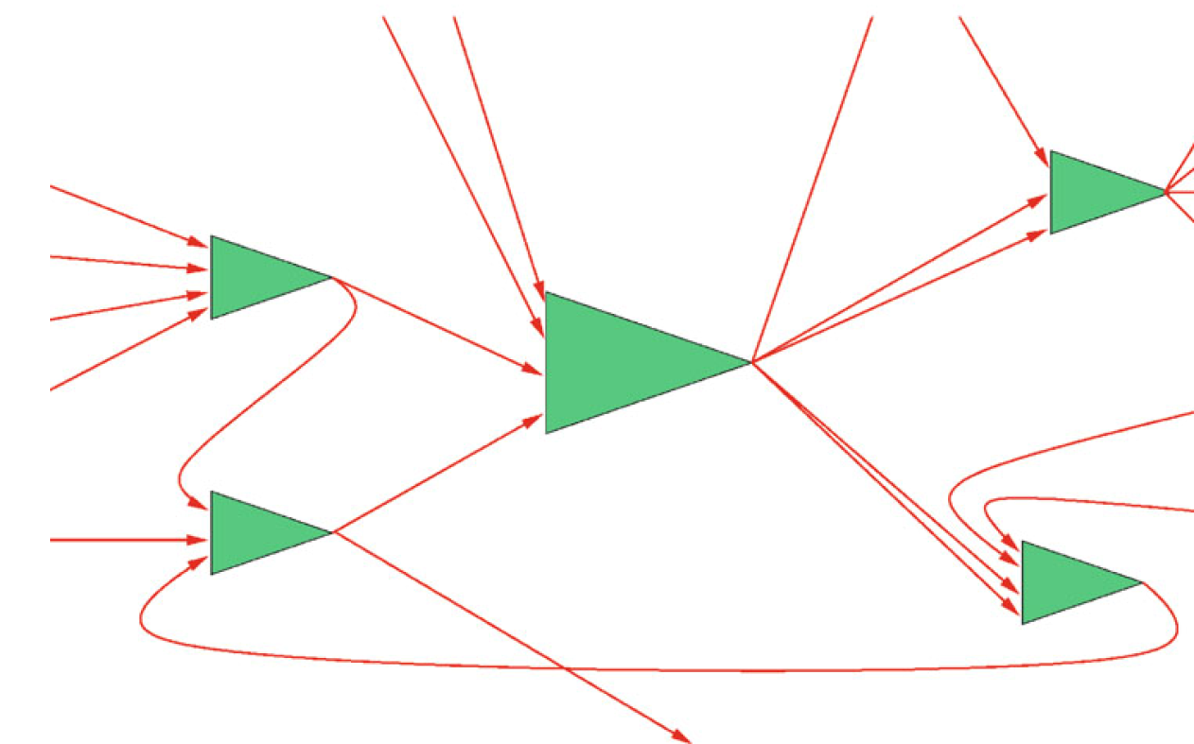

Figure 2.x: Model of network (Ertel, 2021)

The above figure above represents the network. The green triangles are the neurons connected by wires. The following picture shows how this is implemented.

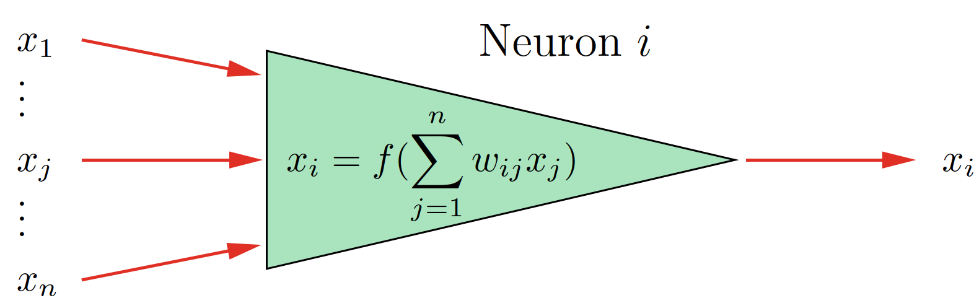

Figure 2.x: Mathematical Neuron (Ertel, 2021)

The input voltage of each wire is represented by variables named in the picture. The higher the voltage value of the human brain is, the higher the value of is in the mathematical model. The factor is fixed to each and represents how strong the connection to the respective previous neuron is. The better the connection, the more electrical power will go through. Despite this being a factor, its value can change, if the connection is changing as result of an adapting process. The product of each input and its factor will then be summed up. This is the output value .

Despite its called learning network in most networks the input data is processed through fixed calculations. In most cases it is a kind of matrix multiplication or applying filters and mask. It is also possible to several steps of calculation. That’s why an expert is required, who knows what the network is used for. The expert can then create the processing formulas.

What is it the network is learning then? It is the adjustment of the factors . When saying the network is being trained, it means that the artificial network does the calculation of the factors based on the received input data. With that the network is then able to detect patterns.

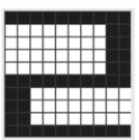Ein Bild, das Quadrat, Rechteck, Text, Kreuzworträtsel enthält.

Figure 2.x: Pattern of number 2 (Ertel, 2021)

In the above picture an example of pattern image recognition is shown. The network is trained to detect numbers. It is trained as an example with the number 2 on the left side of the figure. The network should then be able to recognize the 2. What makes a neuronal network special, that it is not just able to recognize the same image of the number, but also an image with changes. That is necessary in the real world as there are for example disturbances. This is shown on the right side of the figure. Some pixels of the 2 are not in place. If there was a standard recognition, it would fail to find the 2, but we want to recognize it as a 2. That is where the neuronal network comes in to play. What the network does is applying filters and masks to the picture. This will be done until the pattern of the 2 is recognized.

Another example is face recognition. If you take a picture of a person. The next day you want to recognize the face, it will be hardly possible. Because every day a person looks a bit different. And over the years a person’s face can change immensely. The network still needs to be able to recognize the pattern of a human face. For that a series of pictures is required to enable the network to learn. It then can find similarities and use them to recognize a change face.

The basic idea is simple. The question how such a network works exactly is more complicated. Scientists researching on the matter for a while and still will. The issue is the huge size of the brain with approximately 1011 neurons and the problem that its hardly possible to access the human brain. That’s why there are many different models that try to attempt to rebuild the brain. Each model has its benefits an application its suits. For our project it will be the convolutional neuronal network and the recurrent neuronal network.

978-3-658-32075-1.pdf 325

The challenge is to provide the computer with the information. For Human it is often easy to acquire a series of data, not for a computer.

It is required to provide as much raw data as possible, without giving many rule bases.

### 2.2.2 Convolutional Neuronal Network

The issue of most network is, that they have a vast number of data as input. Processing all of it in just one step would take very long. This is addressed by having several steps of processing. Each step filters more concrete information about the data.

It is based on the mathematical convolution.

Receives its data through a input layer. Publicizes data through a output layer.

### 2.2.3 Recurrent Neuronal Network