MES technology has come a long way since its inception in the 1980s and is now a vital component in the success of manufacturing companies around the world. The following chapter will cover the definition of a MES, its functionalities and how it is embedded into an enterprise. After that the role of MES in the context of Industry 4.0 will be evaluated.

## Functionality of a MES

MES is designed to improve operational efficiency and increase overall productivity by giving manufacturers insight into their production processes and providing them with tools to help optimize workflows. This is achieved by monitoring all aspects of the production process in real time.

Nowadays the functionality of a MES is described by the combination of three functional scopes. Those areas have to work hand in hand to create a high performance MES and enable a well-timed and effective manufacturing control.

First there is the function group production, where data acquisition plays the most important role. For production data order and person related times and quantities are recorded, but also machine data is collected to manage machines and other operational resources. Moreover operational data such as order and personnel timing an amounts are acquired. Other possible applications of a MES in the connection with production are tool and resource management, where tools and other auxiliary materials are managed, material and production logistics, where information about currently circulating material is provided, energy management and many more.

When it comes to human resources a MES should be able to handle time recording, time management, personnel resource planning and wage calculation. Furthermore short-term manpower planning and escalation management can also be use cases for a MES.

For the third field quality assurance different mechanisms like production inspection, complaints management, testing and measurement data acquisition can be implemented into a MES.

Lots of associations have developed standards to describe the requirements of a MES. As defined by the VDI (Verein Deutsche Ingenieure, *engl*. Association of German Engineers) in the guideline VDI 5600 the tasks of a MES are the following:

* Detailed planning and detailed scheduling control
* Operating resources management
* Material management
* Personnel management
* Data acquisition and processing
* Interface management
* Performance analysis
* Quality management
* Information management
* Order management
* Energy management

Furthermore the context of the MES in the complete enterprise is described in these standards, where the attempts in the VDI 5600 and the ISA 95 with three levels stacked on each other.

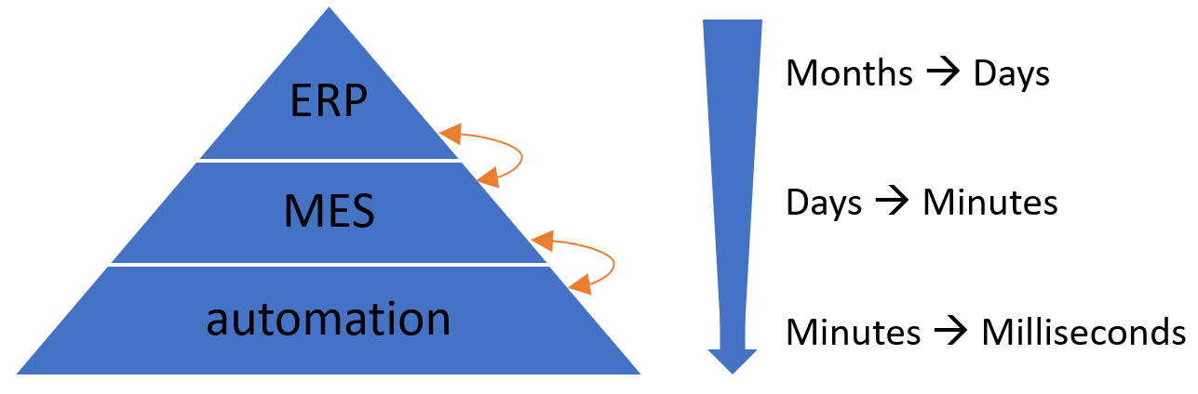

Figure 2.x Architecture of an enterprise with MES

As shown in the figure the MES is located in between the ERP (enterprise resource planning) and the automation on shopfloor level . Furthermore the time horizons of the different stages get significantly shorter from top to bottom. As in the ERP long- or mid-term decisions are made, the interested time period varies from months to days, whereas for the MES single days to minutes matter. For the shopfloor level, where the actual production happens, it can even depends on milliseconds.

Since the MES has interfaces with lots of other systems, it acts like a hub for the data. The ERP provides the base-data such as orders, quality requirements and capacity planning that needs to be saved and processed in the MES. But the MES also has to receive data from the production on shopfloor level including sensor values, process data, machine status, counter ticks or measurements that get processed to business relevant units. It is also possible that the MES provides specific data for the production for instance process value specifications, target values or recipes. When it is not possible to access these data automatically, workers have to insert them manually. When the MES is seen as a hub, it is important that it is integrated horizontally as well as vertically, which means that the information is distributed on the MES level and also throughout the different levels of the pyramid.

When using a MES a database, either an external one or the MES itself, with high requirements is needed. Data has to be consistent, plausible and complete, which is also relevant for data acquisition. Furthermore the database has to meet various security aspects so that the production is not endangered in case of power outage and other problems.

## MES in the context of Industry 4.0

The term Industry 4.0 has been circulating in the manufacturing industry for a while, but there are different approaches to revolutionizing industrial production. It is agreed that the use of information technology and increased networking can significantly improve the efficiency of industrial production, potentially increasing productivity by more than 30%. However achieving productivity gains requires the use of applications that take advantage of these new technologies and changes in organization such as MES.

Many visionaries dream of the ultimate networking of all resources and systems in manufacturing, where each machine is aware of its capabilities and each material knows which product it will become and for which customer it is destined. While this vision has evolved, a more practical approach seeks for each resource to be able to communicate with every other resource, allowing for early error detection and an increase in the flexibility and intelligence of the machines. Decentralized decision-making will become more common, but human experience will always be needed for final decision-making. This vision is known as a Smart Factory.

The concept of a Smart Factory presents new requirements for manufacturing software such as MES. IT systems need to become more flexible in order to adapt to short-term changes in manufacturing processes easily. The increasing interconnectivity generates huge amounts of data that require semantic structuring to become valuable. This "Big Data" must be processed in real-time to derive intelligent and useful insights. Industry 4.0 has to include human involvement and concrete use cases for optimal success.

The basic principles of a MES as defined in VDI guideline 5600 provide a good starting point for the Industry 4.0 era. In particular horizontal integration and comprehensive penetration of the company are of the most important issues here. The collection of data in production, their aggregation and also the processing and displaying in real time are essential for the success of a smart factory. However there is much more to it than the processing of data and measured values into meaningful information. In the future modern companies will depend much more on the integration of all functions and modules across all elements involved in production. In addition the importance of cross-system data exchange will increase, which is therefore an other task a MES must fullfil.

In summary, it can be stated that MES systems would be ideally suited as a central information and data hub in a smart factory. But in order to do so in perfection today's systems still need to be further developed. Still the basic approach of the MES idea is already heading in the right direction. The goal must be to synchronize all systems and functions involved in production. Transparent data exchange is the basis for a functioning future scenario. This does not just mean the pure distribution of data, but also application-related preprocessing or aggregation. For example ERP systems only need final summary values and not the comprehensive detailed data from the individual status messages at the machine. An MES system, as the central hub, has the task to provide each user and each system with exactly the data that is expected or required.

The developments and enhancements of the MES 4.0 concept aim to satisfy market and customer demands, such as mass customization and resource efficiency, to ensure manufacturing companies remain competitive in an increasingly globalized market. MES 4.0 provides flexible software tools to support the individualization of mass-produced products and improve efficiency, which is crucial for maintaining and expanding market leadership in a high-wage, highly automated region. The concepts of Industry 4.0 and MES 4.0 will promote sustainable efficiency in manufacturing in the long term.